|  |
| --- |
|  |
|  |
|  |
|  |
|  |

Fig. S1. Soil nitrous oxide flux (µg-N kg-1 soil day-1) as influenced by residues and nutrients under 80% FC moisture content during the incubation period of 87 days.

|  |
| --- |
|  |
|  |
|  |
|  |
|  |

Fig. S2. Soil nitrous oxide flux (µg-N kg-1 soil day-1) as influenced by residues and nutrients under 60% FC moisture content during the incubation period of 87 days.

|  |
| --- |
|  |
|  |
|  |
|  |
|  |

Fig. S3. Soil carbon dioxide flux (mg-C kg-1 soil day-1) as influenced by residues and nutrients under 80% FC moisture content during the incubation period of 87 days.

|  |
| --- |
|  |
|  |
|  |
|  |
|  |
|  |

Fig. S4. Soil carbon dioxide flux (mg-C kg-1 soil day-1) as influenced by residues and nutrients under 60% FC moisture content during the incubation period of 87 days.

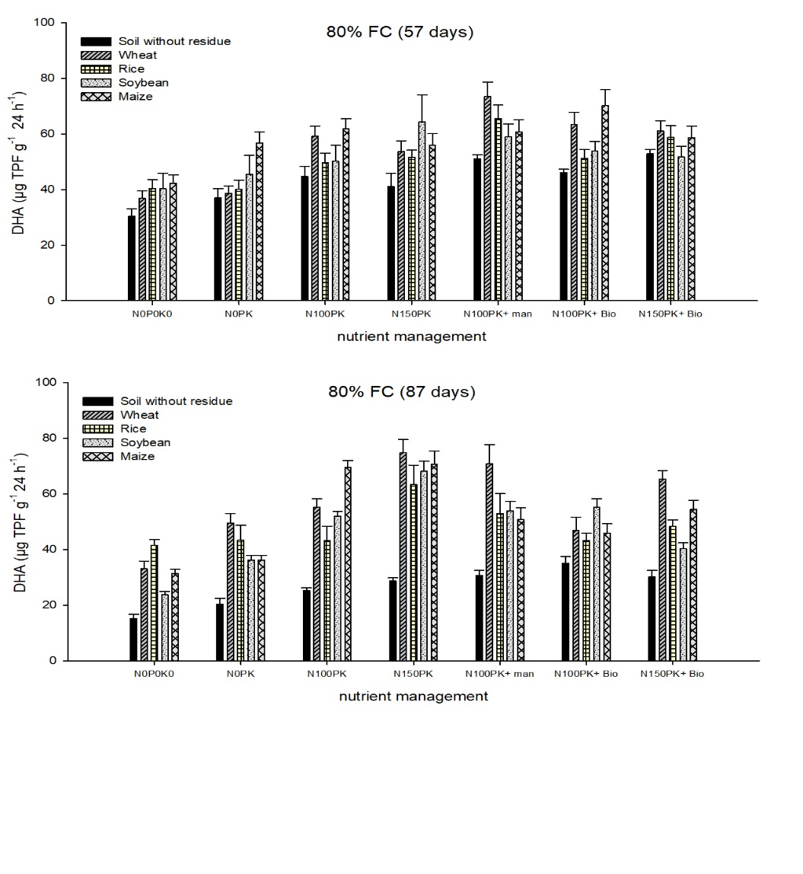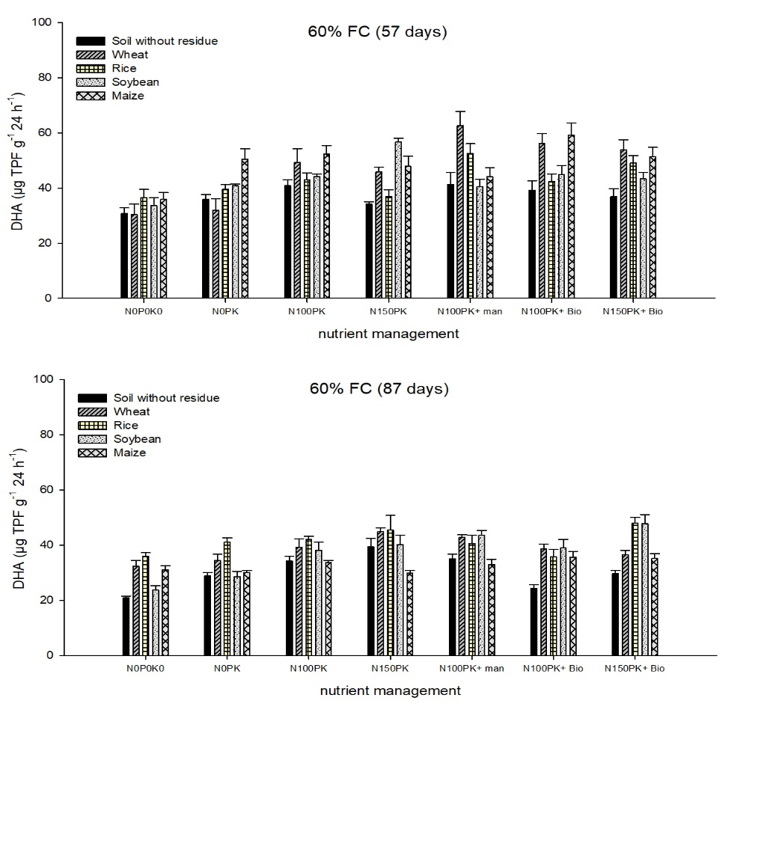

Fig. S5. Dehydrogenase activity (µg TPF g-1 24h-1) as influenced by residue types, nutrients and soil moisture after 57 and 87 days of incubation. Details of statistics of dehydrogenase activity are provided in Table 8.

**Table S1**

The NO3 –N, NO2–N, NH4–N and total mineral N (mg kg-1 soil) in soil as influenced by residues and nutrients at 57 days of incubation under 80% FC.

|  |  |  |  |  |  |  |
| --- | --- | --- | --- | --- | --- | --- |
| Nutrient management | Control soil | Wheat | Rice | Soybean | Maize | Mean |
| NO3 –N | | | | | |
| N0P0K0 | 54.2 | 13.4 | 23.1 | 32.0 | 17.6 | 28.0 |
| N0PK | 61.2 | 27.6 | 18.3 | 19.3 | 40.6 | 33.4 |
| N100PK | 78.7 | 55.4 | 75.0 | 73.5 | 78.1 | 72.1 |
| N150PK | 82.3 | 80.7 | 94.8 | 99.3 | 124.3 | 96.3 |
| N100PK + MANURE | 103.3 | 61.3 | 72.5 | 65.8 | 71.0 | 74.8 |
| N100PK + BIOCHAR | 67.2 | 45.0 | 65.1 | 40.3 | 80.0 | 59.5 |
| N150PK+ BIOCHAR | 89.6 | 76.1 | 86.9 | 95.7 | 93.2 | 88.3 |
| Mean | 76.6 | 51.3 | 62.2 | 60.8 | 72.1 |  |
|  | NO2-N | | | | | |
| N0P0K0 | 0.23 | 0.32 | 0.63 | 0.76 | 0.23 | 0.43 |
| N0PK | 0.32 | 0.28 | 0.27 | 0.43 | 0.36 | 0.33 |
| N100PK | 0.37 | 0.31 | 0.31 | 0.43 | 0.72 | 0.43 |
| N150PK | 0.27 | 0.32 | 0.32 | 0.44 | 0.54 | 0.38 |
| N100PK + MANURE | 0.22 | 0.27 | 0.38 | 0.32 | 0.49 | 0.34 |
| N100PK + BIOCHAR | 0.23 | 0.26 | 0.36 | 0.37 | 0.22 | 0.29 |
| N150PK+ BIOCHAR | 0.49 | 0.22 | 0.27 | 0.41 | 0.23 | 0.32 |
| Mean | 0.30 | 0.28 | 0.36 | 0.45 | 0.40 |  |
|  | NH4-N | | | | | |
| N0P0K0 | 49.7 | 48.5 | 48.0 | 55.5 | 57.3 | 51.81 |
| N0PK | 41.1 | 53.8 | 53.0 | 52.3 | 56.9 | 51.41 |
| N100PK | 53.3 | 51.4 | 51.8 | 54.6 | 55.5 | 53.30 |
| N150PK | 57.7 | 61.0 | 48.6 | 57.5 | 55.4 | 56.03 |
| N100PK + MANURE | 43.1 | 57.6 | 53.7 | 57.7 | 48.1 | 52.06 |
| N100PK + BIOCHAR | 50.0 | 52.5 | 56.3 | 46.7 | 45.9 | 50.25 |
| N150PK+ BIOCHAR | 52.8 | 49.6 | 56.2 | 55.4 | 62.2 | 55.25 |
| Mean | 49.66 | 53.47 | 52.52 | 54.24 | 54.47 |  |
|  | Total mineral N | | | | | |
| N0P0K0 | 104.1 | 62.2 | 71.8 | 88.3 | 75.1 | 80.3 |
| N0PK | 102.6 | 81.7 | 71.5 | 72.1 | 97.8 | 85.2 |
| N100PK | 132.4 | 107.1 | 127.1 | 128.5 | 134.3 | 125.9 |
| N150PK | 140.3 | 141.9 | 143.7 | 157.2 | 180.3 | 152.7 |
| N100PK + MANURE | 146.6 | 119.2 | 126.6 | 123.8 | 119.7 | 127.2 |
| N100PK + BIOCHAR | 117.4 | 97.7 | 121.7 | 87.4 | 126.1 | 110.1 |
| N150PK+ BIOCHAR | 142.9 | 125.9 | 143.4 | 151.5 | 155.6 | 143.9 |
| Mean | 126.6 | 105.1 | 115.1 | 115.5 | 127.0 |  |

**Table S2**

The NO3 –N, NO2–N, NH4–N and total mineral N (mg kg-1 soil) in soil as influenced by residues and nutrients at 87 days of incubation under 80% FC.

|  |  |  |  |  |  |  |
| --- | --- | --- | --- | --- | --- | --- |
| Nutrient management | Control soil | Wheat | Rice | Soybean | Maize | Mean |
| NO3 –N | | | | | |
| N0P0K0 | 32.3 | 18.9 | 19.3 | 38.4 | 27.0 | 27.2 |
| N0PK | 34.1 | 13.0 | 25.5 | 18.5 | 19.4 | 22.1 |
| N100PK | 67.3 | 39.9 | 40.4 | 84.3 | 63.8 | 59.1 |
| N150PK | 97.2 | 61.9 | 69.0 | 100.6 | 94.4 | 84.6 |
| N100PK + MANURE | 87.4 | 61.8 | 65.6 | 89.4 | 80.5 | 76.9 |
| N100PK + BIOCHAR | 85.5 | 57.1 | 60.2 | 80.2 | 80.7 | 72.8 |
| N150PK+ BIOCHAR | 84.7 | 60.0 | 85.9 | 119.8 | 103.7 | 90.8 |
| Mean | 69.8 | 44.7 | 52.3 | 75.9 | 67.1 |  |
|  | NO2-N | | | | | |
| N0P0K0 | 0.63 | 0.74 | 0.60 | 0.82 | 1.08 | 0.63 |
| N0PK | 0.67 | 0.44 | 0.54 | 0.70 | 0.92 | 0.67 |
| N100PK | 0.87 | 0.83 | 0.78 | 0.91 | 0.65 | 0.87 |
| N150PK | 0.96 | 1.17 | 0.59 | 1.07 | 0.98 | 0.96 |
| N100PK + MANURE | 0.85 | 1.15 | 0.50 | 1.49 | 1.74 | 0.85 |
| N100PK + BIOCHAR | 0.61 | 0.91 | 0.38 | 0.81 | 1.13 | 0.61 |
| N150PK+ BIOCHAR | 0.60 | 0.97 | 0.48 | 1.01 | 0.66 | 0.60 |
| Mean | 0.74 | 0.89 | 0.55 | 0.97 | 1.02 |  |
|  | NH4-N | | | | | |
| N0P0K0 | 43.6 | 69.9 | 75.8 | 49.5 | 75.9 | 62.9 |
| N0PK | 59.7 | 73.1 | 55.5 | 63.7 | 58.8 | 62.2 |
| N100PK | 66.3 | 58.4 | 69.7 | 63.0 | 61.7 | 63.8 |
| N150PK | 73.4 | 65.1 | 68.0 | 68.2 | 61.0 | 67.1 |
| N100PK + MANURE | 38.8 | 70.2 | 65.5 | 74.5 | 56.1 | 61.0 |
| N100PK + BIOCHAR | 57.2 | 73.4 | 76.0 | 73.0 | 80.8 | 72.1 |
| N150PK+ BIOCHAR | 77.7 | 69.5 | 68.9 | 62.4 | 65.0 | 68.7 |
| Mean | 59.5 | 68.5 | 68.5 | 64.9 | 65.6 |  |
|  | Total mineral N | | | | | |
| N0P0K0 | 76.5 | 89.6 | 95.8 | 88.6 | 104.0 | 90.9 |
| N0PK | 94.5 | 86.6 | 81.5 | 82.9 | 79.1 | 84.9 |
| N100PK | 134.4 | 99.1 | 110.8 | 148.2 | 126.1 | 123.7 |
| N150PK | 171.5 | 128.2 | 137.6 | 169.8 | 156.4 | 152.7 |
| N100PK + MANURE | 127.0 | 133.1 | 131.6 | 165.4 | 138.4 | 139.1 |
| N100PK + BIOCHAR | 143.3 | 131.4 | 136.6 | 154.0 | 162.6 | 145.6 |
| N150PK+ BIOCHAR | 163.0 | 130.4 | 155.3 | 183.2 | 169.4 | 160.2 |
| Mean | 130.0 | 114.1 | 121.3 | 141.7 | 133.7 |  |

**Table S3**

The NO3 –N, NO2–N, NH4–N and total mineral N (mg kg-1 soil) in soil as influenced by residues and nutrients at 57 days of incubation under 60% FC.

|  |  |  |  |  |  |  |
| --- | --- | --- | --- | --- | --- | --- |
| Nutrient management | Control soil | Wheat | Rice | Soybean | Maize | Mean |
| NO3 –N | | | | | |
| N0P0K0 | 49.4 | 11.5 | 20.0 | 23.9 | 13.7 | 23.7 |
| N0PK | 55.6 | 13.4 | 13.6 | 13.7 | 35.3 | 26.3 |
| N100PK | 58.8 | 49.5 | 39.7 | 36.3 | 43.1 | 45.5 |
| N150PK | 56.4 | 53.2 | 57.6 | 61.1 | 63.8 | 58.4 |
| N100PK + MANURE | 54.8 | 48.5 | 45.6 | 54.3 | 70.1 | 54.6 |
| N100PK + BIOCHAR | 37.8 | 40.6 | 35.2 | 34.3 | 72.8 | 44.2 |
| N150PK+ BIOCHAR | 95.2 | 56.9 | 55.6 | 45.9 | 59.0 | 62.5 |
| Mean | 58.3 | 39.1 | 38.2 | 38.5 | 51.1 |  |
|  | NO2-N | | | | | |
| N0P0K0 | 0.21 | 0.08 | 0.25 | 0.25 | 0.25 | 0.21 |
| N0PK | 0.25 | 0.08 | 0.16 | 0.25 | 0.25 | 0.20 |
| N100PK | 0.32 | 0.24 | 0.28 | 0.16 | 0.15 | 0.23 |
| N150PK | 0.25 | 0.16 | 0.40 | 0.33 | 0.24 | 0.28 |
| N100PK + MANURE | 0.29 | 0.08 | 0.16 | 0.31 | 0.16 | 0.20 |
| N100PK + BIOCHAR | 0.21 | 0.25 | 0.24 | 0.11 | 0.32 | 0.22 |
| N150PK+ BIOCHAR | 0.24 | 0.24 | 0.32 | 0.32 | 0.32 | 0.29 |
| Mean | 0.25 | 0.16 | 0.26 | 0.25 | 0.24 |  |
|  | NH4-N | | | | | |
| N0P0K0 | 32.6 | 34.1 | 34.8 | 43.0 | 42.5 | 37.40 |
| N0PK | 35.7 | 33.9 | 39.1 | 45.4 | 46.6 | 40.13 |
| N100PK | 30.5 | 35.5 | 36.0 | 47.2 | 49.4 | 39.73 |
| N150PK | 32.8 | 33.6 | 36.2 | 45.3 | 37.7 | 37.14 |
| N100PK + MANURE | 33.4 | 36.2 | 34.0 | 38.9 | 30.4 | 34.58 |
| N100PK + BIOCHAR | 32.7 | 33.2 | 32.0 | 40.4 | 25.7 | 32.80 |
| N150PK+ BIOCHAR | 32.0 | 39.5 | 21.7 | 33.1 | 34.0 | 32.04 |
| Mean | 32.81 | 35.14 | 33.41 | 41.90 | 38.04 |  |
|  | Total mineral N | | | | | |
| N0P0K0 | 82.2 | 45.7 | 55.1 | 67.1 | 56.5 | 61.3 |
| N0PK | 91.6 | 47.4 | 52.9 | 59.3 | 82.1 | 66.6 |
| N100PK | 89.6 | 85.2 | 76.0 | 83.7 | 92.7 | 85.5 |
| N150PK | 89.4 | 87.0 | 94.1 | 106.7 | 101.8 | 95.8 |
| N100PK + MANURE | 88.5 | 84.8 | 79.8 | 93.4 | 100.6 | 89.4 |
| N100PK + BIOCHAR | 70.8 | 74.0 | 67.5 | 74.8 | 98.9 | 77.2 |
| N150PK+ BIOCHAR | 127.4 | 96.6 | 77.6 | 79.4 | 93.3 | 94.8 |
| Mean | 91.3 | 74.4 | 71.8 | 80.6 | 89.4 |  |

**Table S4**

The NO3 –N, NO2–N, NH4–N and total mineral N (mg kg-1 soil) in soil as influenced by residues and nutrients at 87 days of incubation under 60% FC.

|  |  |  |  |  |  |  |
| --- | --- | --- | --- | --- | --- | --- |
| Nutrient management | Control soil | Wheat | Rice | Soybean | Maize | Mean |
| NO3 –N | | | | | |
| N0P0K0 | 28.6 | 33.0 | 33.4 | 36.3 | 47.1 | 35.7 |
| N0PK | 43.2 | 30.8 | 35.9 | 47.9 | 38.6 | 39.3 |
| N100PK | 70.3 | 51.6 | 33.8 | 52.7 | 23.2 | 46.3 |
| N150PK | 63.7 | 55.2 | 44.9 | 63.4 | 62.0 | 57.8 |
| N100PK + MANURE | 42.7 | 52.0 | 32.2 | 91.6 | 27.2 | 49.1 |
| N100PK + BIOCHAR | 52.0 | 38.0 | 59.8 | 56.4 | 20.3 | 45.3 |
| N150PK+ BIOCHAR | 48.7 | 45.7 | 39.4 | 69.1 | 47.4 | 50.0 |
| Mean | 49.9 | 43.7 | 39.9 | 59.6 | 38.0 |  |
|  | NO2-N | | | | | |
| N0P0K0 | 0.55 | 0.57 | 0.28 | 0.49 | 0.56 | 0.49 |
| N0PK | 0.58 | 0.37 | 1.12 | 0.36 | 0.56 | 0.60 |
| N100PK | 0.40 | 0.73 | 0.40 | 0.60 | 0.37 | 0.50 |
| N150PK | 0.29 | 0.83 | 0.59 | 0.57 | 0.50 | 0.56 |
| N100PK + MANURE | 0.37 | 0.32 | 0.73 | 0.61 | 0.77 | 0.56 |
| N100PK + BIOCHAR | 0.57 | 0.68 | 0.52 | 0.40 | 0.67 | 0.57 |
| N150PK+ BIOCHAR | 0.40 | 0.28 | 0.24 | 0.84 | 0.37 | 0.43 |
| Mean | 0.45 | 0.54 | 0.56 | 0.55 | 0.54 |  |
|  | NH4-N | | | | | |
| N0P0K0 | 51.4 | 37.8 | 49.4 | 39.7 | 53.5 | 46.33 |
| N0PK | 56.0 | 47.3 | 48.2 | 42.9 | 46.9 | 48.27 |
| N100PK | 59.0 | 32.2 | 49.0 | 62.3 | 50.1 | 50.52 |
| N150PK | 37.6 | 35.3 | 48.7 | 52.9 | 54.4 | 45.79 |
| N100PK + MANURE | 35.7 | 57.4 | 50.2 | 61.8 | 48.7 | 50.75 |
| N100PK + BIOCHAR | 33.0 | 34.4 | 40.9 | 51.5 | 52.8 | 42.49 |
| N150PK+ BIOCHAR | 61.6 | 67.7 | 65.5 | 52.9 | 46.1 | 58.77 |
| Mean | 47.7 | 44.6 | 50.3 | 52.0 | 50.3 |  |
|  | Total mineral N | | | | | |
| N0P0K0 | 80.5 | 71.3 | 83.1 | 76.5 | 101.2 | 82.5 |
| N0PK | 99.7 | 78.4 | 85.2 | 91.2 | 86.1 | 88.1 |
| N100PK | 129.6 | 84.5 | 83.2 | 115.5 | 73.6 | 97.3 |
| N150PK | 101.7 | 91.4 | 94.1 | 116.9 | 116.9 | 104.2 |
| N100PK + MANURE | 78.7 | 109.7 | 83.1 | 154.0 | 76.6 | 100.4 |
| N100PK + BIOCHAR | 85.5 | 73.0 | 101.2 | 108.3 | 73.7 | 88.4 |
| N150PK+ BIOCHAR | 110.7 | 113.7 | 105.1 | 122.9 | 93.9 | 109.2 |
| Mean | 98.1 | 88.9 | 90.7 | 112.2 | 88.9 |  |