Supplementary Material

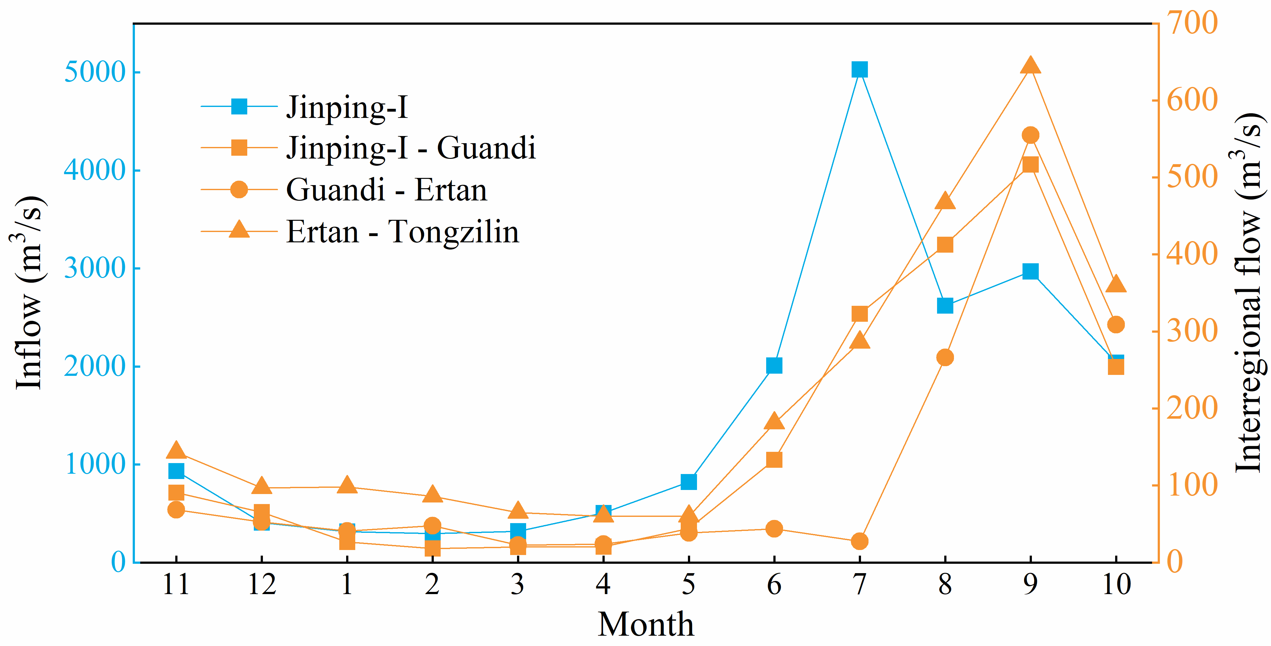

**Supplementary Figure 1.** The inflow and interregional flow of cascade HPPs of the Yalong River in a normal year (Note: the Jinping-II plant is an in-conduit HPP).

**Supplementary Table 1.** Characteristics of hydropower plants on the lower reaches of the Yalong River.

|  |  |  |  |  |  |
| --- | --- | --- | --- | --- | --- |
| Indexes | Jinping-Ⅰ | Jinping-Ⅱ | Guandi | Ertan | Tongzilin |
| Normal water level (m) | 1880 | 1646 | 1330 | 1200 | 1015 |
| Flood limited water level (m) | 1859 | - | - | 1190 | - |
| Dead water level (m) | 1800 | 1640 | 1328 | 1155 | 1012 |
| Total storage (108 m3) | 77.60 | 0.14 | 7.29 | 57.90 | 0.72 |
| Regulation ability | Yearly | Daily | Daily | Seasonally | Daily |
| Installed capacity (MW) | 3600 | 4800 | 2400 | 3300 | 600 |

**Supplementary Table 2.** The $Q^{min}$ and $h_{E}$ of hydropower plants in a normal year (Note: $Q^{min}$ = minimum discharge flow, m3/s; = water evaporation from the OWS, mm).

|  |  |  |  |  |  |  |  |  |  |  |
| --- | --- | --- | --- | --- | --- | --- | --- | --- | --- | --- |
| Month | Jinping-Ⅰ | | Jinping-Ⅱ | | Guandi | | Ertan | | Tongzilin | |
| $$Q^{min}$$ | $$h_{E}$$ | $$Q^{min}$$ | $$h_{E}$$ | $$Q^{min}$$ | $$h_{E}$$ | $$Q^{min}$$ | $$h_{E}$$ | $$Q^{min}$$ | $$h_{E}$$ |
| 11 | 339 | 46.3 | 45 | 46.3 | 200 | 60.4 | 401 | 74.5 | 422 | 74.5 |
| 12 | 373 | 40.1 | 45 | 40.1 | 200 | 49.8 | 401 | 59.5 | 422 | 59.5 |
| 1 | 373 | 40.2 | 45 | 40.2 | 200 | 45.3 | 401 | 50.4 | 422 | 50.4 |
| 2 | 373 | 63.6 | 45 | 63.6 | 200 | 79.3 | 401 | 94.9 | 422 | 94.9 |
| 3 | 373 | 124.0 | 50 | 124.0 | 200 | 155.1 | 401 | 186.2 | 422 | 186.2 |
| 4 | 373 | 108.1 | 60 | 108.1 | 200 | 142.8 | 401 | 177.5 | 422 | 177.5 |
| 5 | 373 | 121.3 | 76 | 121.3 | 200 | 175.0 | 401 | 228.7 | 422 | 228.7 |
| 6 | 339 | 96.5 | 77 | 96.5 | 200 | 155.8 | 401 | 215.0 | 422 | 215.0 |
| 7 | 339 | 81.6 | 45 | 81.6 | 200 | 104.4 | 401 | 127.1 | 422 | 127.1 |
| 8 | 339 | 60.6 | 45 | 60.6 | 200 | 76.3 | 401 | 92.0 | 422 | 92.0 |
| 9 | 339 | 57.6 | 45 | 57.6 | 200 | 76.4 | 401 | 95.2 | 422 | 95.2 |
| 10 | 339 | 68.4 | 45 | 68.4 | 200 | 74.4 | 401 | 80.3 | 422 | 80.3 |

**Supplementary Table** **3** Parameter settings of the Non-dominated Sorting Genetic Algorithm.

|  |  |
| --- | --- |
| Parameters | Value |
| Number of generations | 1000 |
| Population size | 1000 |
| Crossover rate | 0.9 |
| Mutation rate | 0.2 |