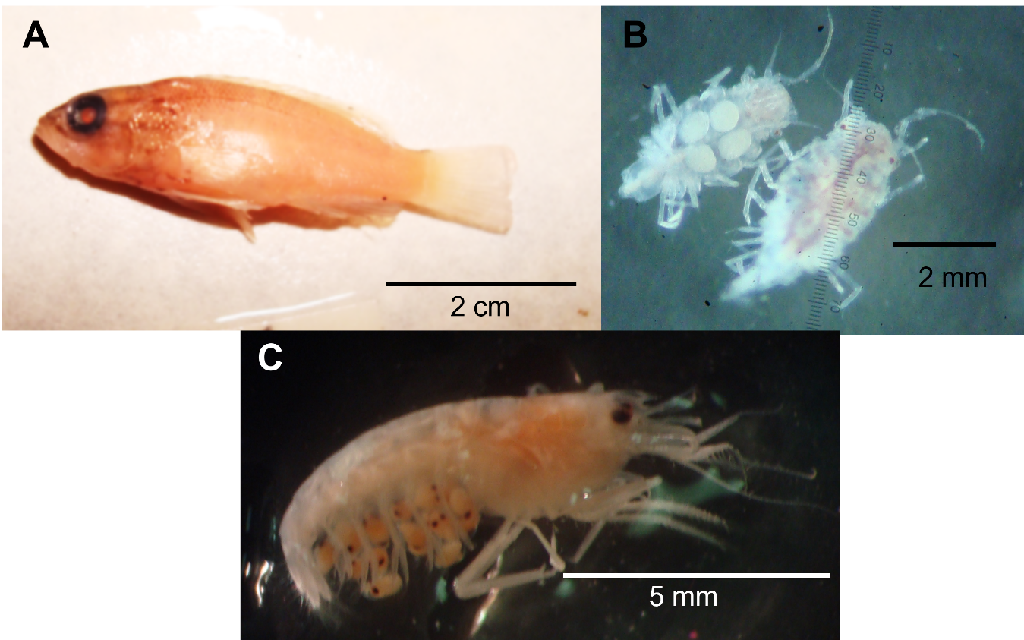
Figure S1. A. Juvenile Lutjanus colorado. B. Isopods Munna sp. carrying eggs. C. Amphipoda indet. 1. Carrying advanced eggs with embryos.

