**Figure:**

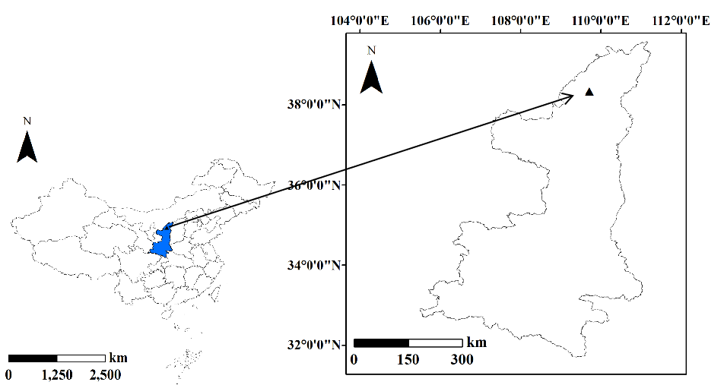

**Figure S1** The location of study site.

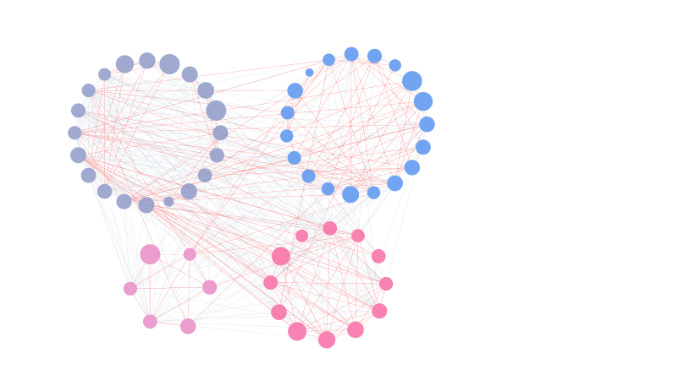

**Figure S2** A network of EcM fungi associated with *P. sylvestris*. The dots represent different EcM OTUs, colored represent different models in the whole network. The pink line indicates a positive correlation and the grey line indicates a negatively correlation.

|  |  |  |  |  |  |
| --- | --- | --- | --- | --- | --- |
| **Figure S3** EcM fungal topological roles in roots of *P. sylvestris* plantation  **Table:**  **Table S1** DNA sequence BLAST results of the ITS region of DNA extracted from root tips associated with *P. sylvestris* | | | | | |
| **Taxon** | **Accession no.** | **Sequence length (bp)** | **Best Blast match (accession no.)** | **Match (%)** | **Important value (%)** |
| *Hygrocybe singeri* | MT229482 | 295 | *Hygrocybe* *singer* (MN089502) | 97 | 0.62 |
| *Hygrocybe persistens* | MT229483 | 277 | *Hygrocybe persistens* (KY243919) | 91 | 1.39 |
| *Hygrocybe conica* | MT229484 | 297 | *Hygrocybe* *conica* (JN021030) | 98 | 0.88 |
| *Tuber beyerlei* | MT229485 | 173 | *Tuber beyerlei* (MK342068) | 100 | 23.54 |
| *uncultured Tuber* | MT229486 | 283 | *uncultured Tuber* (JQ711826) | 99 | 2.60 |
| *Hebeloma collariatum* | MT229487 | 316 | *Hebeloma collariatum* (FJ904154) | 100 | 5.27 |
| *Uncultured Inocybe* | MT229488 | 332 | *Uncultured Inocybe* (LC013766) | 100 | 13.60 |
| *Uncultured Inocybe* | MT229489 | 338 | *Uncultured Inocybe* (LC204346) | 98 | 0.40 |
| *Inocybe exilis* | MT229490 | 301 | *Inocybe exilis* (JX630516) | 99 | 1.70 |
| *Uncultured Inocybe* | MT229491 | 313 | *Uncultured Inocybe* (KY684456) | 91 | 0.39 |
| *Inocybe godeyi* | MT229492 | 340 | *Inocybe godeyi* (AJ889954) | 91 | 1.48 |
| *Inocybe decipiens* | MT229493 | 297 | *Inocybe decipiens* (MK342092) | 100 | 1.03 |
| *Inocybe calospora* | MT229494 | 284 | *Inocybe calospora* (MK342090) | 100 | 0.99 |
| *Inocybe dunensis* | MT229495 | 297 | *Inocybe dunensis* (MK659791) | 100 | 0.57 |
| *Inocybe chelanensis* | MT229496 | 293 | *Inocybe chelanensis* (MK342116) | 100 | 0.30 |
| *Inocybe decemgibbosa* | MT229497 | 277 | *Inocybe decemgibbosa* (JF908102) | 99 | 0.25 |
| *Tomentella* sp. | MT229498 | 282 | *Tomentella* sp. (MK342049) | 97 | 8.44 |
| *uncultured Tomentella* | MT229499 | 275 | *uncultured Tomentella* (KX510034) | 97 | 1.45 |
| *uncultured Tomentella* | MT229500 | 275 | *uncultured Tomentella* (LC013869) | 98 | 9.10 |
| *Tomentella ellisii* | MT229501 | 276 | *Tomentella ellisii* (AJ408375) | 99 | 7.77 |
| *Tomentella badia* | MT229502 | 276 | *Tomentella badia* (JQ711882) | 95 | 3.60 |
| *Tomentella badia* | MT229503 | 274 | *Tomentella badia* (EU819522) | 100 | 2.16 |
| *uncultured Tomentella* | MT229504 | 277 | *uncultured Tomentella* (KC455345) | 94 | 1.35 |
| *Tomentella lilacinogrisea* | MT229505 | 273 | *Tomentella lilacinogrisea* (JX630533) | 94 | 1.44 |
| *uncultured Tomentella* | MT229506 | 276 | *uncultured Tomentella* (LC013824) | 100 | 0.98 |
| *Tomentella* sp. | MT229507 | 279 | *Tomentella* sp. (MK342103) | 100 | 0.80 |
| *uncultured Tomentella* 8 | MT229508 | 275 | *uncultured Tomentella* (KY574425) | 94 | 0.54 |
| *uncultured Tomentella* 9 | MT229509 | 278 | *uncultured Tomentella* (MH342103) | 99 | 0.42 |
| *Tomentella* sp. | MT229510 | 275 | *Tomentella* sp. (MK342070) | 100 | 7.51 |
| *Tomentella* sp. | MT229511 | 275 | *Tomentella* sp. (MK342082) | 100 | 1.23 |
| *Tomentella fuscocinerea* | MT229512 | 277 | *Tomentella fuscocinerea* (MK342084) | 100 | 5.09 |
| *Tomentella pilosa* | MT229513 | 277 | *Tomentella pilosa* (MK342101) | 100 | 2.14 |
| *uncultured Tomentella* | MT229514 | 275 | *uncultured Tomentella* (KU176261) | 95 | 0.95 |
| *Rhizopogon mohelnensis* | MT229515 | 298 | *Rhizopogon mohelnensis* (MK342072) | 100 | 10.71 |
| *Rhizopogon rubescens* | MT229516 | 298 | *Rhizopogon rubescens* (JX907816) | 100 | 30.41 |
| *Uncultured Rhizopogon* | MT229517 | 299 | *Uncultured Rhizopogon* (FJ013089) | 100 | 10.56 |
| *Uncultured Peziza* | MT229518 | 288 | *Uncultured Peziza* (FJ013089) | 100 | 1.82 |
| *Suillus luteus* | MT229519 | 283 | *Suillus luteus* (KU721218) | 100 | 3.86 |
| *Russula pectinatoides* | MT229520 | 289 | *Russula pectinatoides* (KX095009) | 99 | 2.68 |
| *Russula livescens* | MT229521 | 289 | *Russula livescens* (GU371295) | 100 | 0.58 |
| *Russula* sp. | MT229522 | 289 | *Russula* sp*.* (GU371295) | 100 | 0.68 |
| *Russula aeruginea* | MT229523 | 286 | *Russula aeruginea* (KX095030) | 97 | 0.64 |
| *Russula cyanoxantha* | MT229524 | 276 | *Russula cyanoxantha* (KX267641) | 99 | 1.03 |
| *Russula* sp. | MT229525 | 273 | *Russula* sp*.* (MK342080) | 100 | 1.20 |
| *Russula nauseosa* | MT229526 | 264 | *Russula nauseosa* (KT933985) | 99 | 0.82 |
| *Geopora arenicola* | MT229527 | 284 | *Geopora arenicola* (FM206449) | 99 | 6.45 |
| *Geopora* sp. | MT229528 | 296 | *Uncultured Geopora* (MK342078) | 100 | 1.95 |
| *Wilcoxina mikolae* | MT229529 | 264 | *Wilcoxina mikolae* (JQ310818) | 99 | 4.38 |
| *Lactarius deliciosus* | MT229530 | 305 | *Lactarius deliciosus* (AF140276) | 96 | 2.07 |
| *Lactarius* sp. | MT229531 | 241 | *Uncultured Lactarius* (KY574343) | 98 | 0.61 |
| *Tulostoma melanocyclum* | MT229532 | 346 | *Tulostoma melanocyclum* (KU519106) | 100 | 1.13 |
| *Cortinarius alpinus* | MT229533 | 312 | *Cortinarius alpinus* (GU234096) | 99 | 1.23 |
| *Cortinarius* sp. | MT229534 | 238 | *Uncultured Cortinarius* (JX630542) | 100 | 1.26 |
| *Genabea fragilis* | MT229535 | 241 | *Genabea fragilis* (EU887662) | 100 | 2.33 |
| *uncultured Sebacina* | MT229536 | 255 | *uncultured Sebacina* (KY684559) | 100 | 1.17 |
| *uncultured Sebacina* | MT229537 | 249 | *uncultured Sebacina* (KJ769303) | 94 | 1.44 |
| *Sebacina* sp. | MT229538 | 253 | *Sebacina* sp.(MK342083) | 100 | 0.62 |
| *uncultured Sebacina* | MT229539 | 252 | *uncultured Sebacina* (KX444489) | 99 | 0.19 |
| *Sebacina* sp. | MT229540 | 250 | *Sebacina* sp.(MK342109) | 100 | 0.60 |
| *Sebacina* sp. | MT229541 | 247 | *Sebacina* sp.(MK342105) | 100 | 0.76 |
| *uncultured Sebacina* | MT229542 | 250 | *uncultured Sebacina* (KY574399) | 99 | 0.61 |
| *Agaricus xanthodermus* | MT229543 | 367 | *Agaricus* *xanthodermus* (JF514527) | 100 | 0.16 |
| *Agaricus comtulus* | MT229544 | 185 | *Agaricus comtulus* (MH858309) | 97 | 0.86 |
| *Ramaria abietina* | MT229545 | 287 | *Ramaria abietina* (AJ408383) | 99 | 2.97 |
| *Ramaria decurrens* | MT229546 | 286 | *Ramaria decurrens* (AJ408375) | 90 | 0.79 |
| *Amphinema* sp. | MT229547 | 249 | *Amphinema* sp. (MK342079) | 100 | 5.63 |
| *Amphinema* sp. | MT229548 | 256 | *Amphinema* sp.(MK342086) | 100 | 3.80 |
| *uncultured Lachnum* | MT229549 | 239 | *uncultured Lachnum* (FJ378862) | 100 | 1.86 |
| *uncultured Lachnum* | MT229550 | 242 | *uncultured Lachnum* (FJ378862) | 95 | 1.17 |
| *Clitopilus peunulus* | MT22951 | 308 | *Clitopilus peunulus* (KX960794) | 98 | 1.01 |
| *Hydnum* sp. | MT229552 | 253 | *Hydnum* sp. (MK342117) | 100 | 0.63 |
| *Geastrum xerophilum* | MT229553 | 241 | *Geastrum xerophilum* (MG987624) | 99 | 0.70 |

|  |  |  |  |  |  |  |  |  |  |  |  |
| --- | --- | --- | --- | --- | --- | --- | --- | --- | --- | --- | --- |
| **Table S2** The spearman rank correction matrixes between soil factors and EM fungi | | | | | | | | | | | |
|  | pH | SWC | TN | TP | SOC | NH4+ | NO3- | URE | PHO | INV | Age |
| *Hygrocybe* | 0.28 | 0.03 | -0.38 | -0.43 | -0.54 | -0.48 | -0.61 | -0.62 | -0.45 | 0.66 | -0.62 |
| *Tuber* | 0.31 | -0.32 | 0.29 | -0.15 | 0.13 | 0.13 | -0.11 | -0.05 | -0.04 | 0.04 | 0.00 |
| *Hebeloma* | -0.14 | 0.46 | 0.46 | -0.35 | 0.02 | 0.37 | 0.23 | 0.09 | 0.13 | -0.16 | 0.15 |
| *Inocybe* | 0.13 | 0.06 | 0.09 | -0.53 | -0.53 | -0.18 | -0.56 | -0.53 | -0.18 | 0.57 | -0.47 |
| *Tomentella* | 0.10 | 0.02 | 0.03 | -0.16 | -0.30 | 0.11 | -0.21 | -0.25 | -0.01 | 0.25 | -0.21 |
| *Rhizopogon* | -0.42 | 0.25 | -0.04 | 0.31 | 0.30 | 0.14 | 0.42 | 0.51 | 0.02 | -0.33 | 0.32 |
| *Peziza* | 0.25 | -0.32 | 0.00 | -0.28 | -0.24 | -0.18 | 0.05 | -0.03 | -0.25 | 0.22 | -0.03 |
| *Suillus* | 0.34 | -0.46 | -0.31 | -0.20 | -0.24 | -0.45 | -0.03 | -0.14 | -0.27 | 0.14 | -0.08 |
| *Russula* | 0.32 | 0.03 | -0.11 | -0.60 | -0.68 | -0.34 | -0.51 | -0.59 | -0.26 | 0.55 | -0.53 |
| *Geopora* | -0.23 | 0.13 | 0.41 | 0.03 | 0.11 | 0.44 | 0.34 | 0.31 | 0.31 | -0.20 | 0.32 |
| *Wilcoxina* | -0.06 | -0.08 | 0.30 | -0.31 | -0.05 | 0.14 | 0.25 | 0.09 | 0.22 | -0.15 | 0.19 |
| *Lactarius* | 0.18 | 0.25 | -0.27 | 0.08 | -0.09 | -0.11 | -0.13 | -0.23 | -0.39 | 0.05 | -0.19 |
| *Tulostoma* | 0.03 | -0.25 | 0.16 | -0.14 | 0.04 | -0.06 | 0.03 | -0.07 | 0.13 | 0.04 | 0.07 |
| *Cortinarius* | 0.26 | 0.11 | -0.24 | -0.28 | -0.40 | -0.37 | -0.50 | -0.55 | -0.34 | 0.57 | -0.50 |
| *Genabea* | 0.03 | -0.52 | -0.36 | 0.01 | -0.17 | -0.32 | -0.11 | -0.10 | -0.06 | 0.27 | -0.13 |
| *Sebacina* | -0.15 | 0.05 | -0.04 | 0.14 | -0.01 | 0.03 | -0.21 | -0.17 | 0.22 | 0.13 | -0.12 |
| *Agaricus* | 0.07 | -0.30 | -0.15 | -0.10 | -0.11 | -0.34 | -0.07 | -0.10 | 0.19 | -0.02 | -0.02 |
| *Ramaria* | -0.02 | 0.2 | -0.12 | 0.30 | 0.07 | 0.18 | 0.23 | 0.18 | 0.05 | -0.12 | 0.10 |
| *Amphinema* | -0.14 | -0.19 | -0.05 | 0.22 | 0.15 | 0.09 | -0.01 | 0.07 | 0.14 | -0.29 | 0.13 |
| *Lachnum* | -0.51 | 0.35 | 0.09 | 0.23 | 0.11 | 0.33 | 0.19 | 0.35 | 0.08 | -0.18 | 0.17 |
| *Clitopilus* | -0.03 | -0.10 | -0.13 | -0.07 | -0.02 | -0.06 | 0.23 | 0.07 | -0.01 | -0.10 | 0.10 |
| *Hydnum* | 0.19 | -0.06 | -0.25 | 0.25 | 0.12 | -0.12 | 0.12 | 0.06 | -0.19 | 0.06 | 0.00 |
| *Geastrum* | -0.42 | 0.01 | 0.25 | 0.30 | 0.45 | 0.13 | 0.45 | 0.36 | 0.25 | -0.32 | 0.43 |

|  |  |  |
| --- | --- | --- |
| **Table S3** Mantel test of the correlations between the EM fungi and environmental variables | | |
|  | ***r*** | ***P*** |
| Stand age | -0.0445 | 0.780 |
| SWC | 0.0773 | 0.106 |
| pH | 0.0579 | 0.175 |
| SOC | 0.0695 | 0.115 |
| TN | 0.0288 | 0.287 |
| TP | 0.0835 | 0.073 |
| NH4+ | 0.0182 | 0.368 |
| NO3- | 0.0219 | 0.351 |
| INV | 0.0401 | 0.756 |
| URE | 0.0265 | 0.301 |
| PHO | 0.0036 | 0.452 |
| All | 0.0645 | 0.163 |