Supplementary Material

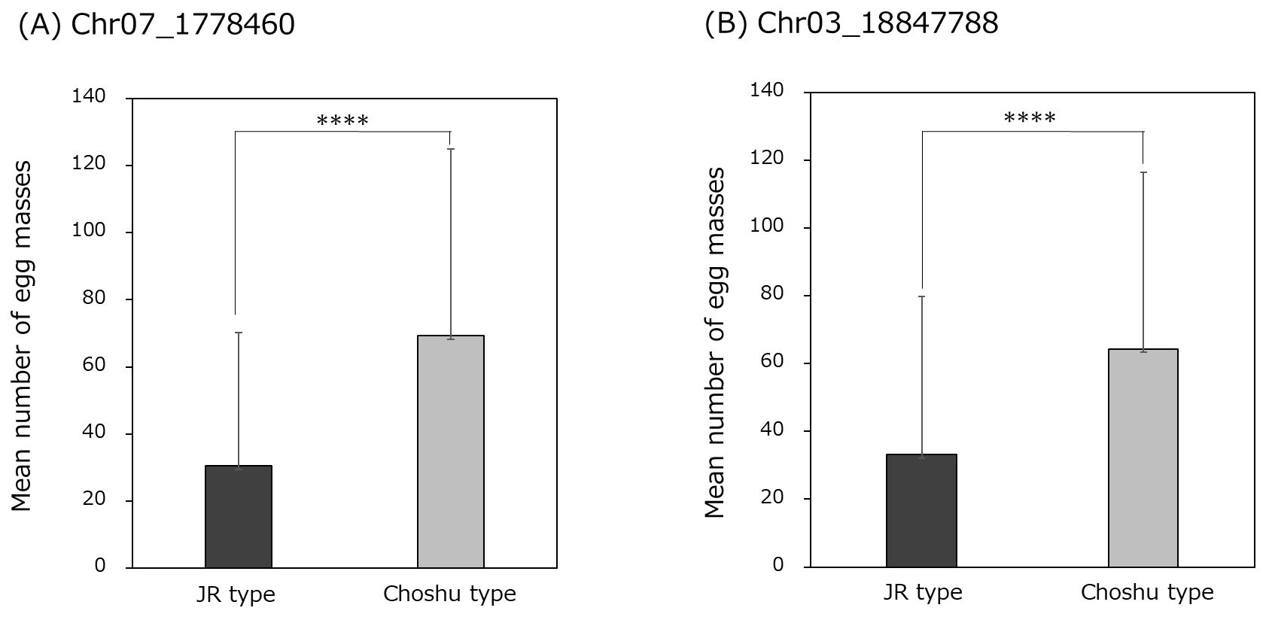

Supplementary Figure 1. The mean number of egg masses on F1 lines grouped according to the genotype of the identified SNPs on Chr03 and Chr07. (A) Chr07_1778460 SNP. (B) Chr03_18847788 SNP.

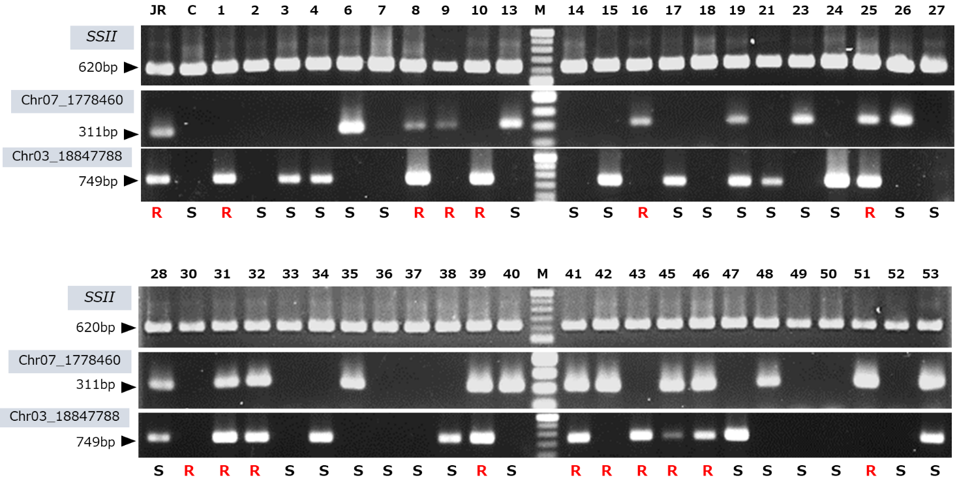

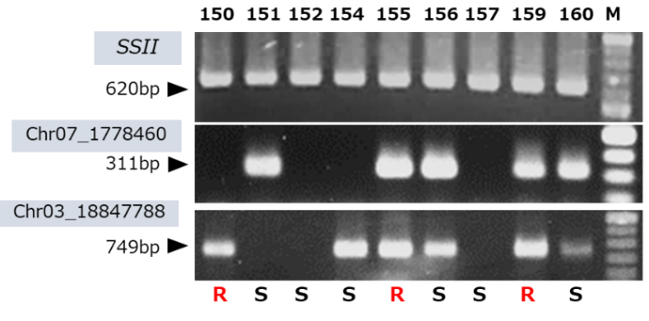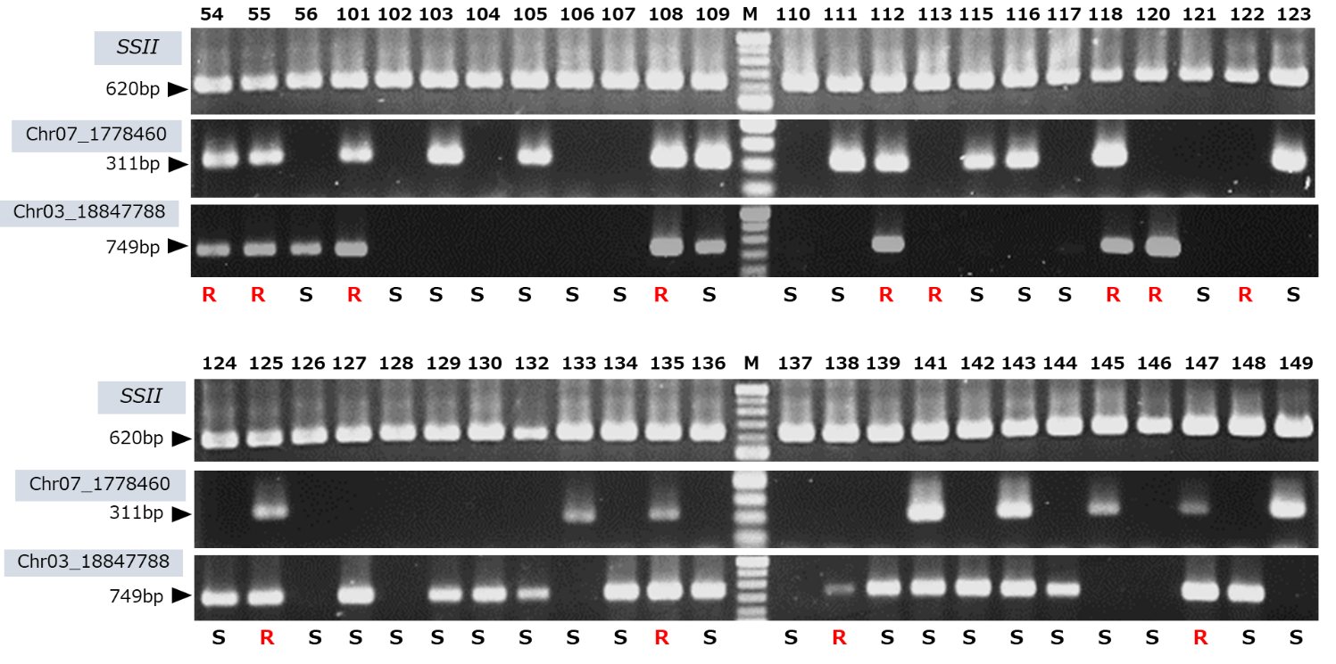

Supplementary Figure 2. Genotyping results using DNA markers derived from the Chr07_1778460 and Chr03_18847788 SNPs of the parental cultivars and 103 F1 lines. *SSII*, positive control; JR: J-Red, C: Choshu, 2-160: F1 lines, and M: 100 bp DNA ladder. The evaluation of resistance to the SP2 race is shown on the bottom of each lane. R and S indicate resistance and susceptibility, respectively.

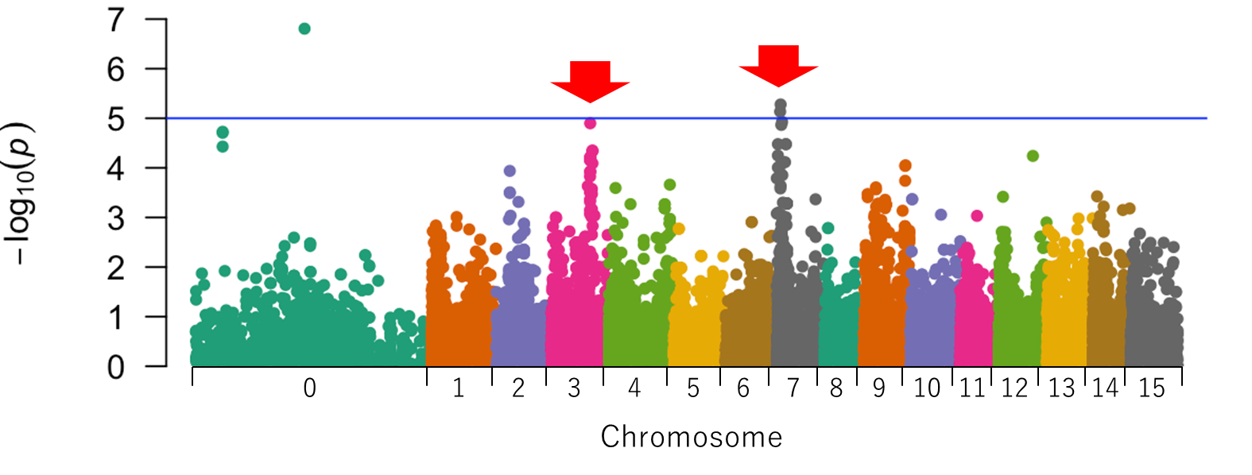(A)

(B)

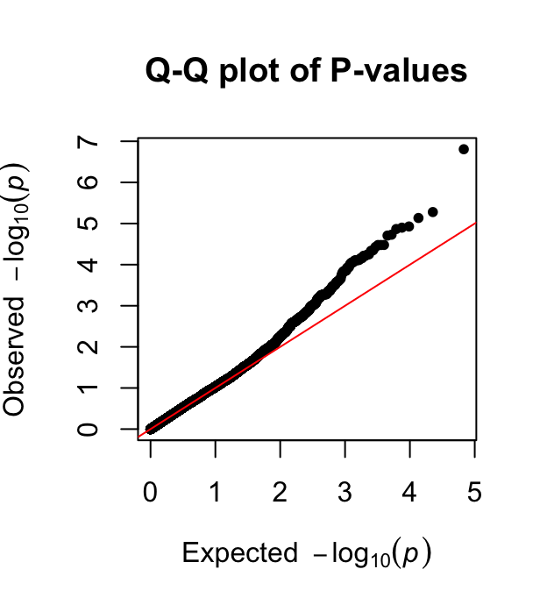

Supplementary Figure 3. Manhattan and Q-Q plots created using only simplex markers. (A) Manhattan plot. X-axis: the chromosomal number; Y-axis: -log10 (*P*). The blue line represents the significance threshold –log10(1 × 10-5) for ‘suggestive’ associations (Turner, 2018). (B) Q-Q plot.