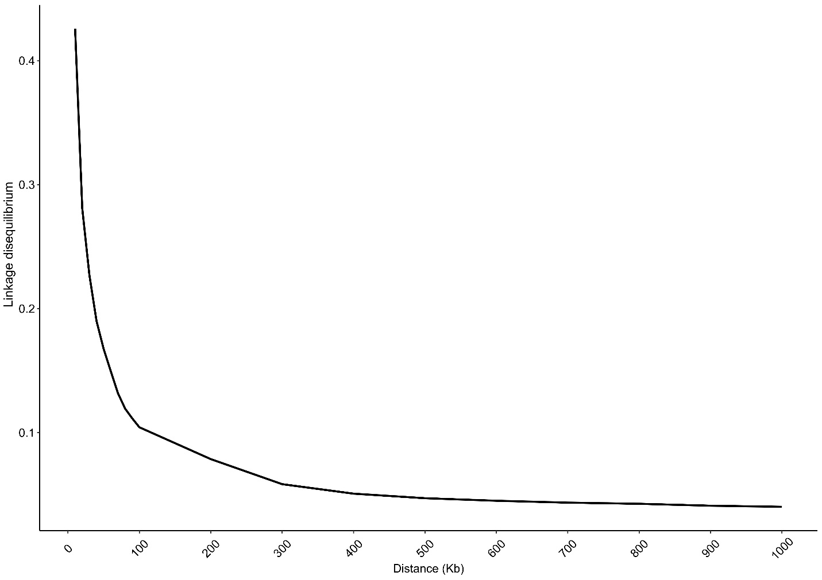

**Supplementary Figure 1.** Decrease of linkage disequilibrium (LD) with the increase of markers distance (kb) in the Purunã breed.