***Supplementary Material***

1. **Supplementary Figures and Tables**

**Table S1**. Models parameters related to the spherical, pipe- and sill-like synthetic sources.

**Table S2**. Models parameters related to the layered half-space, noisy and multi-source cases.

**Figure S1.** Noisy synthetic vertical deformation field.

**Figure S2.** Spherical, pipe- and sill-like synthetic sources: E-W deformation.

**Figure S3.** Spherical, pipe- and sill-like synthetic sources: vertical derivative of E-W deformation.

**Figure S4.** Fernandina volcano: first-order vertical derivative of E-W deformation.

**Figure S5.** Fernandina volcano: second-order vertical derivative of E-W deformation.

**Figure S6.** Fernandina volcano: third-order vertical derivative of E-W deformation.

**Figure S7.** Fernandina volcano: summary of the results.

**Table S1**. Models parameters related to the spherical, pipe- and sill-like synthetic sources.

|  |  |  |  |
| --- | --- | --- | --- |
|  | **SPHERE CASE** | **PIPE CASE** | **SILL CASE** |
| Domain extent along: $x$ -direction $y$ -direction $z$ -direction | 100 km  100 km  50 km | 100 km  100 km  50 km | 100 km  100 km  50 km |
| Source extent along: $x$ -direction $y$ -direction $z$ -direction | 0.5 km  0.5 km  0.5 km | 0.5 km  0.5 km  2.5 km | 5 km  5 km  1 km |
| Source position along: $x$ -direction $y$ -direction $z$ -direction | 50 km  50 km  -3 km | 50 km  50 km  -3 km | 50 km  50 km  -3 km |
| Young’s modulus | 1 GPa | 1 GPa | 1 GPa |
| Poisson’s coefficient | 0.25 | 0.25 | 0.25 |
| Source pressure-change | 5 MPa | 3 MPa | 1 MPa |
| Source mesh range | Tetrahedral  0.01 – 0.1 km | Tetrahedral  0.01 – 0.1 km | Tetrahedral  0.01 – 0.1 km |
| Domain mesh range | Tetrahedral  0.2 – 8 km | Tetrahedral  0.2 – 8 km | Tetrahedral  0.2 – 8 km |
| Free surface mesh | Mapped (step: 0.4 km) | Mapped (step: 0.4 km) | Mapped (step: 0.4 km) |
| Boundary conditions:  half-space bottom  half-space sides  half-space top | Fixed Constraint  Roller  Free | Fixed Constraint  Roller  Free | Fixed Constraint  Roller  Free |

**Table S2**. Models parameters related to the layered half-space, noisy and multi-source synthetic cases.

|  |  |  |  |  |
| --- | --- | --- | --- | --- |
|  | **LAYERED HALF-SPACE (SILL)** | **NOISY**  **(SILL)** | **MULTI-SOURCE** | |
| Domain extent along: $x$ -direction $y$ -direction $z$ -direction | 100 km  100 km  50 km | 100 km  100 km  50 km | 100 km  100 km  50 km | |
| Source extent along: $x$ -direction $y$ -direction $z$ -direction | 3 km  3 km  1 km | 3 km  3 km  1 km | **Sphere**  1 km  1 km  1 km | **Pipe**  0.6 km  0.6 km  2 km |
| Source position along: $x$ -direction $y$ -direction $z$ -direction | 50 km  50 km  -2 km | 50 km  50 km  -2 km | 46.5 km  50 km  -5 km | 53.5 km  50 km  -2 km |
| Young’s modulus  Poisson’s coefficient  Source pressure-change | 2 to 10 GPa  0.25  1 MPa | 2 to 10 GPa  0.25  1 MPa | 1 GPa  0.25  6 MPa 2 MPa | |
| Source mesh range | Tetrahedral  0.01 – 0.1 km | Tetrahedral  0.01 – 0.1 km | Tetrahedral  0.01 – 0.1 km | |
| Domain mesh range | Tetrahedral  0.1 – 8 km | Tetrahedral  0.1 – 8 km | Tetrahedral  0.1 – 8 km | |
| Free surface mesh | Mapped (step: 0.4 km) | Mapped (step: 0.4 km) | Mapped (step: 0.4 km) | |
| Boundary conditions:  half-space bottom  half-space sides  half-space top | Fixed Constraint  Roller  Free | Fixed Constraint  Roller  Free | Fixed Constraint  Roller  Free | |

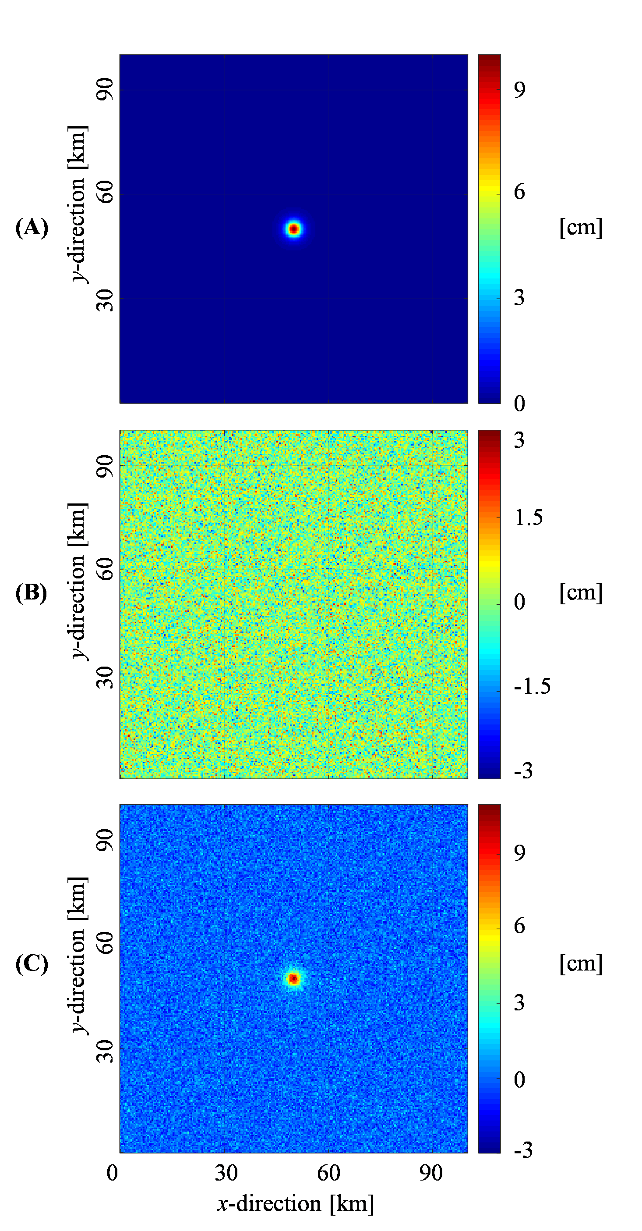

**Figure S1. Noisy synthetic vertical deformation field.** (**A**) Modeled vertical deformation related to the layered half-space case, on which (**B**) 30% of high-wavenumber noise, with respect to the maximum value of (**A**), is considered to retrieve (**C**) the vertical component of ground deformation field related to the noisy case.

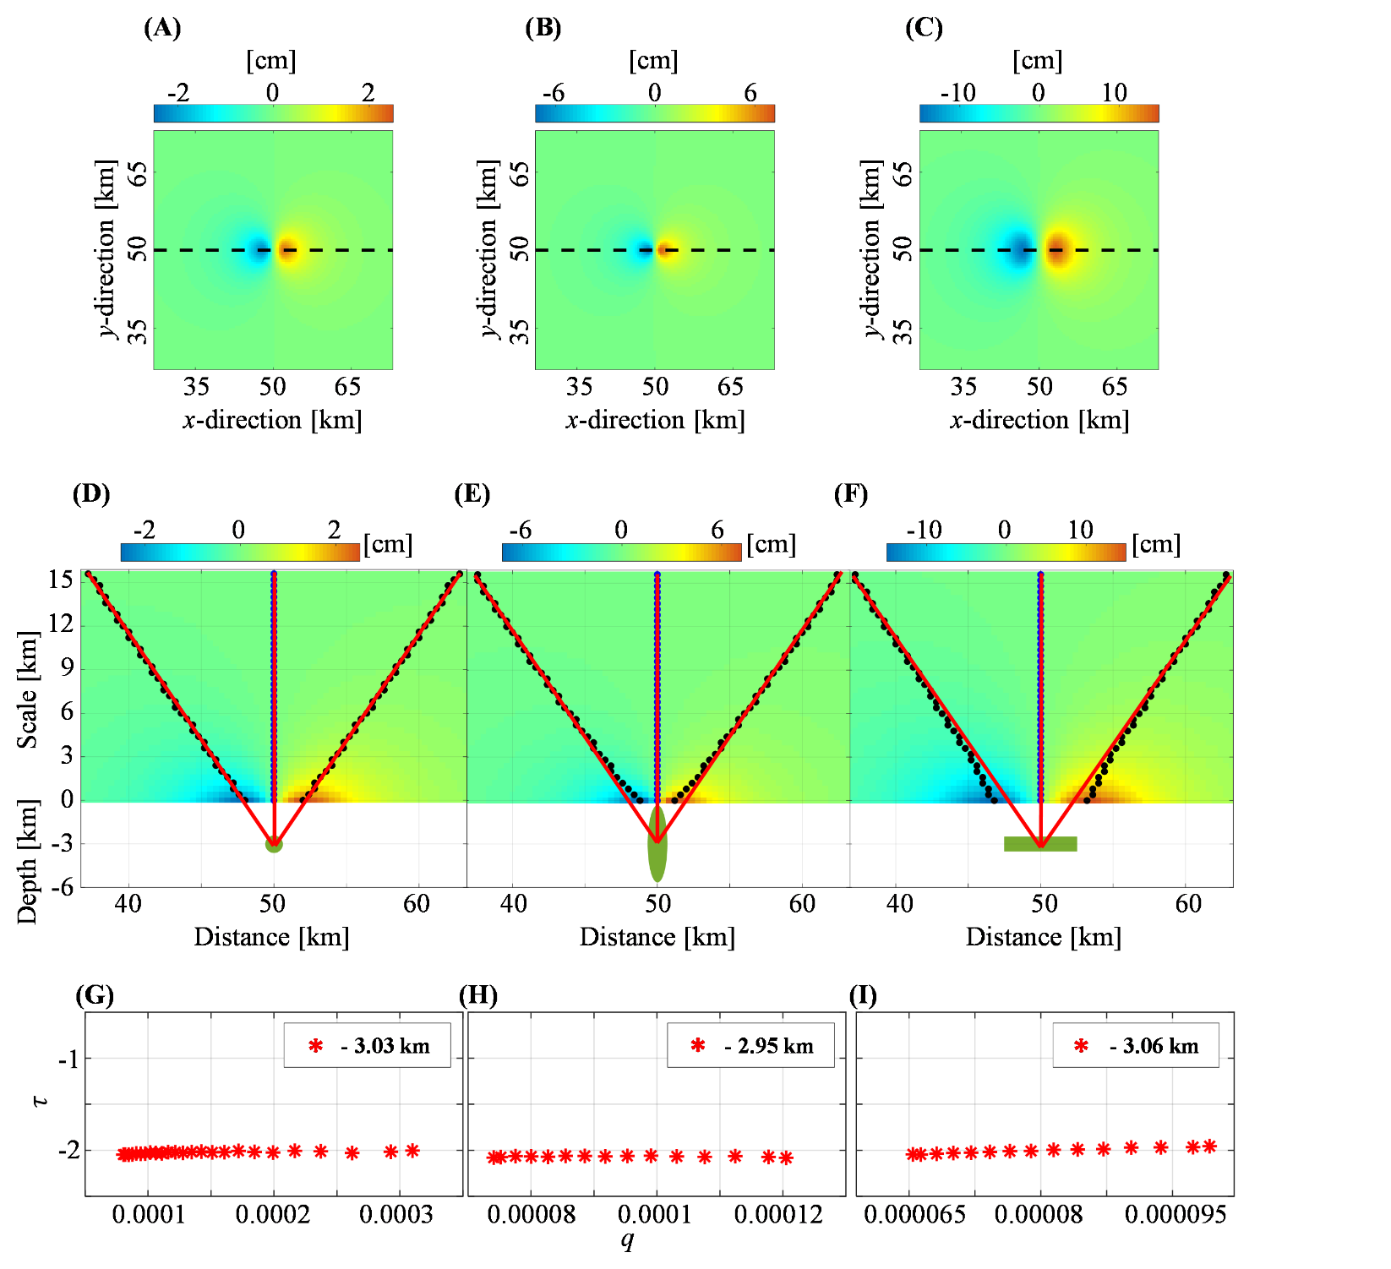

**Figure S2. Spherical, pipe- and sill-like synthetic sources: E-W deformation.** Modeled E-W component ($p=0$) generated by the over-pressurized (**A**) spherical, (**B**) pipe- and (**C**) sill-like sources; the black dashed lines indicate the positions of the analyzed profiles. (**D-F**) Multiridge method applied to the three cases; E-W deformations are also shown at different scales $z$; blue and black dots point out the zeros of vertical (subset I) and horizontal (subset II) derivatives of the analyzed E-W deformation, respectively, while the red solid lines the best fit regression lines; the green geometries show the projections of the sources on the - plane. (**G-I**) ScalFun method applied to the three cases; red stars indicate [-] in function of [km-1] using the source depth retrieved by multiridge method, where $f$ are the values of the analyzed E-W deformation at the subset II.

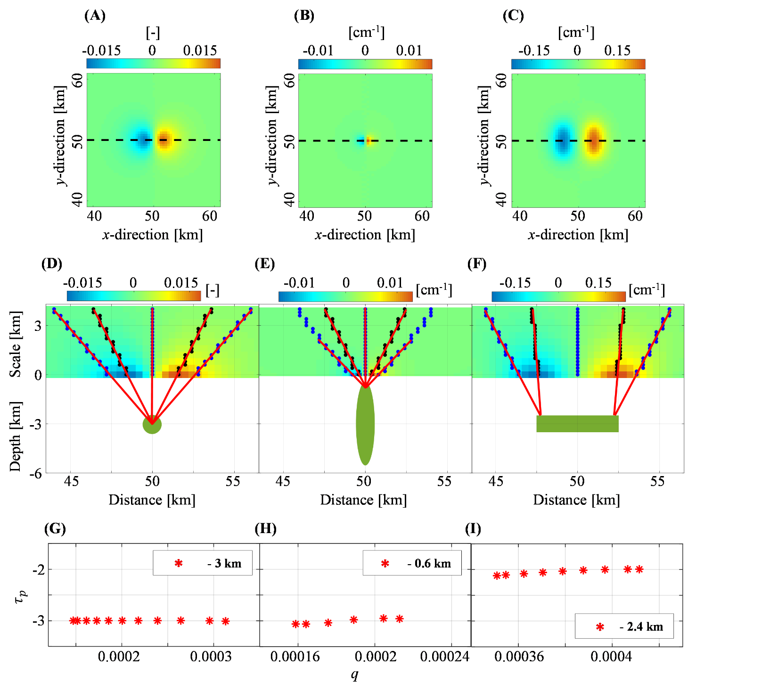

**Figure S3. Spherical, pipe- and sill-like synthetic sources: vertical derivative of E-W deformation.** (**A**) First-order ($p=1$) and (**B,C**) second-order ($p=2$) vertical derivatives of the modeled E-W component generated by the over-pressurized spherical, pipe- and sill-like sources, respectively; the black dashed lines indicate the positions of the analyzed profiles. (**D-F**) Multiridge method applied to the three cases; vertical derivatives are also shown at different scales $z$; blue and black dots point out the zeros of vertical (subset I) and horizontal (subset II) derivatives of the analyzed dataset, respectively, while the red solid lines the best fit regression lines; the green geometries show the projections of the sources on the - plane; (**G-I**) ScalFun method applied to the three cases; red stars indicate [-] in function of [km-1] using the source depth retrieved by multiridge method, where $f_{p}$ are the values of the analyzed vertical derivative at the subset II.

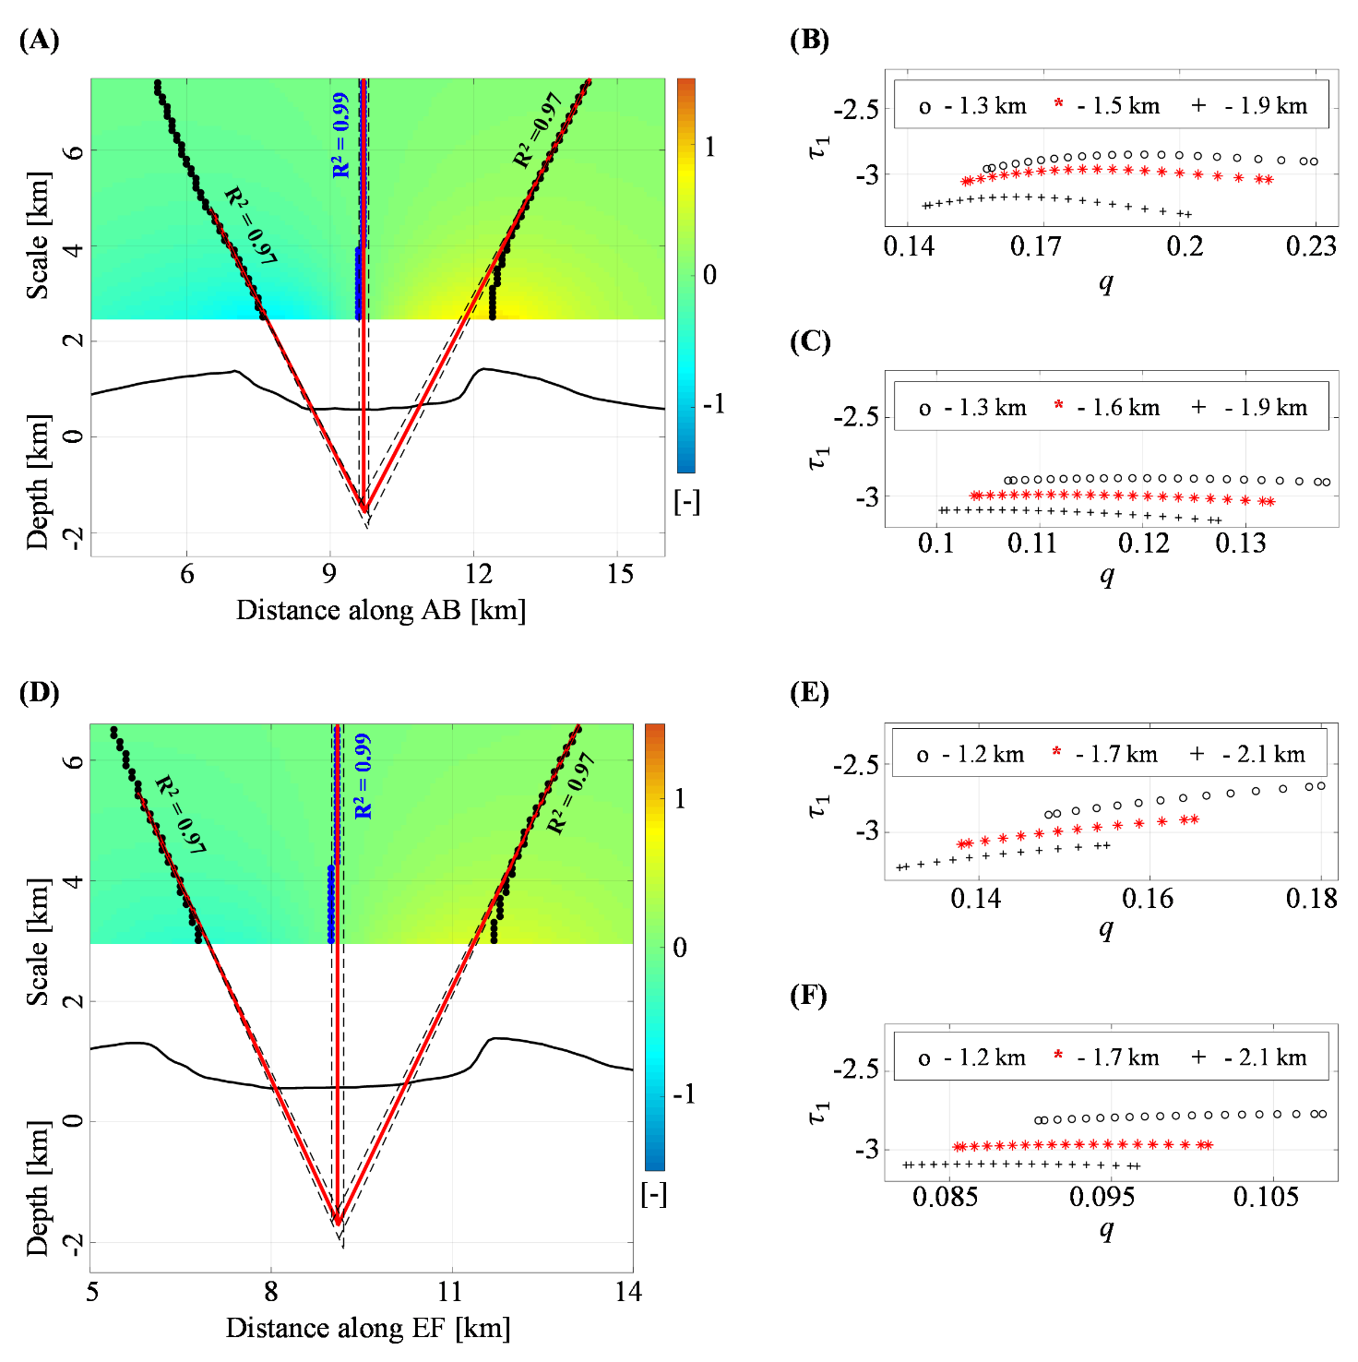

**Figure S4.** **Fernandina volcano: first-order vertical derivative of E-W deformation.** Multiridge and ScalFun methods along the (**A-C**) AB and (**D-F**) EF sections of the first-order ($p=1$) vertical derivative of the E-W component recorded in the time interval 01/2013-06/2013; blue and black dots point out the zeros of vertical (subset I) and horizontal (subset II) derivatives of the analyzed dataset, respectively; vertical derivatives are also show at different scales ; red solid and black dashed lines represent the best-fit regression lines and the linear regression boundary solutions, respectively; for each regression line, we indicate the R2 coefficient; black solid lines are the topography; red stars and black crosses and circles indicate [-] in function of [km-1] calculated using the best-fit and boundary depth solutions retrieved by Multiridge method, respectively, where $f_{1}$ are the values of the analyzed first-order vertical derivative at the subset II.

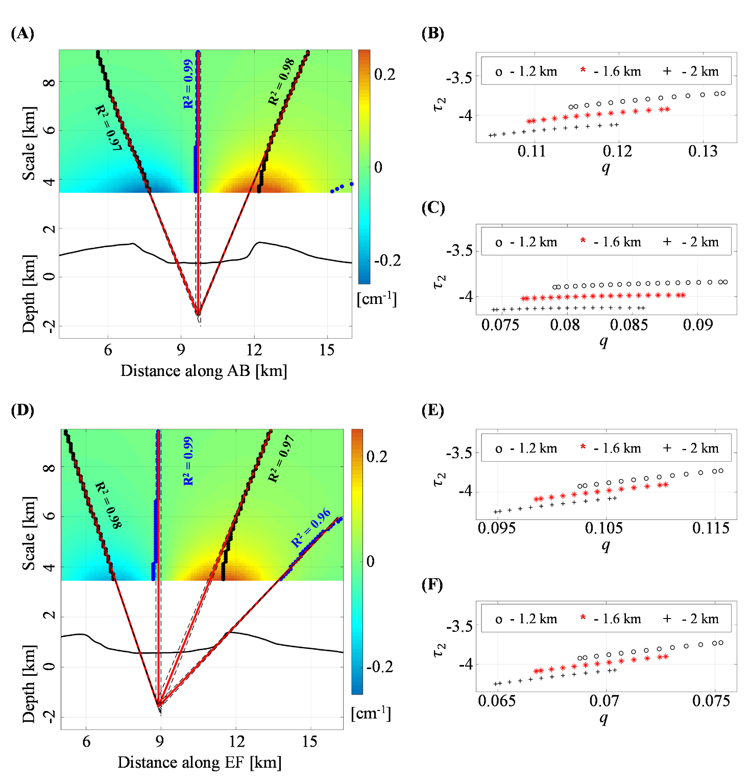

**Figure S5.** **Fernandina volcano: second-order vertical derivative of E-W deformation.** Multiridge and ScalFun methods along the (**A-C**) AB and (**D-F**) EF sections of the second-order ($p=2$) vertical derivative of the E-W component recorded in the time interval 01/2013-06/2013; blue and black dots point out the zeros of vertical (subset I) and horizontal (subset II) derivatives of the analyzed dataset, respectively; vertical derivatives are also show at different scales ; red solid and black dashed lines represent the best-fit regression lines and the linear regression boundary solutions, respectively; for each regression line, we indicate the R2 coefficient; black solid lines are the topography; red stars and black crosses and circles indicate [-] in function of [km-1] calculated using the best-fit and boundary depth solutions retrieved by Multiridge method, respectively, where $f_{2}$ are the values of the analyzed second-order vertical derivative at the subset II.

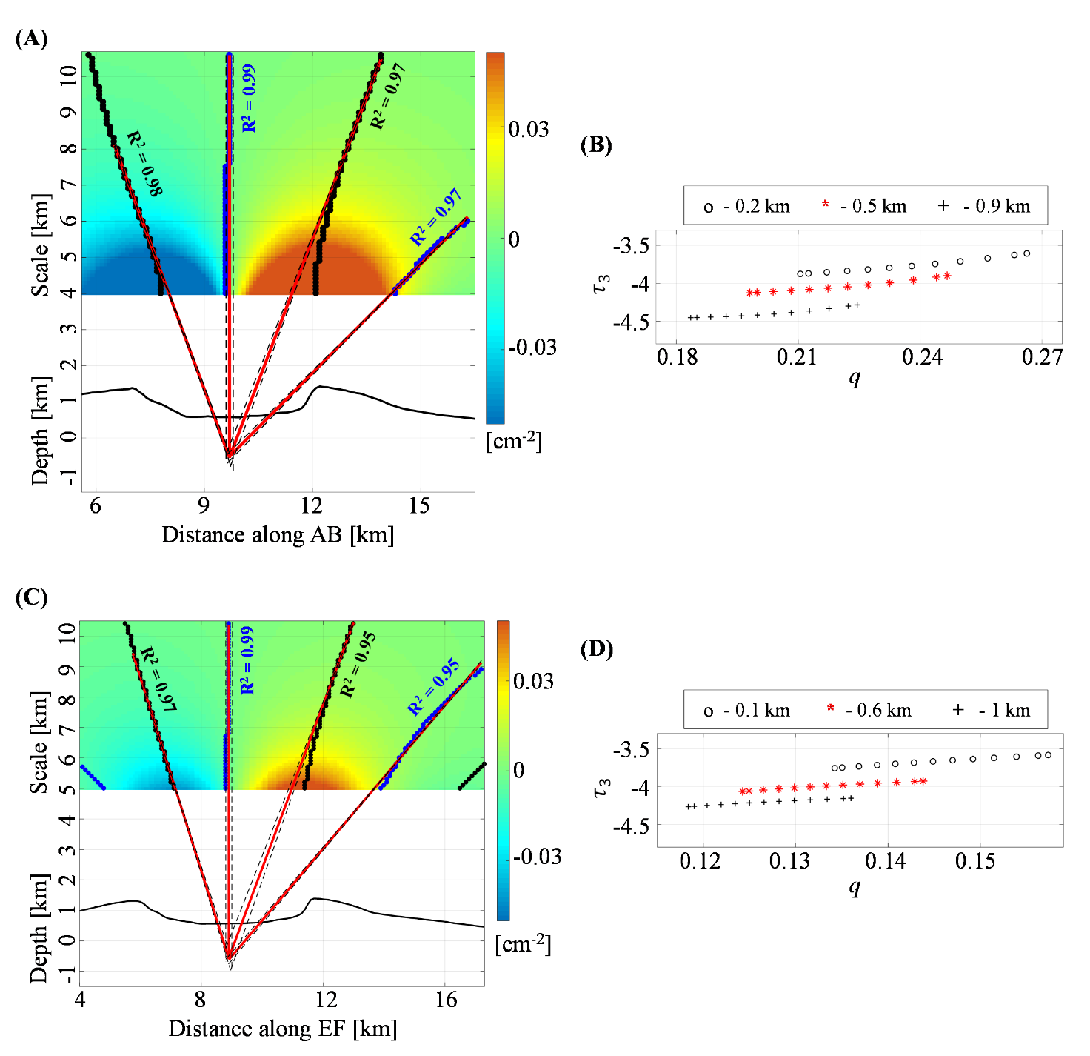

**Figure S6.** **Fernandina volcano: third-order vertical derivative of E-W deformation.** Multiridge and ScalFun methods along the (**A,B**) AB and (**C,D**) EF sections of the third-order ($p=3$) vertical derivative of the E-W component recorded in the time interval 01/2013-06/2013; blue and black dots point out the zeros of vertical (subset I) and horizontal (subset II) derivatives of the analyzed dataset, respectively; vertical derivatives are also show at different scales ; red solid and black dashed lines represent the best-fit regression lines and the linear regression boundary solutions, respectively; for each regression line, we indicate the R2 coefficient; black solid lines are the topography; red stars and black crosses and circles indicate [-] in function of [km-1] calculated using the best-fit and boundary depth solutions retrieved by Multiridge method, respectively, where $f_{3}$ are the values of the analyzed third-order vertical derivative at the subset II.

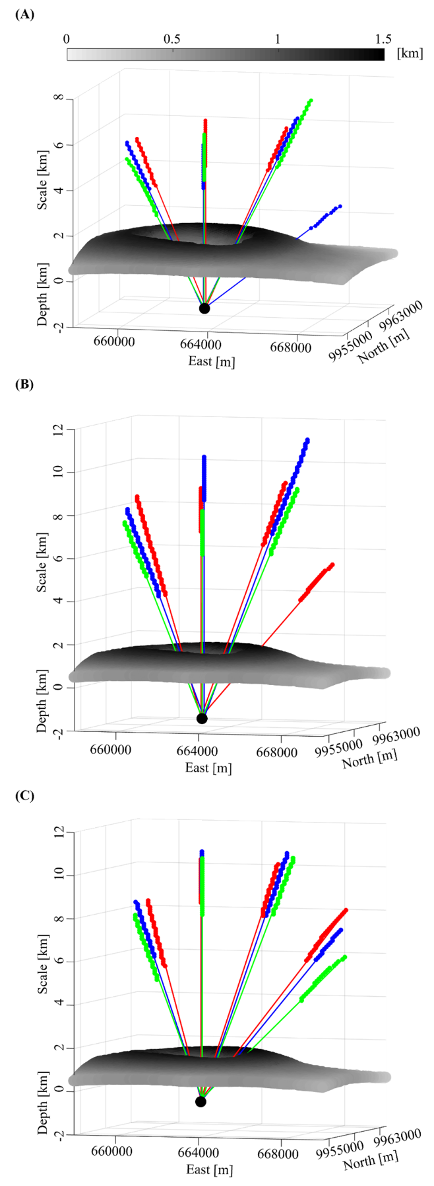

**Figure S7.** **Fernandina volcano: summary of the results.** 3D plot of ridges intersections (black dots) in the analyzed case of (**A**) first-order ($p=1$), (**B**) second-order ($p=2$) and (**C**) third-order ($p=3$) vertical derivatives of the E-W component recorded in the time interval 01/2013-06/2013. The green, blue and red colors are related to the AB, CD and EF traces; topography is also shown. UTM-WGS84 projection zone:15S.