SUPPLEMENTARY MATERIAL
Supplementary Figure S1.
A
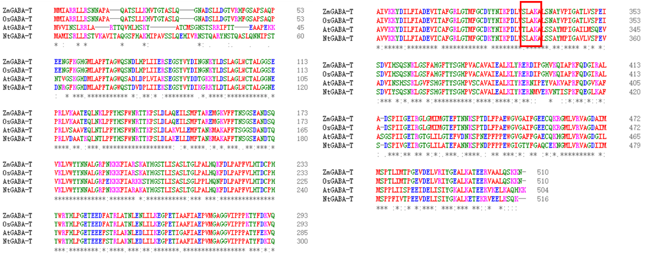
B
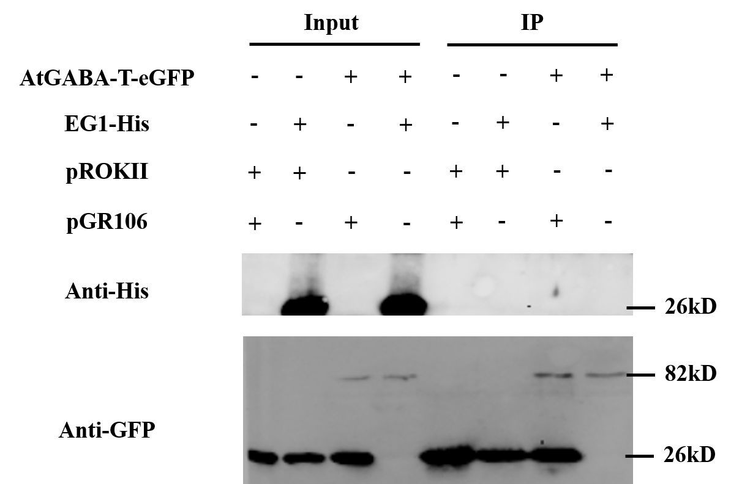
C
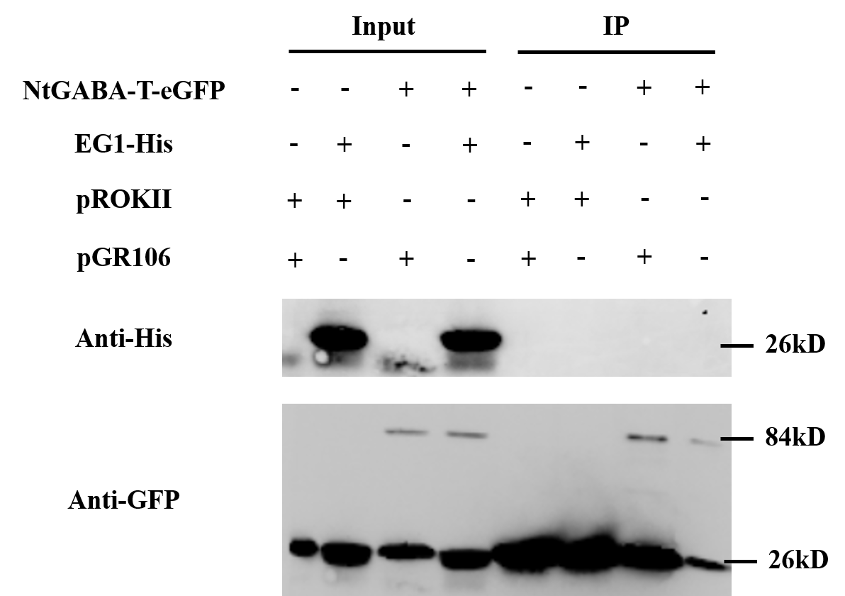

Supplementary Figure S1. EG1 does not interact with GABA-T in other species. (A) Sequence alignment of GABA-T in Zea mayz, Oryza sativa, Arabidopsis thaliana and Nicotiana tabacum. (B) Pull-down assay of EG1-His6 and AtGABA-T-eGFP. EG1 stably expressed by Pichia pastoris GS115 and purified by Ni-NTA agarose was mixed with AtGABA-T-eGFP transiently expressed by Nicotiana benthamiana, then incubated with GFP beads at 4°C overnight, after immunoprecipitation, proteins were detected by western blot using anti-His and anti-GFP antibodies.The experiment was repeated independently three times with similar results. (C) Pull-down assay of EG1-His6 and NtGABA-T-eGFP. Methods and results are the same as (B).
Supplementary Figure S2.
A
Anti-HA
B
Anti-GFP
Supplementary Figure S2. Original uncropped blot figures of Figure 1D. (A) Anti-HA antibodies were used to detect the HA tag (B) Anti-GFP antibodies were used to detect the GFP tag.

Supplementary Figure S3.
A
Anti-HA
B
Anti-GFP
C
Anti-Actin

Supplementary Figure S3. Original uncropped blot figures of Figure 3D. (A) Anti-HA antibodies were used to detect the HA tag (B) Anti-GFP antibodies were used to detect the GFP tag. (C) Anti-Actin antibodies were used to detect the plant actin. The red square indicates the destination swimlanes.

Supplementary Figure S4.
A
Anti-HA
B
Anti-GFP
Supplementary Figure S4. Original uncropped blot figures of Figure 6B. (A) Anti-HA antibodies were used to detect the HA tag (B) Anti-GFP antibodies were used to detect the GFP tag.

Supplementary Figure S5.
A
Anti-His
B
Anti-GFP
Supplementary Figure S5. Original uncropped blot figures of Figure S2B. (A) Anti-His antibodies were used to detect the His tag (B) Anti-GFP antibodies were used to detect the GFP tag.
Supplementary Figure S6.
A
Anti-His
B
Anti-GFP
Supplementary Figure S6. Original uncropped blot figures of Figure S2C. (A) Anti-His antibodies were used to detect the His tag (B) Anti-GFP antibodies were used to detect the GFP tag.

