Supporting information for

Spatio-temporal impact on vegetation by tunnel discharging in the Jinping II hydropower station: Evidence from the NDVI and GPP monitoring dataset of 2001-2019

a

d

c

Fig. S1 Spatial patterns of NDVI (a, c) and GPP (b, d) from 2001 to 2019 in karst (a, b) and non-karst areas (c, d)

Fig. S2 Box plot for GPP and NDVI of the BC, DC and AC in karst (c,d,g,h,k,l)and non-karst(a,b,e,f,i,j) areas. within 1km（a,b,c,d），3km (e,f,g,h) and 5 km (i,j,k,l)range on both sides of the diversion tunnel group . BC: before construction, DC: during construction, AC: after construction

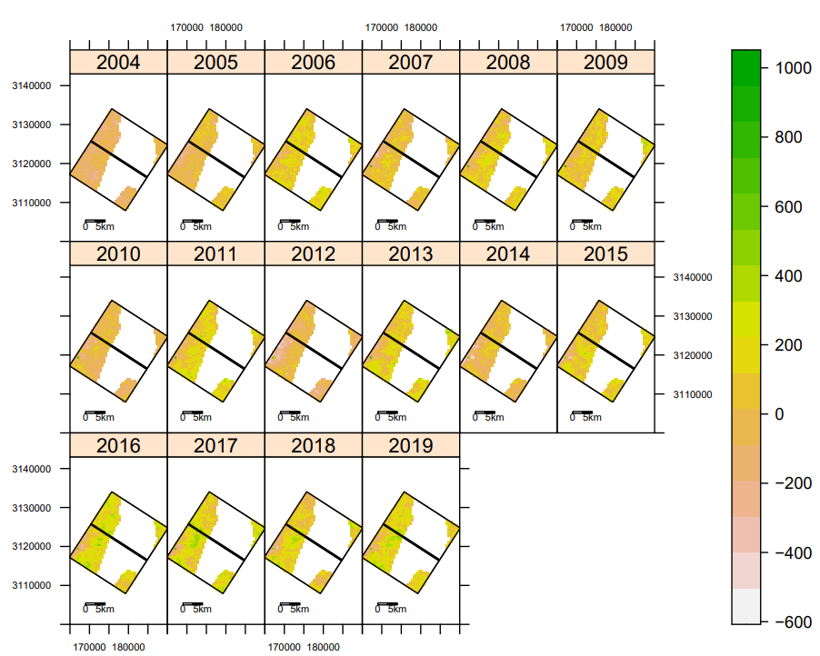

a

b

d

c

Fig. S3 Spatial change of NDVI (a, c) and GPP (b, d) during the DC and AC compared with those of the BC in karst areas (a, b) and non-karst areas (c, d)

Fig.S4 Area fraction of negative NDVI and GPP throughout DC and AC in karst(c,d,g,h,k,l) and non-karst areas(a,b,e,f,i,j) ,within 1km(a,b,c,d)，3km(e,f,,g,h)，5km(i,j,k,l) range on both sides of the diversion tunnel group

Fig. S5 Annual precipitation in the study areas