Supplementary Material A: Mural Whiteboard: Workshop 1

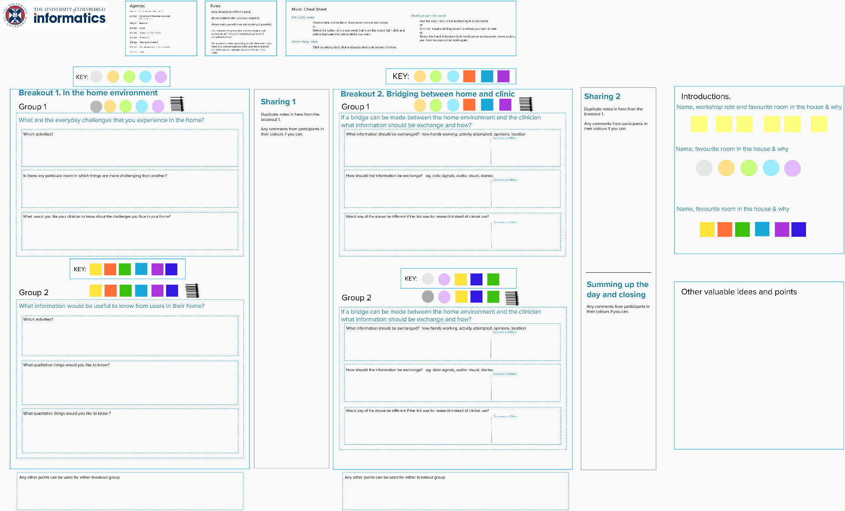
Supplementary Material A: Mural Whiteboard: Workshop 2 First Half

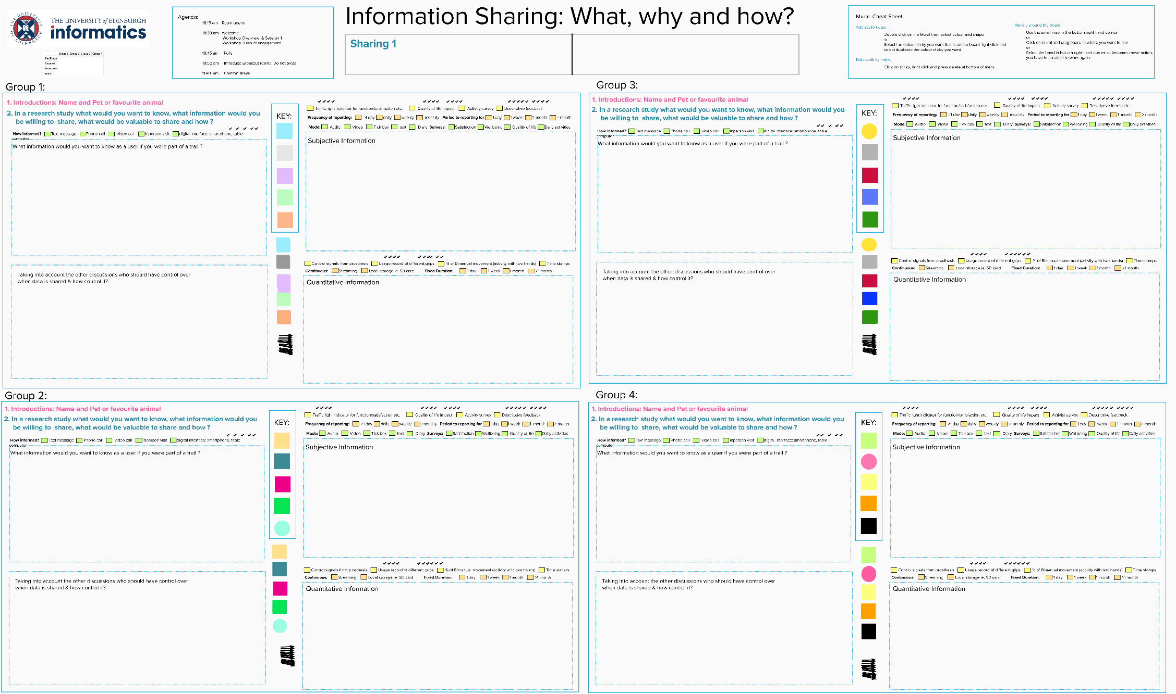

Supplementary Material A: Mural Whiteboard: Workshop 2 Second Half

