**Attachment 1: Spirals used real size**

Easy spiral – right hand

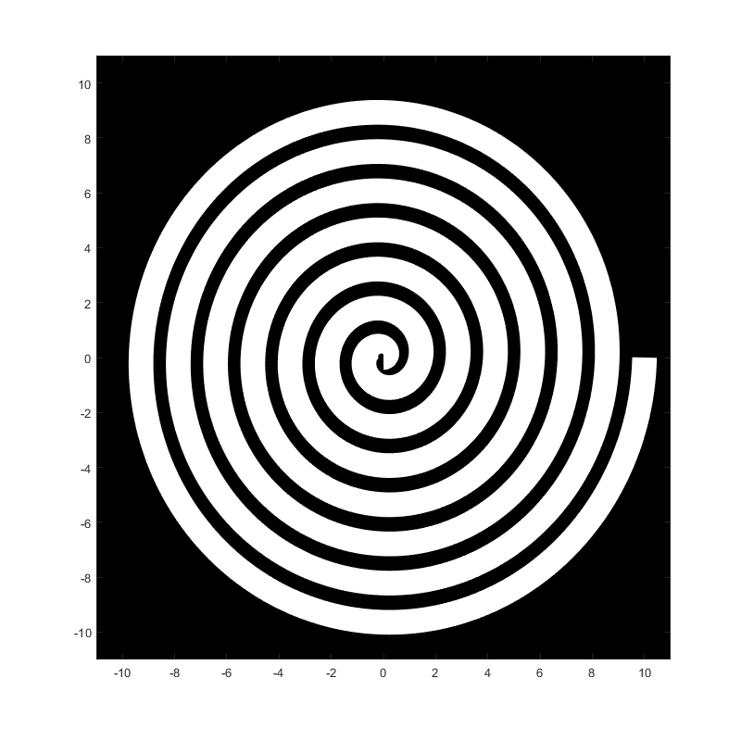

Easy spiral – left hand

Moderate spiral – right hand

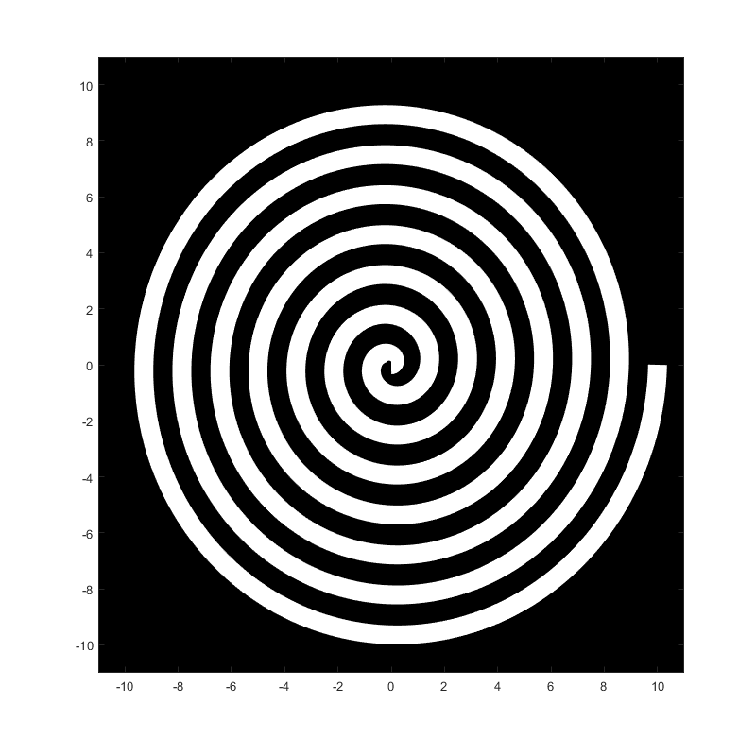

Moderate spiral – left hand



Difficult spiral – right hand

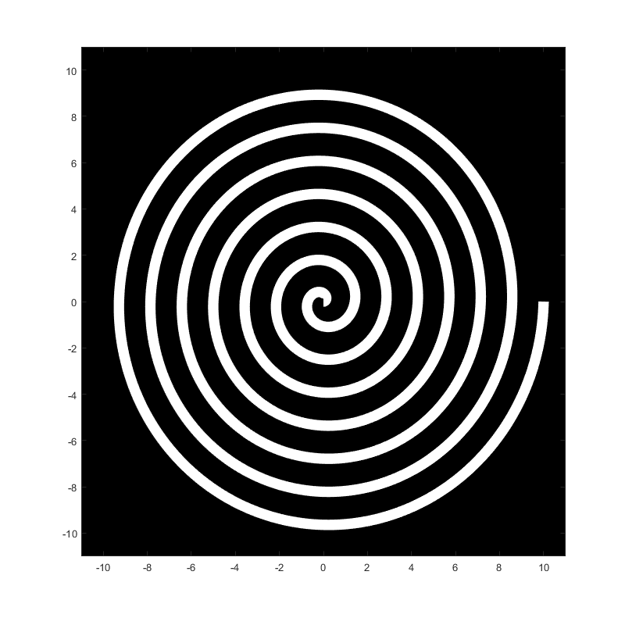

Difficult spiral – left hand

