Supplementary Material

# Supplementary Data

Biomarker liquid concentrations, temperature, salinity, chlorophyll *a* and nutrient concentrations in surface and DCM waters.

|  |  |  |  |  |  |  |  |  |  |  |  |  |  |  |  |
| --- | --- | --- | --- | --- | --- | --- | --- | --- | --- | --- | --- | --- | --- | --- | --- |
|  | Station | Longitude (°E) | Latitude (°N) | Sampling data | Water depth (m) | Sample depth (m) | CTD_T (℃) | Salinity (PSU) | Chl *a* (ug L−1) | DIN (umol L−1) | DIP (umol L−1) | Si (umol L−1) | Brassicasterol/epi-brassicasterol (ng L−1) | Dinosterol (ng L−1) | C37 alkenones (ng L−1) |
|  | TR17 | 143.87 | 37.81 | 20110730 | 7039 | 2 | 23.0 | 34.1 |  | 0.03 | 0.05 |  | 67 | 8.3 | 15 |
|  | TR18 | 143.57 | 37.87 | 20110731 | 5237 | 2 | 23.2 | 34.1 | 0.09 |  | 0.02 | 0.1 | 124 | 15 | 36 |
|  | TR19 | 143.46 | 38.07 | 20110731 | 3957 | 2 | 23.8 | 34.2 | 0.09 | 0.01 | 0.00 |  | 118 | 12 | 23 |
|  | TR21 | 143.52 | 38.18 | 20110801 | 3936 | 2 | 23.0 | 34.1 | 0.11 | 0.08 | 0.01 | 0.2 | 91 | 10 | 16 |
|  | TR24 | 142.25 | 37.07 | 20110802 | 2124 | 2 | 19.1 | 33.1 | 0.10 |  |  |  | 69 | 4.4 | 9 |
|  | TR26 | 141.33 | 36.00 | 20110802 | 1186 | 2 | 20.7 | 33.6 | 0.08 |  |  |  | 52 | 2.2 | 3 |
|  | TR03 | 150.01 | 36.49 | 20110718 | 5864 | 2 | 26.7 | 34.3 | 0.03 | 0.07 | 0.01 | 0.1 | 54 | 9.1 | 1 |
|  | TR02 | 145.00 | 36.49 | 20110717 | 5446 | 2 | 22.9 | 34.3 | 0.06 | 0.27 | 0.01 | 0.3 | 98 | 13 | 5 |
|  | TR01 | 143.03 | 36.50 | 20110716 | 7653 | 2 | 23.6 | 34.1 | 0.05 |  |  |  | 41 | 6.2 | 0.8 |
|  | TR05 | 157.85 | 32.33 | 20110719 | 2616 | 2 | 25.6 | 35.0 |  |  |  |  | 35 | 6.9 | 0.2 |
|  | TR06 | 158.46 | 32.56 | 20110719 | 2393 | 2 | 25.0 | 34.7 |  |  |  |  | 45 | 8.4 | 0.2 |
|  | TR04 | 157.85 | 32.00 | 20110719 | 2928 | 2 | 26.3 | 35.0 | 0.03 | 0.14 | 0.07 | 1.2 | 40 | 5.5 | 0.4 |
| surface | TR08 | 165.00 | 32.50 | 20110722 | 6193 | 2 | 25.5 | 35.0 | 0.02 | 0.14 | 0.05 | 0.5 | 28 | 5.4 | 0.7 |
|  | TR07 | 165.01 | 30.00 | 20110720 | 5869 | 2 | 26.9 | 35.0 | 0.01 | 0.32 |  | 0.2 | 29 | 6.6 | 0.2 |
|  | TR09 | 165.00 | 35.00 | 20110722 | 5885 | 2 | 21.9 | 34.4 | 0.05 | 0.44 | 0.11 | 2.0 | 35 | 4.6 | 6.2 |
|  | TR10 | 165.00 | 37.50 | 20110723 | 5321 | 2 | 20.9 | 34.4 | 0.07 | 0.38 | 0.14 | 1.4 | 25 | 1.0 | 46 |
|  | TR11 | 165.00 | 40.00 | 20110723 | 5449 | 2 | 18.3 | 34.5 | 0.31 | 1.73 | 0.25 | 5.4 | 115 | 5.1 | 52 |
|  | TR12 | 165.00 | 42.50 | 20110724 | 5008 | 2 | 11.1 | 33.1 | 0.71 | 8.55 | 0.86 | 12.6 | 149 | 2.9 | 5.0 |
|  | TR13 | 165.00 | 44.99 | 20110725 | 5908 | 2 | 9.2 | 32.9 | 0.37 | 11.91 | 1.22 | 18.8 | 53 | 1.1 | 1.5 |
|  | TR16 | 160.05 | 47.00 | 20110728 | 5222 | 2 | 10.9 | 32.6 | 0.20 | 5.78 | 0.88 | 6.3 | 218 | 5.6 | 2.1 |
|  | TR14 | 165.00 | 47.50 | 20110726 | 5890 | 2 | 8.8 | 32.9 | 0.15 | 15.42 | 1.48 | 25.7 | 156 | 3.9 | 4.8 |
|  | TR15 | 165.00 | 51.00 | 20110726 | 4808 | 2 | 10.7 | 32.8 | 0.20 | 10.53 | 1.08 |  | 153 | 3.1 | 1.0 |
|  | TE3 | 129.83 | 34.25 | 20170720 | 124 | 5 | 26.4 | 32.4 | 0.17 | 0.02 | 0.01 | 7.0 | 59 | 22 | 17 |
|  | C4 | 127.81 | 29.68 | 20170722 | 631 | 5 | 30.4 | 34.0 | 0.10 | 0.00 | 0.00 | 2.0 | 53 | 23 | 1.8 |
|  | C1 | 126.93 | 30.24 | 20170723 | 99 | 5 | 30.1 | 31.8 | 0.17 | 0.00 | 0.00 | 3.8 | 101 | 41 | 3.4 |
|  | CK5 | 128.84 | 31.76 | 20170721 | 812 | 5 | 28.7 | 33.2 | 0.23 | 0.14 | 0.00 | 1.9 | 54 | 13 | 1.7 |
|  | C01 | 122.07 | 23.00 | 20190730 | 4898 | 1 | 29.7 | 34.5 | 0.03 |  |  |  | 59 | 13 | 2.1 |
|  | C05 | 122.07 | 22.33 | 20190803 | 4734 | 1 | 30.1 | 34.2 | 0.04 | 0.01 | 0.01 | 0.9 | 31 | 7.1 | 2.2 |
|  | C06 | 122.69 | 22.33 | 20190801 | 4956 | 1 | 29.9 | 34.5 | 0.04 | 0.01 | 0.00 | 0.7 | 8.3 | 1.0 | 0 |
|  | C08 | 123.99 | 22.34 | 20190731 | 5433 | 1 | 30.0 | 34.6 | 0.04 | 0.01 | 0.14 | 0.7 | 39 | 12 | 0.9 |
|  | C09 | 122.06 | 21.65 | 20190803 | 4701 | 1 | 29.2 | 34.5 | 0.06 | 0.02 | 0.00 | 0.8 | 78 | 15 | 20 |
|  | M5 | 126.83 | 28.80 | 20190712 | 152 | 3 | 27.9 | 33.7 | 0.06 | 0.01 | 0.00 | 1.8 | 55 | 7.3 | 12 |
|  | M3 | 126.70 | 28.87 | 20190712 | 140 | 3 | 27.3 | 33.4 | 0.09 | 0.00 | 0.00 | 1.7 | 52 | 12 | 13 |
|  | L5 | 127.01 | 28.48 | 20190715 | 605 | 3 | 27.8 | 33.1 | 0.15 |  |  |  | 54 | 5.5 | 24 |
|  | TR18 | 143.57 | 37.87 | 20110731 | 5237 | 48 | 16.4 | 34.6 | 0.28 | 9.39 | 0.74 | 10.8 | 47 | 5.9 | 6.5 |
|  | TR19 | 143.46 | 38.07 | 20110731 | 3957 | 22 | 21.2 | 34.5 | 0.63 | 3.19 | 0.25 | 2.7 | 113 | 13 | 9.0 |
|  | TR21 | 143.52 | 38.18 | 20110801 | 3936 | 28 | 19.8 | 34.6 | 0.66 | 4.11 | 0.31 | 4.6 | 115 | 11 | 20 |
|  | TR26 | 141.33 | 36.00 | 20110802 | 1186 | 28 | 14.7 | 34.1 | 0.54 |  |  |  | 67 | 1.8 | 16 |
|  | TR03 | 150.01 | 36.49 | 20110718 | 5864 | 85 | 20.7 | 34.7 | 0.24 | 0.29 | 0.03 | 0.6 | 38 | 4.4 | 0 |
|  | TR02 | 145.00 | 36.49 | 20110717 | 5446 | 30 | 18.9 | 34.6 | 0.94 | 4.91 | 0.58 | 6.3 | 87 | 6.2 | 0 |
|  | TR04 | 157.85 | 32.00 | 20110719 | 2928 | 105 | 18.3 | 34.8 | 0.27 | 1.80 | 0.10 | 1.1 | 27 | 3.3 | 0 |
|  | TR08 | 165.00 | 32.50 | 20110722 | 6193 | 75 | 18.9 | 34.8 | 0.27 | 0.75 | 0.08 | 0.8 | 49 | 4.4 | 1.6 |
|  | TR07 | 165.01 | 30.00 | 20110720 | 5869 | 100 | 17.9 | 34.7 | 0.36 | 1.98 | 0.05 | 1.3 | 56 | 5.7 | 1.3 |
| DCM | TR09 | 165.00 | 35.00 | 20110722 | 5885 | 70 | 16.8 | 34.6 | 0.26 | 6.68 | 0.58 | 6.2 | 19 | 1.3 | 0 |
|  | TR10 | 165.00 | 37.50 | 20110723 | 5321 | 60 | 17.1 | 34.6 | 0.62 | 2.51 | 0.31 | 3.5 | 51 | 0.9 | 9.2 |
|  | TR11 | 165.00 | 40.00 | 20110723 | 5449 | 30 | 17.8 | 34.5 | 0.94 | 1.55 | 0.28 | 5.7 | 110 | 4.4 | 16 |
|  | TR12 | 165.00 | 42.50 | 20110724 | 5008 | 25 | 11.0 | 33.1 | 0.92 | 8.44 | 0.89 | 13.9 | 161 | 2.5 | 3.1 |
|  | TR13 | 165.00 | 44.99 | 20110725 | 5908 | 30 | 8.4 | 33.0 | 0.45 | 12.62 | 1.25 | 18.3 | 126 | 1.8 | 1.5 |
|  | TR16 | 160.05 | 47.00 | 20110728 | 5222 | 30 | 5.9 | 32.9 | 0.64 | 16.78 | 1.61 | 28.0 | 194 | 7.5 | 7.3 |
|  | TR14 | 165.00 | 47.50 | 20110726 | 5890 | 60 | 4.4 | 33.1 | 0.28 | 19.02 | 1.70 | 31.4 | 60 | 2.9 | 1.6 |
|  | TR15 | 165.00 | 51.00 | 20110726 | 4808 | 30 | 5.7 | 32.9 | 0.32 | 19.93 | 1.85 | 2.5 | 99 | 3.8 | 0.9 |
|  | TE3 | 129.83 | 34.25 | 20170720 | 124 | 36 | 21.1 | 34.5 | 1.97 | 0.43 | 0.03 | 0.6 | 126 | 26 | 18 |
|  | C4 | 127.81 | 29.68 | 20170722 | 631 | 63 | 22.5 | 34.6 | 1.14 | 2.53 | 0.19 | 5.0 | 48 | 8.5 | 5.8 |
|  | C1 | 126.93 | 30.24 | 20170723 | 99 | 72 | 19.0 | 34.6 | 0.61 | 0.00 | 0.02 | 1.9 | 45 | 12 | 4.6 |
|  | CK5 | 128.84 | 31.76 | 20170721 | 812 | 54 | 19.7 | 34.4 | 0.79 | 0.24 | 0.00 | 2.6 | 96 | 12 | 8.6 |
|  | C01 | 122.07 | 23.00 | 20190730 | 4898 | 96 | 24.5 | 34.8 | 0.54 |  |  |  | 60 | 6.9 | 11 |
|  | C05 | 122.07 | 22.33 | 20190803 | 4734 | 136 | 20.6 | 34.9 | 0.09 | 0.26 | 0.09 | 1.5 | 19 | 2.3 | 0 |
|  | C06 | 122.69 | 22.33 | 20190801 | 4956 | 119 | 22.2 | 34.9 | 0.54 | 0.06 | 0.03 | 1.2 | 22 | 3.1 | 0 |
|  | C08 | 123.99 | 22.34 | 20190731 | 5433 | 122 | 21.9 | 34.9 | 0.53 | 0.01 | 0.00 | 1.2 | 41 | 5.7 | 1.7 |
|  | C09 | 122.06 | 21.65 | 20190803 | 4701 | 108 | 25.2 | 34.8 | 0.28 | 0.10 | 0.03 | 1.0 | 55 | 5.6 | 10 |
|  | M5 | 126.83 | 28.80 | 20190712 | 152 | 46 | 25.2 | 34.3 | 1.16 | 0.45 | 0.05 | 2.5 | 54 | 6.4 | 9.1 |
|  | L5 | 127.01 | 28.48 | 20190712 | 140 | 63 | 24.6 | 34.3 | 0.71 |  |  |  | 40 | 4.0 | 5.0 |

# Supplementary Figures and Tables

## Supplementary Figures

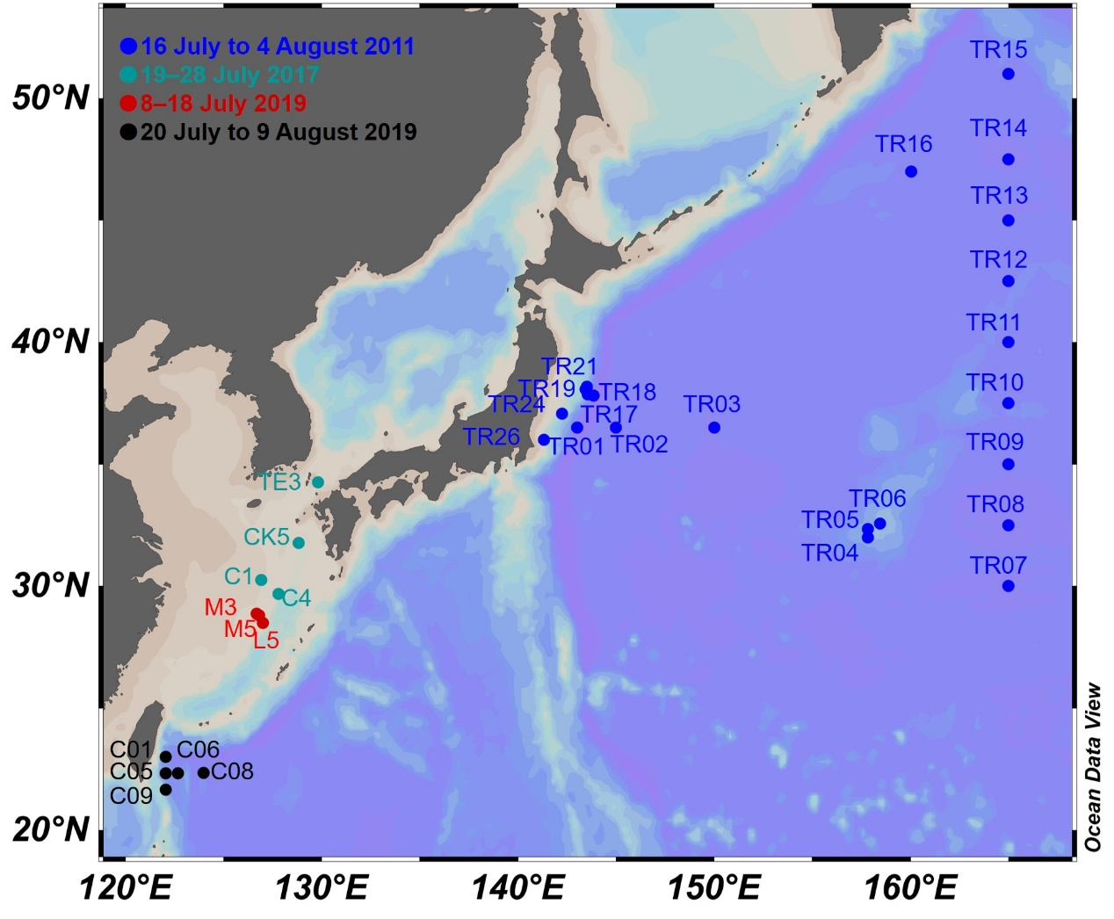

**Supplementary Figure S1.** Map showing the sampling sites and cruise time.



**Supplementary Figure S2.** (A) The linear regression between CTD-based fluorescence (μg L−1) and extracted Chl *a* concentration (μg L−1) using solvent (four stations using 90% acetone and 23 stations using N, N-dimethylformamide) at 27 stations; (B) the vertical stratification index (VSI).

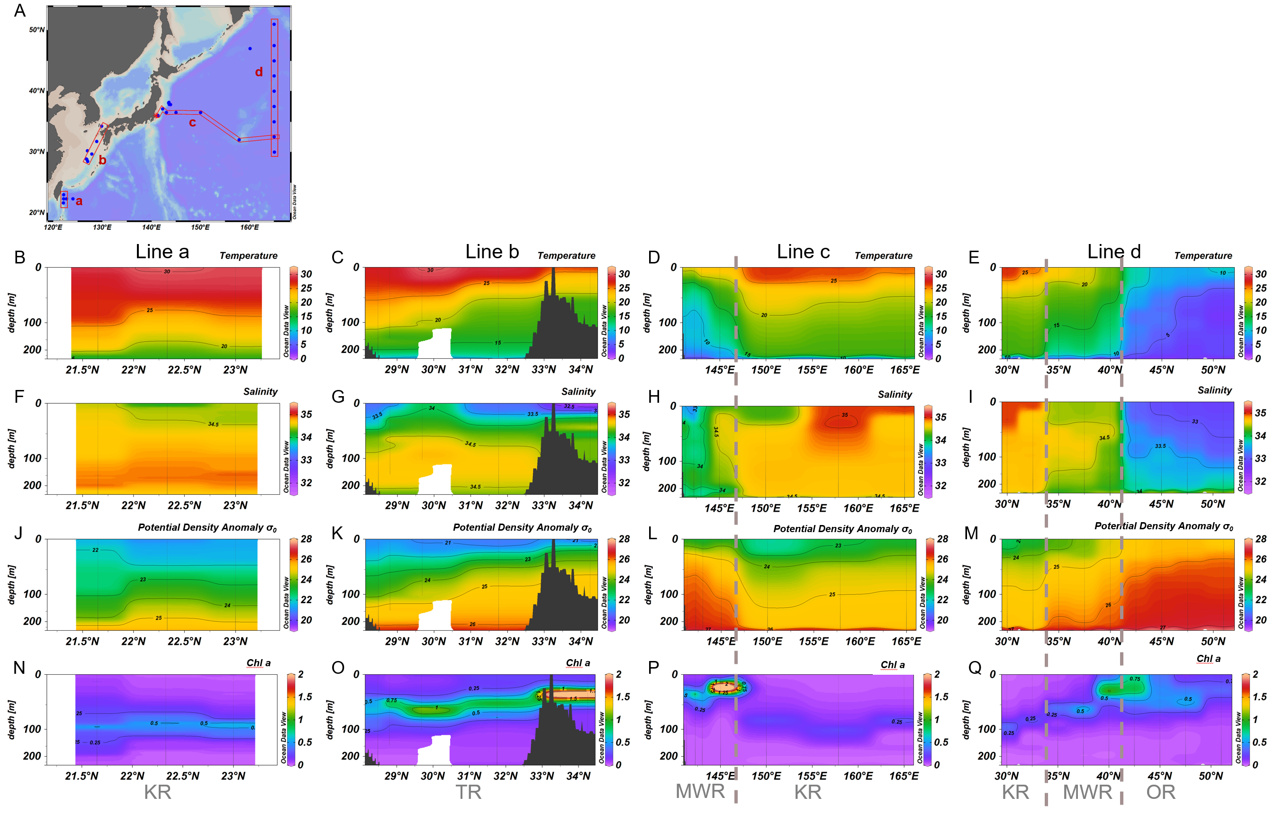

**Supplementary Figure S3.** Map of line sections (A) and transects of temperature (°C; B–E), salinity (PSU; F–I), potential density anomaly (kg m−3; J–M) and in situ chlorophyll *a* concentration (μg L−1; N–Q) along line a (B, F, J and N), line b (C, G, K and O), line c (D, H, L and P) and line d (E, I, M and Q). KR: Kuroshio region, TR: Tsushima region, MWR: mixed water region, OR: Oyashio region. Broken lines are used to separate different water masses along Line c and d. Note the difference in color scales.

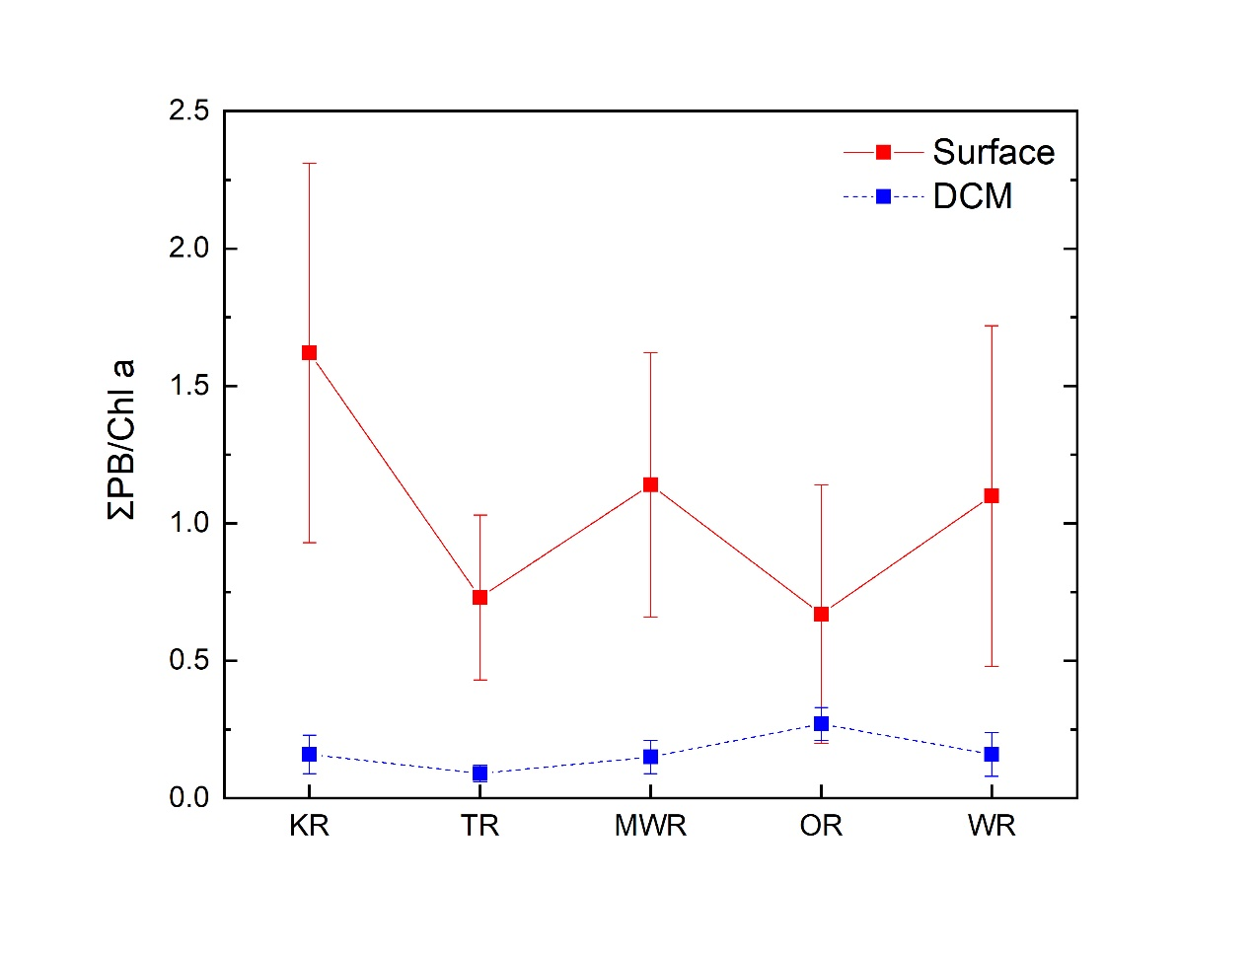

**Supplementary Figure S4.** Mean values (± SD) of the sum of the three lipid biomarkers [ΣPB] to Chl *a* ratios (μg μg−1) in surface and DCM waters of the four regions and the whole study area (WR). KR: Kuroshio Region; TR: Tsushima Region; MWR: Mixed Water Region; OR: Oyashio Region.

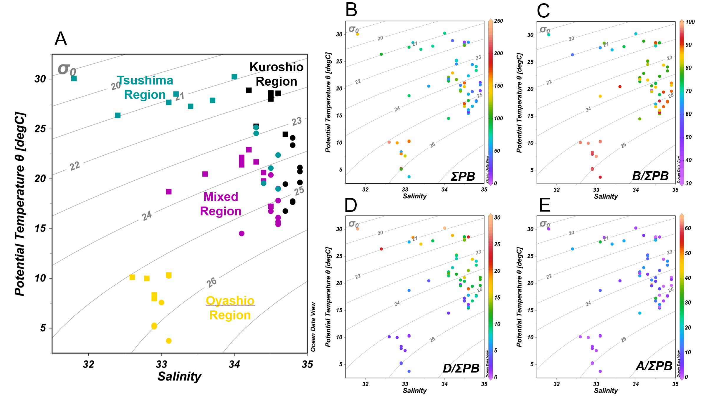

**Supplementary Figure S5.** Potential temperature versus salinity plots superimposed by (A) different regions (solid square: surface waters; solid circle: DCM waters), (B) the sum of three lipid biomarkers (ΣPB; ng L−1), (C) brassicasterol/epi-brassicasterol/ΣPB (B/ΣPB; %), (D) dinosterol/ΣPB (D/ΣPB; %), and (E) C37 alkenones/ΣPB (A/ΣPB; %).

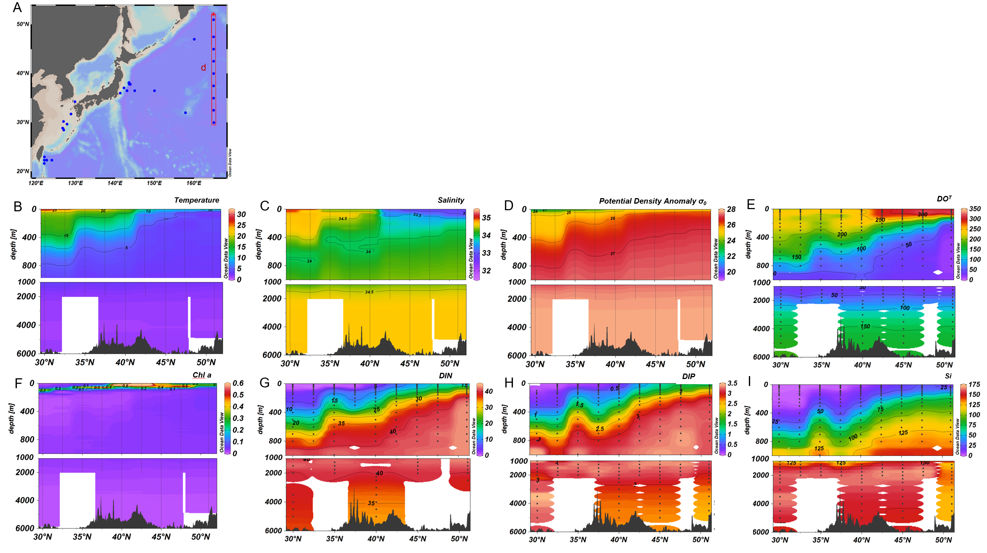

**Supplementary Figure S6.** Map of d section (A), and transects of temperature (°C; B), salinity (PSU; C), potential density anomaly (kg m−3; D), dissolve oxygen (μmol L−1; E), in situ chlorophyll *a* concentration (μg L−1; F), dissolved inorganic nitrogen (DIN, μmol L−1; G); dissolved inorganic phosphorus (DIP, μmol L−1; H), and dissolved silicate (Si, μmol L−1; I).

## Supplementary Tables

Table S1. Ranges (averages) of lipid biomarker concentrations (ng L−1) and proportions (% of the sum of the three lipid biomarkers), Chl *a* concentration (μg L−1), nutrient concentrations (μmol L−1), temperature (℃) and salinity (PSU) in surface and DCM waters of the four regions and the whole study area (WR) in the northwest Pacific Ocean.

|  |  |  |  |  |  |  |  |  |  |  |  |  |  |  |  |
| --- | --- | --- | --- | --- | --- | --- | --- | --- | --- | --- | --- | --- | --- | --- | --- |
| Region | Water layer | B | D | A | ΣPB | Chl *a* | B/ΣPB | D/ΣPB | A/ΣPB | DIN | DIP | Si | Temperature | Salinity | *n* |
| KR | Surface | 8.3–78  (41) | 1.0–15  (8.1) | 0–20  (2.5) | 9.3–112  (51) | 0.01–0.06  (0.03) | 69–90%  (81%) | 10–23%  (16%) | 0–18%  (3%) | 0.01–0.32  (0.09) | 0–0.14  (0.04) | 0.1–1.2  (0.6) | 25.0–30.1  (27.7) | 34.2–35.0  (34.6) | 11 |
| DCM | 19–60  (41) | 2.3–6.9  (4.6) | 0–11  (2.9) | 22–77  (48) | 0.09–0.25  (0.35) | 77–90%  (86%) | 8–12%  (10%) | 0–15%  (4%) | 0.01–1.98  (0.66) | 0–0.10  (0.05) | 0.6–1.5  (1.1) | 17.9–25.2  (21.1) | 34.7–34.9  (34.8) | 9 |
| TR | Surface | 52–101  (61) | 5.5–41  (18) | 1.7–24  (11) | 68–145  (89) | 0.06–0.23  (0.14) | 61–79%  (69%) | 7–29%  (19%) | 2–29%  (12%) | 0–0.14  (0.03) | 0–0.01  (0.00) | 1.7–7.0  (3.0) | 26.4–30.4  (28.4) | 31.8–34.0  (33.1) | 7 |
| DCM | 40–126  (68) | 4.0–26  (12) | 4.6–18  (8.6) | 49–170  (88) | 0.61–1.97  (1.06) | 73–82%  (78%) | 8–20%  (13%) | 7–13%  (10%) | 0–2.53  (0.73) | 0–0.19  (0.06) | 0.6–5.0  (2.5) | 19.0–25.2  (22.0) | 34.3–34.6  (34.4) | 6 |
| MWR | Surface | 25–124  (76) | 1.0–15  (7.5) | 0.8–52  (19) | 46–176  (103) | 0.05–0.31  (0.10) | 35–91%  (75%) | 1–13%  (7%) | 2–64%  (18%) | 0.01–1.73  (0.42) | 0–0.25  (0.07) | 0.1–5.4  (1.6) | 18.3–23.8  (21.8) | 33.1–34.5  (34.1) | 11 |
| DCM | 19–115  (76) | 0.9–13  (5.6) | 0–19.5  (9.5) | 20–145  (91) | 0.26–0.94  (0.61) | 79–93%  (84%) | 2–10%  (6%) | 0–19%  (10%) | 1.55–9.39  (4.62) | 0.25–0.74  (0.44) | 2.7–10.8  (5.7) | 14.7–21.2  (17.8) | 34.1–34.6  (34.5) | 8 |
| OR | Surface | 53–218  (146) | 1.1–5.6  (3.3) | 1.0–5.0  (2.9) | 56–226  (152) | 0.15–0.71  (0.33) | 95–97%  (96%) | 2–2%  (2%) | 1–3%  (2%) | 5.78–15.42  (10.44) | 0.86–1.48  (1.10) | 6.3–25.7  (15.8) | 8.8–11.1  (10.2) | 32.6–33.1  (32.9) | 5 |
| DCM | 60–194  (128) | 1.8–7.5  (3.7) | 0.9–7.3  (2.9) | 65–209  (135) | 0.28–0.92  (0.52) | 93–97%  (95%) | 1–4%  (3%) | 1–3%  (2%) | 8.44–19.93  (15.36) | 0.89–1.85  (1.46) | 2.5–31.4  (18.8) | 4.4–11.0  (7.1) | 32.9–33.1  (33.0) | 5 |
| WR | Surface | 8.3–218  (72) | 1.0–41  (9.1) | 0–52  (9.6) | 9.3–226  (90) | 0.01–0.71  (0.13) | 35–97%  (79%) | 1–29%  (12%) | 0–64%  (10%) | 0–15.42  (2.15) | 0–1.48  (0.25) | 0.1–25.7  (4.0) | 8.8–30.4  (23.4) | 31.8–35.0  (33.9) | 34 |
| DCM | 19–194  (72) | 0.9–26  (6.2) | 0–20  (6.0) | 20–209  (85) | 0.09–1.97  (0.61) | 73–97%  (85%) | 1–20%  (8%) | 0–19%  (6%) | 0–19.93  (4.72) | 0–1.85  (0.44) | 0.6–31.4  (6.2) | 4.4–25.2  (17.9) | 32.9–34.9  (34.3) | 28 |

B: brassicasterol/epi-brassicasterol; D: dinosterol; A: C37 alkenones; ∑PB: the sum of the three lipid biomarkers. KR: Kuroshio Region; TR: Tsushima Region; MWR: Mixed Water Region; OR: Oyashio Region.