Table S1 The latitude and longitude of the sampling point and depth.
site | longitude | latitude | Depth (m)
S02 | 114.92 | 20.9 | 260
S03 | 115.41 | 20.62 | 350
S07 | 116.02 | 20.33 | 757
S36 | 117.28 | 19.2 | 3661
S39 | 117 | 18 | 3951
C06 | 117.59 | 21.36 | 650
C17 | 118 | 21 | 1728
C23 | 118.5 | 20.49 | 2351
C33 | 119 | 19.61 | 3390
N02 | 118 | 22 | 241
N31 | 119.5 | 21.14 | 3112
N36 | 119.99 | 20.755 | 3645

Table S2 Medium
 | Material | Final concentration(g/L)
Mineral salt medium (MSM) | NaCl | 30.0g/L
 | Na₂HPO₄ | 0.6g/L
 | KH₂PO₄ | 0.5g/L
 | (NH₄)₂SO₄ | 5.0g/L
 | Yeast extract | 2.0g/L
 | CaCl₂ | 0.111g/L
 | FeSO₄ | 0.152g/L
 | MgSO₄ | 0.72g/L
 | Add deionized Water 1000 mL, pH 7.2~7.5
Simplified 2216E medium | Peptone | 5 g/L
 | Yeast extract | 1 g/L
 | FeSO₄·7H₂O | 0.01g/L
 | Add natural seawater 1000 mL, pH 7.6; solid media 2% agar
1/50 2216E medium | 1 / 50 of 2216E medium component content
Artificial seawater (AS) | KH₂PO₄ | 1.0g/L
 | K₂HPO₄ | 0.5g/L
 | FeSO₄·7H₂O | 0.01g/L
 | NaCl | 10g/L
 | CaCl₂ | 0.1g/L
 | (NH₄)₂SO₄ | 1.5g/L
 | MgSO₄ | 0.2g/L
 | Add deionized Water 1000 mL, pH 7.0

Table S3 Alpha diversity indices
Sample\Estimators | shannon | simpson | ace | chao | coverage
C06 | 6.422514 | 0.004752 | 3390.902494 | 3267.221557 | 0.975046
C17 | 6.507353 | 0.004482 | 3592.385047 | 3484.709193 | 0.973722
C23 | 5.967934 | 0.012878 | 3702.69757 | 3527.264414 | 0.970351
C33 | 6.28025 | 0.006113 | 3643.997335 | 3537.766667 | 0.97158
N02 | 6.468491 | 0.004939 | 2746.303764 | 2726.857143 | 0.985349
N31 | 6.593635 | 0.005062 | 3975.516659 | 3887.889279 | 0.97013
N36 | 6.749654 | 0.004074 | 3677.900384 | 3588.986464 | 0.976401
S02 | 6.683713 | 0.003268 | 3962.541178 | 3828.967742 | 0.970004
S03 | 6.506069 | 0.0043 | 3658.888164 | 3564.944444 | 0.972147
S07 | 6.122929 | 0.008158 | 3543.633752 | 3562.026954 | 0.971454
S36 | 5.953045 | 0.008545 | 3229.508067 | 3237.591512 | 0.974006
S39 | 5.561588 | 0.015565 | 2388.003508 | 2350.366762 | 0.98308

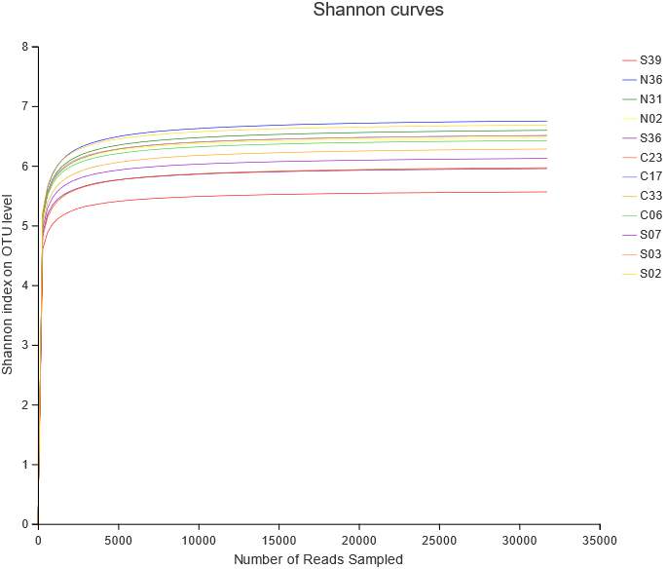
Fig. S1. Shannon dilution curve.

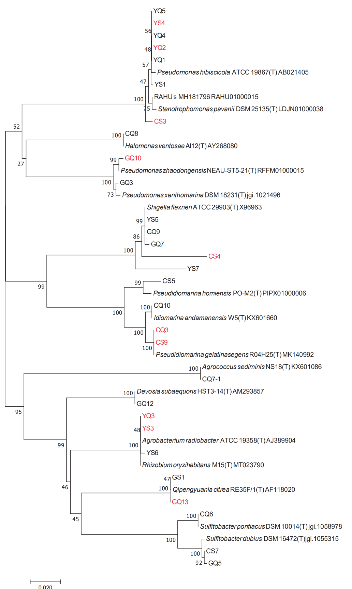
Fig. S2. Neighbour-joining phylogenetic tree based on 16S rDNA gene sequence.
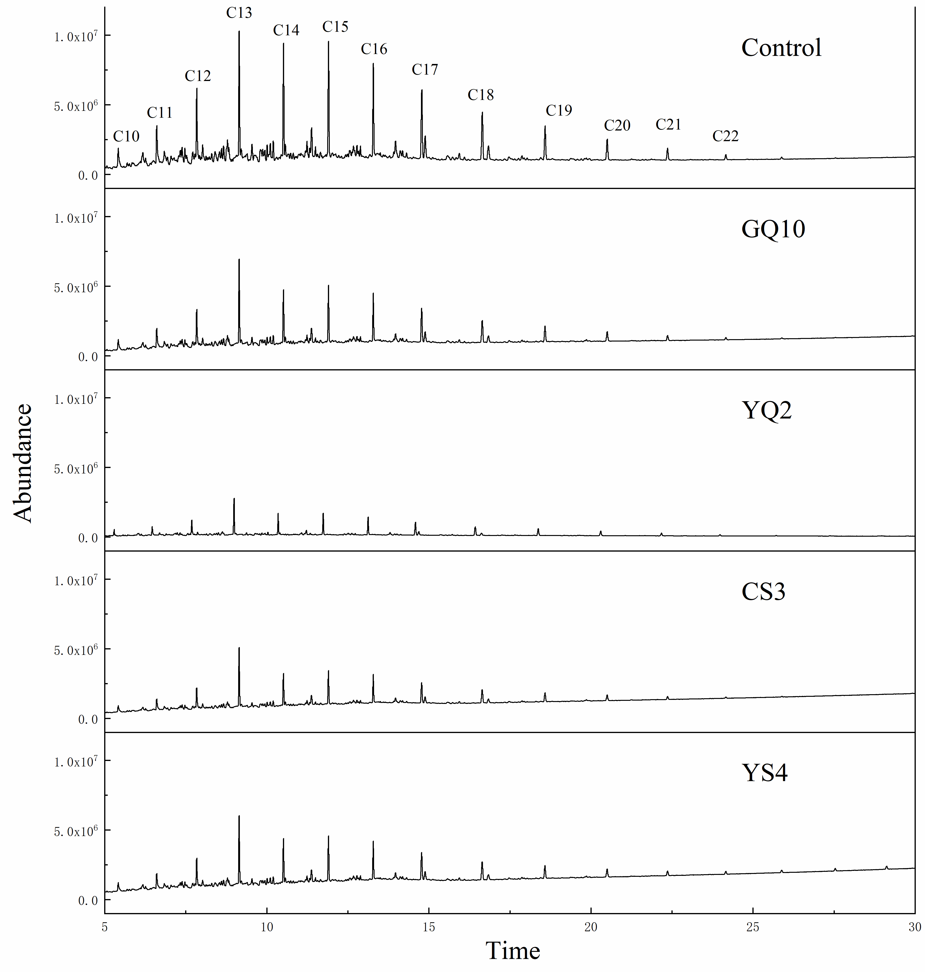
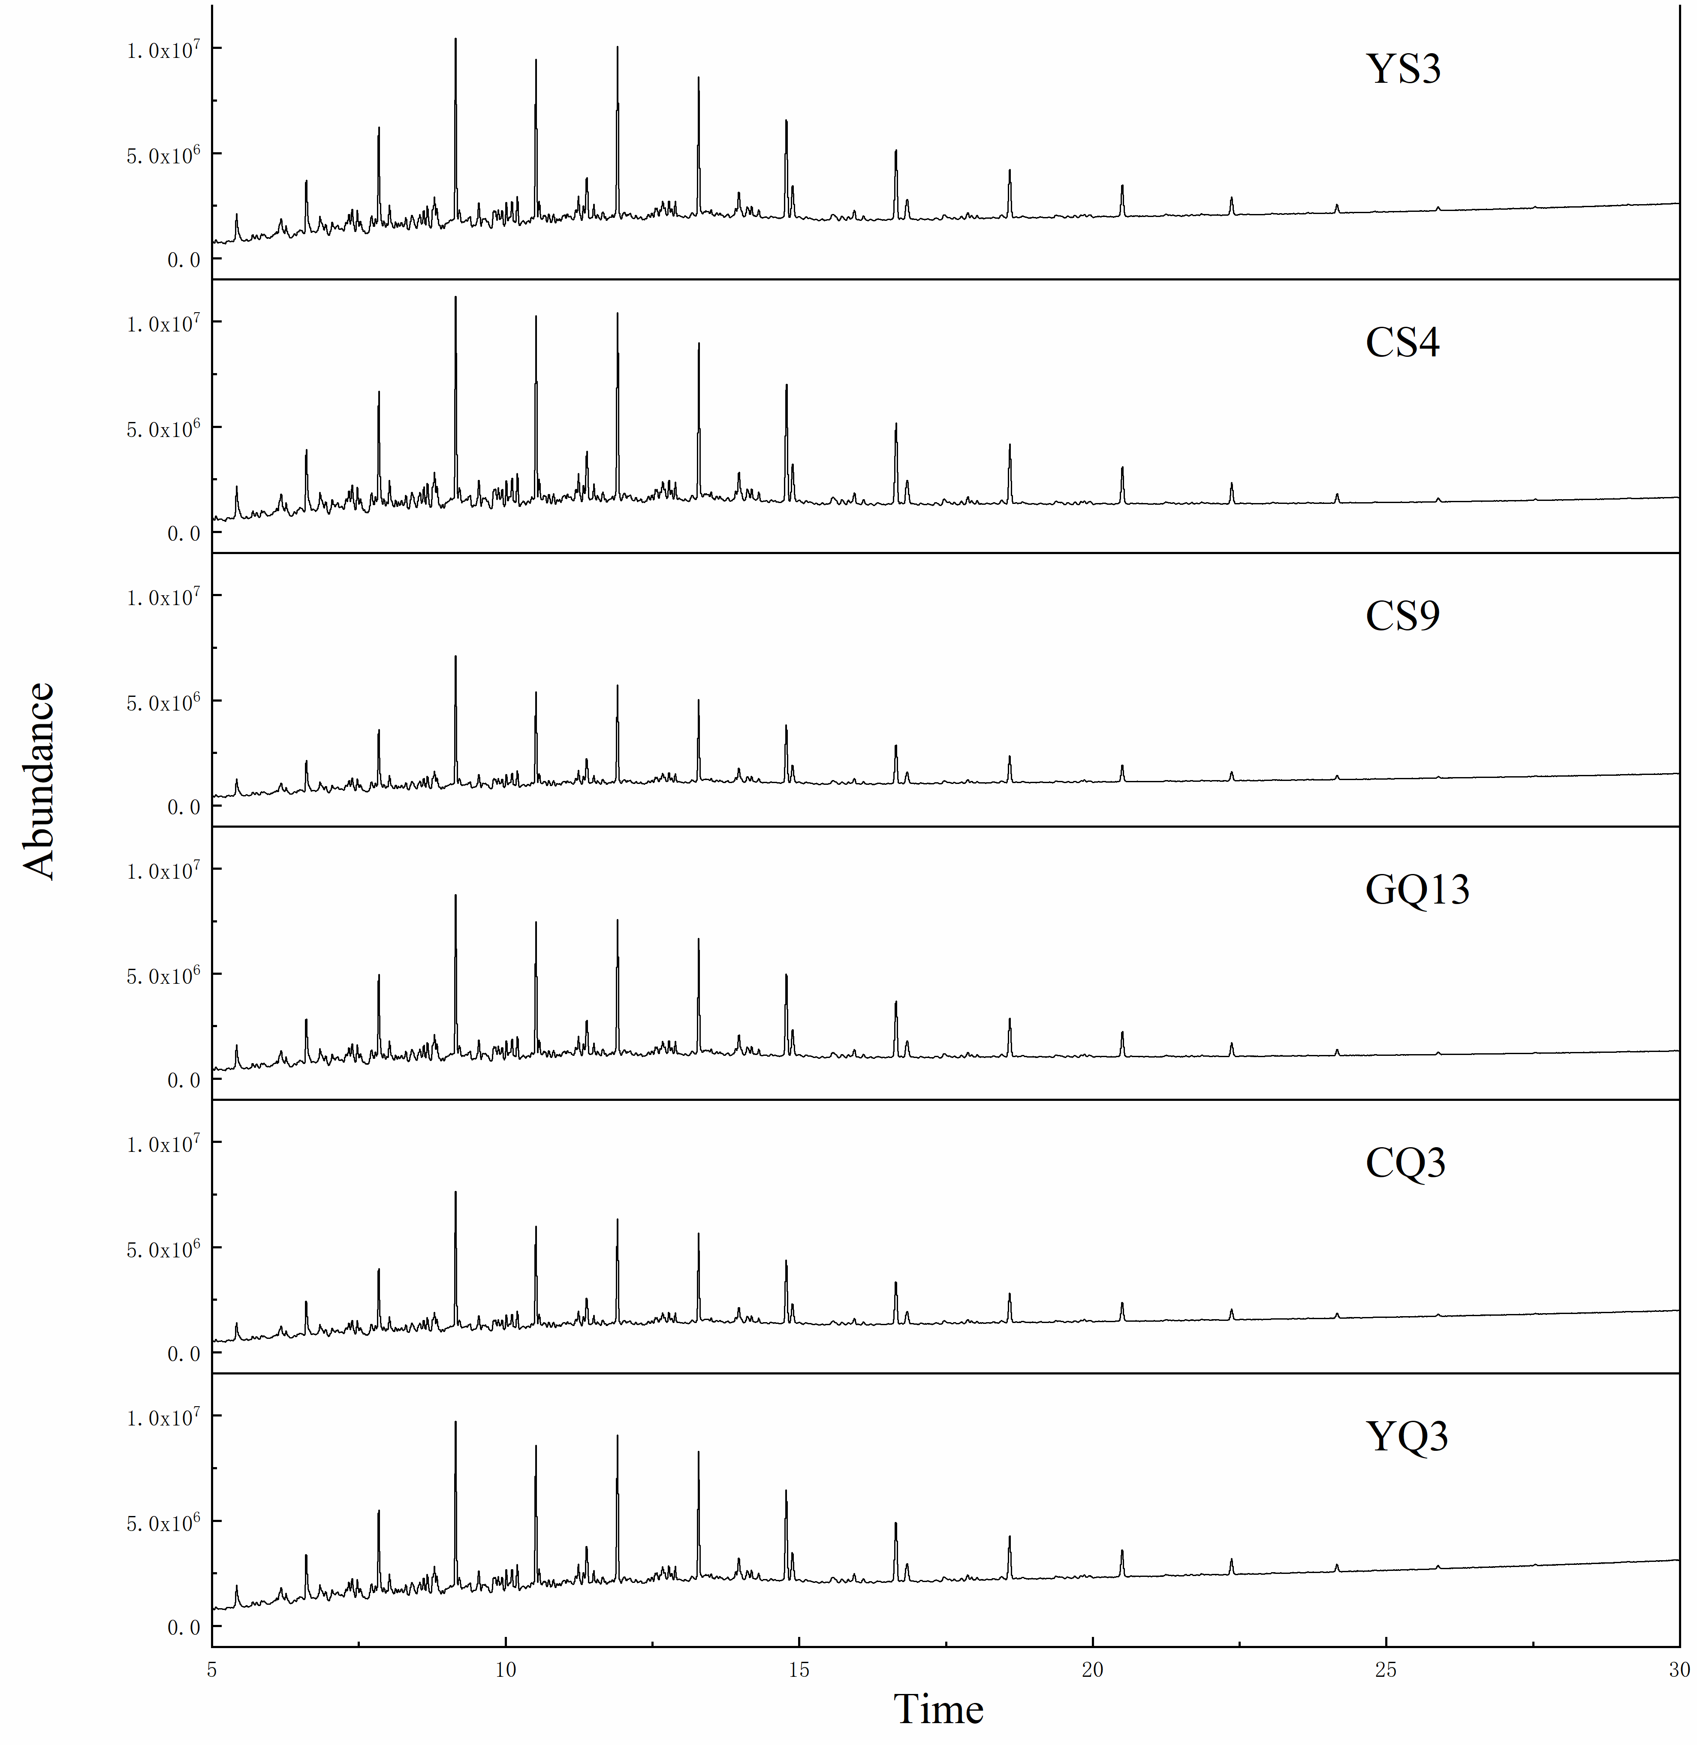
Fig. S3. GC-MS spectra.

