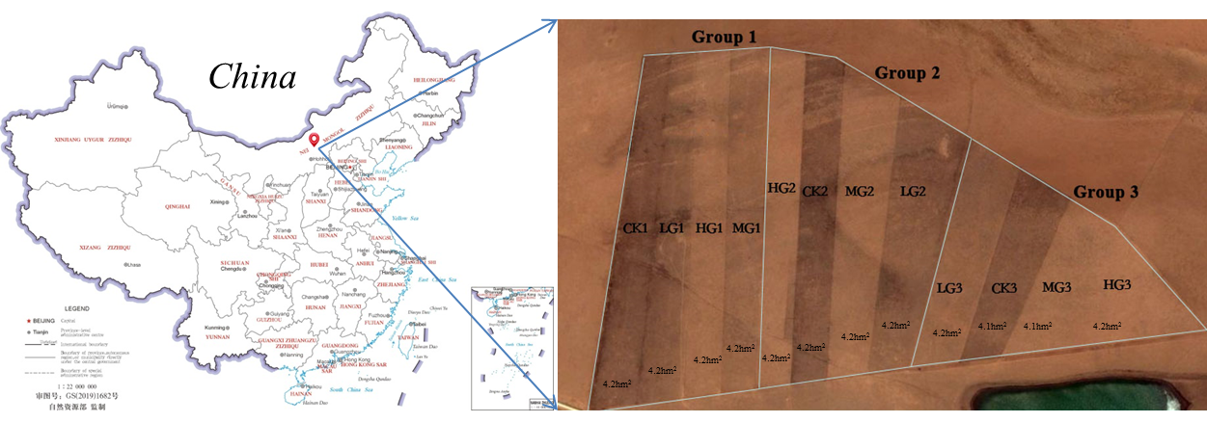

Fig. S1 Schematic diagram of studied site

Note: CK: without grazing, LG: 0.91 sheep unit·hm-2∙half∙year-1, MG: 1.82 sheep unit·hm-2∙half∙year-1, HG: 2.71 sheep unit·hm-2∙half∙year-1)



Fig. S2 The SDR dynamics of dominant and sub-dominant species during 2004-2017

Note: The correlations between the SDR of sub-dominant species and that of *S. breviflora* was given in subgraphs. \*, *P* < 0.05; \*\*, *P* < 0.01.

C:\Users\Administrator\Desktop\桌面\论文写作\论文（2020年4月21日预测多样性变化论文）20210723已投\图表及数据\species diversity与功能性状相关性分析图.TIF

Fig. S3 Pearson’s correlation analysis between the functional traits of *S. breviflora*, population, community, and species diversity.

Note: \*, *P* < 0.05; \*\*, *P* < 0.01.