Supplementary Material 1

# Supplementary Data

$Augite, olivine and Plagioclase mineral dissolution$

The weathering rates (Wr) of augite and plagioclase were calculated using the rate law of of Palandri & Kharaka (2004)(with the acid, neutral and alkaline dissolution rates respectively given by **Equation SI.2, SI.3 and SI.4**). This rate is normalized for temperature. In Figure **SF1** the weathering rate of augite and plagioclase (as labradorite) are shown in function of pH. At pH 7.7, the weathering rate according to Knauss et al. (2013) is 7 times higher than the rate law according to Palandri et al. (2004), as the former weathering law does not have a k neutral parameter. For labradorite, the alkaline kinetics of albite were multiplied by four in correspondence with the observations of (Gudbrandsson, Wolff-Boenisch, Gislason, & Oelkers, 2011), for all simulations these kinetics were used for labradorite.

$$Wr\left(mineral\right)\left[\frac{mol}{m^{2}*s}\right]=rate_{acid}+rate_{neutral}+rate_{alkaline} (Eq. SI.1)$$

$$rate_{acid}= k_{acid}*e^{-Ea_a*(1/(273.15+T)-1/298.15)/8.314}*{\left(H^{+}\right)}^{nacid} (Eq. SI.2)$$

$$rate_{neutral}= k_{neutral}*e^{-Ea_neutral*(1/(273.15+T)-1/298.15)/8.314} (Eq. SI.3)$$

$$rate_{alkaline}= k_{alkaline}*e^{-Ea_alk*(1/(273.15+T)-1/298.15)/8.314}*{\left(H^{+}\right)}^{nalkaline} (Eq. SI.4)$$

With H+ = proton concentration, T = temperature in °C, Ea = activation energy (kJ/mol), k = rate constant (mol/m²/s),   
n = unitless exponent.

## Three simulations using different rate laws and Al(OH)3 equilibrium phase.

Three simulations were run to verify the simulation sensitivity to assumptions of the rate law and of the Al(OH)3 equilibrium phase as the latter may cause Al-induced weathering inhibition. In simulation 1, the rate law of Palandri et al. (2004) was used, while simulations 2 and 3 used the augite weathering law from Knauss et al. (1993). Solution in all simulated cells are in equilibrium with equilibrium phases (gases and minerals, e.g. CO2 and calcite, Al(OH)3). Regarding Al(OH)3, we used either amorphous Al(OH)3(a) or gibbsite (Al(OH)3) an equilibrium phase **(**simulations 1 and 2 versus simulation 3; Table **ST2).**

PHREEQC model results were compared to cation (Mg, Ca) pore water composition for the top soil layer (0-5cm depth) for these different simulations. We calculated the difference (delta) in Mg and Ca pore water concentration between the basalt and control treatment and compared this delta for experimental data and simulated values (Figure **SF2**). Due to budget constraints, pore water data are only available for the first 14 days of the experiment. In the first simulation, the simulated delta in pore water cation concentration was smaller than the experimental delta for Ca and Mg respectively. Modifying the rate law for the Mg-bearing mineral augite in simulation 2 and 3 decreased the offset between simulated and experimental Mg pore water concentration (Table **ST8**). For Ca however, simulated values differed significantly from the observations, even after modifying the augite rate law. The additional dissolution of the Ca-rich mineral labradorite in simulation 3 (compared to simulation 2) had only a minor on influence simulated Ca concentration in the pore water. In conclusion, simulation 2 and 3 provide a better fit to the experimental data than simulation 1 based on comparison of pore water Mg, but underestimate the basalt-induced increase of the Ca concentration in the top soil pore water.

Based on pore water Mg comparison, simulation 2 and 3 provide a better fit to experimental Mg pore water. Next, as shown in Table **ST2**, the latter simulations differ in the Al equilibrium phase that is inserted (amorphous Al(OH)3 (Al(OH)3(a) and gibbsite respectively). With gibbsite as equilibrium phase, the dissolution of Al-containing minerals (labradorite in this case) is not inhibited in the simulation, while with Al(OH)3(a) it is. We question whether it is fair to insert gibbsite as the Al solution controlling equilibrium phase as was done in simulation 3, as it is a lower energy Al oxide polymorph. According to Oswald’s Rule of Stages, the higher energy polymorph (which controls the solution chemistry) forms first, and then decomposes in stages to lower energy polymorphs (Van Santen, 1984). Therefore, we believe that Al(OH)3(a) is controlling the solution chemistry (to some extent). In the main text, simulation 2 was selected over simulation 3, hence providing a conservative estimate of inorganic CO2 sequestration. Nevertheless, the extent to which the predicted Al(OH)3(a) inhibition of plagioclase weathering reflects reality remains uncertain. The difficulty in modelling this is that in the PHREEQC surface functionality, the WHAM functions by Postma and Appelo (2005) provide sorption constants in the available databases up to divalent ions, but not higher. However, free Al can bind to organic matter, which cannot be simulated with the available PHREEQC databases. Ignoring binding of Al to organic matter implies that aqueous Al3+concentration is overestimated and dissolution of Al-holding minerals and hence CO2 sequestration are underestimated. One option to resolve this is to use the WHAM model from Tipping and Hurley (1992) to iteratively speciate the metals complexing to particulate organic matter and then speciate the solution fraction with PHREEQC.

These different simulation approaches result in differences in modelled inorganic CO2 sequestration. In Figure **SF3** and Figure **SF4**, modelled inorganic CO2 sequestration are shown after 100 days (experimental period) and 5 years of simulation. An overview is given in Table **ST3**.

## PRS probe data

Extended PRS data can be consulted in **ST4.**

## DIC (mg/L) vs Total alkalinity (TA, mEq/L) calibration curve

In **SF5** the calibration curve for DIC in function of total alkalinity is displayed.

## Mg and Ca: distribution in soil ~ depth

In **SF6** the Mg and Ca concentration (mg/kg soil) for basalt and control treatments are shown at different soil depths: (0-20cm), (20-30 cm) and (30-50cm).

## Elements contributing to CEC increase

In **ST5** an overview of the elements contributing to soil CEC (in mEQ/100g soil) for different depths (0-20cm), (20-30 cm) and (30-50cm) is given for the control and basalt treatment.

## Ca and Mg pore water mass balance

In this section, a mass balance for Ca and Mg is constructed for the control and basalt treatments **Equation SI.5** (**SF7**). The ‘b’ and ‘c’ subscripts in the equation reflect the basalt and control treatment respectively. For Mg, an identical approach was followed. After substituting Eq. SI.5 into **Eq. SI.6**, **Eq. SI.7** is derived which is simplified as **Eq. SI.8**. Hence, the modelled changes on top soil (0-5cm, modelled cell 1) pore water cation concentrations can be attributed to the different factors listed in **ST6.**

|  |  |
| --- | --- |
| $$LeachateC = SW+ InputwaterCa – (Calcite-Ca)_c – (Surf-Ca)_c – (CaX2)_c – (potato-Ca)_c$$ | $$\left(Eq.SI.5\right)$$ |
| $$Leachate_{B = SW + InputwaterCa + BW – {\left(Calcite-Ca\right)}_{b} – {\left(Surf-Ca\right)}_{b} – {\left(CaX2\right)}_{b} – {\left(potato-Ca\right)}_{b }}$$ | $$(Eq.SI.6)$$ |
| $Leachate_{B =BW – (Calcite-Ca)_b – (Surf-Ca) _b – (CaX2) _b – (potato-Ca) _b + Leachate_(C )+(Calcite-Ca)_c+ (Surf-Ca)_c+ (CaX2)_c+ (potato-Ca) _c }$ | $$(Eq.SI.7)$$ |
| $$Δleachate\left(B-C\right)= BW + ΔCaX2 \left(C-B\right)+ Δsurf-Ca \left(C-B\right)+ Δ Calcite-Ca \left(C-B\right)+ Δ potato-Ca \left(C-B\right)$$ | $$(Eq.SI.8)$$ |

With BW = basalt weathering, SW= soil weathering, CaX2= cation exchange for Ca,   
Ca-Surf = Ca surface adsorption.

In conclusion, **ST6** shows that modelled changes in Ca between the basalt and control treatment are attributed to changes in (in quantitative declining order) calcite precipitation, followed by cation exchange and marginally by surface adsorption. No Mg-carbonate precipitation was predicted by the model, making cation exchange the largest predicted Mg phase change among treatments with a marginal influence of organic matter surface complexation.

## Mineral decline of olivine, plagioclase (labradorite) and augite

In **SF8** the decline of olivine, plagioclase (labradorite) and augite mineral is displayed over 5 years.

## Enhanced weathering and mineral carbonation potential of durubas basalt

|  |  |
| --- | --- |
| $$Epot [\frac{kgCO2}{ton basalt}]=\frac{44gCO2}{100*mol CO2}*\left(α\frac{m\%CaO}{MM_{CaO}}+β\frac{m\%MgO}{MM_{MgO}}+ε\frac{m\%Na2O}{MM_{Na2O}}+θ\frac{m\%K2O}{MM_{K2O}}+γ\frac{m\%SO3}{MM_{SO3}}+δ\frac{m\%P2O5}{MM_{P2O5}}\right)*η*1000$$ | **(Eq SI.9)** |
| $$Cpot[\frac{kg CO2}{ton basalt}]=\frac{44gCO2}{100*mol CO2}*\left(α\frac{m\%CaO}{MM_{CaO}}+β\frac{m\%MgO}{MM_{MgO}}+γ\frac{m\%SO3}{MM_{SO3}}+δ\frac{m\%P2O5}{MM_{P2O5}}\right)*1000$$ | **(Eq SI.10)** |

In **Equation SI.9 and 10** the theoretical enhanced weathering and mineral carbonation carbon dioxide removal (CDR) potential are calculated. With coefficients α, β, γ, δ, ε and θ, which consider the relative contribution of each oxide to CDR in function of pH (see supplementary of Renforth, 2019). At the (neutral) pH of our experiment, α, β, ε and θ equal 1, while γ equals -1 and δ about -1.75. We did not have data on the SO3% of our basalt, so this factor is ignored in the above calculation. The η is equivalent to the amount of HCO3- that remains in solution (and hence does not precipitate). Theoretically, 1 out of 2 HCO3- molecules degasses per mole of carbonate precipitate, which implies that η equals 2 in case of no carbonate precipitation. However, due to buffering in the carbonate system, the value is between 1.4 and 1.7 for typical seawater chemistry, pCO2 and temperature (Renforth, 2019). To calculate maximum potential, η was thus set as 1.7.

## Tap water composition

In **ST7**, the composition of the tap water (supplier: Waterlink) used for irrigation is given.

## Olivine composition and uncertainty: sensitivity analysis

In our simulations, olivine was simulated as 5 mass % of the DURUBAS basalt. However this value was rounded in the suppliers’ XRD data sheet, the maximum error on this number is thus 2.5 mass%. Moreover, olivine composition is in between the Mg-endmember fosterite (Mg2SiO4) and fayalite (Fe2SiO4, the Fe-endmember). In a sensitivity analysis, we verified to what extent the difference between modelled and observed Mg concentration in top soil pore water could be due to the uncertainty on the mineralogical composition. Assuming olivine composition was Mg2SiO4 and olivine concentration was 7.5 mass%, we found that there is a discrepancy with experimental pore water Mg after 14 days and simulation 2 consistently provides a smaller difference with experimental results than simulation 1.

## Supplementary references

Chou, L., & Wollast, R. (1985). Steady-state kinetics and dissolution mechanisms of albite. In *American Journal of Science* (Vol. 285, Issue 10, pp. 963–993). https://doi.org/10.2475/ajs.285.10.963

Gudbrandsson, S., Wolff-Boenisch, D., Gislason, S. R., & Oelkers, E. H. (2011). An experimental study of crystalline basalt dissolution from 2pH11 and temperatures from 5 to 75°C. *Geochimica et Cosmochimica Acta*, *75*(19), 5496–5509. https://doi.org/10.1016/j.gca.2011.06.035

Tipping, E., & Hurley, M. A. (1992). A unifying model of cation binding by humic substances. Geochimica et Cosmochimica Acta, 56(10), 3627–3641. https://doi.org/10.1016/0016-7037(92)90158-F

Van Santen, R. A. (1984). The Ostwald step rule. Journal of Physical Chemistry, 88(24), 5768–5769. https://doi.org/10.1021/j150668a002

# Supplementary Figures and Tables

## Supplementary Figures

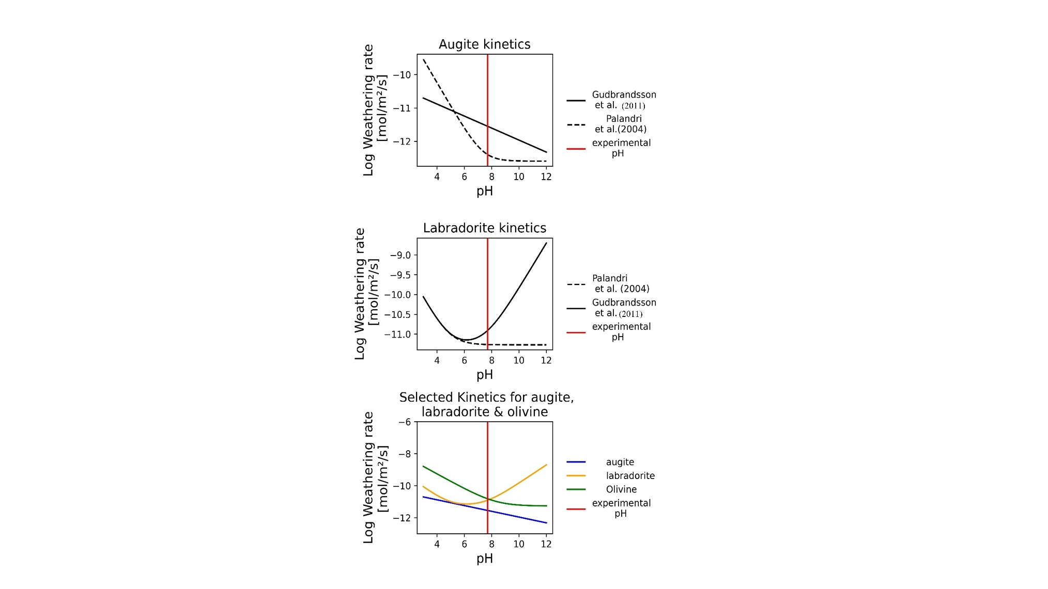

**Figure 1 (SF1).** Comparison of different weathering rate equations for augite (top) and labradorite (middle). The weathering laws on the lowest subfigure were selected for running the PHREEQC simulations 2 and 3.

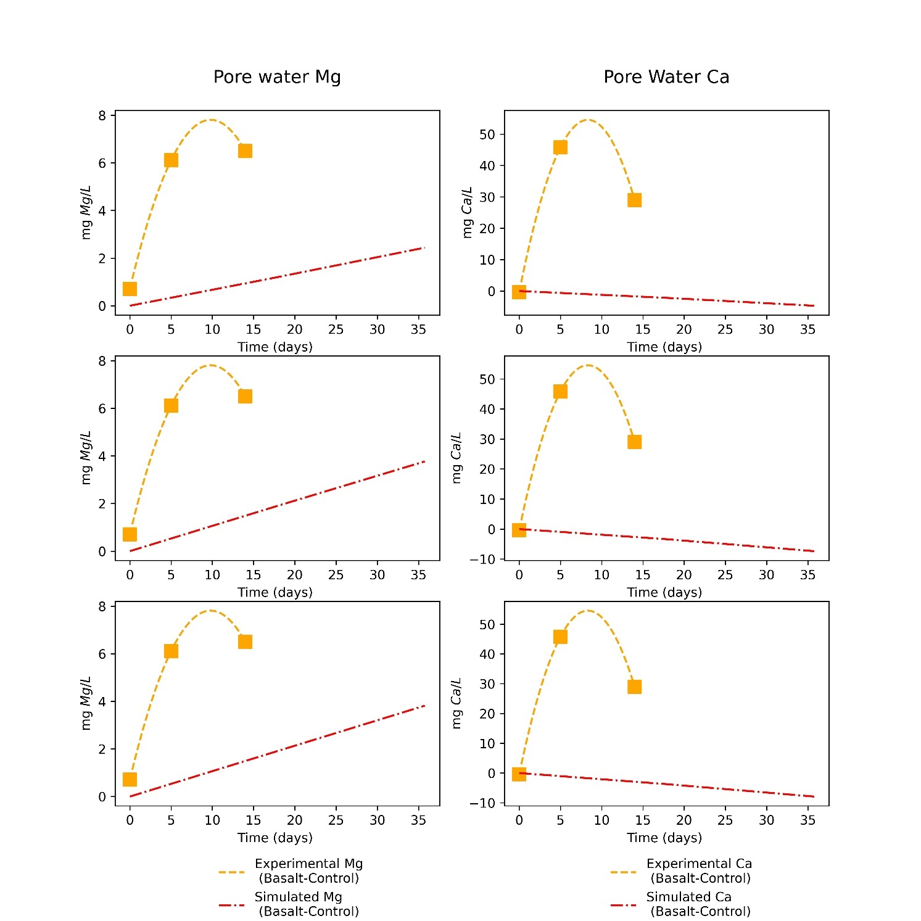

**Figure 2 (SF2).** Differences between basalt and control treatment Ca and Mg pore water concentration for 3 different simulations, compared to the experimental difference. Outcomes of simulation 1, 2 and 3 are shown in row 1, 2 and 3 respectively.

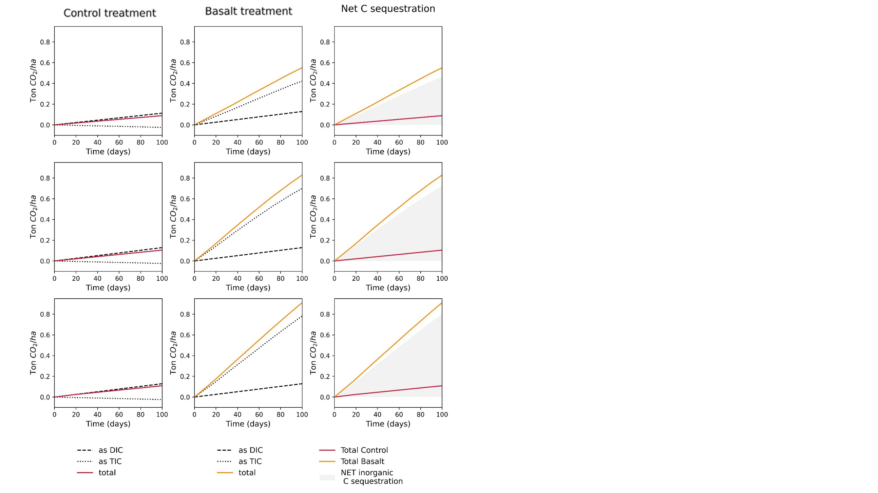

**Figure 3 (SF3).** Simulated C sequestration (as TIC, DIC and total) for control mesocosms (- basalt, left), basalt mesocosms (+ basalt, center), and Net inorganic C sequestration (right). Outcomes of simulations 1, 2 and 3 are shown in rows 1, 2 and 3 respectively.

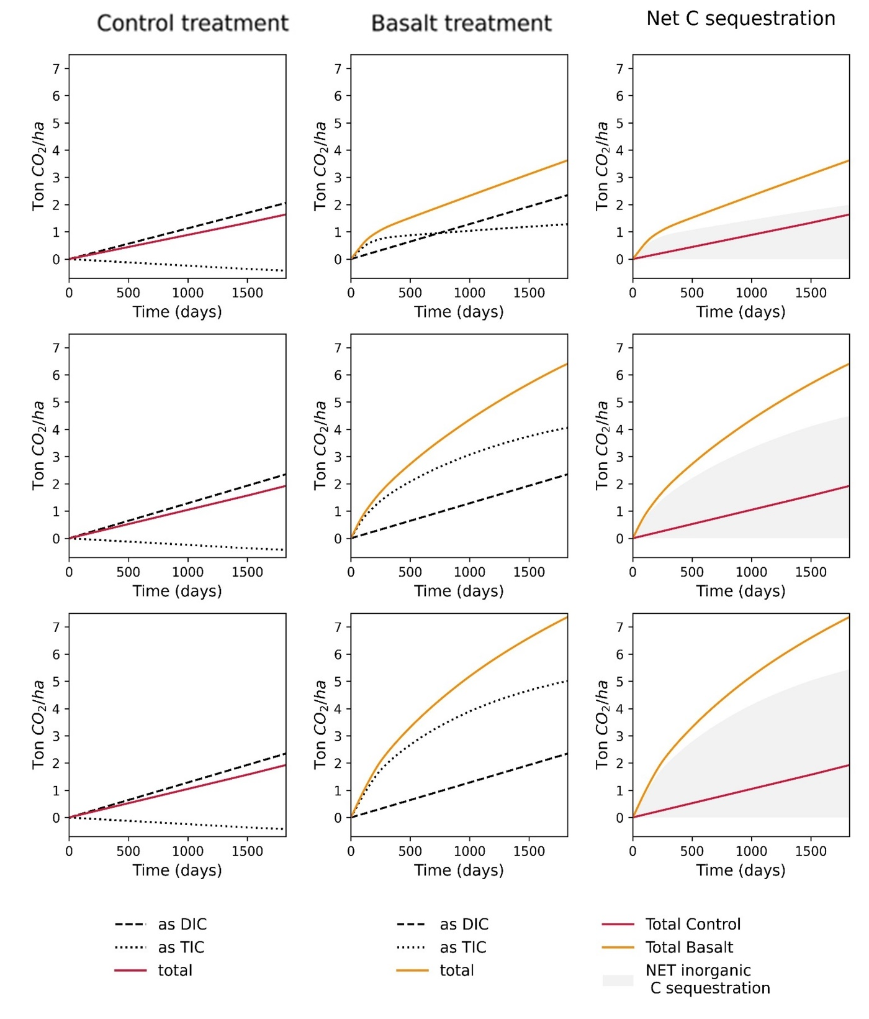

**Figure 4 (SF4).** Simulated inorganic CO2 sequestration for 5 years.  
Outcomes of simulations 1, 2 and 3 are shown in rows 1, 2 and 3 respectively.

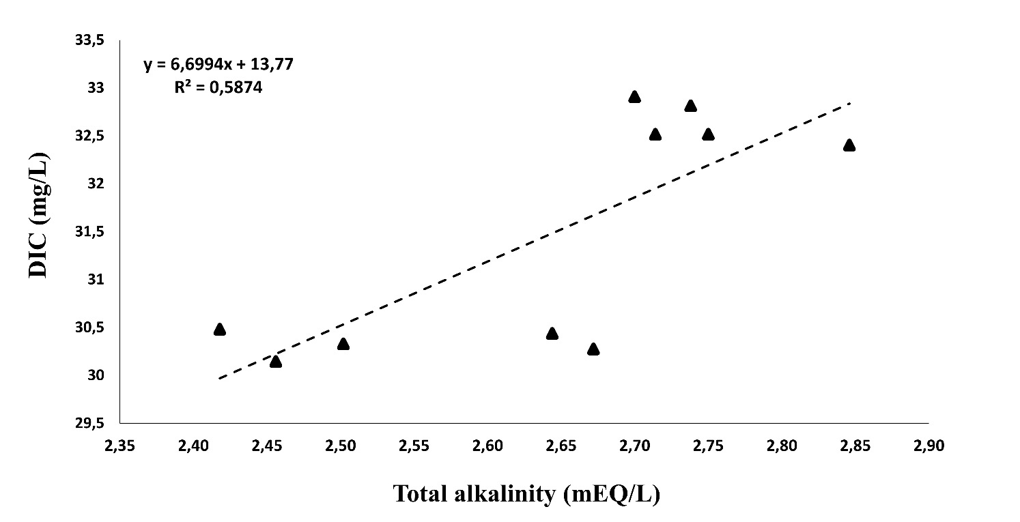

**Figure 5 (SF5):** Relationship between DIC and total alkalinity in leachate samples.

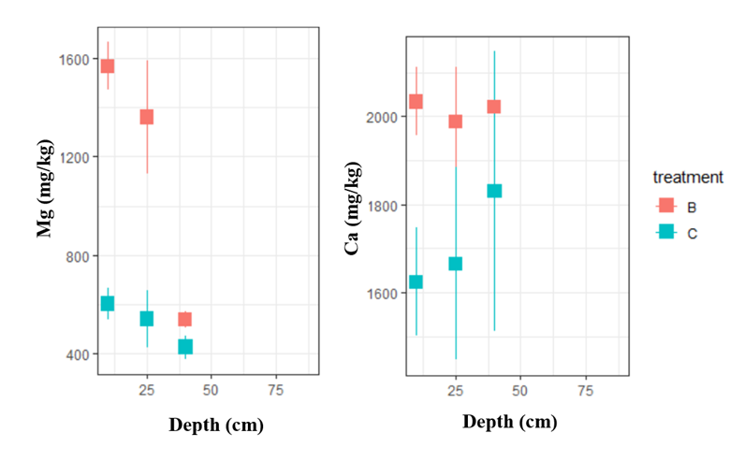

**Figure 6 (SF6).** Distribution of Mg and Ca in solid soil samples at different depths for basalt (B) and control (C) treatments.

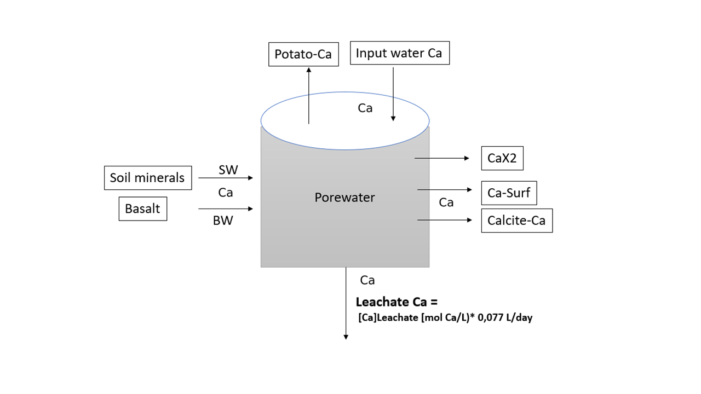

**Figure 7 (SF7).** Ca mass balance of 1 simulated cell. The leachate of cell 1 is the input solution of cell 2. With BW = basalt weathering, SW= soil weathering, CaX2= cation exchange for Ca, Ca-Surf = Ca surface adsorption.

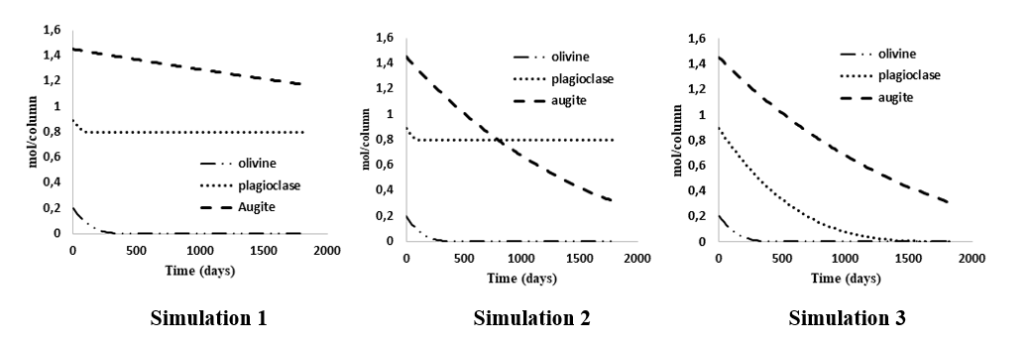

**Figure 8 (SF8).** Decline of olivine, plagioclase (labradorite) and augite mineral (mol/mesocosm) in function of time (in days). The effect of changing the augite rate law (simulation 1-2) and Al hydroxide equilibrium phase (simulation 2-3) on mineral weathering is displayed.

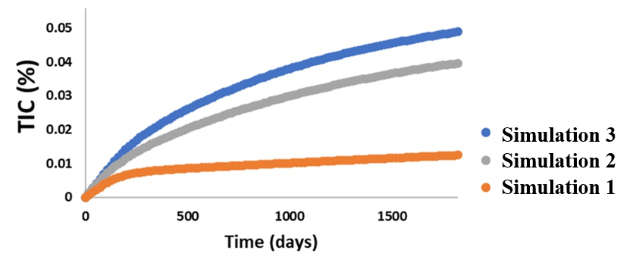**Figure 9 (SF9).** TIC change (in %) in the top soil (0-20cm) resulting from calcite and siderite precipitation in function of time (days) in the basalt mesocosms according to simulation 1, 2 and 3. The effect of changing the augite rate law (simulation 1-2) and Al hydroxide equilibrium phase (simulation 2-3) on mineral weathering is displayed.

## Supplementary Tables

**Table ST1:**  Overview of different rate law parameters for Equation SI.1.

|  |  |  |  |  |  |  |  |  |  |
| --- | --- | --- | --- | --- | --- | --- | --- | --- | --- |
| **Mineral** | **k acid (mol/m²/s)** | **Ea acid  (kJ/mol)** | **n acid** | **k neutral (mol/m²/s)** | **Ea neutral  (kJ/mol)** | **k alkaline (mol/m²/s)** | **Ea alkaline  (kJ/mol)** | **n alkaline** | **Source** |
| **Augite (only acid kinetics)** | 2.88*10^(-10) | 78 | 0.18 | / | / | / | / | / | k_acid & n acid 🡪(Knauss, , 1993) ; Ea 🡪 Palandri (2004) |
| **Augite (acid + neutral)** | 10^(-6.82) | 78 | 0.7 | 10^(-11.97) | 78 | / | / | / | Palandri (2004) |
| **Labradorite (acid + neutral+ alkaline)** | 10^(-7.87) | 42.1 | 0.626 | -10.91 | 45.2 | 4*10(-15.6) a | 71 a | -0.572 a | Palandri (2004) ; k alkaline 🡪 (Gudbrandsson, , 2011) |
| **Labradorite (acid + neutral)** | 10^(-7.87) | 42.1 | 0.626 | -10.91 | 45.2 | / | / | / | Palandri (2004) |

a For alkaline labradorite kinetics, the kinetics of albite (source: (Chou & Wollast, 1985)) were multiplied by 4 as was done by Gudbrandsson et al. (2011).

**Table ST2:** Overview of the different simulationswith variations in augite weathering law and Al(OH)3 equilibrium phase.

|  |  |  |
| --- | --- | --- |
|  | **Source of augite  rate law parameters** | **Al(OH)3  equilibrium phase** |
| ***Simulation* 1** | Palandri et al. (2004) | Amorphous |
| ***Simulation* 2** | Knauss et al. (1993) | Amorphous |
| ***Simulation* 3** | Knauss et al. (1993) | Gibbsite |

|  |  |  |  |  |  |  |
| --- | --- | --- | --- | --- | --- | --- |
| ***Simulation*** | **Net inorganic CO2 sequestration**  **(107 days) [ton CO2/ha]** | **Net inorganic CO2 sequestration**  **(1 year) [ton CO2/ha]** | **Net inorganic CO2 sequestration**  **(5 years) [ton CO2/ha]** | **%**  **of Cpot after 5y** | **%**  **of**  **Epot  after  5y** | **TIC increase in topsoil (%)**  **After 99 days** |
| ***Simulation 1*** | 0.49 | 0.97 | 1.99 | 17.77% | 9.57% | 0.004 |
| ***Simulation 2*** | 0.77 | 1.83 | 4.48 | 40.00% | 21.54% | 0.008 |
| ***Simulation 3*** | 0.99 | 2.30 | 5.43 | 48.48% | 26.10% | 0.008 |

**Table ST3:** Simulated inorganic CO2 sequestration (in ton CO2/ha) after the experimental period (107 days of simulation), 1 year and 5 years. CO2 sequestration after 5 years of simulation relative to the Epot and Cpot of the utilized basalt for the 3 models. Associated simulated top soil (0-20cm) TIC increase in the experimental timeframe.

1Cpot =potential CO2 sequestration through mineral carbonation **(11.2 ton CO2/ha, section 1.11).**2 Epot = potential CO2 sequestration through enhanced weathering **(20.8 ton CO2/ha, section 1.11).**

**Table ST4:** Extended PRS data. For Ca, Mg, K, Al and P section 3.1.2 can be consulted.   
Repeated-measures anova was utilized for determining basalt and time effects.

|  |  |  |  |  |  |  |  |
| --- | --- | --- | --- | --- | --- | --- | --- |
|  | **µg element/10cm²/7 days** | | | | | | |
|  | **NO3-N** | **NH4-N** | | **Total N** | **Zn** | | **Fe** |
| **June, Control treatment** | 101.00 ± 10.90 | 2.02 ± 0.52 | | 103.00 ± 11.10 | 1.93 ± 0.26 | | 7.34 ± 1.16 |
| **June, Basalt treatment** | 112.00 ± 28.40 | 1.51 ± 0.32 | | 114.00 ± 28.30 | 1.84 ± 0.27 | | 7.26 ±1.69 |
| **August, Control treatment** | 29.30 ± 4.41 | 0.96 ± 0.20 | | 30.30 ± 4.31 | 5.94 ± 0.40 | | 24.50 ± 2.39 |
| **August, Basalt treatment** | 24.30 ± 5.62 | 2.61 ± 0.63 | | 26.90 ± 2.95 | 5.39 ± 0.49 | | 24.50 ± 1.93 |
| **Basalt effect** | p=0.59 | p=0.23 | | p=0.71 | p=0.38 | | p=0.99 |
| **Time effect** | **P<0.001\*\*\*** | p=0.96 | | **P<0.001\*\*\*** | **P<0.001\*\*\*** | | **P<0.001\*\*\*** |
| **Time x Basalt effect** | N.S. | **P<0.01\*\*** | | N.S. | N.S. | | N.S. |
|  | **µg element/10cm²/7 days** | | | | | | |
|  | **Cu** | | **Mn** | | | **Pb** | |
| **June, Control treatment** | 0.78 ± 0.11 | | 0.43 ± 0.09 | | | 2.61 ± 0.35 | |
| **June, Basalt treatment** | 0.84 ± 0.17 | | 0.35 ± 0.10 | | | 2.94 ± 0.81 | |
| **August, Control treatment** | 2.94 ± 0.26 | | 1.05 ± 0.22 | | | 11.60 ± 0.96 | |
| **August, Basalt treatment** | 3.20 ± 0.30 | | 0.75 ± 0.04 | | | 11.60 ± 1.00 | |
| **Basalt effect** | p=0.45 | | p=0.18 | | | p=0.83 | |
| **Time effect** | **P<0.001\*\*\*** | | **P<0.001\*\*\*** | | | **P<0.001\*\*\*** | |
| **Time x Basalt effect** | N.S. | | N.S. | | | N.S. | |

N.S. = Not significant

**Table ST5:** Overview of elements contributing to CEC (in mEq/100g soil)   
± standard error (se) for different depths (0-20cm), (20-30 cm) and (30-50cm).  
One-way anova was utilized for determining basalt effects.

|  |  |  |  |
| --- | --- | --- | --- |
| **Depth 0-20 cm** | **Control** | **Basalt** | **p value** |
| Al | 0.006 ± 0.001 | 0.012 ±0.001 | **<0.01\*\*** |
| Ca | 4.939 ± 0.358 | 5.571 ±0.241 | 0.18 |
| Mg | 0.396 ± 0.022 | 0.553 ± 0.017 | **<0.001\*\*\*** |
| Na | 0.124 ± 0.010 | 0.162 ±0.006 | **0.01\*** |
| K | 0.197 ± 0.010 | 0.211 ±0.020 | 0.56 |
| Mn | 0.021 ±0.003 | 0.015 ±0.001 | 0.13 |
| Fe | 0.009 ± 0.000 | 0.008 ± 0.000 | 0.10 |
| **Depth 20-30 cm** | **Control** | **Basalt** | **p value** |
| Al | 0.007 ±0.002 | 0.006 ± 0.002 | 0.75 |
| Ca | 4.194 ± 0.205 | 5.000 ± 0.171 | **0.02\*** |
| Mg | 0.317 ± 0.026 | 0.481 ± 0.031 | **<0.01\*\*** |
| Na | 0.100 ± 0.006 | 0.136 ± 0.010 | **0.02\*** |
| K | 0.204 ± 0.025 | 0.178 ± 0.015 | 0.39 |
| Mn | 0.019 ± 0.001 | 0.017 ± 0.001 | 0.27 |
| Fe | 0.008 ±0.000 | 0.007 ± 0.000 | 0.11 |
| **Depth 30-50 cm** | **Control** | **Basalt** | **p value** |
| Al | 0.009 ±0.002 | 0.012 ±0.001 | 0.28 |
| Ca | 5.333 ± 0.368 | 4.404 ± 0.330 | 0.10 |
| Mg | 0.330 ± 0.012 | 0.306 ± 0.016 | 0.25 |
| Na | 0.158 ±0.020 | 0.164 ±0.019 | 0.82 |
| K | 0.200 ± 0.059 | 0.121 ± 0.007 | 0.22 |
| Mn | 0.020 ± 0.001 | 0.016 ± 0.001 | **0.02\*** |
| Fe | 0.007 ± 0.000 | 0.007 ± 0.000 | 0.80 |

**Table ST6:** Ca and Mg changes in cell 1 (topsoil 0-5cm pore water) (mmol Ca (or Mg)/mesocosm): Ca changes in the different soil-Ca stocks (CaX2, Surf-Ca and calcite-Ca) were simulated for the first 18 days of the growing season. Simulation results represent the outcome of simulation 2. For Potato-Ca and Potato-Mg, experimental data after 99 days are shown.

|  |  |  |  |
| --- | --- | --- | --- |
| Ca (mmoles) | Control | Basalt | Basalt-Control |
| Calcite-Ca | -0.65 | 10.43 | 11.08 |
| CaX2-Ca* | -0.00 | -2.37 | -2.37 |
| Surf-Ca* | 0.01 | -0.12 | -0.12 |
| Potato-Ca (experimental) | 25.30 | 29.60 | 4.30 |
| Mg (mmoles) | Control | Basalt | Basalt-Control |
| (carbonate)-Mg | 0.00 | 0.00 | 0.00 |
| MgX2- Mg* | -0.40 | 2.16 | 2.56 |
| Surf-Mg* | -0.01 | 0.06 | 0.07 |
| Potato-Mg (experimental) | 84.49 | 94.16 | 9.67 |

**\*** Surface adsorbed and exchanged cations are expressed in mmoles/L pore water. Other numbers are in mmoles/mesocosm.

**Table ST7: Composition of the tap water used for irrigation (supplier: Waterlink).**

|  |  |  |  |  |  |  |
| --- | --- | --- | --- | --- | --- | --- |
| **Parameter** | **unit** | **sample 1** | **sample 2** | **sample 3** | **Average** | **standard error** |
| pH | / | 7.90 | 8.06 | 8.24 | 8.07 | 0.08 |
| TA | (mg/l as CaCO3) | 143.20 | 144.20 | 145.60 | 144.33 | 0.57 |
| TA | (meq/l) | 2.86 | 2.88 | 2.91 | 2.89 | 0.01 |
| NH4-N | (mg N/l) | 0.03 | 0.05 | 0.05 | 0.04 | 0.00 |
| (NO2+ NO3)-N | (mg N/l) | 1.52 | 1.50 | 1.52 | 1.51 | 0.01 |
| DINa | (mg/l) | 1.55 | 1.55 | 1.56 | 1.55 | 0.00 |
| Al | (mg Al/l) | 0.04 | 0.05 | 0.05 | 0.05 | 0.00 |
| Ca | (mg Ca/l) | 63.43 | 66.63 | 66.97 | 65.68 | 0.92 |
| Cr | (mg Cr/l) | <0.0002 | <0.0002 | <0.0002 | 0.00 | 0.00 |
| Cu | (mg Cu/l) | 0.01 | 0.01 | 0.01 | 0.01 | 0.00 |
| Fe | (mg Fe/l) | 0.01 | 0.01 | 0.01 | 0.01 | 0.00 |
| K | (mg K/l) | 6.25 | 6.50 | 6.60 | 6.45 | 0.09 |
| Mg | (mg Mg/l) | 8.67 | 9.02 | 9.13 | 8.94 | 0.11 |
| Mn | (mg Mn/l) | 0.00 | 0.00 | 0.00 | 0.00 | 0.00 |
| Na | (mg Na/l) | 48.84 | 51.12 | 51.57 | 50.51 | 0.69 |
| Ni | (mg Ni/l) | 0.00 | 0.00 | 0.00 | 0.00 | 0.00 |
| PO4-P | (mg P/l) | 0.01 | 0.01 | 0.01 | 0.01 | 0.00 |
| SO4-S | (mg S/l) | 26.94 | 28.39 | 28.48 | 27.94 | 0.41 |
| Si | (mg Si/l) | 1.02 | 1.07 | 1.08 | 1.05 | 0.01 |
| Zn | (mg Zn/l) | 0.02 | 0.03 | 0.03 | 0.03 | 0.00 |

aDissolved inorganic Nitrogen

**Table ST8: Sensitivity of olivine mass% and composition on the discrepancy between pore water experimental and simulated Mg concentration (in mg/L)**

|  |  |  |  |
| --- | --- | --- | --- |
| **Experimental Pore water Mg (0-5cm) after 2 weeks of weathering (mg/L)** | | | **6.50** |
| **Olivine-form** | **Olivine** | **Model** | **<=> Modelled Pore water Mg (0-5cm).  after 2 weeks of weathering (mg/L)** |
| Mg1.04Fe0.96SiO4 | 5 | Simulation 1 | 1.20 |
| Mg1.04Fe0.96SiO4 | 7.5 | Simulation 1 | 1.46 |
| Mg2FeSiO4 | 7.5 | Simulation 1 | 2.26 |
| Mg1.04Fe0.96SiO4 | 5 | Simulation 2 | 1.90 |
| Mg1.04Fe0.96SiO4 | 7.5 | Simulation 2 | 2.17 |
| Mg2FeSiO4 | 7.5 | Simulation 2 | 2.90 |