## **Supplementary Materials**

## **Supplementary Information**

**Supplementary Figure S1.** Transect layers (cores) from S1, S2 and S3 stations corresponding respectively to usually submerged soil, intermittently flooded soil and soil covered with halophytes. The cores were sampled in winter showing the layers (L1, L2, L3 for S1; L1, L2 for S2 and S3).

**Supplementary Figure S2.** Comparison of physical-chemical parameters. Non-metric multidimensional scale (NMDS) in the different layers (L1, L2, L3 or L1, L2) from each station (S1, S2, S3) at winter (wet period) and summer (dry period). The significant environmental variables are represented by vector.

**Supplementary Figure S3.** Rarefaction curves based on 16S rRNA gene MiSeq Illumina sequencing. Winter, W (wet period); Summer, S (dry period); Stations: S1, S2, S3; Layers: L1, L2, L3; Replicate: R1, R2, R3. The curves were calculated with singletons using the "rarecurve" function in Vegan package.

**Supplementary Table S1.** Gaz flux production from the study site located at stations S1, S2, and S3 in Salineta wetland in winter (W, wet period) and summer (S, dry period). Mean ± SD are presented (n = 4). The same small letter indicates no significant difference of means compared by ANOVA, *p* < 0.05.

**Supplementary Table S2.** Physical-chemical parameters in the different layers (L1, L2, L3 or L1, L2) from each station (S1, S2, S3) at winter (W, wet period) and summer (S, dry period) at Salineta wetland. Mean ± SD are presented (n = 3, except for S.S1.L2, n = 2). The same small letter indicates no significant difference of means compared by ANOVA, *p* < 0.05.

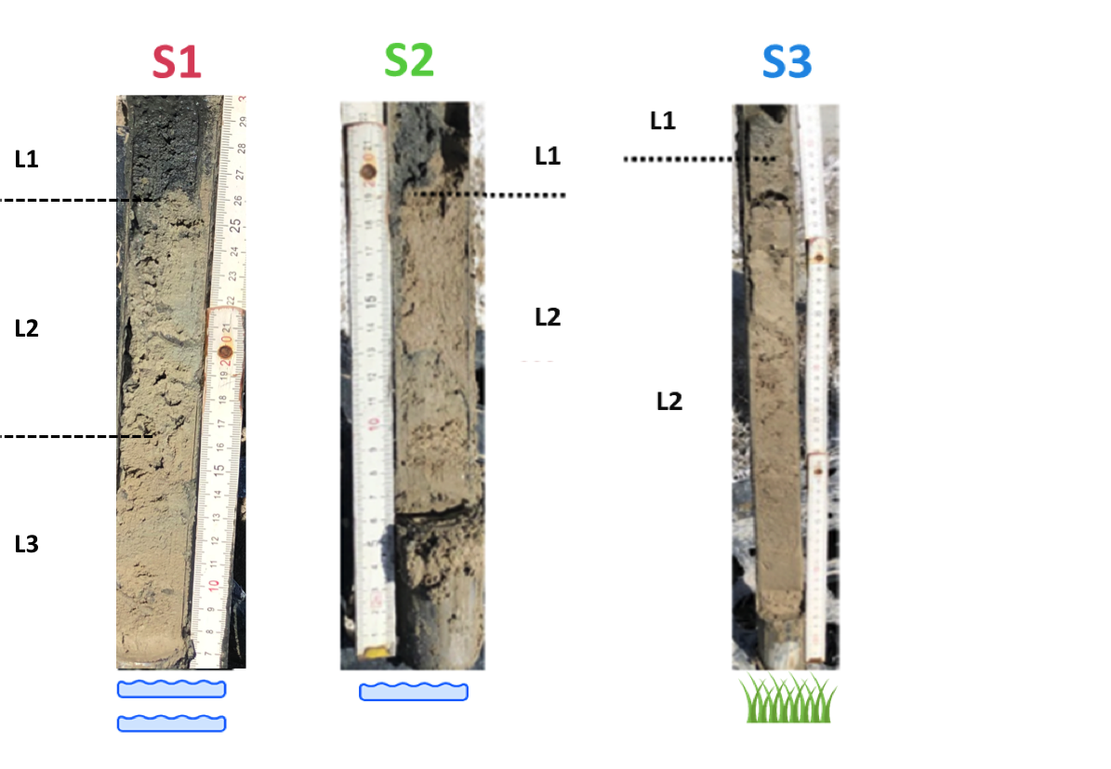

**Supplementary Figure S1.** Transect layers (cores) from S1, S2 and S3 stations corresponding respectively to usually submerged soil, intermittently flooded soil and soil covered with halophytes. The cores were sampled in winter showing the layers (L1, L2, L3 for S1; L1, L2 for S2 and S3).

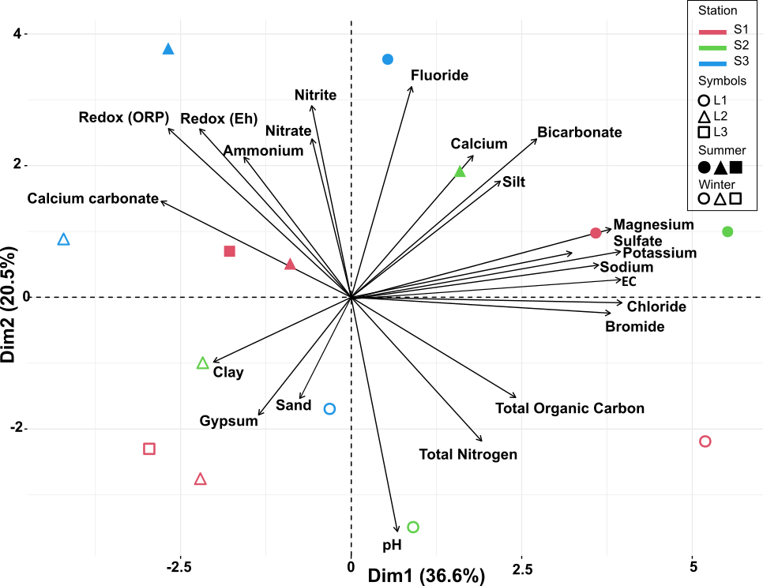

**Supplementary Figure S2.** Comparison of physical-chemical parameters. Non-metric multidimensional scale (NMDS) in the different layers (L1, L2, L3 or L1, L2) from each station (S1, S2, S3) at winter (wet period) and summer (dry period). The significant environmental variables are represented by vector.

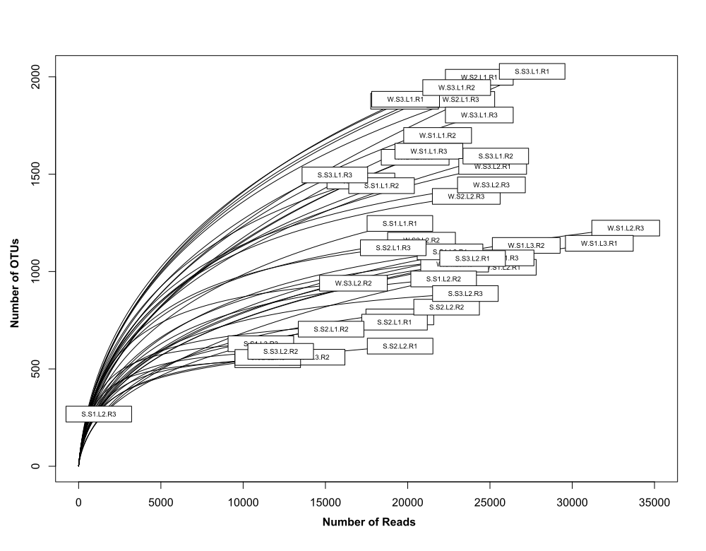

**Supplementary Figure S3.** Rarefaction curves based on 16S rRNA gene MiSeq Illumina sequencing.Winter, W (wet period); Summer, S (dry period); Stations: S1, S2, S3; Layers: L1, L2, L3; Replicate: R1, R2, R3.

**Supplementary Table S1.** Gaz flux production from the study site located at stations S1, S2, and S3 in Salineta wetland in winter (W, wet period) and summer (S, dry period). Mean ± SD are presented (n = 4). The same small letter indicates no significant difference of means compared by ANOVA, *p* < 0.05.

|  |  |  |  |  |  |  |
| --- | --- | --- | --- | --- | --- | --- |
| Gaz  Flux (mgm-2day-1) |  | |  | | Stations |  |
|  | **Seasons** | **S1** | | **S2** | | **S3** |
| CO2 | W | 30.21 ± 93.4b | | -13.73 ± 81.4b | | 425.63 ± 210.2a |
|  | S | 63.02 ± 82.5b | | 37.07 ± 54.8b | | 318.80 ± 129.6a |
| CH4 | W | 0 ± 0.15b | | 0.10 ± 0.2ab | | 0.73 ± 0.5a |
|  | S | -0.05 ± 0.13a | | -0.14 ± 0.04a | | -0.33 ± 0.2a |
| N2O | W | -0.094 ± 0.1a | | -0.019 ± 0.2a | | -0.125 ± 0.2a |
|  | S | 0.588 ± 0.35a | | 0.520 ± 0.5a | | -0.049 ± 0.17a |

**Supplementary Table S2.** Physical-chemical parameters in the different layers (L1, L2, L3 or L1, L2) from each station (S1, S2, S3) at winter (W, wet period) and summer (S, dry period) at Salineta wetland. Mean ± SD are presented (n = 3, except for S.S1.L2, n = 2). The same small letter indicates no significant difference of means compared by ANOVA, *p* < 0.05.

|  |  |  |  |  |  |  |  |  |
| --- | --- | --- | --- | --- | --- | --- | --- | --- |
| **Physical-chemical parameter** | | **Stations** | | | | | | |
|  | | **S1** | | | **S2** | | **S3** | |
| **Compounds** | | L1 | L2 | L3 | L1 | L2 | L1 | L2 |
| **Redox (ORP, mV)** | W  S | -334 ± 4g-130 ± 4.4f | -76 ± 4d-53 ± 1e | 65 ± 5c0d | -254 ± 14e-155 ± 20g | 191 ± 14.7a107 ± 9c | -291 ± 9f234 ± 7.2a | 137 ± 9b224 ± 10.5b |
| **Redox (Eh. mV)** | W  S | -134 ± 3g  70 ± 2e | 124 ± 1d  147 ± 1d | 265 ± 1.5c  0g | -54 ± 2e  45 ± 2f | 391 ± 1.5a  307 ± 3.4c | -91 ± 2f  434 ± 1.5a | 337 ± 2b  424 ± 3b |
| **pH** | W  S | 8.9 ± 0.06ab  8.6 ± 0.17a | 8.9 ± 0.01ab  8.22 ± 0.06abc | 8.7 ± 0.06bc  8.1 ± 0.11abc | 9.1 ± 0.14a  8.4 ± 0.15ab | 8.7 ± 024bc  8 ± 0.13bc | 8.8 ± 0.03bc  8.4 ± 0.14ab | 8.5 ± 0.02c  7.8 ± 0.30c |
| **EC (dS/m 1:5v)** | W  S | 35.8 ± 5.02a  50.3 ± 5.42a | 14.2 ± 2.40bc  21.03 ± 2.05c | 12.2 ± 1.41bc  17.3 ± 1.05b | 27.2 ± 14.65ab  55.5 ± 16.15a | 18.5 ± 1.07abc  27.7 ± 6.28b | 14.3 ± 3.12bc  25.1 ± 4.78b | 6.4 ± 1.47c  12.3 ± 1.4b |
| **Calcium carbonate equivalent (%)** | W  S | 14.9 ± 1.73c  7.3 ± 2.52d | 18.2 ± 0.45bc  15.5 ± 1.9bcd | 20.4 ± 0.97bc  17.3 ± 1.43bc | 13.4 ± 3.91c  9.8 ± 2.46cd | 17.9 ± 1.34bc  17.8 ± 1.63bc | 29.8 ± 7.31ab  23.9 ± 5.77b | 34.9 ± 6.45a  39.6 ± 4.47a |
| **Gypsum (%)** | W  S | 28.1 ± 1.04b  25.7 ± 3.97ab | 40.8 ± 2.55ab  43.55 ± 4.7a | 35.1 ± 0.39b  40.9 ± 4.84a | 50.9 ± 3.11a  25.1 ± 11.36ab | 50.7 ± 3.37a  37.5 ± 6.68ab | 27.9 ± 8.09b  36.7 ± 4.57ab | 33.3 ± 7.56b  20.2 ± 3.19b |
| **Total Organic Carbon (Dicromate) (%)** | W  S | 1.6 ± 0.02a  0.6 ± 0.01a | 0.5 ± 0.03c  0.54 ± 0.03a | 0.4 ± 0.004c  0.3 ± 0.02a | 0.9 ± 0.12b  0.5 ± 0.46a | 0.5 ± 0.07c  0.6 ± 0.09a | 1 ± 0.01b  0.7 ± 0.07a | 0.4 ± 0.04c  0.5 ± 0.06a |
| **Total Organic Carbon (LECO) (%)** | W  S | 2.7 ± 0.29a  1 ± 0.48a | 1 ± 0.18bc  1.2 ± 0.22a | 1.1 ± 0.25bc  1 ± 0.37a | 0.7 ± 0.34c  0.6 ± 0.12a | 0.7 ± 0.40c  1.1 ± 0.19a | 1.7 ± 0.42b  1.2 ± 0.18a | 0.3 ± 0.06c  1.2 ± 0.26a |
| **Total Nitrogen (%)** | W  S | 0.2 ± 0.02a  0.04 ± 0.01ab | 0.1 ± 0.001cd  0.03 ± 0.023ab | 0.1 ± 0.02cd  0.02 ± 0.01b | 0.1 ± 0.01bc  0.1 ± 0.02ab | 0.04 ± 0.01cd  0.05 ± 0.01ab | 0.1 ± 0.01b  0.1 ± 0.01a | 0.04 ± 0.01d  0.04 ± 0.002ab |
| **Clay (%)** | W  S | 36.3 ± 0.96cd  34.5 ± 10.15ab | 48.9 ± 0.32a  31.35 ± 8.56ab | 46.9 ± 1.93ab  48.5 ± 8.84a | 28.1 ± 5.92d  30.1 ± 3.02ab | 39.3 ± 2.84bc  35.9 ± 4.71ab | 29.2 ± 3.29d  19.4 ± 5.94b | 35.6 ± 0.10cd  42.6 ± 2.62ab |
| **Silt (%)** | W  S | 51.4 ± 1.06a  38.6 ± 6.54bc | 24 ± 6.13c  22.84 ± 3.54cd | 20.8 ± 1.09c  21.8 ± 3.65d | 24.4 ± 8.69c  42.4 ± 6.09ab | 28.2 ± 2.25c  42 ± 9.58ab | 49.8 ± 1.64ab  56 ± 3.19a | 36 ± 7.45bc  39.5 ± 2.23b |
| **Sand (%)** | W  S | 12.3 ± 0.10b  26.9 ± 11.66a | 27.1 ± 5.81ab  45.8 ± 5.01a | 32.3 ± 3.02ab  29.6 ± 12.47a | 47.5 ± 14.61a  27.4 ± 8.17a | 32.6 ± 2.95ab  22 ± 4.92a | 21 ± 1.65b  24.6 ± 3.31a | 28.4 ± 7.54ab  17.8 ± 0.42a |
| **Fluoride (mg/L)** | W  S | 0.009 ± 0.02a  0.2 ± 0.03a | 0.035 ± 0.01a  0.11± 0.004a | 0.023 ± 0.004a  0.1 ± 0.06a | 0.038 ± 0a  0.1 ± 0.03a | 0.029 ± 0.01a  0.1 ± 0.02a | 0.009 ± 0.02a  0.1 ± 0.01a | 0.07 ± 0.08a  0.1 ± 0.01a |
| **Chloride (mg/L)** | W  S | 8185.3 ± 103.25a  5831.3 ± 405.7abc | 3003.8 ± 1114.4bc  4684.4 ± 535.07abc | 2614.4 ± 69.79bc  3454 ± 239.79bc | 5834.7 ± 3267.95ab  8085.4 ± 2581.97a | 4156.8 ± 164.3bc  6592.3 ± 1096.4ab | 2806.8 ± 536.75bc  4899.4 ± 636.57abc | 869.1 ± 308.69c  2672.7 ± 447.64c |
| **Bromide (mg/L)** | W  S | 6.9 ± 0.13a  4.4 ± 0.31abc | 2.6 ± 1.03bc  4.1 ± 0.5abc | 2.2 ± 0.005bc  2.9 ± 0.31c | 5.1 ± 2.9ab  6.3 ± 1.39a | 3.6 ± 0.22abc  5.9 ± 1.16ab | 2.4 ± 0.39bc  3.8 ± 0.19bc | 0.7 ± 0.22c  2.4 ± 0.44c |
| **Nitrite (mg/L)** | W  S | 0a  0a | 0a  0a | 0a  0a | 0a  0a | 0a  0a | 0a  0.8 ± 0.42a | 0.009 ± 0.02a  0.7 ± 1.15a |
| **Nitrate (mg/L)** | W  S | 0a  0.2 ± 0.42b | 0.8 ± 0.24a  0.44 ± 0.17b | 0.1 ± 0.02a  0.5 ± 0.43b | 0.1 ± 0.06a  0b | 0.6 ± 0.55a  0.1 ± 0.21b | 0a  6.6 ± 1.68a | 1 ± 1.05a  1.8 ± 0.67b |
| **Sulfate (mg/L)** | W  S | 9826.5 ± 2119.24a  33703.2 ± 5124.2a | 5291.3 ± 545.35a  6580.4 ± 149.6b | 3790.4 ± 825.1a  5418.5 ± 32.57b | 10194.4 ± 6124.4a  33855.7 ± 13911a | 5160.9 ± 704.52a  7871.5 ± 2283.4b | 4053.5 ± 1612.72a  9979.5 ± 2302.1b | 2720 ± 87.57a  3633 ± 86.65b |
| **Bicarbonate (mg/L)** | W  S | 223.7 ± 88.07a  223.7 ± 127.02a | 81.4 ± 35.23a  213.6 ± 43.15a | 122 ± 0a  223.7 ± 35.23a | 132.2 ± 35.23a  325.4 ± 35.23a | 91.5 ± 0a  244.1 ± 183.06a | 142.4 ± 88.07a  183.1 ± 105.7a | 122 ± 52.84a  244.1 ± 105.7a |
| **Sodium (mg/L)** | W  S | 8015.2 ± 1756.94a  17201.5 ± 3233ab | 3506.4 ± 753.67abc  4273.6 ± 446.4c | 2532.8 ± 294.64bc  3618.2 ± 467.44c | 6383.8 ± 3802.7ab  19614 ± 7570.03a | 3309.8 ± 176.63abc  6835.5 ± 3074.36bc | 2397.2 ± 598.95bc  5740.8 ± 2250.5c | 827 ± 246.67c  2019.8 ± 365.04c |
| **Ammonium (mg/L)** | W  S | 0a  0b | 0a  2.38 ± 0.03ab | 0a  2.9 ± 0.12a | 0a  0b | 0.2 ± 0.4a  0.5 ± 0.86b | 0.5 ± 0.44a  1.4 ± 1.38ab | 1 ± 0.97a  1.4 ± 0.46ab |
| **Potassium (mg/L)** | W  S | 314 ± 25.16a  241 ± 14.55ab | 124.9 ± 44.45b  193.5 ± 18.5ab | 101.7 ± 3.37b  158.8 ± 18.63ab | 194.1 ± 100.14ab  296 ± 67.92a | 137.9 ± 15.69b  296.2 ± 88.63a | 137.5 ± 17.91b  231.7 ± 59.75ab | 69.1 ± 0.8b  135.5 ± 22.86b |
| **Calcium (mg/L)** | W  S | 800.9 ± 8.44a  698.5 ± 13.9a | 428 ± 181.43bc  728 ± 5.5a | 306 ± 55.91c  764.5 ± 53.7a | 612.4 ± 168.55abc  711.1 ± 2.95a | 739.9 ± 86.1ab  864.7 ± 118.32a | 732.2 ± 100.73ab  727.7 ± 96.27a | 660 ± 45.72ab  727.6 ± 55.96a |
| **Magnesium (mg/L)** | W  S | 1651.5 ± 242.21a  1680.1 ± 149.22ab | 493.3 ± 180.06bc  856.3 ± 119ab | 455.7 ± 2.29bc  813.4 ± 123.15b | 1106.7 ± 620.53ab  2337.9 ± 777.51a | 820.4 ± 102.06abc  1452.1 ± 468.49ab | 591.1 ± 204bc  1756.6 ± 639.81ab | 178.4 ± 44.97462.2 462.2 ± 81.80b |