Supplementary Data
Supplemental Table S1 Relative cardiovascular risk in different metabolic status
Metabolic Phenotype | HR (95%CI)
 | Unadjusted | Full Adjusted
MHN | Ref | Ref
MHO | 1.115(0.760-1.634) | 1.163(0.784-1.723)
MUN | *1.496(1.092-2.050) | *1.414(1.024-1.953)
MUO | *1.634(1.220-2.190) | *1.747(1.295-2.363)
* for p<0.05
Model adjusted for age, sex, body mass index, smoking, family history of coronary artery disease. Gensini score, left ventricular ejection fraction, creatinine, low density lipoprotein cholesterol, and previous use of statin.

Supplementary Data
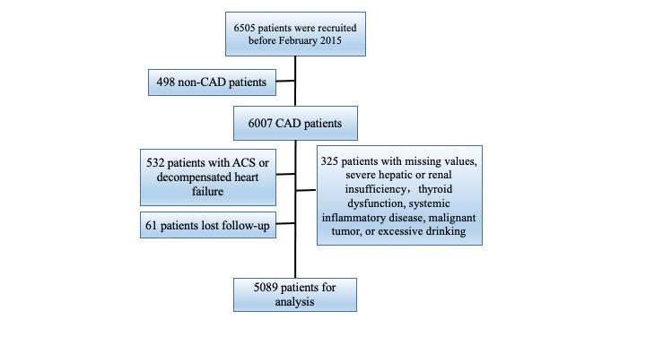
Supplemental Figure S1 Flowchart of the study

