Supporting Information
Recent Advances in Antimony Sulfide-Based Nanomaterials for High-Performance Sodium-Ion Batteries: A Review
Guangxin Wang ^{a, 1}, Mingyi Guo ^{a, 1,} *, Yunchao Zhao ^{a, b}, Yibo Zhao ª, Kun Tang ª, Zhijun Chen ^{c}, Heinz-Rolf Stock ª, Yong Liu ^{a, b,} *
ª Research Center for High Purity Materials, Henan University of Science and Technology, School of Materials Science and Engineering, Henan University of Science and Technology, Luoyang 471023, P. R. China
^{b} National Joint Engineering Research Center for Abrasion Control and Molding of Metal Materials, Henan Key Laboratory of High-Temperature Structural and Functional Materials, Henan University of Science and Technology, Luoyang 471003, P. R. China
^{c} Luoyang Bearing Research Institute Co. , Ltd. Luoyang 471039, P. R. China

* Corresponding authors and E-mail address:
Mingyi Guo, gmy19910513@163.com;
Prof. Yong Liu, liuyong209@haust.edu.cn;
¹ Mingyi Guo and Guangxin Wang contributed equally to this work.

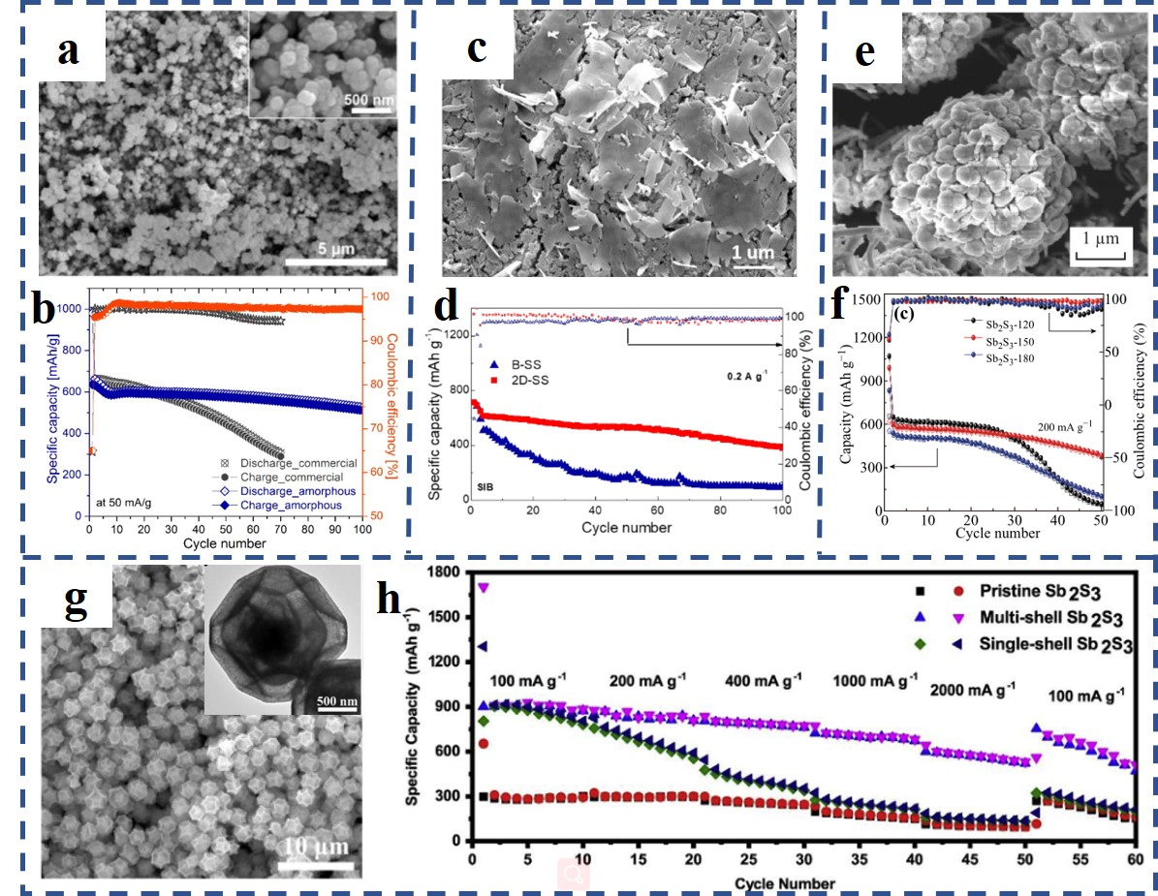
Fig S1. (a) SEM image of α-Sb₂S₃ nanoparticles; (b) Cycle performance of α-Sb₂S₃ at 0.05 A g⁻¹; (c) SEM image of the few-layer 2D-Sb₂S₃ nanosheets; (d) Cyclic capacity of 2D-SS measured at 0.2 A g⁻¹;(e) SEM image of Sb₂S₃ hollow microspheres; (f) Cycling performances of three experimental Sb₂S₃ electrodes at 1A g⁻¹; (g) SEM and TEM images of multi-shell Sb₂S₃; (h) Comparison of the rate performance of multi-shell Sb₂S₃, single-shell Sb₂S₃ and pristine Sb₂S₃. (a,b) are adapted with permission from Ref. (Hwang et al., 2016). Copyright 2013, The Royal Society of Chemistry. (c,d) are adapted with permission from Ref. (Yao et al., 2019). Copyright 2018, Elsevier. (e,f) are adapted with permission from Ref. (Xie et al., 2018). Copyright 2018, Springer. (g,h) are adapted with permission from Ref. (Xie et al., 2019). Copyright 2019, Elsevier.

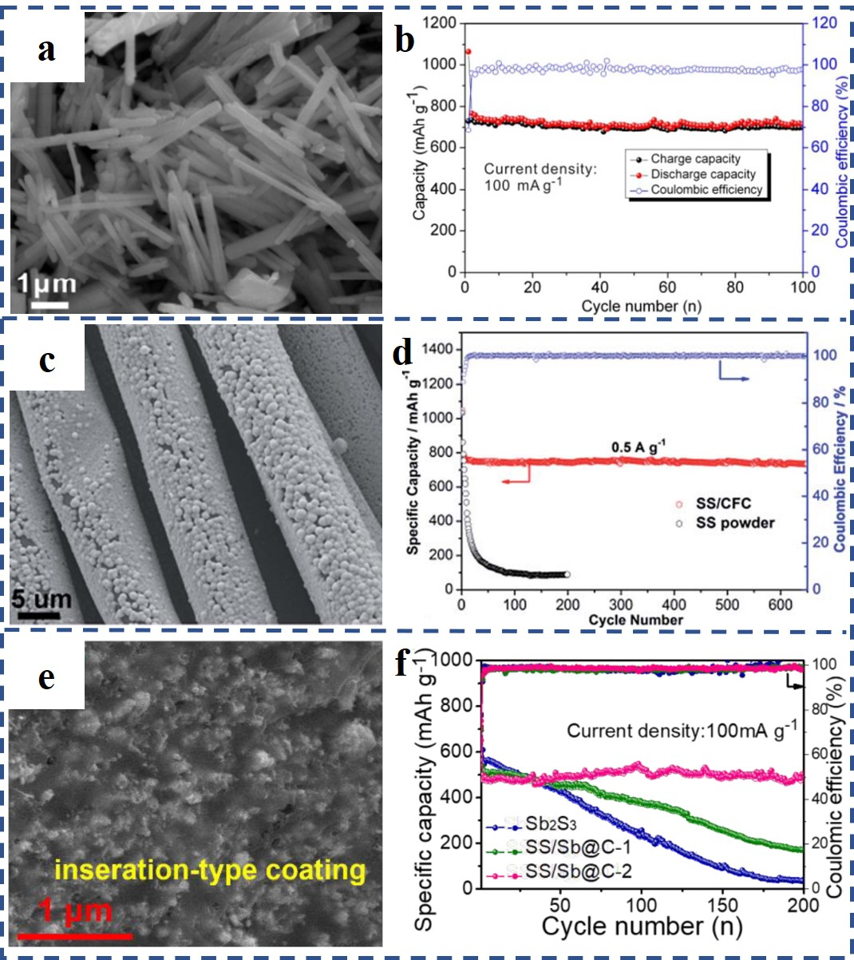
Fig S2. (a) SEM image of Sb₂S₃@C rods; (b) Cycle performance of Sb₂S₃@C rods at 0.1 A g⁻¹; (c) SEM image of SS/CFC; (d) Cycle performances of SS/CFC and SS powder at 0.5 A g⁻¹; (e) SEM image of SS/Sb@C nanocomposites; (f) Cycling performances of SS/Sb@C and Sb₂S₃ nanocomposites at 0.1 A g⁻¹. (a,b) are adapted with permission from Ref. (Hongshuai Hou, 2015). Copyright 2015, American Chemical Society. (c,d) are adapted with permission from Ref. (Liu et al., 2017). Copyright 2017, The Royal Society of Chemistry. (e,f) are adapted with permission from Ref. (Zhao et al., 2020). Copyright 2020, The Royal Society of Chemistry.
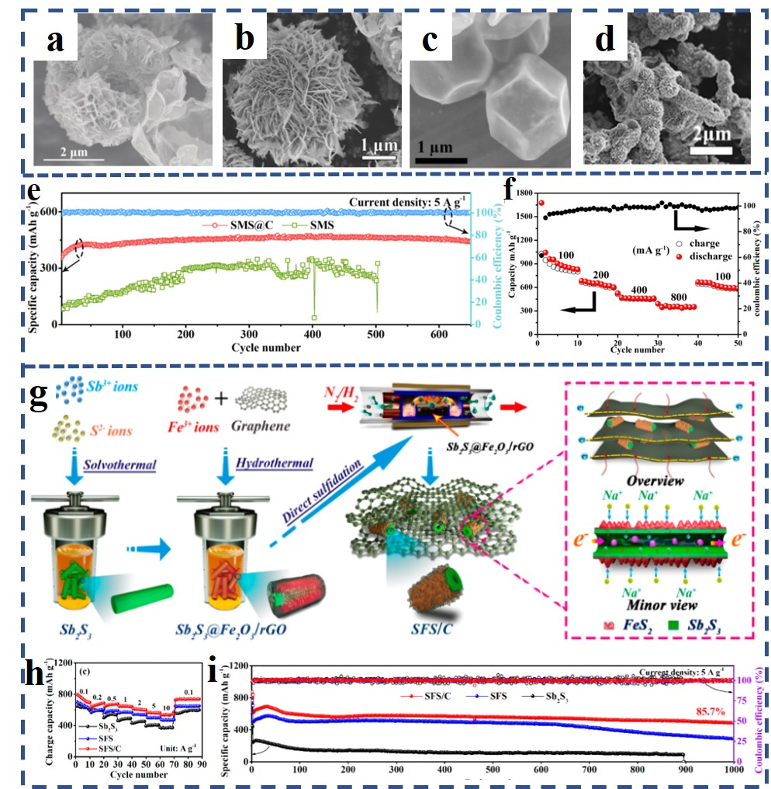
Fig S3. SEM images: (a) In₂S₃-Sb₂S₃@MCNTs microsphere, (b) Sb₂S₃/MoS₂@C composite (SMS@C), (c) ZnS-Sb₂S₃@C polyhedron and (d) Sb₂S₃@FeS₂/N-graphene composite (SFS/C ); (e) Sodium storage properties of the SMS@C and SMS heterostructure at 5 A g⁻¹; (f) Rate capability of ZnS-Sb₂S₃@C core-shell SIBs anode; (g) Schematic illustration of the fabrication process of the SFS/C composite; (h) Charge capability of the SFS/C anode at various rates; (i) Cycle performances of Sb₂S₃, SFS, and SFS/C composites at a high rate of 5 A g⁻¹. (a) is adapted with permission from Ref. (Huang et al., 2018). Copyright 2018, Wiley-VCH . (b, e) are adapted with permission from Ref. (Wang et al., 2021). Copyright 2021, Elsevier. (c, f) are adapted with permission from Ref. (Shihua Dong, 2017). Copyright 2017, American Chemical Society. (d, g-i) are adapted with permission from Ref. (Cao et al., 2020). Copyright 2020, American Chemical Society.
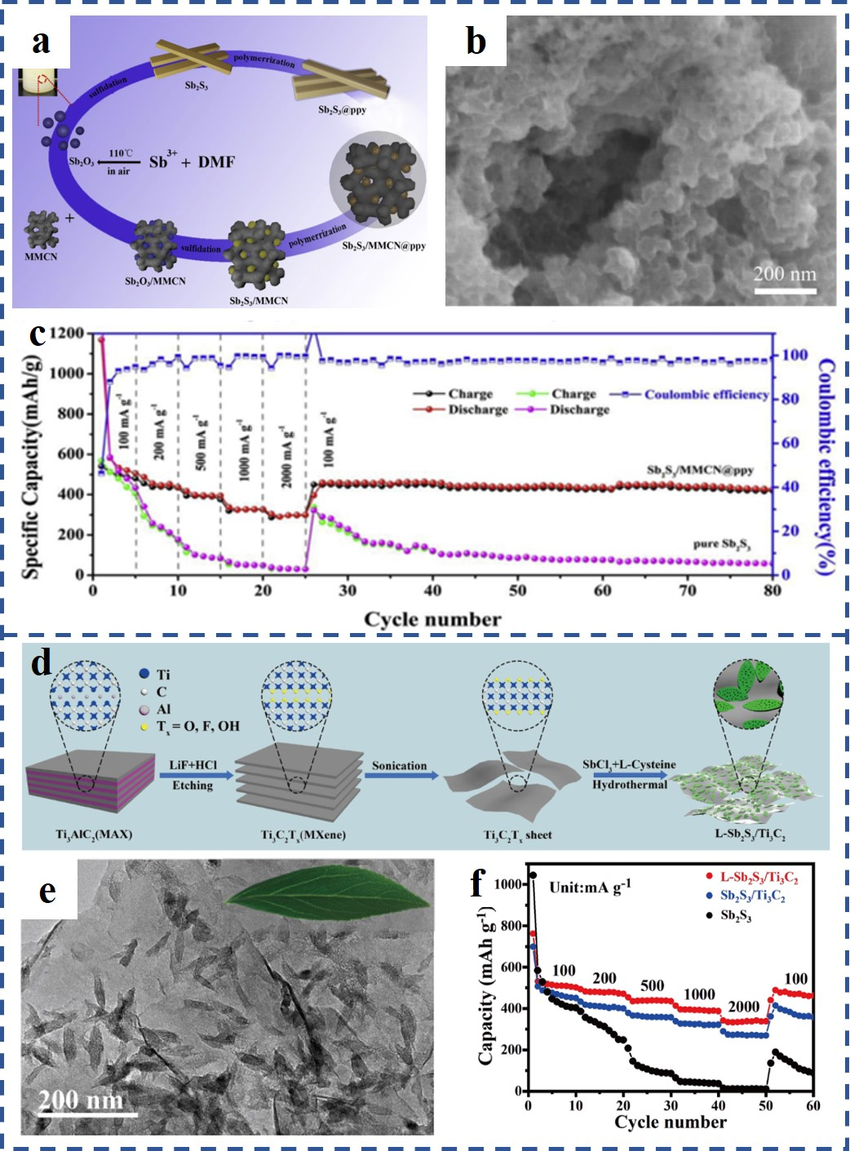
Fig S4. (a) Schematic diagram of the formation process of the Sb₂S₃/MMCN@PPy composite; (b) SEM image of Sb₂S₃/MMCN@PPy composite; (c) Rate capability performances of pure Sb₂S₃ and Sb₂S₃/MMCN@PPy composite; (d) Schematic illustration of the synthetic process of L-Sb₂S₃/Ti₃C₂ composite; (e) SEM image of L-Sb₂S₃/Ti₃C₂ composite; (f) Rate capability performances of Sb₂S₃, Sb₂S₃/Ti₃C₂, and L-Sb₂S₃/Ti₃C₂. (a-c) are adapted with permission from Ref. (Yin et al., 2019). Copyright 2019, Elsevier. (d-f) are adapted with permission from Ref. (He et al., 2021). Copyright 2021, Science China Press and Springer-Verlag GmbH Germany, part of Springer Nature.

References
Cao, L., Gao, X., Zhang, B., Ou, X., Zhang, J., and Luo, W.B. (2020). Bimetallic Sulfide Sb2S3@FeS2 Hollow Nanorods as High-Performance Anode Materials for Sodium-Ion Batteries. ACS Nano 14(3), 3610-3620. doi: 10.1021/acsnano.0c00020.
He, F., Tang, C., Zhu, G., Liu, Y., Du, A., Zhang, Q., et al. (2021). Leaf-inspired design of mesoporous Sb2S3/N-doped Ti3C2Tx composite towards fast sodium storage. Science China Chemistry 64(6), 964-973. doi: 10.1007/s11426-020-9942-9.
Hongshuai Hou, M.J., Zhaodong Huang, Yingchang Yang, Yan Zhang, Jun Chen, Zhibin Wu, and Xiaobo Ji (2015). One-Dimensional Rod-Like Sb2S3-Based Anode for High-Performance Sodium-Ion Batteries. ACS APPLIED MATERIALS & INTERFACES 7(34), 19362-19369.
Huang, Y., Wang, Z., Jiang, Y., Li, S., Wang, M., Ye, Y., et al. (2018). Conductivity and Pseudocapacitance Optimization of Bimetallic Antimony-Indium Sulfide Anodes for Sodium-Ion Batteries with Favorable Kinetics. Adv Sci (Weinh) 5(10), 1-12. doi: 10.1002/advs.201800613.
Hwang, S.M., Kim, J., Kim, Y., and Kim, Y. (2016). Na-ion storage performance of amorphous Sb2S3nanoparticles: anode for Na-ion batteries and seawater flow batteries. J. Mater. Chem. A 4(46), 17946-17951. doi: 10.1039/c6ta07838a.
Liu, S., Cai, Z., Zhou, J., Zhu, M., Pan, A., and Liang, S. (2017). High-performance sodium-ion batteries and flexible sodium-ion capacitors based on Sb2X3(X = O, S)/carbon fiber cloth. Journal of Materials Chemistry A 5(19), 9169-9176. doi: 10.1039/c7ta01895a.
Shihua Dong, C.L., Xiaoli Ge, Zhaoqiang Li, Xianguang Miao, and Longwei Yin (2017). ZnS-Sb2S3@C Core-Double Shell Polyhedron Structure Derived from Metal-Organic Framework as Anodes for High Performance Sodium Ion Batteries. Acs Nano 11(6), 6474-6482.
Wang, D., Cao, L., Luo, D., Gao, R., Li, H., Wang, D., et al. (2021). Chain mail heterostructured hydrangea-like binary metal sulfides for high efficiency sodium ion battery. Nano Energy 87, 1-10. doi: 10.1016/j.nanoen.2021.106185.
Xie, F., Zhang, L., Gu, Q., Chao, D., Jaroniec, M., and Qiao, S.-Z. (2019). Multi-shell hollow structured Sb2S3 for sodium-ion batteries with enhanced energy density. Nano Energy 60, 591-599. doi: 10.1016/j.nanoen.2019.04.008.
Xie, J., Liu, L., Xia, J., Zhang, Y., Li, M., Ouyang, Y., et al. (2018). Template-Free Synthesis of Sb2S3 Hollow Microspheres as Anode Materials for Lithium-Ion and Sodium-Ion Batteries. Nanomicro Lett 10(1), 1-12. doi: 10.1007/s40820-017-0165-1.
Yao, S., Cui, J., Deng, Y., Chong, W.G., Wu, J., Ihsan-Ul-Haq, M., et al. (2019). Ultrathin Sb2S3 nanosheet anodes for exceptional pseudocapacitive contribution to multi-battery charge storage. Energy Storage Materials 20, 36-45. doi: 10.1016/j.ensm.2018.11.005.
Yin, W., Chai, W., Wang, K., Ye, W., Rui, Y., and Tang, B. (2019). A highly Meso@Microporous carbon-supported Antimony sulfide nanoparticles coated by conductive polymer for high-performance lithium and sodium ion batteries. Electrochimica Acta 321, 1-12. doi: 10.1016/j.electacta.2019.134699.
Zhao, W., Zhang, L., Jiang, F., Chang, X., Yang, Y., Ge, P., et al. (2020). Engineering metal sulfides with hierarchical interfaces for advanced sodium-ion storage systems. Journal of Materials Chemistry A 8(10), 5284-5297. doi: 10.1039/c9ta13899d.

