A

B

**Figure S1:** Frequency plots of copy number aberration (amplifications in red and deletions in blue), **(A)** in lung adenocarcinomas, **(B)** in tumors stratified on LOH status at the *KRAS* locus.

**Figure S2:** *KRAS* gene mutations in lung adenocarcinoma samples from the Oslo cohort and Uppsala cohort

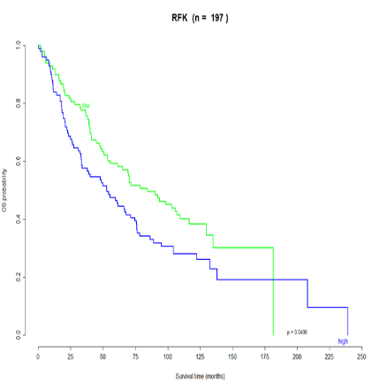

**Figure S3:** Kaplan-Meier survival curve for OS in lung adenocarcinoma for expression of *CDC14A, GABARAPL1* and *RFK*