

***Supplementary Material***

Rice management decisions using process-based models with climate- smart indicators

# Laura, N. Arenas-Calle1*, Alexandre B. Heinemann2, Mellissa A. Soler da Silva,2, Alberto Baeta dos Santos2Julian Ramirez-Villegas3,4,5, Stephen Whitfield1, Andrew, J. Challinor1

1 School of Earth and Environment, University of Leeds, Leeds LS2 9JT, The United Kingdom

2 The Brazilian Agricultural Research Corporation (EMBRAPA) Arroz e Feijão, GO-462 Road, km 12, Santo Antônio de Goiás, GO 75375-000, Brazil

3 Alliance of Biodiversity International and CIAT, Via di San Domenico, 1, 00153 Roma, Italia

4CGIAR Research Program on Climate Change, Agriculture and Food Security (CCAFS), c/o CIAT, Cali, Colombia

5Plant Production Systems Group, Wageningen University, Wageningen, The Netherlands

# * Correspondence:

[eelnac@leeds.ac.uk](mailto:eelnac@leeds.ac.uk) [lnarenasc@gmail.com](mailto:lnarenasc@gmail.com)

Leaf Area Index (LAI) and Rice Yields Although DNDC.v9.5 does not simulate the phenological stages of crops, we compared the observed Leaf Area Index (LAI) with the model outcomes for this parameter, showing a strong correlation between simulated and observed LAI data (R2=0.94). The plant emergence dates coincided in both, observed and simulated data, and coincide with the start of the senescence stage that in DNDC was interpreted by the stabilization of LAI which showed agreement with the period of senescence in the observed data.

Supplementary Material

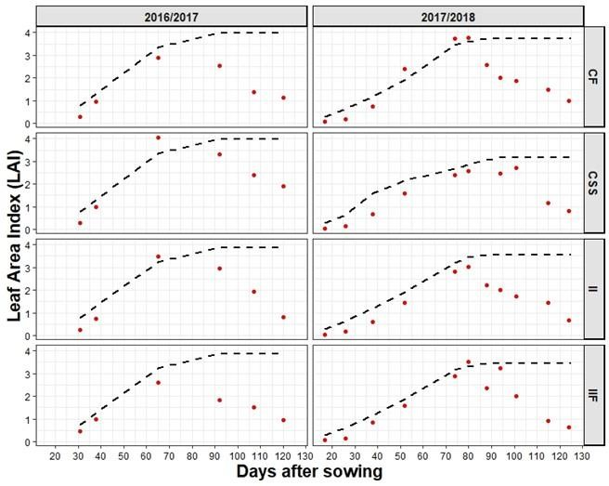

**Figure 1**. Observed (dashed line) and simulated (red dots) Leaf Area Index (LAI) for the Continuous flooding (CF), Intermittent Irrigation (II), Intermittent irrigation until flowering(IIF) and Continuous soil saturation (CSS) irrigation treatments (horizontal panels) during2016-2017 and 2017-2018 cropping seasons (vertical panels)

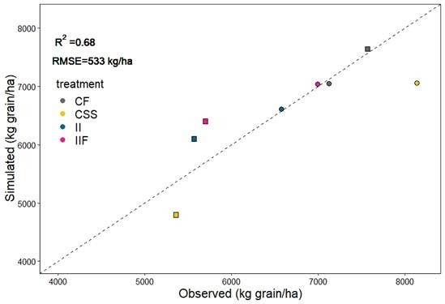

**Figure 2.** Regression of Observed and simulated values of rice yield for Continuous flooding (CF), Intermittent Irrigation (II), Intermittent irrigation until flowering (IIF) and Continuous soil saturation (CSS) irrigation treatments. Circles represent data from 2016-2017 season and square from 2017- 2018. Dashed line represents 1:1 relation of observed vs simulated data.

# Daily fluxes (CH4 and N2O):

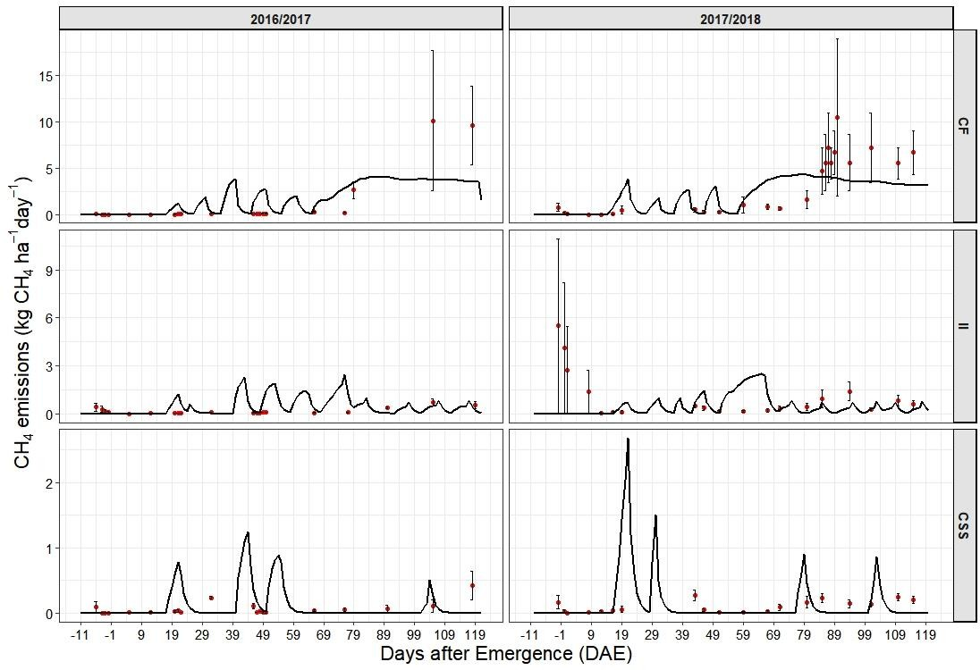

**Figure 3.** Observed (red dots) and simulated (black solid line) daily fluxes of methane(CH4) of Continuous flooding (CF), Intermittent Irrigation (II), and Continuous soil saturation(CSS) irrigation treatments (vertical panels) during 2016/2017 and 2017/2018 cropping seasons(vertical panels)

Supplementary Material

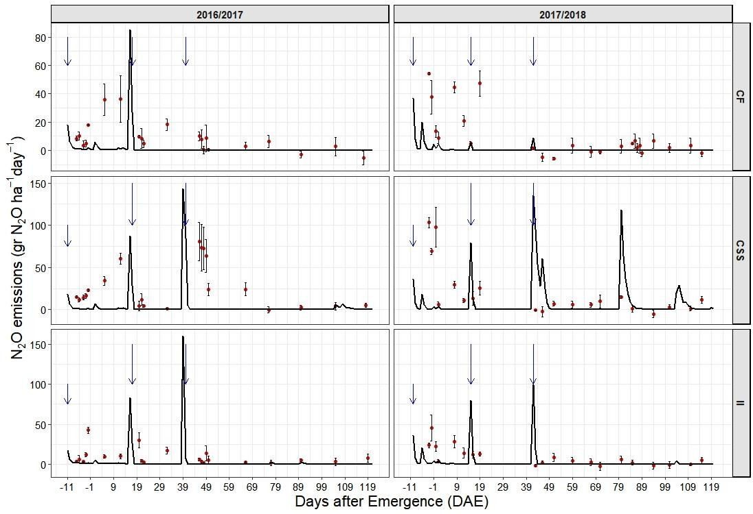

**Figure 4.** Observed (red dots) and simulated (black solid line) daily fluxes of methane(N2O) of Continuous flooding (CF), Intermittent Irrigation (II), and Continuous soil saturation (CSS) irrigation treatments (vertical panels) during 2016/2017 and 2017/2018 cropping seasons (vertical panels. Black vertical arrows indicate the fertilization dates.

**Climate data from the five cropping seasons simulated:**

**Figure 5.** daily precipitation (blue bars), global solar radiation (black solid line), maximum temperature (red dashed line) and minimum temperature (blue dashed line) during the cropping seasons 2014 to 2019. Vertical solid line indicates flowering stage