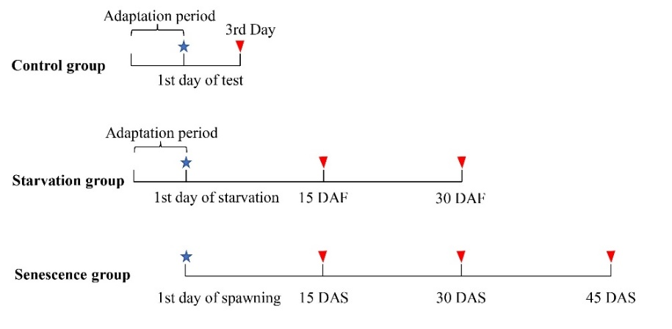

Figure S1. The schematic diagram of the experimental flow. The adaptation period included one day of fasting and three days of feeding. The stars indicate the start of each treatment. The triangles indicate the sampling time points. DAF: days after fasting. DAS: days after spawning.

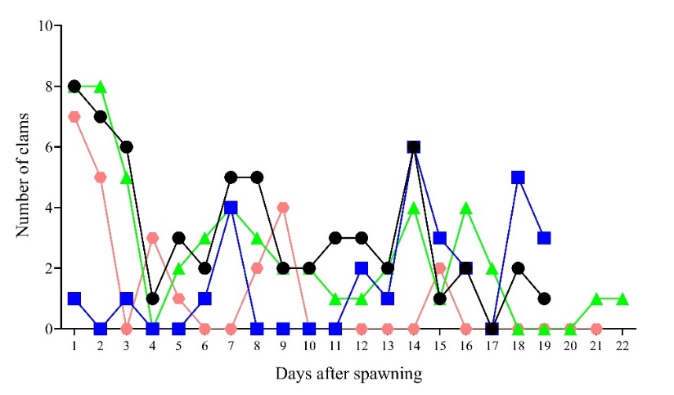

Figure S2. The feeding amount of *O.sinensis* during senescence. Different colors and shapes represent different individuals.



Figure S3. The comparison of feeding amount of *O.sinensis* during senescence. The capital letters represent different senescent individuals. Data are presented as the mean ± SD (nA = 19, nB = 19, nC = 22, nD = 21). Individuals with different lowercase letters are significantly different from each other (p <0.05; Kruskal-Wallis test followed by Dunnett’s T3 test).

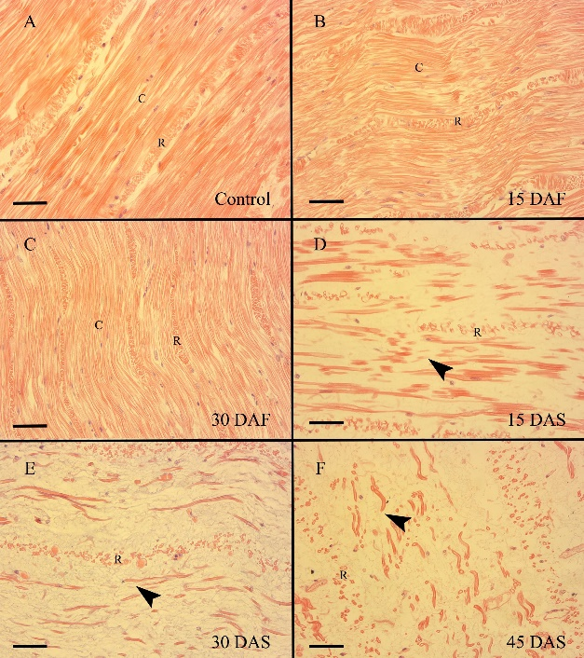

Figure S4. Longitudinal sections of *O.sinensis* mantle muscle. Black arrow heads indicate the broken circular muscle fibers. C: circular muscle fiber. DAF: days after fasting. DAS: days after spawning. R: radial muscle fiber. Scale bar:50 μm.

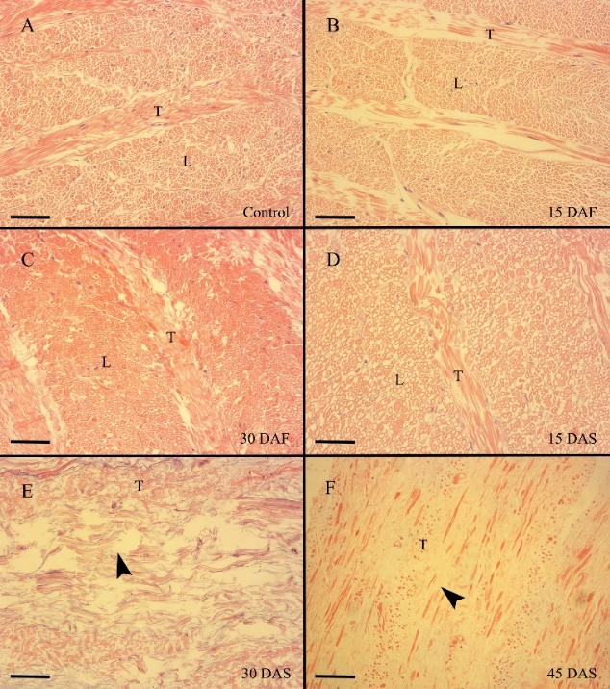

Figure S5. Histology of *O.sinensis* arm muscle. A, B, C, D: transverse section view. E, F: longitudinal section view. Black arrow heads indicate the broken longitudinal muscle fibers. DAF: days after fasting. DAS: days after spawning. L: longitudinal muscle fiber. T: trabeculae. Scale bar:50 μm

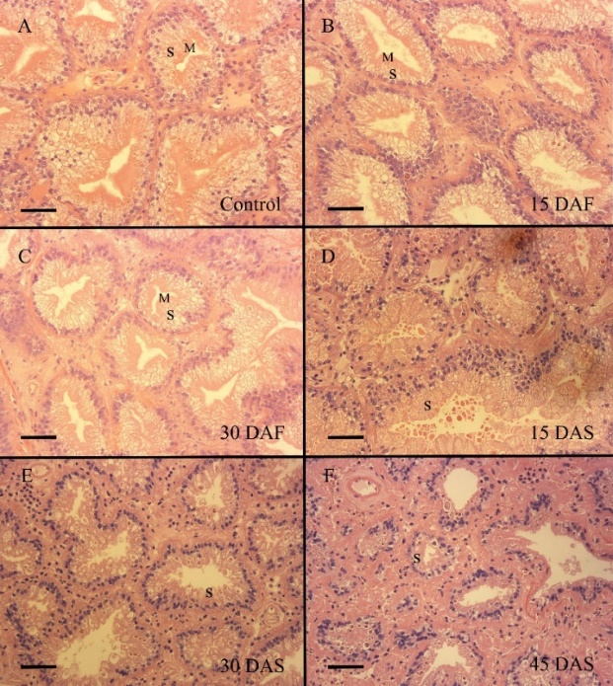

Figure S6. Histology of *O.sinensis* digestive gland. DAF: days after fasting. DAS: days after spawning. M: microvilli. S: secretory cell. Scale bar:50 μm



Figure S7. The digestive gland index of *O.sinensis*. Data are presented as the mean ± SD (n = 3). Groups with different letters are significantly different from each other (p <0.05; Kruskal-Wallis test followed by Dunnett’s T3 test) DAF: days after fasting. DAS: days after spawning.

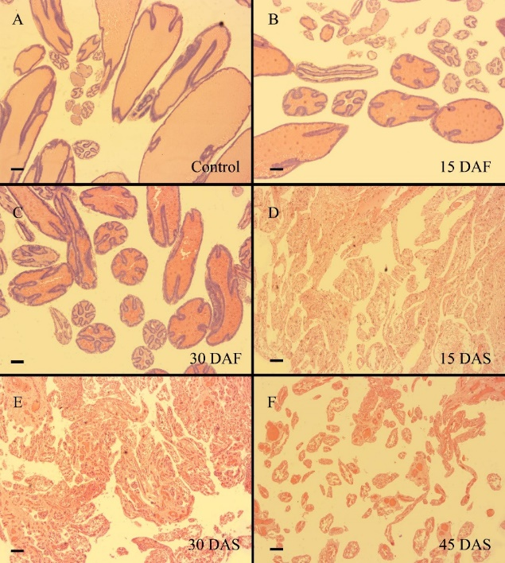

Figure S8. Histology of *O.sinensis* ovary. DAF: days after fasting. DAS: days after spawning. Scale bar:100 μm



Figure S9. The gonadosomatic index of *O.sinensis*. Data are presented as the mean ± SD (n = 3). Groups with different letters are significantly different from each other (p <0.05; Kruskal-Wallis test followed by Dunnett’s T3 test). DAF: days after fasting. DAS: days after spawning.