**Spatiotemporal Variability of Microplastics in the Eastern Baltic Sea**

Arun Mishra1*, Natalja Buhhalko1,Kati Lind1, Inga Lips2, Taavi Liblik1, Germo Väli1, Urmas Lips1

1Department of Marine Systems, Tallinn University of Technology, Akadeemia tee 15a 12618, Tallinn, Estonia

2 European Global Ocean Observing System, Euro GOOS AISBL, Rue Vautier 29, 1000 Brussels, Belgium

\***Correspondence:**

Arun Mishra, [arun.mishra@taltech.ee](mailto:arun.mishra@taltech.ee)

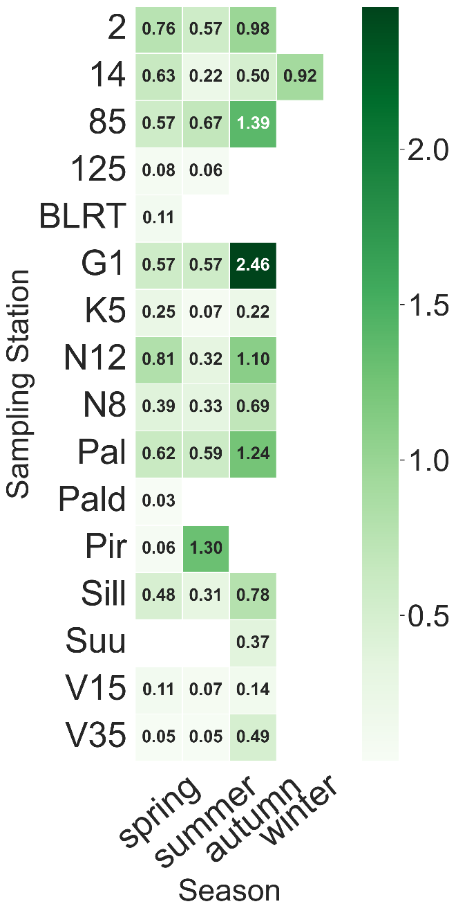  
Supplementary Figure 1 - Seasonal variation of mean MP concentration. Samples are categorized into 4 seasons: spring (April-June), summer (July-August), autumn (September-November), winter (December-February). The concentration values are in counts/m3.

Supplementary Table 1. MP sampling sites for each year along with observation period

|  |  |  |
| --- | --- | --- |
| Year 2016 | | |
| Station Name | Number of Samplings | Observation period |
| 85 | 4 | 23-04-2016,31-05-2016,25-08-2016,25-10-2016 |
| 2 | 4 | 21-04-2016,30-05-2016,26-08-2016,24-10-2016 |
| 14 | 4 | 22-04-2016,02-06-2016,28-08-2016,30-10-2016 |
| G1 | 3 | 01-06-2016,23-08-2016,26-10-2016 |
| N12 | 4 | 22-04-2016,02-06-2016,28-08-2016,31-10-2016 |
| N8 | 4 | 22-04-2016,03-06-2016,28-08-2016,31-10-2016 |
| Paljassaare | 4 | 25-04-2016,30-05-2016,22-08-2016,24-10-2016 |
| Sillamäe | 4 | 22-04-2016,03-06-2016,28-08-2016,31-10-2016 |
| Year 2017 | | |
| Station Name |  |  |
| 2 | 3 | 31-05-2017,31-05-2017,31-05-2017 |
| 14 | 3 | 29-05-2017,29-05-2017,29-05-2017 |
| 85 | 3 | 01-06-2017,01-06-2017,01-06-2017 |
| K5 | 3 | 02-06-2017,02-06-2017,02-06-2017 |
| N8 | 3 | 30-05-2017,30-05-2017,30-05-2017 |
| Paljassaare | 3 | 31-05-2017,31-05-2017,31-05-2017 |
| Sillamäe | 3 | 30-05-2017,30-05-2017,30-05-2017 |
| Year 2018 | | |
| 2 | 1 | 09-04-2018 |
| 14 | 4 | 11-01-2018,11-01-2018,01-06-2018,23-10-2018 |
| 85 | 2 | 17-04-2018,26-08-2018 |
| 125 | 1 | 31-05-2018 |
| BLRT | 1 | 28-05-2018 |
| K5 | 3 | 18-04-2018,31-05-2018,27-10-2018 |
| N8 | 3 | 20-04-2018,02-06-2018,28-09-2018 |
| Paljassaare | 2 | 28-05-2018,24-09-2018 |
| Pirita | 2 | 28-05-2018,24-09-2018 |
| Sillamäe | 2 | 02-06-2018,28-09-2018 |
| Suurupi | 1 | 07-11-2018 |
| V15 | 2 | 31-05-2018,28-10-2018 |
| V35 | 2 | 31-05-2018,27-10-2018 |
| Year 2019 | | |
| 2 | 2 | 15-04-2019,19-06-2019 |
| 14 | 2 | 01-06-2019,20-09-2019 |
| 85 | 2 | 18-04-2019,29-05-2019 |
| 125 | 2 | 28-05-2019,20-09-2019 |
| K5 | 3 | 19-04-2019,28-05-2019,19-09-2019 |
| N8 | 3 | 16-04-2019,01-06-2019,21-09-2019 |
| Paldiski | 1 | 17-04-2019 |
| Paljassaare | 2 | 15-04-2019,26-06-2019 |
| Sillamäe | 3 | 16-04-2019,31-05-2019,21-09-2019 |
| V15 | 2 | 28-05-2019,20-09-2019 |
| V35 | 2 | 28-05-2019,20-09-2019 |
| Year 2020 | | |
| 2 | 2 | 01-06-2020,24-08-2020 |
| 14 | 2 | 05-06-2020,20-10-2020 |
| 85 | 2 | 02-06-2020,25-08-2020 |
| 125 | 2 | 04-06-2020,26-08-2020 |
| K5 | 2 | 04-06-2020,26-08-2020 |
| N8 | 2 | 05-06-2020,28-08-2020 |
| Paljassaare | 2 | 01-06-2020,24-08-2020 |
| Sillamäe | 2 | 05-06-2020,28-08-2020 |
| V15 | 2 | 04-06-2020,27-08-2020 |
| V35 | 2 | 04-06-2020,27-08-2020 |