**Fig. Supplement**

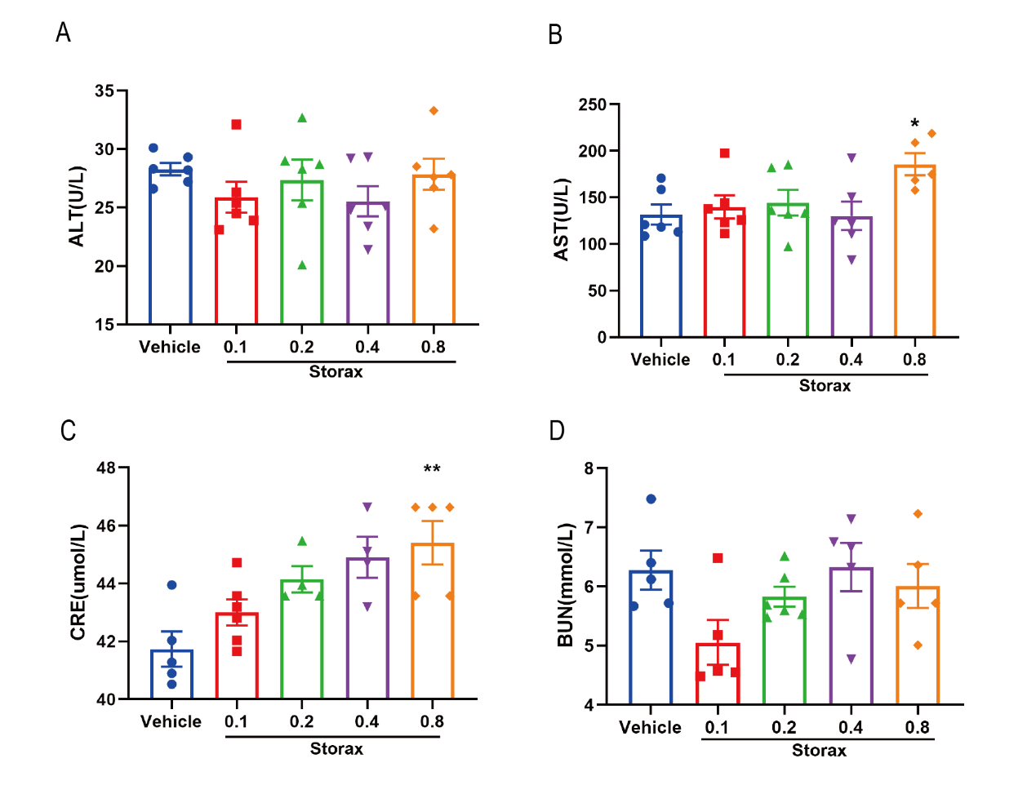

(A-D) Liver and kidney function examination. Data were shown as the mean ± SD. ##*P*<0.01, ###*P*<0.001 vs. Sham group, \**P*<0.05, \*\**P*<0.01 vs. Storax group, n=5.