

A

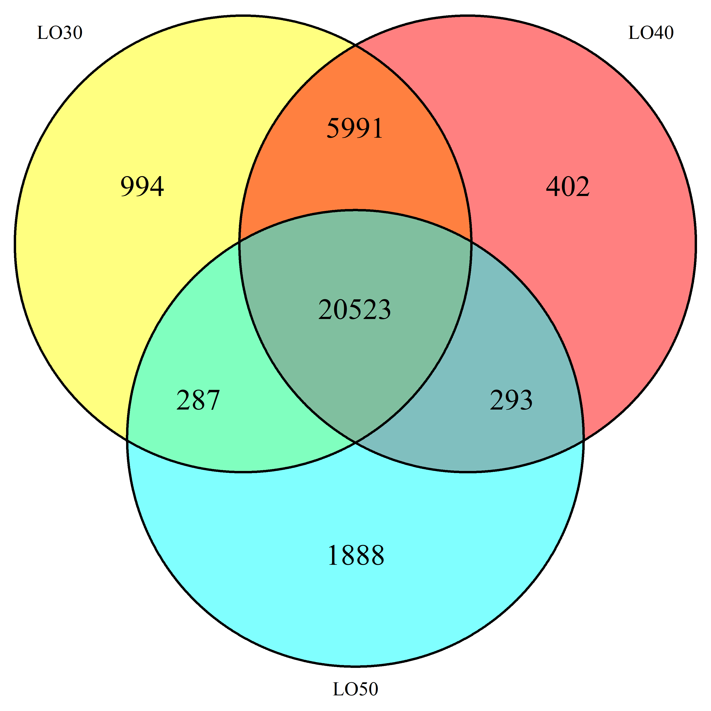

B

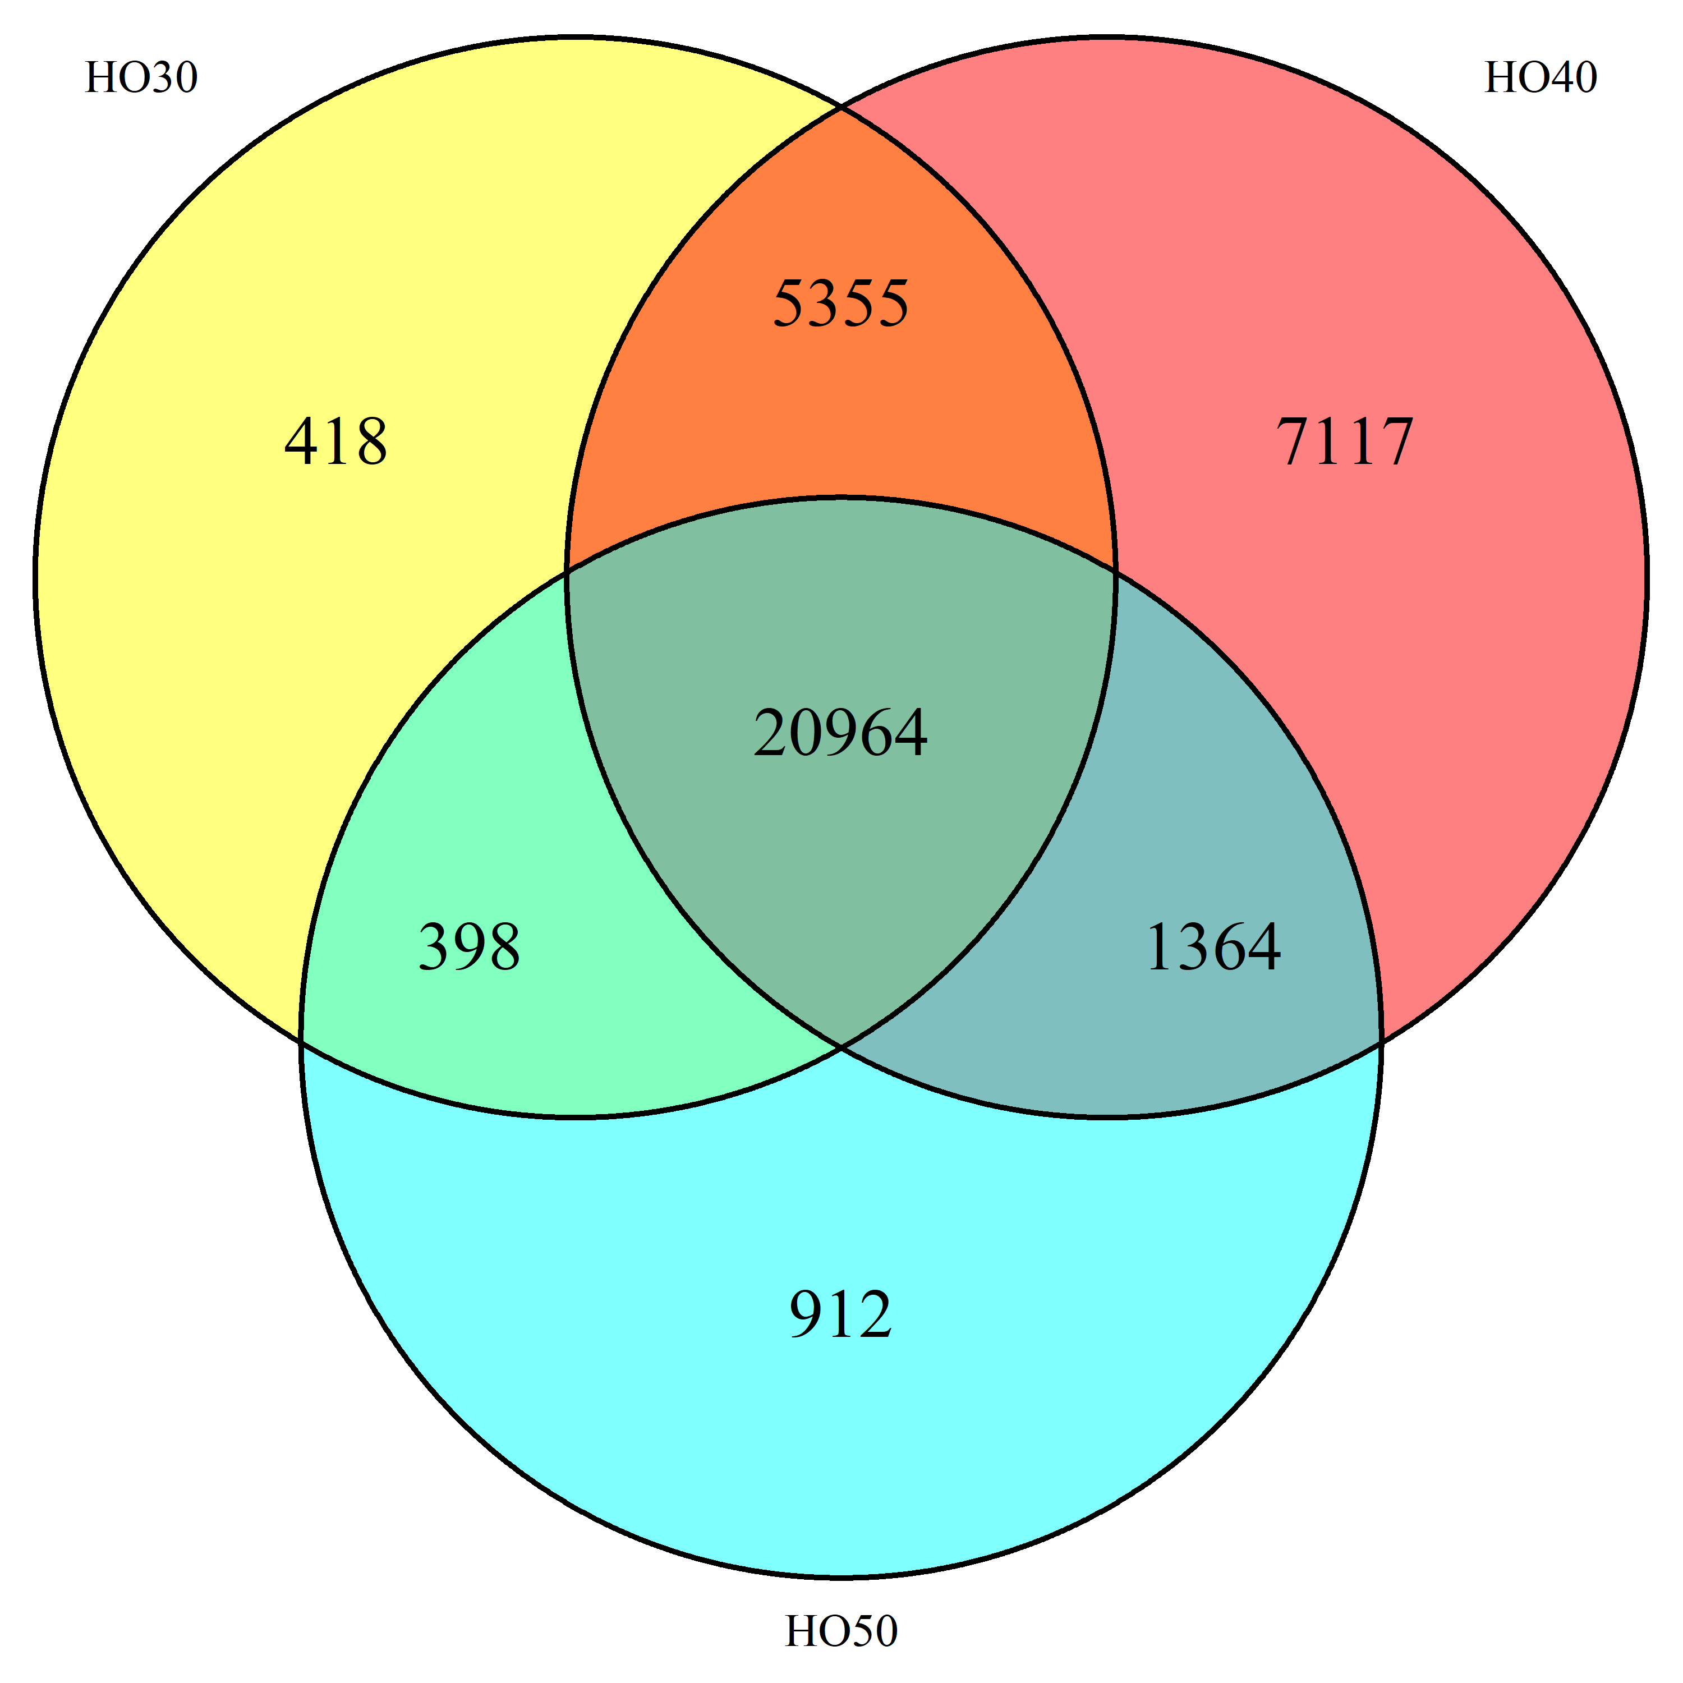

C

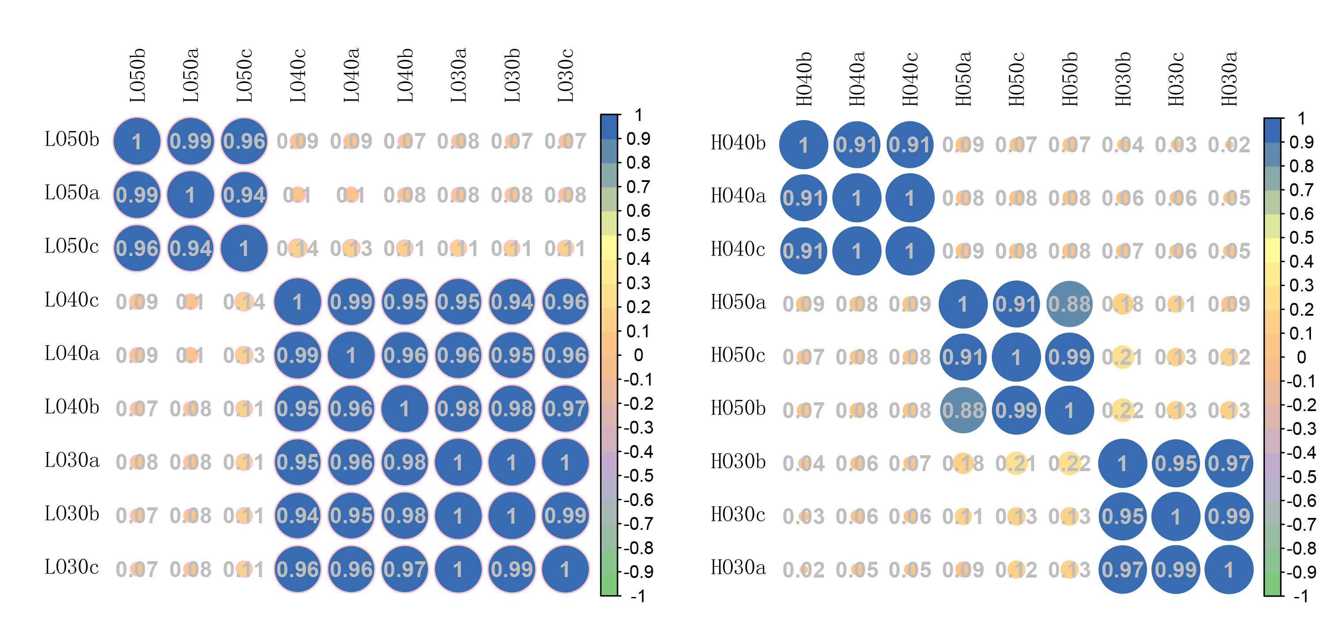

D

**FIGURE S1|** Global gene expression profiling of HO and LO. **(A)**Numbers of detected transcripts in each sample. **(B,C)**Venn diagrams of differentially expressed transcripts among the three samples of **(B)** LO and **(C)** HO. **(D)** Pearson correlation coefficient analysis between biological duplicates.