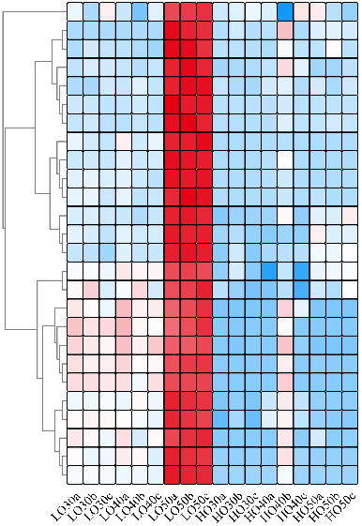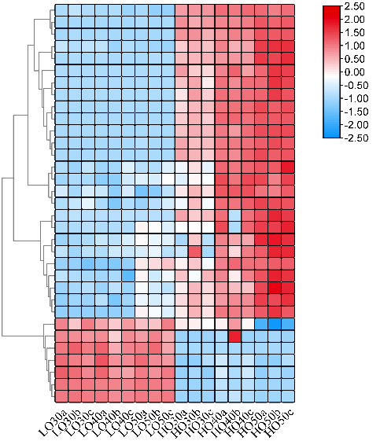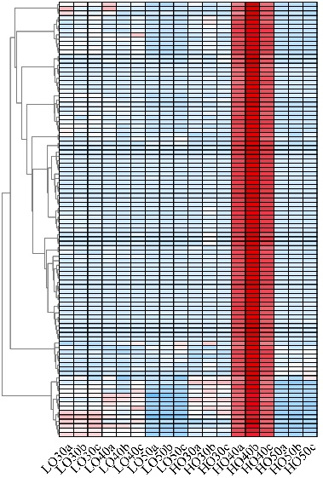

A B C

**FIGURE S2|** Heatmap comparison of the trait-specifical module genes. **(A)**skyblue module; **(B)**purple module; **(C)**yellow module; The heatmap was clustered by pearson method of TBtools software. Heatmap indicate the gene expression level by log2[FPKM] with color scale, each row represents a single gene, the IDs and names of selected DEGs are indicated to the right of the histograms, and each column represents a sample.