Supplementary Material

# Introduction

In the supporting Material we provide additional information about the chronostratigraphy of Core M125-35-3 (supplementary Figure 1) and a comprehensive depiction of the raw data used to calculate Mass Accumulation Rates (MAR) as shown in the main text. MARs were calculated after the following equation:

$$MAR=DBD×SR×C$$

where *DBD* is Dry Bulk Density (Supplementary Figure 2b), *SR* is the Sedimentation Rate (Supplementary Figure 1 & 2a) and *C* is the concentration of the analyzed parameters of Core M125-35-3. MARs were calculated for organic components crenarchaeol, alkenones, n-alkanes and brGDGTs and inorganic XRF derived elemental concentrations of Fe, Ti, K, Al, Si and Ca of Core M125-35-3. Concentrations of the above-mentioned parameters of Core M125-35-3 were shown in supplementary Figure 2c-l. Elemental MARs, which are not shown in the main text are summarized in Supplementary Figure 3a-e, as well as the sum of terrestrial derived elements Al, Ti, Fe and K versus Ca (Supplementary Figure 3f).

# Supplementary Figures

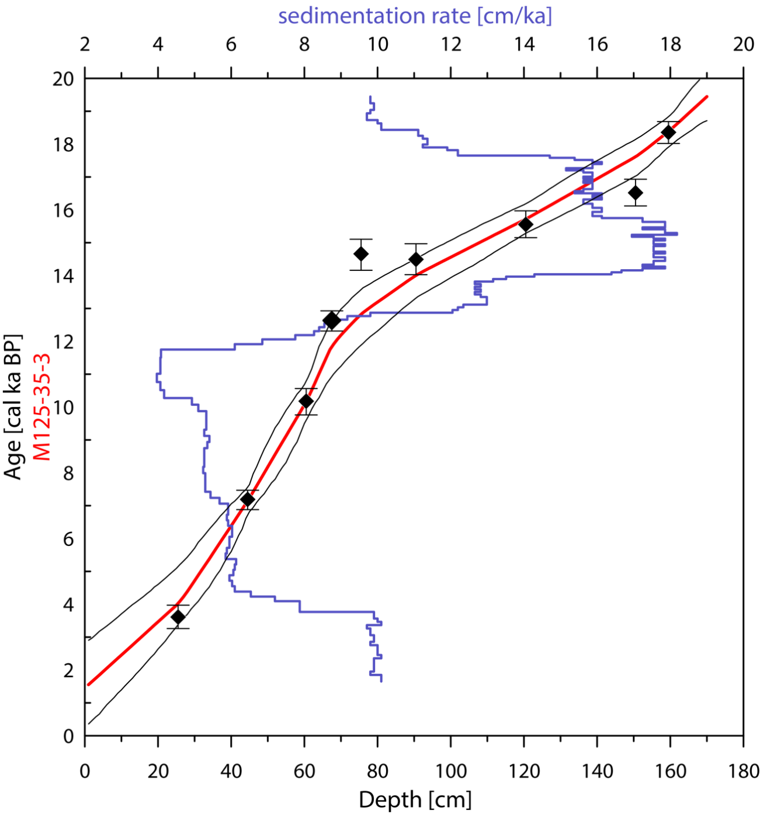

**Supplementary Figure** 1: Age model and sedimentation rate of sediment Core M125-35-3. The red thick line illustrates the median age probabilities modelled with Bacon, which is used to construct the age model of Core M125-35-3. The black lines indicate maximum and minimum age probabilities for the model outcome. Black diamonds illustrate AMS 14C-dates for Core M125-35-3 including 2σ-error bars. The dark blue line indicates sedimentation rates.

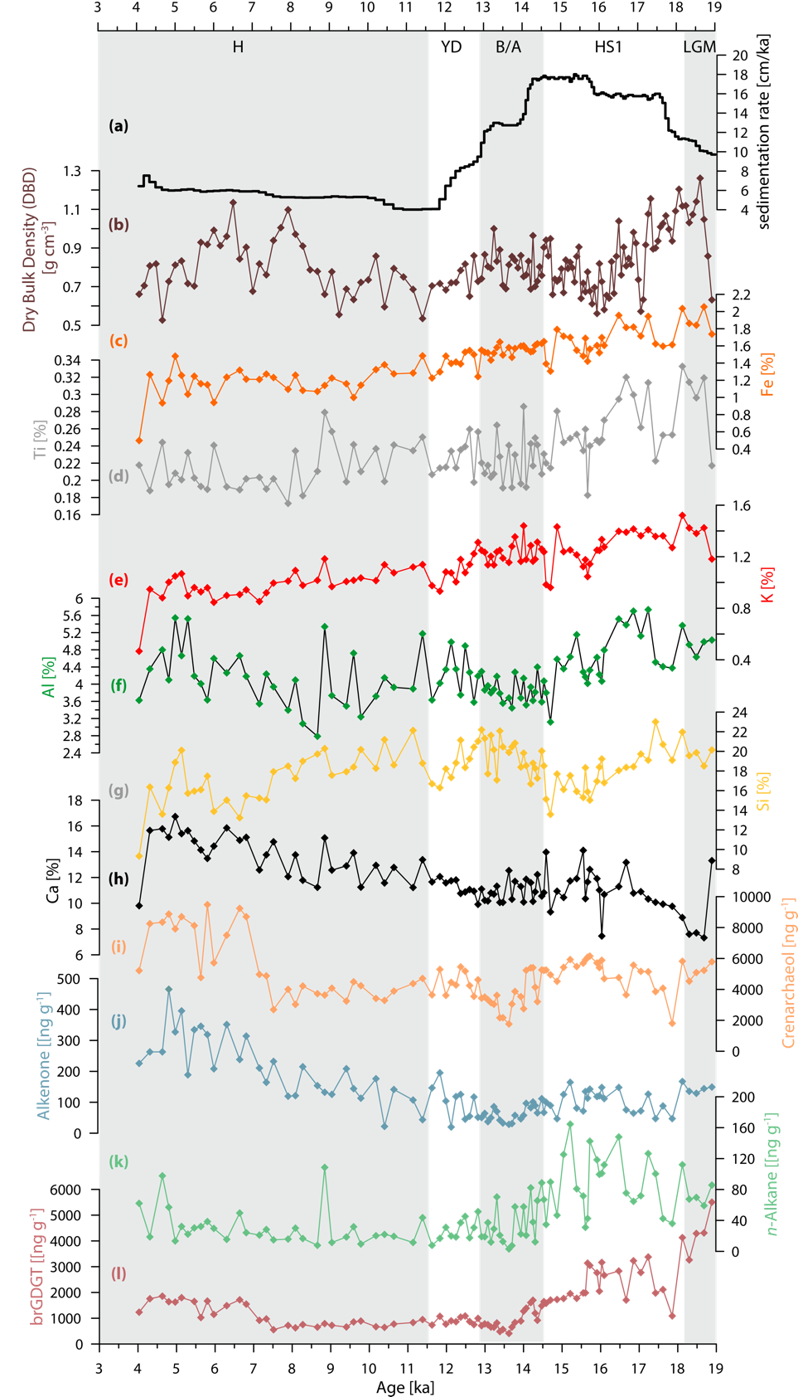

**Supplementary Figure 2.** Data from Core M125-35-3 used to calculate Mass Accumulation Rates (MAR) and concentrations of Si (b) versus age. a) sedimentation rate of Core M125-35-3, b) Dry Bulk Density (DBD), c-h) Elemental concentrations of Fe, Ti, K, Al, Si and Ca. j-m) lipid biomarker concentrations of crenarchaeol, alkenones, *n*-alkanes and branched glycerol dialkyl glycerol tetraethers (brGDGTs).

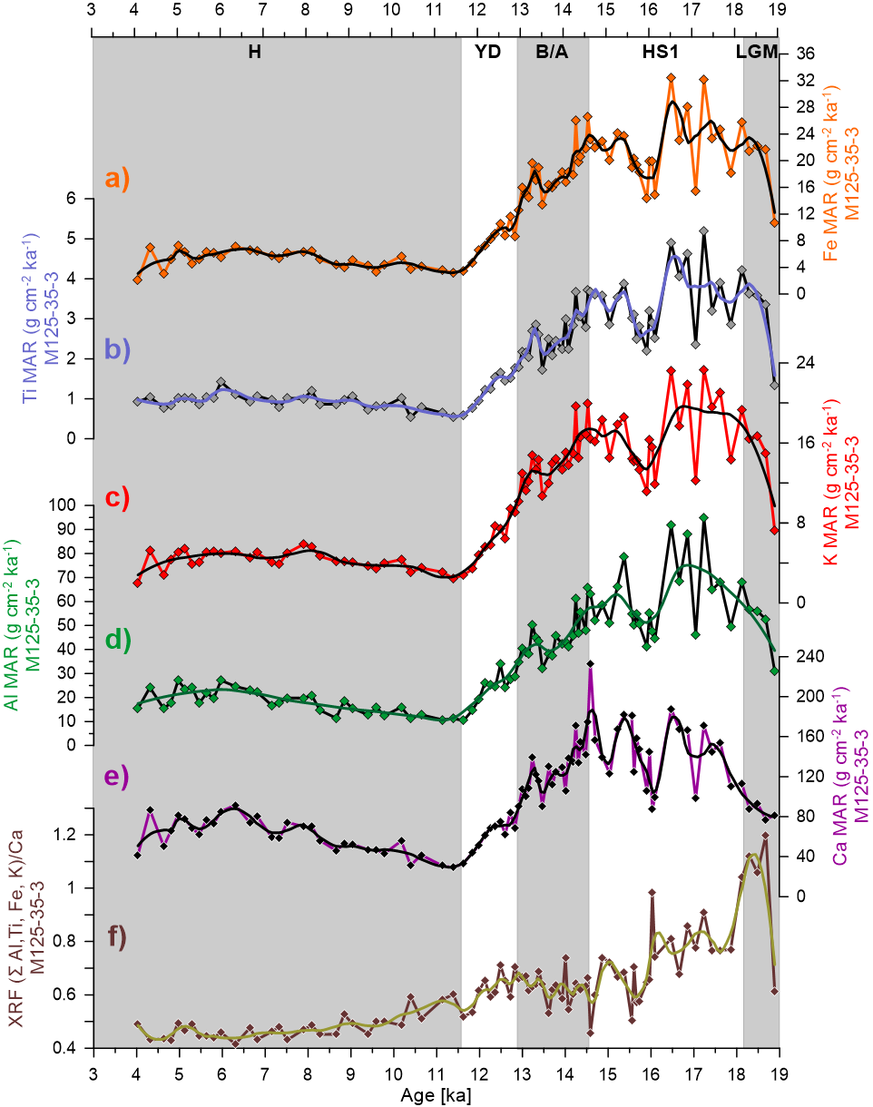

**Supplementary Figure 3.** XRF-derived elemental mass accumulation rates for **a)** Fe, **b)** Ti, **c)** K, **d)** Al, **g)** Ca. **f)** Sum of terrestrial elements (Al, Ti, Fe, K) versus marine originating Ca. LGM: Last Glacial Maximum, HS1: Heinrich Stadial 1, B/A: Bølling-Allerød interstadial, YD: Younger Dryas, H: Holocene.