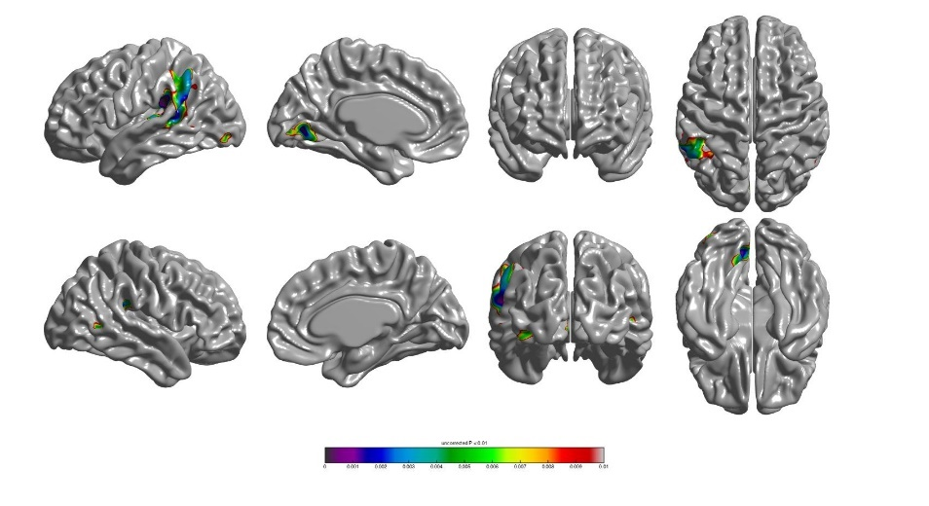
Supplementary Figure 1. Correlation maps demonstrating the association between cortical thickness and sentence repetition score in PPA patients with an uncorrected p-value of 0.01

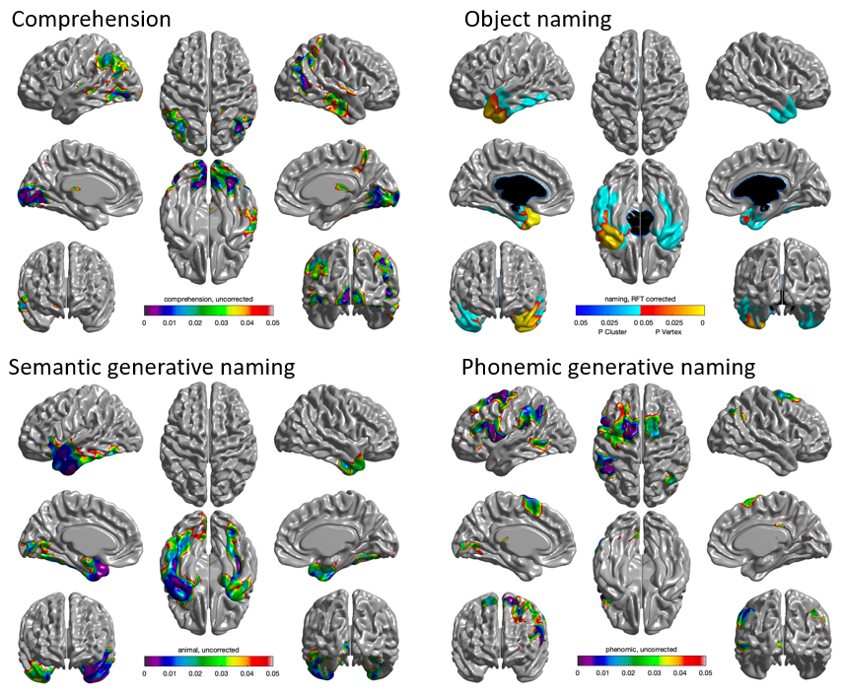
Supplementary Figure 2. Correlation maps demonstrating the association between cortical thickness in 70 patients with PPA (20 nfvPPA, 30 svPPA, and 20 lvPPA). The statistical maps were thresholded using random field theory (RFT) at p < 0.05 in object naming test and uncorrected p-value of 0.01 in comprehension, semantic generative naming, and phonemic generative naming tests.

