Supplementary materials

**1 Supplementary Figures and Tables**

**1.1 Supplementary Figures**

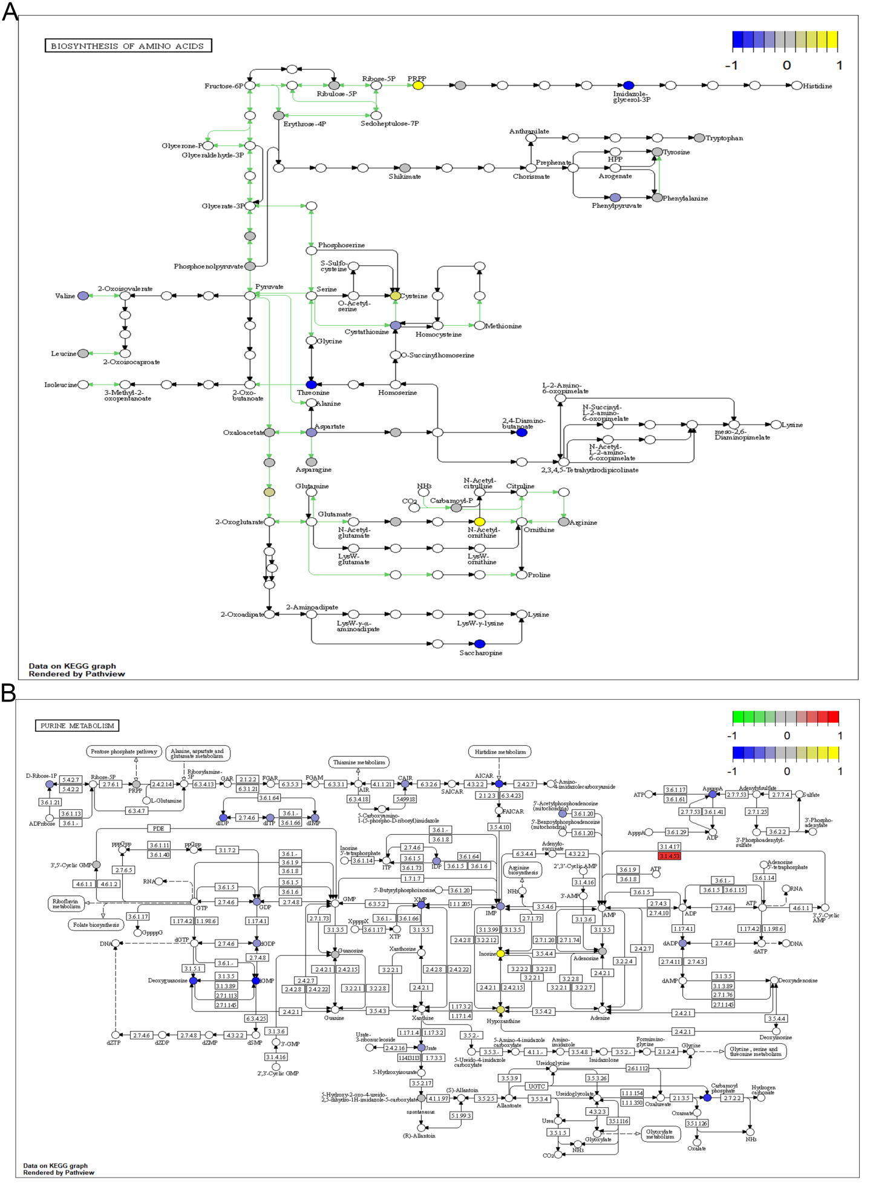

**Figure S1.** Metabolic signaling pathways significantly dysregulated in CD4+ T cells. A-B. Map of metabolic signaling pathways significantly dysregulated in microenvironmental CD4+ T cells in HT (A) and GD (B) patient.

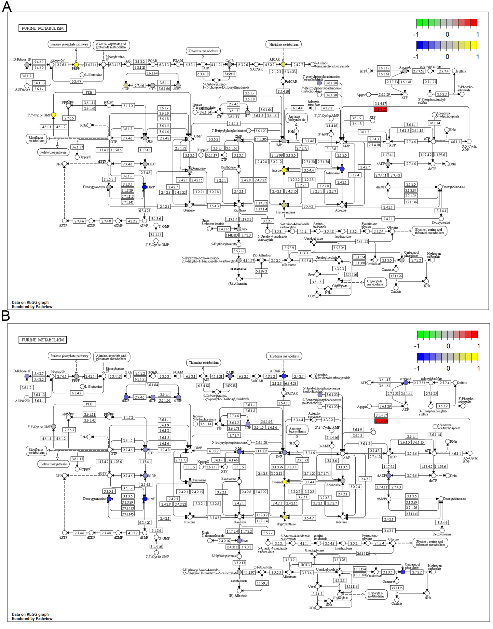

**Figure S2.** Metabolic signaling pathways significantly dysregulated in CD8+ T cells. A-B. Map of metabolic signaling pathways significantly dysregulated in microenvironmental CD8+ T cells in HT (A) and GD (B) patient.

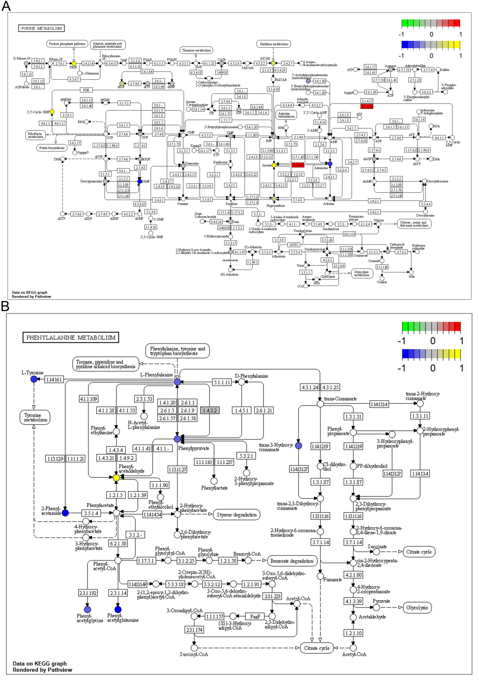

**Figure S3.** Metabolic signaling pathways significantly dysregulated in macrophages. A-B. Map of significantly dysregulated metabolic signaling pathways of microenvironmental Mac cells in HT (A) and GD (B) patient.

**1.2 Supplementary Table**

**Table S1. Demographic and clinical data.**

**Table S2. Marker genes of CD4+T cell, CD8+T cell and macrophage.**

**Table S3. Primer sequences for qPCR.**

**Table S4. Dysregulated genes in HT and GD patients.**