**Supplementary data**

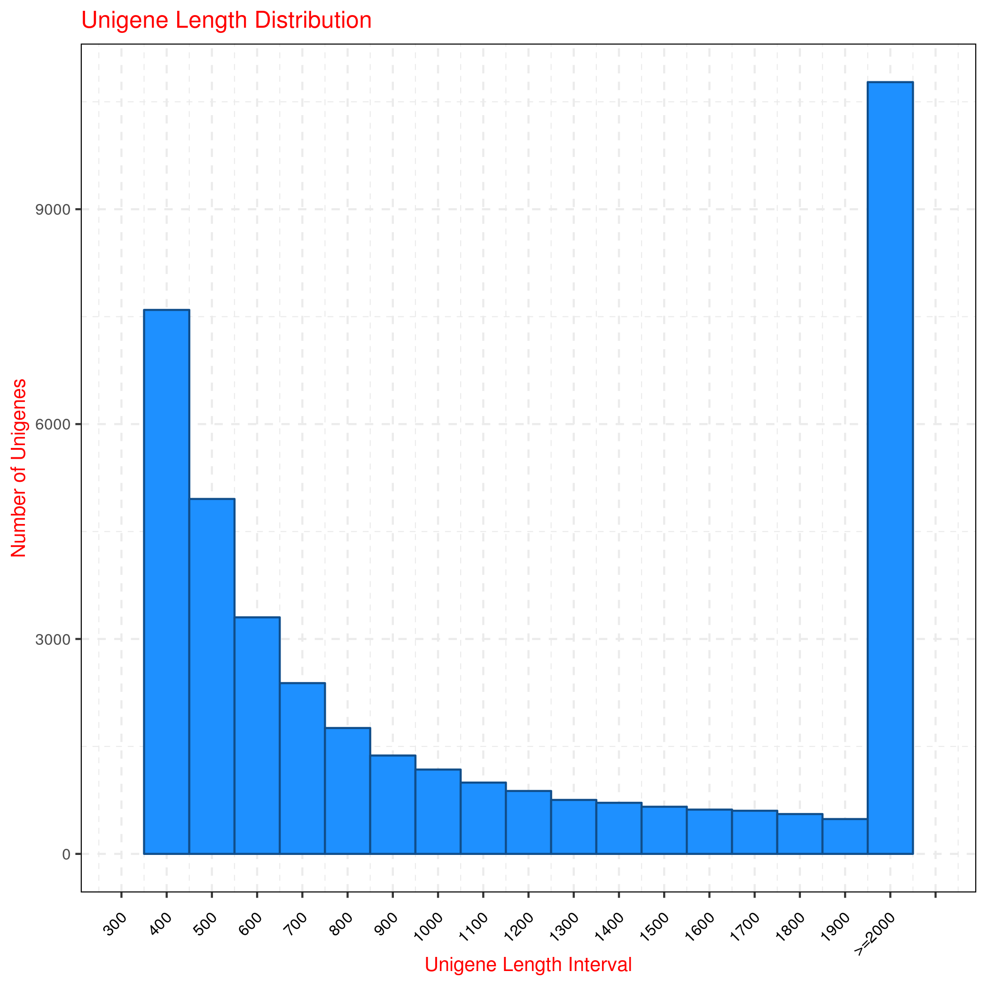

Figure S1. Number and length distribution of unigenes

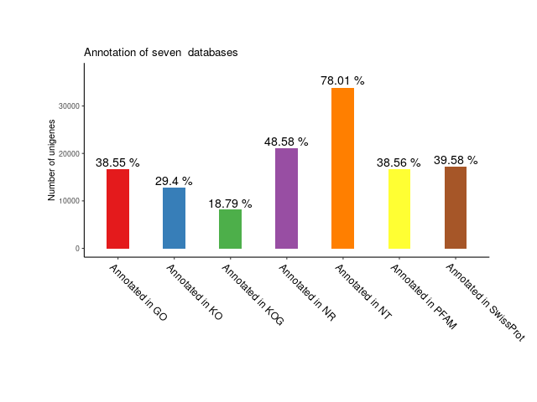

Figure S2. Gene annotation in the seven databases

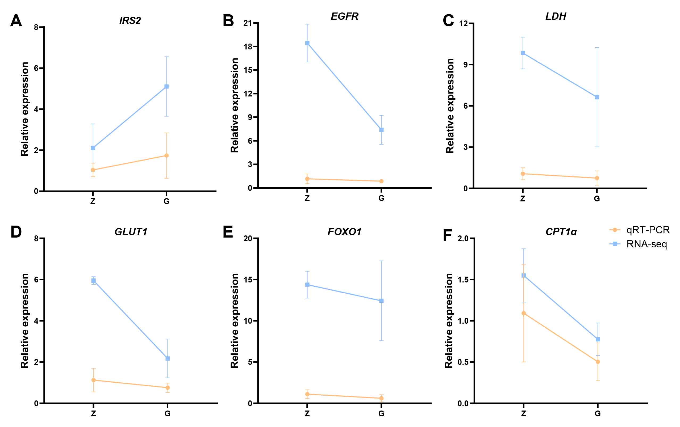

Figure S3. QRT-PCR was used to detect differential expression genes in the transcriptome data. The results of RNA-seq were mainly consistent with those of qRT-PCR.