Supplementary Material

# Supplemental Methods

## Cu(II) 1,3,5-Benzene-tris-triazole (CuBTTri) Synthesis

The ligand 1,3,5-tris(1H-1,2,3-triazol-5-yl)benzene (H3BTTri) and MOF H3[(Cu4Cl)3(BTTri)8·(H2O)12]·72H2O (CuBTTri) were synthesized by a simplified method previously reported by Demessence et al. (1). DMF (90 mL) and methanol (10 mL) were added to a flask containing copper(I) iodide (0.505 g, 2.60 mmol) and 1,3,5-triethynylbenzene (2.65 g, 17.6 mmol) and stirred under nitrogen. Trimethylsilyl azide (9.16 g, 79.5 mmol) was added to the flask and stirred at 100 °C for 36 h under nitrogen. The hot mixture was filtered. The filtrate was concentrated to approximately 10 mL then ultrapure water (≥30 mL) was added to produce a pale green precipitate. The solid was washed with ultrapure water and diethyl ether and dried under vacuum. H3BTTri (0.225 g, 0.937 mmol) was dissolved in DMF (40 mL). Copper(II) chloride dihydrate (0.383 g, 2.25 mmol) was added to the solution then heated at 100 °C for 72 h. CuBTTri, the resulting purple precipitate, was filtered and washed with DMF and ultrapure water. Ultrapure water (≥15 mL) was added to a Pyrex bottle containing CuBTTri and heated at 100 °C for 24 h. The solid was filtered and washed with ultrapure water. The washing process was repeated a total of 3 times.

## S-Nitrosoglutathione (GSNO) Synthesis

Synthesis was adapted from a previously-reported method by Hart et al. (2). Briefly, cold glutathione (1.53 g, 5 mmol) was added to ultrapure water (18.2 MΩ∙cm; 8 mL), 2 M hydrochloric acid (2.5 mL), and stirred for 10 minutes in an ice bath. Sodium nitrite (0.345 g, 5 mmol) was added to the solution and the reaction was allowed to proceed over ice for 40 minutes. The precipitate was filtered from the solution, rinsed with cold ultrapure water and acetone, and dried. Solid GSNO was stored at −20 °C and shielded from light. 1H NMR (400 MHz, D2O): 4.68-4.61(dd, 1H, J = 7.14, 5.44 Hz), 4.15-4.02 (br m, 2H), 3.96 (s, 2H), 3.94 (t, 1H, J = 6.59 Hz), 2.46 (t, 2H, J = 7.56 Hz), 2.14 (q, 2H, J = 7.17 Hz) (2).

## General Characterization

Powder X-ray diffraction (PXRD) patterns collected using Bruker D8 Discover DaVinci (Bruker, Billerica, MA, U.S.A.) diffractometer with CuKα radiation from 5-50 2theta at 0.2 s/step. Scanning electron microscopy (SEM) images collected using JEOL 6500 field emission SEM (Peabody, MA, U.S.A) at 15 kV accelerating voltage at 15,000X with 20 nm gold sputter coating to measure MOF particle diameter (n = 150). Optical microscopy images collected using an Invitrogen EVOS M5000 microscope (Waltham, MA, U.S.A.) with 10X objective.

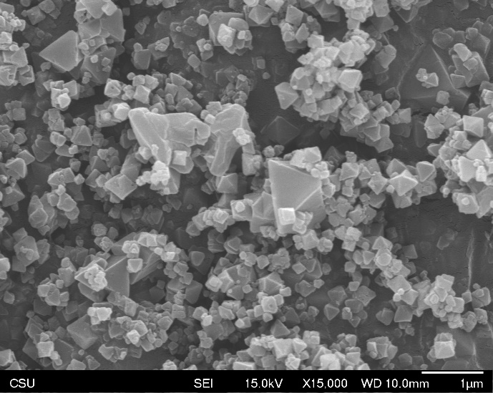

Raw

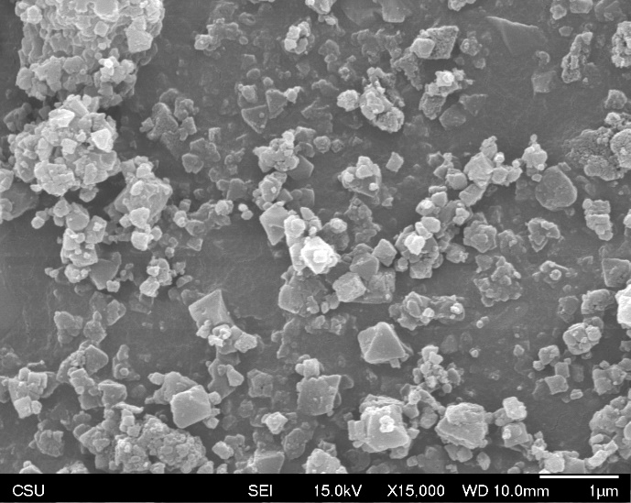

Ground

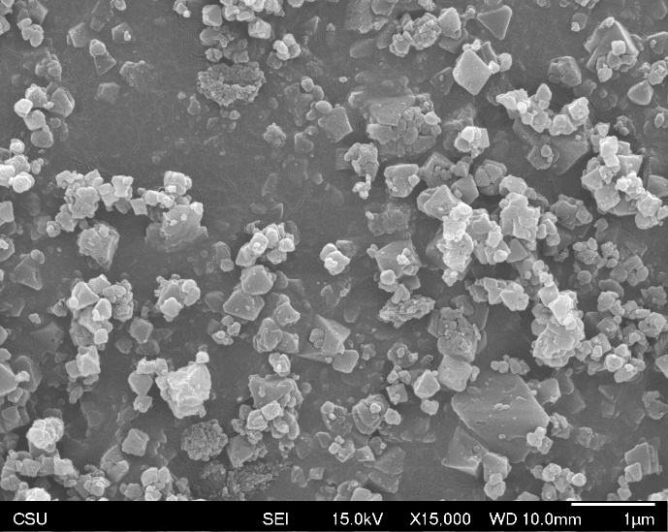

Filtered

**Supplementary Figure 1**. SEM images (15 kV, 15,000X) of MOF particles from three preparation methods. Top: raw, 0.4 ± 0.2 µm diameter; Middle: ground, 0.3 ± 0.1 µm; Bottom: filtered, 0.2 ± 0.1 µm diameter.

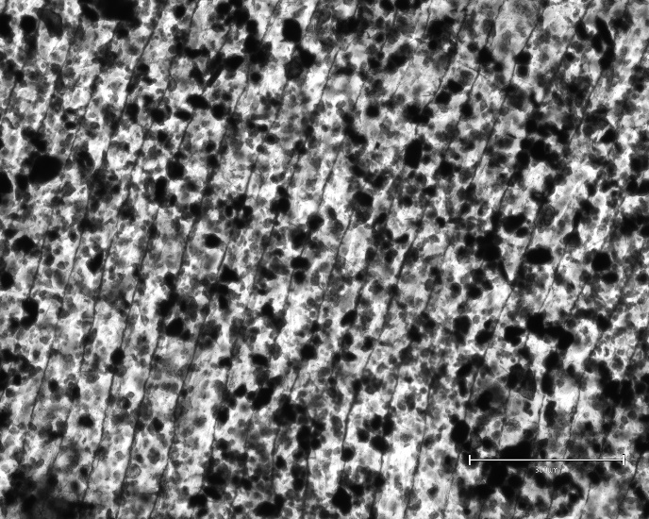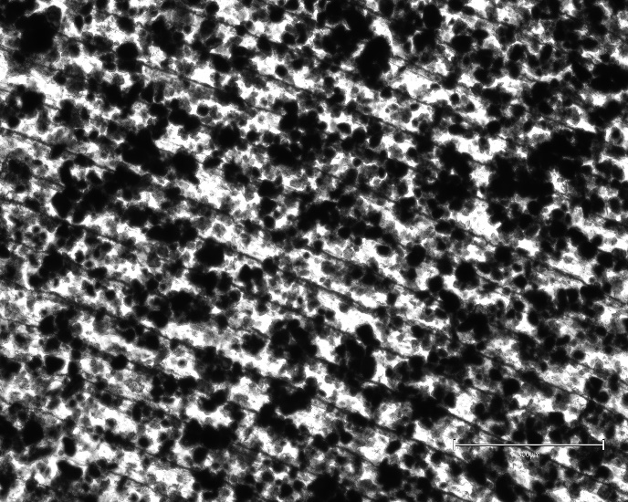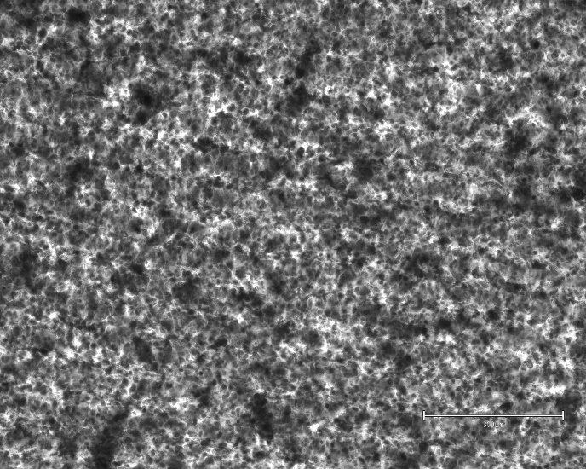

Raw

Ground

Filtered

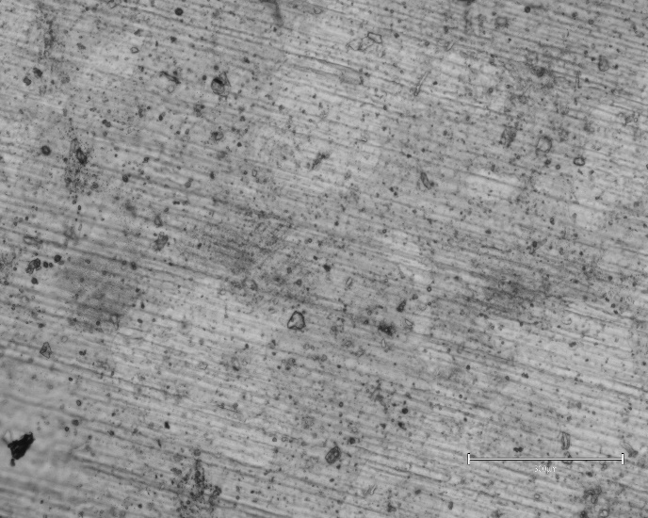

1% MOF/1% PU

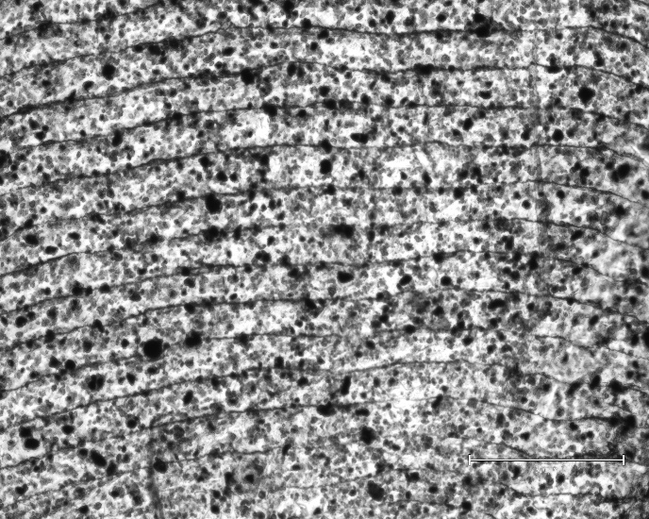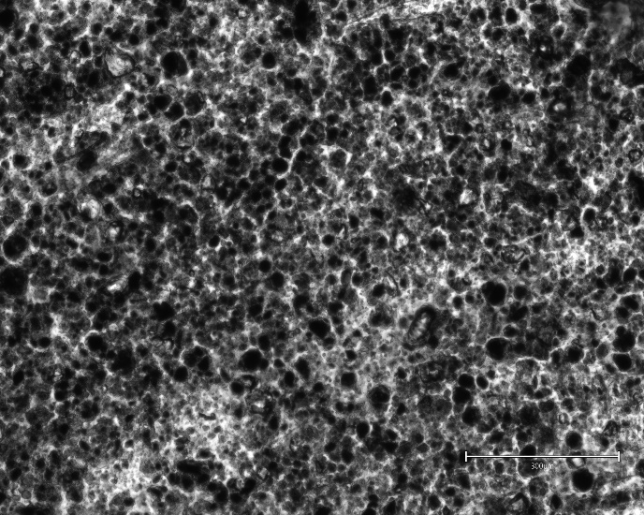

5% MOF/1% PU

10% MOF/1% PU

**Supplementary Figure 2A**. Optical microscope images (10X) of MOF composites. Left: 5% MOF/3% PU films with different MOF processing methods. Right: 1% PU films at 1% (top), 5% (middle), and 10% (bottom) MOF loading.

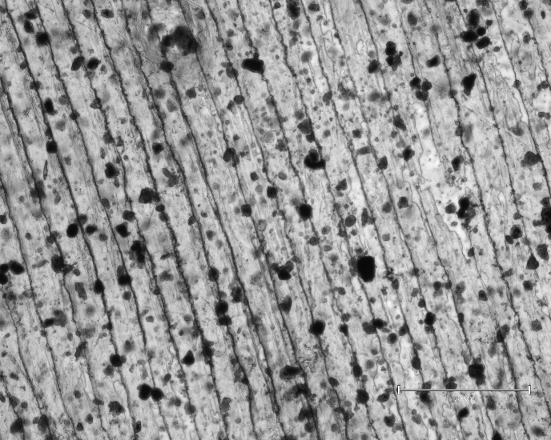

1% MOF/3% PU

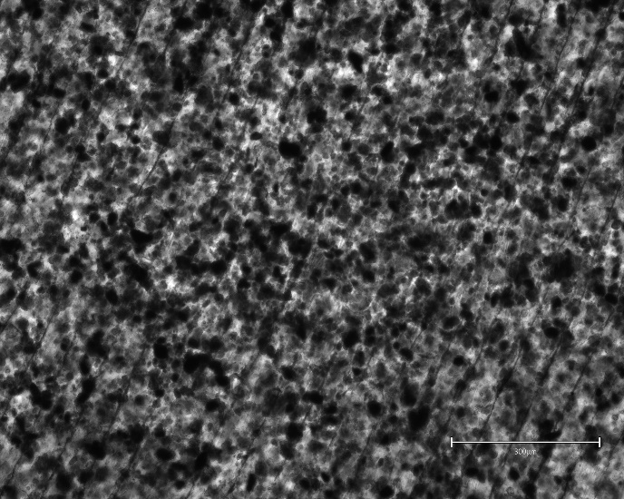

5% MOF/3% PU

10% MOF/3% PU

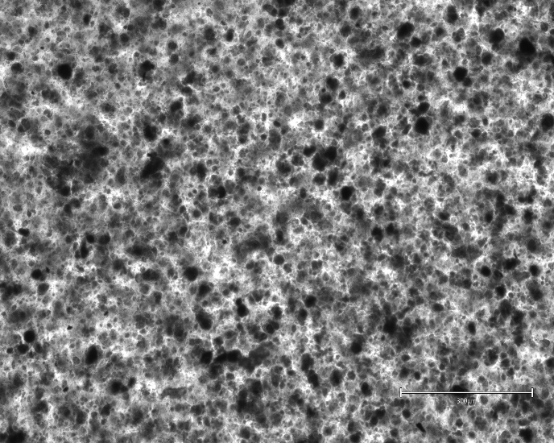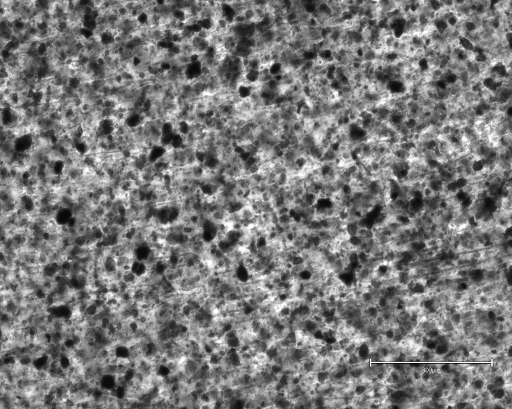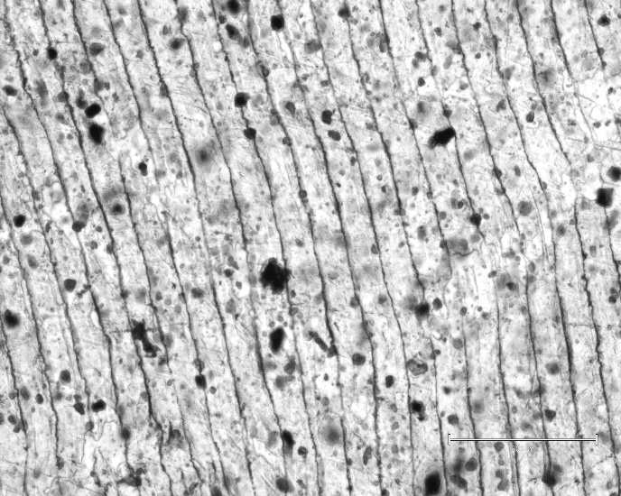

1% MOF/5% PU

5% MOF/5% PU

10% MOF/5% PU

**Supplementary Figure 2B**. Optical microscope images 10X) of MOF composites. Left: 3% PU films at 1% (top), 5% (middle), and 10% (bottom) MOF loading. Right: 5% PU films at 1% (top), 5% (middle), and 10% (bottom) MOF loading.

**Supplementary Figure 3.** Example representation of NO generation from a composite film with labels to show how each statistic is quantified.

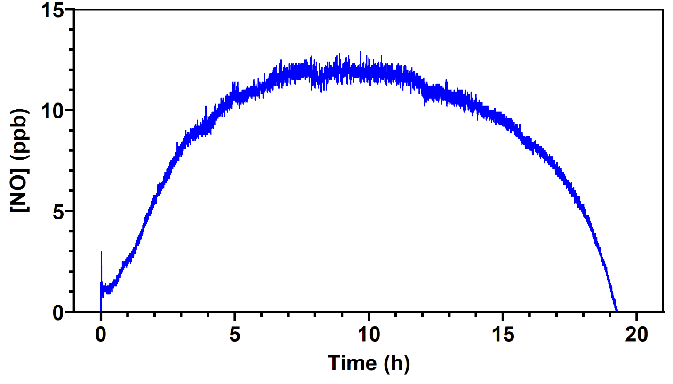

Reaction Time, NO Yield

Steady-State NO Flux

GSNO Injection

**Supplementary Figure 4**. PXRD of raw (black, bottom), ground (red, middle), and filtered (blue, top) MOF particles. Sloping baseline due to residual adsorbed water. Crystal structure identified from an isostructural Cu-MOF H[Cu(DMF)6][Cu4Cl)3(BTT)8–(H2O)12]·3.5HCl·12H2O·16CH3OH (CCDC-624533) (1,3).

|  |  |  |  |  |
| --- | --- | --- | --- | --- |
| **Supplemental Table 1**. CuBTTri powder comparing three MOF preparation techniques. | | | | |
|  | **MOF Preparation**b | **Particle Size**  **(µm)** | **Reaction Time**c  **(h)** | **NO Yield**  **(%)** |
| CuBTTri Powdera | Raw | 0.4 ± 0.2 | 1.8 ± 0.8 | 92 ± 2 |
| Ground | 0.3 ± 0.1 | 1.4 ± 0.2 | 93 ± 6 |
| Filtered | 0.2 ± 0.1 | 1.2 ± 0.1 | 96 ± 6 |
| aCuBTTri powder added at 0.9-1.0 mg, the estimated amount in one 1.2 cm diameter 5 wt.% CuBTTri/3 w/v% PU film.  bCuBTTri powder processing identical to the CuBTTri in the composite materials, except that they were stirred rapidly for 1 h in the water used for the NOA experiments rather than THF used to prepare the composites.  cExperiments conducted using the NOA in ultrapure water with constant N2 bubbling at 25 °C shielded from light with constant N2 bubbling with 10 × 10-6 M GSNO and 10 × 10-6 M GSH. Data reported as mean ± SD (n = 3). | | | | |

# Supplemental References

1. Demessence A, Alessandro DMD, Foo ML, Long JR. Strong CO2 Binding in a Water-Stable, Triazolate-Bridged Metal−Organic Framework Functionalized with Ethylenediamine. J Am Chem Soc. 2009;131(25):8784–6.

2. Hart TW. SOME OBSERVATIONS CONCERNING THE S-NITROSO AND S-PHENYLSULPHONYL DERIVATIVES OF L-CYSTEINE AND GLUTATHIONE. Tetrahedron Lett. 1985;26(16):2013–6.

3. Dincǎ M, Han WS, Liu Y, Dailly A, Brown CM, Long JR. Observation of Cu2+-H2 interactions in a fully desolvated socialite-type metal-organic framework. Angew Chemie - Int Ed. 2007;46(9):1419–22.