Nutritional intake and gut microbiome composition predict Parkinson’s disease

Supplementary Data

Figures:

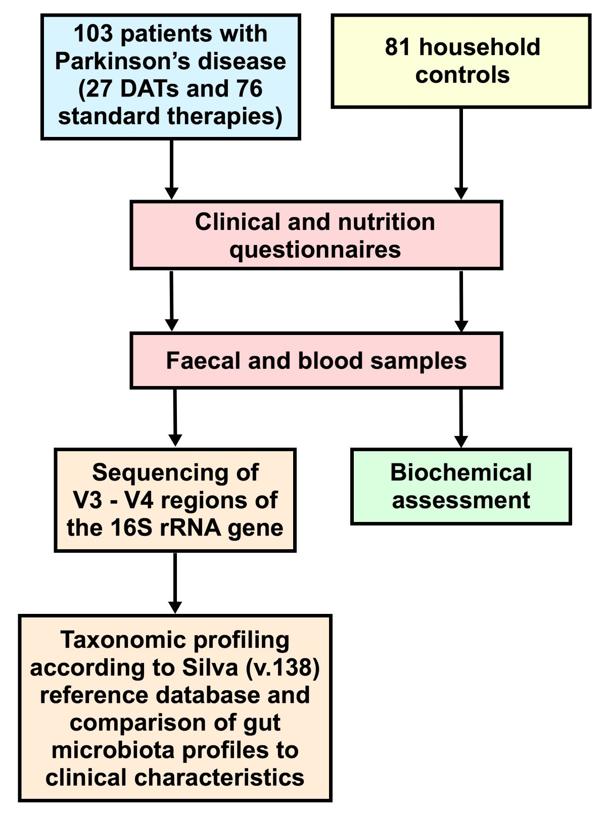

Supplementary Figure 1: Recruitment of Parkinson’s disease (PD) and household control (HC) participants. Participants completed clinical and nutrition questionnaires and provided faecal biospecimens for 16S amplicon sequencing analysis of the gut microbiome and routine biochemical blood tests. Following 16S sequencing, taxonomic profiling was used to assess differences between the PD (n=103) and HC (n=81) groups, evaluating clinical associations with the gut microbiome in addition to performing predictive modelling.
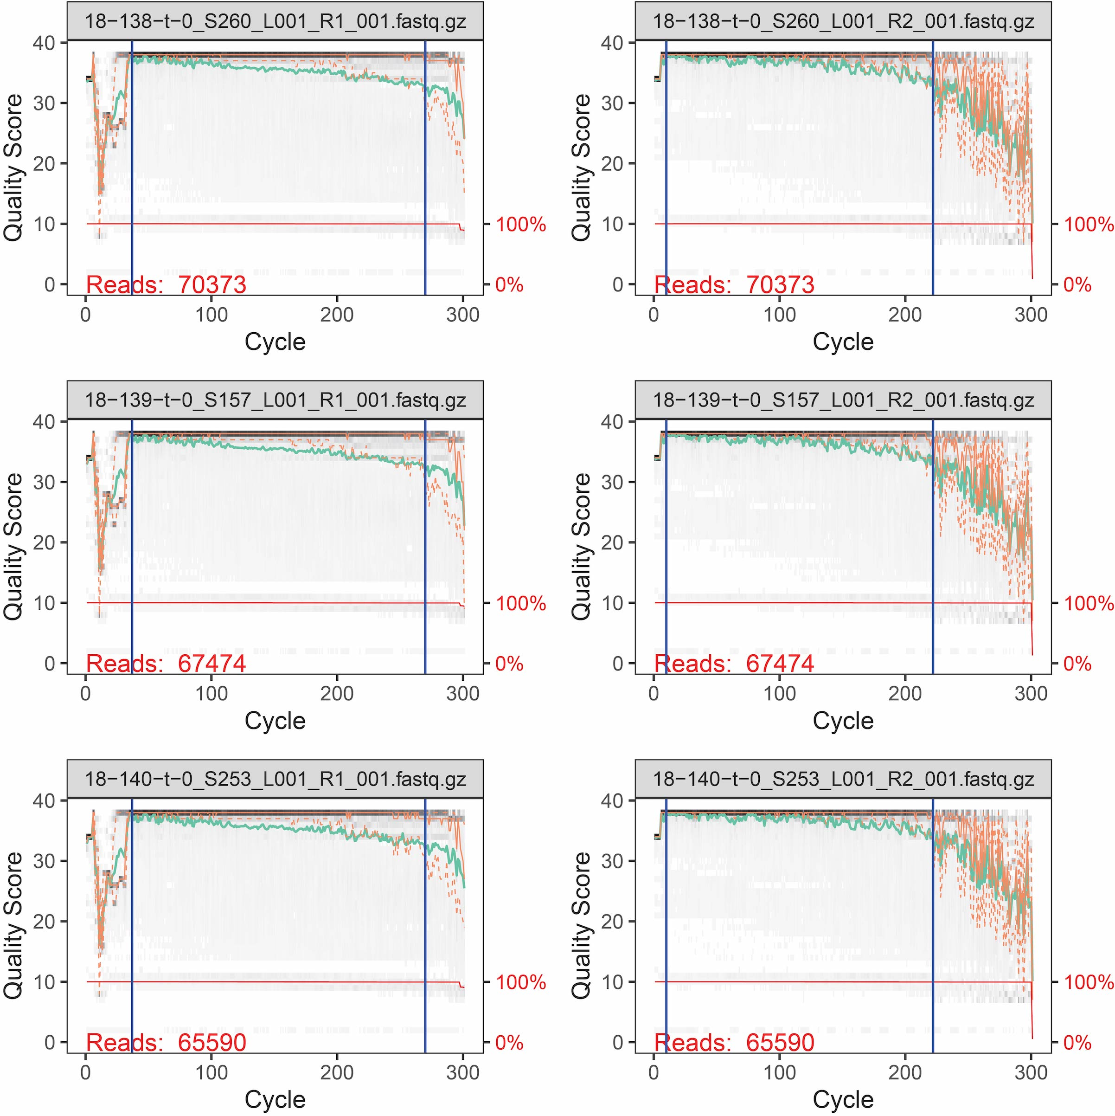
Supplementary Figure 2: 16S amplicon sequencing read trimming and quality control.
A representative selection of samples showing raw paired sequencing read quality (R1 in the left column, R2 in the right column). Reads were trimmed at either end to between 200 and 300 bases for a final read quality score >30. The total number of reads per sample is shown in red in the bottom left of each plot.

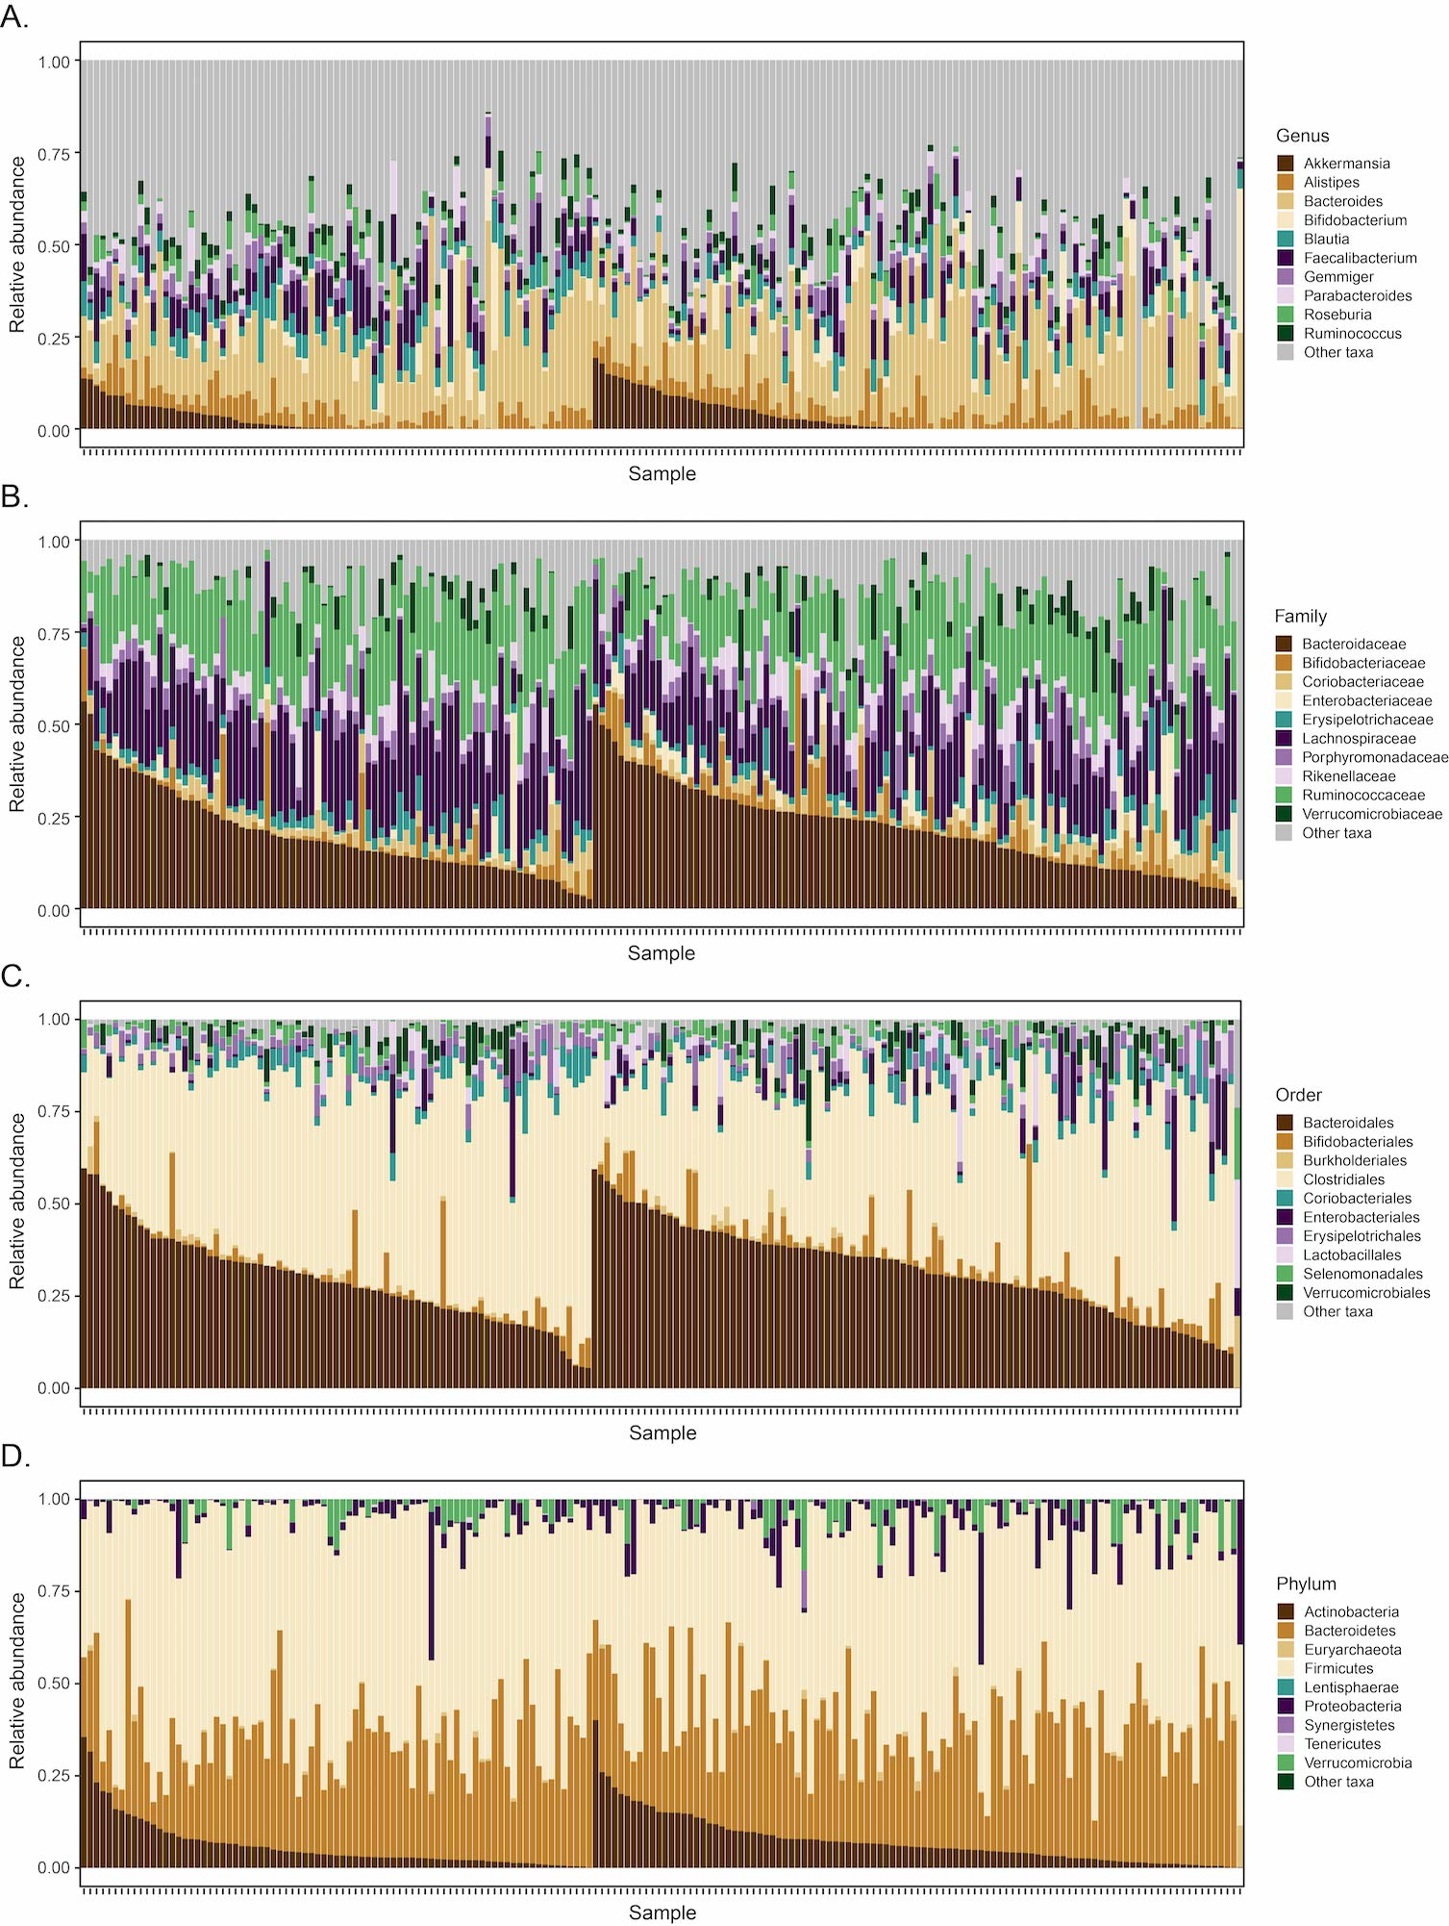

Supplementary Figure 3: Measures of relative gut bacterial abundance between household control (HC) and Parkinson’s disease (PD) groups at four taxonomic levels. Relative bacterial abundances are shown for individual HC (left hand side) and PD (right hand side) participants, ordered by the most representative bacteria at A) genus, B), family, C) order and D) phylum levels. At each taxonomic level shown, a mean relative abundance statistical difference was noted between the HC and PD groups, (PERMANOVA, p<0.01 genus, p<0.01 family, p<0.01 order, p=0.02 phylum taxonomic levels).

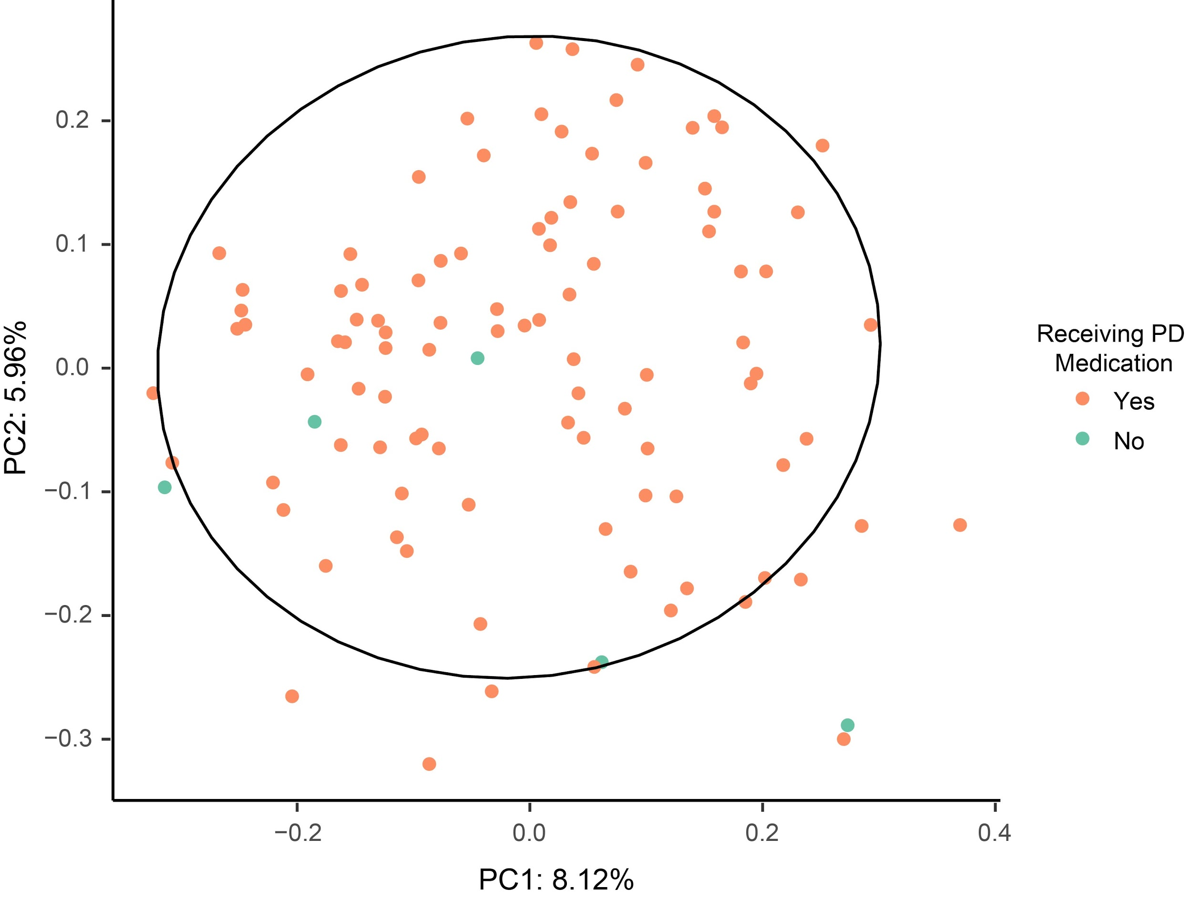

Supplementary Figure 4: Beta diversity in drug naïve and treated Parkinson’s disease (PD) patients. PCoA with Bray-Curtis dissimilarity was used to assess beta diversity at the Amplicon Sequencing Variant (ASV) level, comparing PD patients receiving any PD therapy (orange) with patients who were drug naïve (green). Although not statistically different compared to the overall PD cohort, a slight separation was noted in the drug naïve group, suggesting a potential trend in the subgroup analysis, which would require further evaluation in larger cohorts.

Tables

Supplementary Table 1: Statistically significant Associations Between Gut Bacteria and Clinical Variables after adjusting for Age, Sex and Body Mass Index.

Clinical variable | Bacteria associating  with clinical variable | Spearman Correlation coefficient (r_{s}) | p value
Medications and Therapies  Device-Assisted Therapies  LCIG (n=9)  DBS (n=11)  Apomorphine Infusions (n=7)  Standard Therapies  Levodopa (n=92)  Anticholinergics (n=13)  COMT Inhibitors (n=24)  Amantadine (n=13)  Dopamine Agonists (n=36)  MAO-B Inhibitors (n=19)  Daily Levodopa Dose Equivalence | Tenericutes  Proteobacteria  Enterobacteriales  Enterobacteriaceae  Enterococcus  Klebsiella  Claoacibacillus  Aneroplasma  ASV_155/Klebsiella spp  ASV_512/Clostridiales spp  ASV_404/Blautia spp  Streptococcaceae  Rikenellaceae  Streptococcus  Eggerthella  Alistipes  ASV_222/Streptococcus spp  ASV_25/ Streptococcus spp  ASV_166/Bifidobacterium spp  Intestinibacter  Parasutterella  Actinomyces  ASV_611/Mogibacterium spp  ASV_529/Blautia spp  ASV_382/Ruminococcus spp  ASV_381/Clostridium_sensu_stricto spp  Burkholderiales  Sutterellaceae  Rikenellaceae  Alistipes  Turicibacter  Oscillibacter  Dialister  ASV_166/Bifidobacterium spp  ASV_430/Lactobacillus spp  Actinobacteria  Bifidobacteriaceae  Enterococcaceae  Lactobacillaceae  ASV_139/Lactobacillus spp  ASV_512/Clostridiales spp  Anaerofilum  Lactobacillus  ASV_314/Bacteroides spp  ASV_605/Streptococcus spp  ASV_45/Intestinibacter spp ASV_42/Bifidobacterium spp  Enterobacteriales  Bifidobacteriales  Lactobacillales  Lactobacillaceae  Enterobacteriaceae  Enterococcaceae  Bifidobacteriaceae  ASV_82/Lactobacillus spp  ASV_233/Bifidobacterium spp | 0.276  0.234  0.284  0.294  0.531  0.366  -0.288  0.274  0.411  0.388  0.369  0.332  -0.280  0.331  0.286  -0.260  0.380  0.375  -0.280  0.307  0.295  0.240  0.375  0.352  0.346  0.341  0.335  0.310  0.310  0.310  0.284  0.283  0.259  0.398  0.354  0.255  0.387  0.284  0.273  0.325  0.314  0.264  0.213  0.284  0.274  -0.264  0.243  0.320  0.264  0.236  0.323  0.300  0.293  0.266  0.398  0.335 | 0.010  0.020  <0.001  <0.001  0.010  <0.001  0.020  0.010  <0.001  <0.001  <0.001  <0.001  0.020  0.001  <0.001  0.020  <0.001  <0.001  0.040  <0.001  0.010  0.040  0.001  <0.001  <0.001  <0.001  <0.001  <0.001  <0.001  <0.001  <0.001  <0.001  0.010  <0.001  <0.001  0.010  <0.001  <0.001  0.010  <0.001  <0.001  0.010  0.030  0.001  <0.001  0.010  0.010  <0.001  0.010  0.020  <0.001  <0.001  <0.001  0.010  <0.001  <0.001
Motor Features and Indicators of Disease Severity  UPDRS-III Score  Hoehn and Yahr Stage  PD Duration  PD Onset > 60 years  PD Onset < 40 years  Postural Instability PD Phenotype  Motor Fluctuations | Lactobacillales  Lactobacillaceae  Enterococcaceae  Lactobacillus  Gordonibacter  Enterococcus  Eggerthella  Escherichia/Shigella  Lactobacillaceae  Enterobacteriaceae  Enterococcaceae  Escherichia/Shigella  Lactobacillus  Eggerthella  Enterococcus  Lactobacillus  Eggerthella  Escherichia/Shigella  Anaerovorax  Klebsiella  Bifidobacteriaceae  Cloadbacillus  Oxalobacter  Holdemanella  Bifidobacterium  Ruminococcus2  Dorea  Oxalobacter  Synergistaceae  Oxalobacteraceae  Faecaliococcus  Escherichia/Shigella  Senegalimassillia  ASV_570/Ruminococcus spp  ASV_233/Bifidobacterium spp  Escherichia/Shigella  Klebsiella  Cloacibacillus | 0.284  0.257  0.222  0.254  0.234  0.227  0.219  0.216  0.334  0.295  0.272  0.334  0.332  0.323  0.275  0.323  0.244  0.233  -0.233  0.222  -0.216  0.344  0.331  -0.235  -0.218  0.327  0.265  -0.214  0.333  0.304  0.315  0.271  0.212  0.366  0.322  0.336  0.258  -0.244 | <0.001  0.010  0.030  0.010  0.010  0.030  0.030  0.030  <0.001  <0.001  0.010  <0.001  <0.001  <0.001  0.010  <0.001  0.010  0.020  0.020  0.030  0.040  <0.001  <0.001  0.040  0.040  <0.001  0.010  0.030  <0.001  <0.001  <0.001  0.010  0.030  <0.001  <0.001  <0.001  0.010  0.020
Non-Motor Symptoms  Non-Motor Symptoms Scale (Total Score)  Quality of Life  PDQ-39 Summary Index  SF-36 Physical Component Summary  Depression  Beck’s Depression Inventory Score  Physical Activity  IPAQ Score  Chronic Pain  REM Sleep Behaviour Disorder  Gastrointestinal Function  Bristol Stool Scale Score  ROME-IV Score  Leeds Dyspepsia Score | Pseudoflavonifractor  Gordonibacter  Gemella  ASV_570/Ruminococcus spp  Lactobacillaceae  Victivallaceae  Gordonibacter  Eggerthella  Pseudoflavonifractor  Lactobacillus  Oxalobacter  Firmicutes  Enterobacteriaceae  Bacteroidaceae  Fusicatenibacter  Butyricicoccus  Eggerthella  Holdemania  Pseudoflavonifractor  ASV_32/Blautia spp  ASV_349/Eggerthella spp  ASV_476/Clostridium_XlVa spp  Veillonella  Klebsiella  Pseudoflavonifractor  Lactobacillaceae  Enterobacteriaceae  Lactobacillus  Enterobacteriaceae  Bacteroidaceae  Synergistaceae  Veillonella  ASV_32/Blautia spp  Porphyromonadaceae  Gordonibacter  ASV_151/Bacteroides spp  Butyricicoccus  Faecalibacterium  Escherichia/Shigella  Coprococcus  ASV_350/ Clostridium_XlVa spp  ASV_184/Clostridium_XlVa spp  ASV_15/Faecalibacterium spp  ASV_46/Roseburia spp  Holdemania  Butyricicoccus  Romboutsia  ASV_151/Bacteroides spp  ASV_133/Alistipes spp  Desulfomicrobiaceae  Desulfomicrobium  Mogibacterium | 0.371  0.243  -0.223  0.244  0.273  -0.235  0.300  0.288  0.281  0.274  -0.211  0.378  -0.240  -0.230  0.444  0.438  -0.340  -0.311  -0.310  0.401  -0.267  -0.256  0.314  0.312  0.311  -0.274  -0.233  -0.275  -0.298  0.288  0.267  -0.368  0.334  0.246  0.302  0.322  0.428  0.364  -0.334  0.318  0.398  0.372  0.371  0.371  0.342  0.321  -0.233  0.411  0.388  0.438  0.422  0.350 | <0.001  0.010  0.040  0.010  0.010  0.020  <0.001  <0.001  <0.001  0.010  0.040  <0.001  0.001  0.002  <0.001  <0.001  <0.001  <0.001  <0.001  <0.001  0.001  0.001  <0.001  <0.001  <0.001  0.001  0.002  0.001  <0.001  <0.001  0.001  <0.001  <0.001  0.020  <0.001  <0.001  <0.001  <0.001  <0.001  <0.001  <0.001  <0.001  <0.001  <0.001  <0.001  <0.001  0.002  <0.001  <0.001  <0.001  <0.001  <0.001
Other Clinical Factors  Increasing Age  Male Gender (n=58)  Ethnicity  Caucasian (n=81)  Asian (n=4)  Prior Neuroleptic Exposure (n=3)  BMI  Dietary Influences  Coffee Consumption  Added Sugars | Synergistetes  Euryarchaeota  Lentisphaerae  Firmicutes  Synergistaceae  Methanobacteriaceae  Eisenbergiella  Cloacibacillus  Methanobrevibacter  ASV_343/Eisenbergiella spp  ASV_198/Cloacibacillus spp  ASV_453/Butyricimonas spp  ASV_609/Clostridiales spp  Euryarchaeota  Synergistetes  Synergistaceae  Methanobacteriaceae  Romboutsia  Turicibacter  Rhodospirillaceae  Rikenellaceae  Desulfovibrionaceae  Synergistaceae  Alistipes  Desulfovibrio  ASV_299/Parabacteroides spp  ASV_198/Cloacibacillus spp  Gordonibacter  Escherichia/Shigella  Parasutterella  ASV_173/Parasutterella spp  Actinomycetaceae  Actinomyces  ASV_545/Actinomyces spp  ASV_335/Parabacteroides spp  Anaeroplasma  Romboutsia  Adlercreutzia  Lactobacillus  Mogibacterium  Streptococcus | 0.324  0.256  0.222  -0.222  0.321  0.257  0.388  0.364  0.267  0.384  0.363  0.355  0.323  0.294  0.288  0.287  0.295  0.334  0.299  0.367  0.355  0.263  0.248  0.355  0.301  0.366  0.306  0.298  0.277  0.257  0.489  0.383  0.383  0.383  0.373  -0.311  0.288  0.290  0.344  0.293  0.248 | <0.001  0.001  0.030  0.030  <0.001  <0.001  <0.001  <0.001  <0.001  <0.001  <0.001  <0.001  <0.001  <0.001  <0.001  <0.001  <0.001  <0.001  0.001  <0.001  <0.001  <0.001  0.010  <0.001  <0.001  <0.001  <0.001  <0.001  <0.001  0.010  <0.001  <0.001  <0.001  <0.001  <0.001  <0.001  0.010  <0.001  <0.001  <0.001  0.001

Comparisons with a moderate Spearman correlation (r_{s} = 0.4-0.6) are highlighted in yellow and those with a borderline moderate Spearman correlation (r_{s} = 0.398) are highlighted in blue. All other correlations listed are considered weak Spearman correlations (r_{s} = 0.2-0.4). Further interactive visualization of the data is available online at: http://shiny.maths.usyd.edu.au/PDBug/

