Supplementary Material
Figure S1. The plant material of Allium fistulosum for transcriptome sequencing analysis. Allium fistulosum on the left called W and Allium fistulosum on the right called R.
W is no accumulation of anthocyanins, and the stem is white. R is accumulation of anthocyanins, and the stem is red.
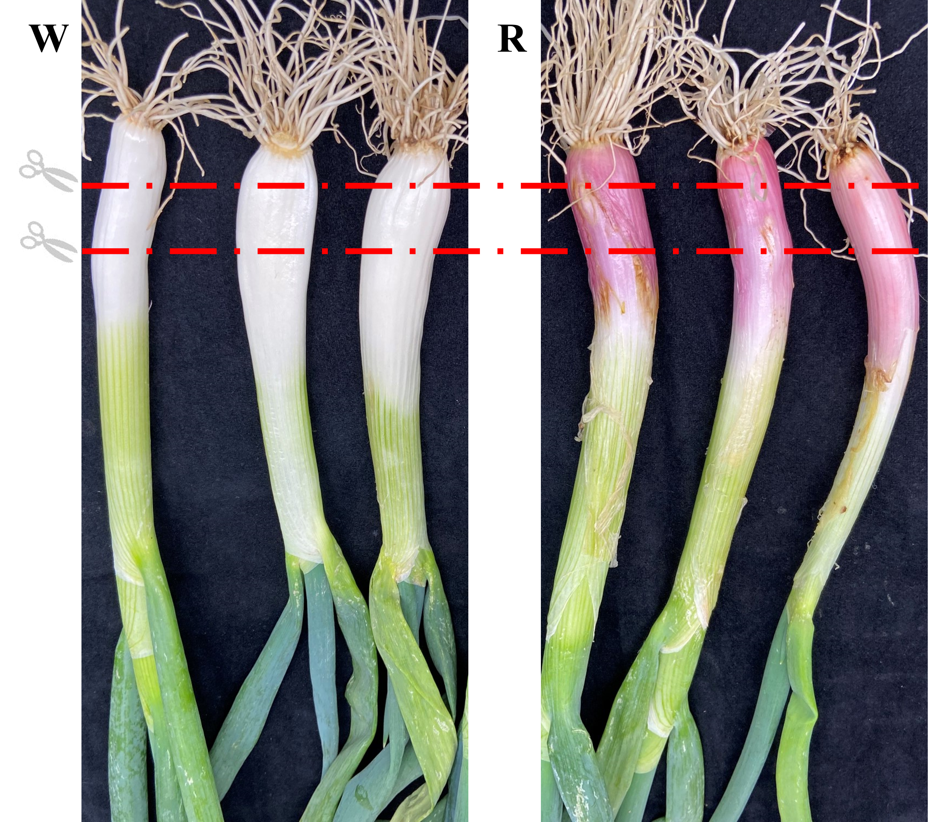
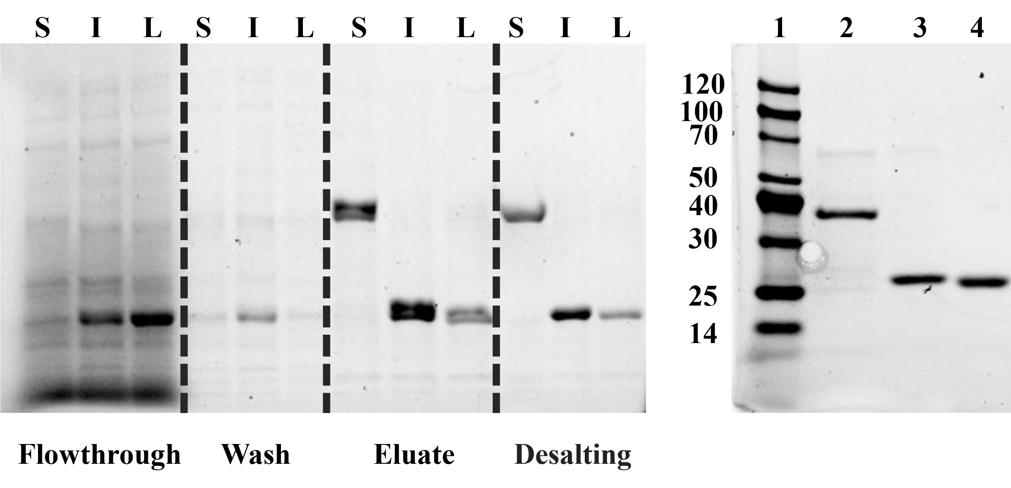
Figure S2: SDS-PAGE of purified His₆-AfCHS, His₆-AfCHI, His₆-AfCHIL.
S, His6-AfCHS; I, His6-AfCHI; L, His6-AfCHIL. 1, protein marker; 2, purified His6-AfCHS; 3, purified His6-AfCHI; 4, purified His6-AfCHIL

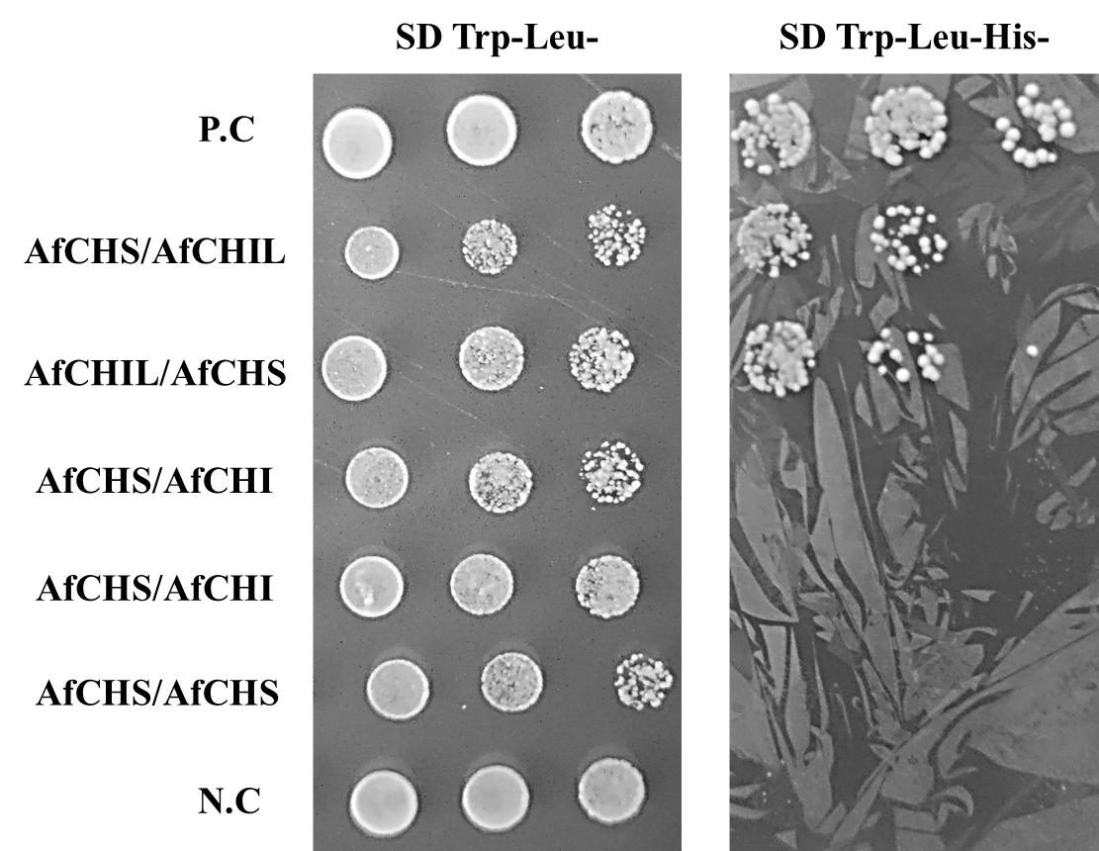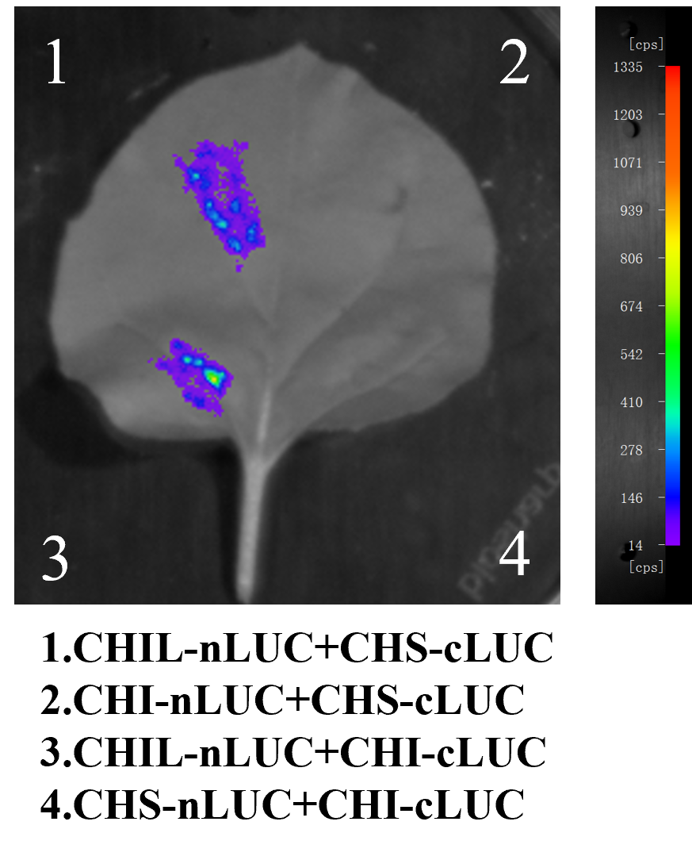
Figure S3. Interaction between AfCHS and AfCHI. (A) Yeast two-hybrid experiment demonstrating the protein-protein interaction between AfCHS and AfCHI. (B) Luciferase complementation imaging assay was used for analyzing the protein-protein interaction of AfCHS and AfCHI.

Figure S4 Subcellular localization of AfCHS and AfCHIL. We used Pro35S:GFP empty vector as a control, and fused AfCHS and AfCHIL proteins with GFP to observe their subcellular localization.

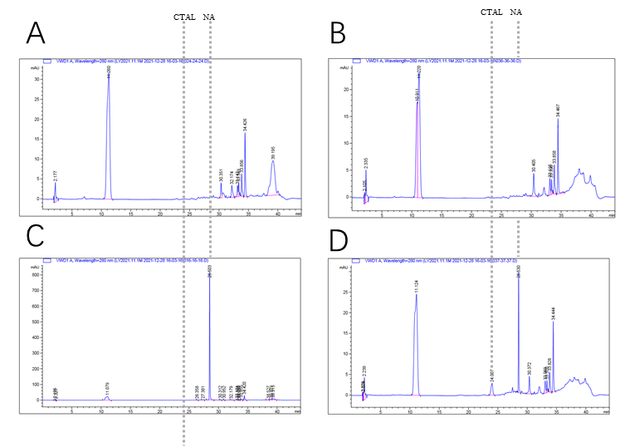
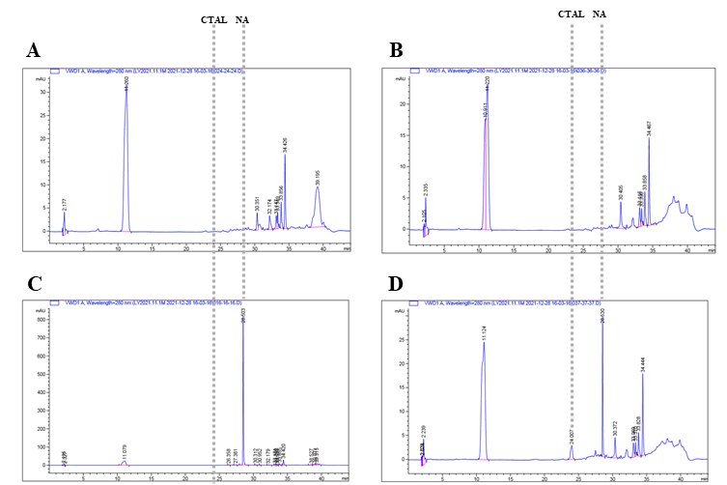
Figure S5 HPLC chromatograms showing the effect of AfCHIL on the enzymatic activity of AfCHS in vitro. (A) empty control, pET15b empty control. (B) only AfCHIL. (C) naringenin standard. (D) AfCHS and AfCHIL

Figure S6. Relative contents of CTAL and naringenin produced by AfCHS or AfCHS/AfCHIL. Data are presented in the form mean ±SD (n=3); **P<0.01.
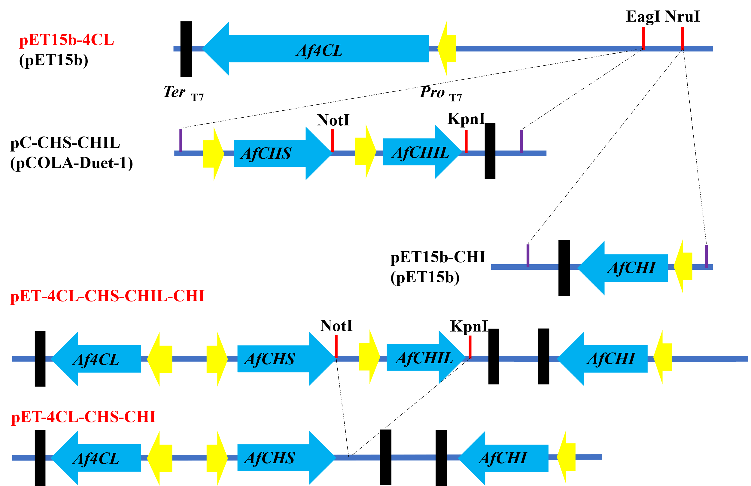
Figure S8. The constructed Genetically engineered E. coli to produce naringenin. pET15b-4CL，pET15b-CHI, and pC-CHS-CHIL composed pET-4CL-CHS-CHIL-CHI. Removal of AfCHIL using enzyme digestion of NotⅠ and KpnⅠ to generate pET-4CL-CHS- CHI.
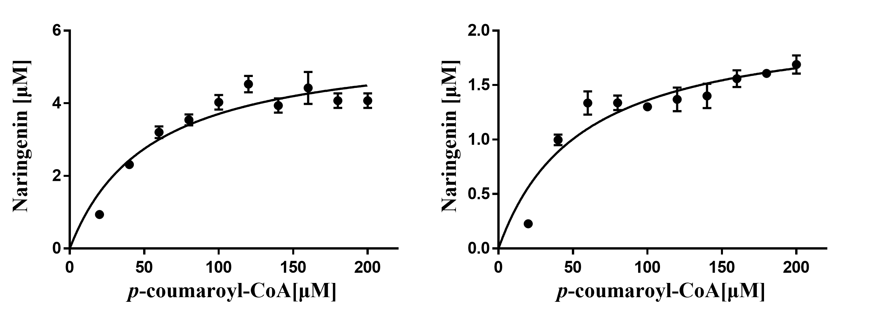
Figure S7. Michaelis-Menten plots of AfCHS and AfCHS/AfCHIL complex.
The kinetic parameters Km and Vmax were calculated by nonlinear regression analysis using GraphPad Prism 8 software. These results were averages of three experiments. Error bars denote SE of the means.

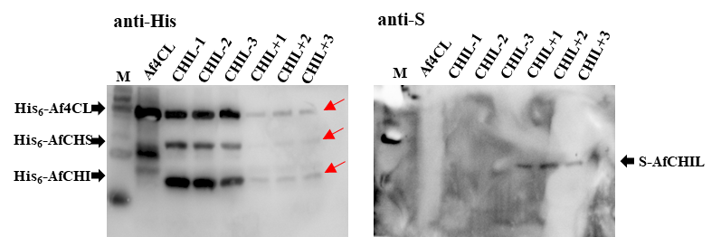
Figure S9. Immunological quantification of pET15b-4CL(Af4CL), pET-4CL-CHS-CHI (CHIL–) and pET-4CL-CHS-CHIL-CHI (CHIL+) were produced in the engineered E. coli cells. To quantify the expressed Af4CL, AfCHS, AfCHI and AfCHIL proteins, in which Af4CL, AfCHS and AfCHI was His₆-tagged while AfCHIL was S-tagged, the 30 μL crude extracts of the engineered E. coli cells were subjected to SDS-PAGE followed by western blotting analyses using anti-His6 IgG (to determine Af4CL, AfCHS and AfCHI) and anti-S IgG (to determine AfCHIL).

Table S1. Identity analysis of CHIs genes from different species.
 | ZmaCHIL | OsaCHIL | AtCHIL | AfCHIL | ZmaCHI | OsaCHI | AfCHI | AtCHI
ZmaCHIL | - | 69.74 | 55.26 | 52.63 | 28.51 | 28.8 | 23.98 | 23.86
OsaCHIL | 69.74 | - | 62.04 | 58.99 | 28.22 | 27.16 | 25.21 | 23.35
AtCHIL | 55.26 | 62.04 | - | 55.81 | 25.52 | 24.58 | 25.96 | 22.83
AfCHIL | 52.63 | 58.99 | 55.81 | - | 26.25 | 24.9 | 25.53 | 22.35
ZmaCHI | 28.51 | 28.22 | 25.52 | 26.25 | - | 77.12 | 61.44 | 54.4
OsaCHI | 28.8 | 27.16 | 24.58 | 24.9 | 77.12 | - | 61.11 | 52
AfCHI | 23.98 | 25.21 | 25.96 | 25.53 | 61.44 | 61.11 | - | 55.82
AtCHI | 23.86 | 23.35 | 22.83 | 22.35 | 54.4 | 52 | 55.82 | -

Table S2. Transcriptome analysis of EBGs genes in Allium fistulosum.
Gene name | Pfam annotation | W FPKM | WL FPKM | R FPKM | RL FPKM | W: R | W: W.L. | R: RL
g536041 | Chalcone-flavanone isomerase | 14.93 | 9.00 | 115.56 | 18.47 | UP | normal | normal
g97733 | Chalcone-flavanone isomerase | 4.95 | 10.70 | 211.16 | 13.03 | UP | normal | normal
g228276 | Chalcone synthases | 1.54 | 0.50 | 410.12 | 0.71 | UP | normal | normal

Table S3. Primers were used in the present study.
Primer Name | Sequence (5' to 3')
For gene cloning
CHS-F | ATGTCAAAGATTGAGGAGAT
CHS-R | TCAACCATCAATGGCCACACTCC
CHIL-F | ATGGAGTCGAAGATGATCAT
CHIL-R | TTAAGCGTCCGATAACATTA
CHI-F | ATGGAAGCAGTGACAAAGTT
CHI-R | TTATGAAAGCACCGGTAACT
4CL-F | ATGGGTTCAATATCAATGGATC
4CL-R | TCATGGTTGCTGAACATTAGG
For quantitative RT-PCR
afqchs-f | GTTGTCGAAATCCCAAAGCTC
afqchs-r | AAGATGAGGTGGGTTATGTGG
afqchil-f | AACATCTGAGCACCTGGAAG
afqchil-r | GCAGTCACAATGGCATCAAAG
afqchi-f | AGAATAAGGCGCTGACACAG
afqchi-r | CCGACAATCTCAATGCTATGC
actin-f | ACACGGCCTGGATAGCAACAT
actin-r | AGAGCAGTATTCCCAAGCATT
For Y2H assays (into pGADT7 or pGBKT7 vector)
AD-CHS-F | GGCCATGGAGGCCAGTGAATTCATGTCAAAGATTGAGGA
AD-CHS-R | CAGCTCGAGCTCGATGGATCCCCTAACCATCAATGGCCA
AD-CHIL-F | GGCCATGGAGGCCAGTGAATTCATGGAGTCGAAGATGAT
AD-CHIL-R | CAGCTCGAGCTCGATGGATCCCTTAAGCGTCCGATAACA
AD-CHI-F | GGCCATGGAGGCCAGTGAATTCATGGAAGCAGTGACAAAGTT
AD-CHI-R | TGCAGCTCGAGCTCGATGGATCCCTCATGAAAGCACCGGTAACT
BD-CHIL-F | TATGGCCATGGAGGCCGAATTCATGGAGTCGAAGATGAT
BD-CHIL-R | CCGCTGCAGGTCGACGGATCCCTTAAGCGTCCGATAACA
BD-CHI-F | TATGGCCATGGAGGCCGAATTCATGGAAGCAGTGACAAA
BD-CHI-R | CCGCTGCAGGTCGACGGATCCCTCATGAAAGCACCGGTA
For LCI assays (into nLUC and cLUC vectors)
CHIL-nLCU-f | GACGAGCTCGGTACCATGGAGTCGAAGATGATCAT
CHIL-nLCU-r | ACGAGATCTGGTCGACAGCGTCCGATAACATTA
CHIL-cLUC-f | GTCCCGGGGCGGTACCATGGAGTCGAAGATGATCAT
CHIL-cLUC-r | AGCTCTGCAGGTCGACTTAAGCGTCCGATAACATTA
CHS-nLCU-f | GACGAGCTCGGTACCATGTCAAAGATTGAGGAGAT
CHS-nLCU-r | ACGAGATCTGGTCGACACCATCAATGGCCACAC
CHS-cLCU-f | GTCCCGGGGCGGTACCATGTCAAAGATTGAGGAGAT
CHS-cLCU-r | AGCTCTGCAGGTCGACTTAACCATCAATGGCCACAC
CHI-nLCU-f | GACGAGCTCGGTACCATGGAGTCGAAGATGATCAT
CHI-nLCU-r | ACGAGATCTGGTCGACTGAAAGCACCGGTAACT
CHI-cLUC-f | GTCCCGGGGCGGTACCATGGAAGCAGTGACAAAGTT
CHI-cLUC-r | AGCTCTGCAGGTCGACTCATGAAAGCACCGGTAACT
For recombinant protein constructs (into pET15b vector)
pET-CHS-F | TGCCGCGCGGCAGCCATATGATGTCAAAGATTGAGGAGAT
pET-CHIL-F | TGCCGCGCGGCAGCCATATGATGGAGTCGAAGATGATCA
pET-CHI-F | TGCCGCGCGGCAGCCATATGATGGAAGCAGTGACAAAGTT
pET-CHS-R | TTAGCAGCCGGATCCTCGAGACCATCAATGGCCACACTCC
pET-CHIL-R | TTAGCAGCCGGATCCTCGAGAGCGTCCGATAACATTAATC
pET-CHI-R | TTAGCAGCCGGATCCTCGAGTGAAAGCACCGGTAACTTTTC
pET-4CL-F | TGCCGCGCGGCAGCCATATGATGGGTTCAATATCAATGGA
pET-4CL-R | GGGCTTTGTTAGCAGCCGGATCTCATGGTTGCTGAACATTAGGGT
For Production of chalcone in E. coli cells
MCS1-CHS-F | ACCATCATCACCACAGCCAGGATCCGATGTCAAAGATTGAGGAGA
MCS1-CHS-R | AGGCGCGCCGAGCTCGAATTACCATCAATGGCCACACTCCT
MCS2-CHIL-F | ATAAGAAGGAGATATACATAATGGAGTCGAAGATGATCAT
MCS2-CHIL-R | TATCCAATTGAGATCTGCCATAGCGTCCGATAACATTAATC
pET-4CL-CHS-CHIL1 | CAGGTCGACAAGCTTGCTTAAATAGGCGCCAGCAACCG
pET-4CL-CHS-CHIL2 | CTTAAGCATTATGCGGCCGCTCATCGTCATCCTCGG
Nru-CHI1 | GGCCATCCAGCCTCGCGTCGGCATGCAAGGAGATGGCGCCC
Nru-CHI2 | GGCTACGTCTTGCTGGCGTTCGGGCTACGTCTTGCTGGCGTTCG

