Longitudinal QA instructions

# Overview

This document provides the instructions for the longitudinal QA experiments as listed in Table 1. Tests are combined into a few scan protocols (i.e., ExamCard) for efficiency reasons. Please submit the required data quarterly archived in zip or 7z format.

## Tests and frequency

We distinguish core tests, which are the focus of the study. These tests should be performed on a three-monthly basis, with a monthly test of the axial B0 & B1 homogeneity as exception. In addition the results and logfiles of a weekly PIQT test are analyzed, as they provide information on f0 stability (important to be measured in the same phantom) and cryogen levels. Results from the monthly MR-MV alignment test using the manufacturer-provided batch script) will also be collected and analyzed.

Optionally analysis of the ACR large phantom tests and geometric distortion assessment using the Modus QUASARTM MRI3D phantom is possible, and we welcome submission of these data sets, as they provide an independent verification of the core tests, which are mainly based on Philips equipment.

Recommended additional tests are the Philips SNR & scaling tests in accordance with Elekta QA guidelines and periodic checks of the cage seal by measuring the RF interference as detailed in [1], but these tests will not be analyzed in this study.

## Phantom requirements

The phantoms required to conduct the longitudinal MR QA experiments are:

Core Tests: Phantoms and cradles are provided with the Unity MRL phantom

* 400 mm diameter performance phantom ‘Body phantom’ (Philips)
* 200 mm diameter performance phantom ‘Head / PIQT phantom’ (Philips)
* MR-MV alignment phantom (Philips)
* 7 slab geometric fidelity phantom (Philips)

Optional Tests: Phantoms would need to be acquired / be available at the participating institute and cradles would need to build / could be obtained from phantom manufacturer. Please contact us if you would need guidance on these, e.g. regarding the cradle design.

* Large ACR MRI phantom (various resellers)
* QUASAR™ MRID3D (ModusQA)

Recommended Tests (in addition to the PIQT phantom used in the scaling / SNR test):

* 2m conducting cable (e.g., power lead)

|  |  |  |  |
| --- | --- | --- | --- |
| Core Tests: | Phantom | Frequency | Required data: |
| B0 & B1 homogeneity (axial) | Body phantom | **monthly** | DICOM images |
| gantry B0 (w/o shim) | Body phantom | quarterly | DICOM images |
| B0 homogeneity (sag + cor) | Body phantom | quarterly | DICOM images |
| Flip angle (B1 homogeneity, sag + cor) | Body phantom | quarterly | DICOM images |
| Gradient fidelity (Philips) | 7-slab geometric distortion phantom | quarterly | DICOM images |
| FBIRN (gradient heating + ghosting) | PIQT phantom | quarterly | DICOM images |
| Radiation Influence | no phantom | quarterly | DICOM images (k-space) |
| Philips PIQT + Logfile | PIQT phantom | **weekly** | Test results in Spreadsheet, additionally: **Logfile** of test day |
| MR-MV alignment | MR-MV phantom | **monthly** | Test results in Spreadsheet |
|  |  |  |  |
| Optional Tests: |  |  |  |
| ACR (independent verification) | ACR Phantom - Large | quarterly | DICOM images |
| Gradient fidelity (Modus) | QUASARTM MRID3D | quarterly | DICOM images |
|  |  |  |  |
| Recommended Tests: |  |  |  |
| Philips SNR + scaling | PIQT phantom | daily | **-** |
| Cage seal / RF interference | 2m long cable | quarterly | - |

*Table 1: core, optional and recommended tests for longitudinal QA study*

## General experimental setup

* All experiments are conducted with Gantry on G=0 unless stated otherwise
* All phantoms should be positioned at isocenter using the specified cradle
* All experiments are conducted using the Anterior and Posterior coil unless stated otherwise
* Logfiles should be taken from the scanner on PIQT days and saved, as these provide useful longitudinal information on f0 stability, cryogen levels and shim settings.
* Always perform a ‘Repeat Prescans’ (Examination Tab) when 1) moving the table to a different position, or 2) reorienting / replacing the test object.

# B0 & B1 homogeneity and B0 dependence on gantry angle

ExamCard: **EXP_B0_B1_combined**

Phantom: Body Phantom

Receive coils: Body coil

QA tests: 2.1 B0 homogeneity, 2.2 B1 homogeneity, 2.3 B0 gantry angle dependence

Required output: DICOM images

## B0 homogeneity

*This test comes in two flavors: We encourage to use the B0 mapping research functionality if it is available. As an alternative, two separate protocol steps are provided which mimic the acquisition enabled by the clinical science key. Another quick dual echo sequence is used, which is designed to enable a link between images acquired at centers with B0 mapping functionality and at centers without it.*

For this test the body phantom is placed in transversal, coronal and sagittal position on the cradle that is provided with the phantom. Make sure the phantom is placed in the isocenter plane accurately. Have the phantom settle for at least 15 minutes each time the phantom is repositioned. Do not manually alter the FOV settings of the scans (all offsets should be set to 0). Start with the transverse orientation (monthly). Continue with testing the B1 homogeneity (see next section). Every three months the gantry-angle dependency of B0 shall be tested and the measurement of B0 and B1 shall be repeated with sagittal and coronal orientation. Make sure to run ‘Repeat Prescans’ after repositioning the phantom.

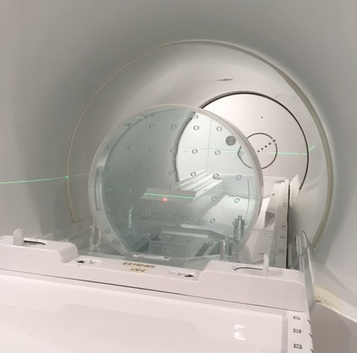

*Figure 1: body phantom in transverse position. Use the Philips cradle, which aligns phantom correctly in X and Y direction. Move the phantom to isocenter along Z.*

## Flip angle accuracy (B1 mapping)

*This test performs a B1 calibration by acquiring images at flip angles of 60° and 120° and calculating (π/3)arccos(S120° / (2·S60°)), which can then be translated into a deviation from the nominal RF power.*

Positioning of the phantom is the same as in 2.1 and should be run directly after the B0 homogeneity measurement.

## Gantry dependent B0

*For this test only one echo time is used. Based on the reconstructed image phase, the B0 stability across gantry angles is evaluated.*

Transverse phantom setup as for 2.1 & 2.2. The protocol step acquires a series of 13 images, which should be acquired at gantry angles 181*°*, 210*°*, 240*°*, 270*°*, 300*°*, 330*°*, 0*°*, 30*°*, 60*°*, 90*°*, 120*°*, 150*°*, and 180*°* to span one full forward rotation. After each image the sequence is paused to allow the user to move the gantry forward. For each gantry position a stack of images is acquired, which is reconstructed with magnitude + phase. As no shimming is performed between the different gantry angles, this test is sensitive to the passive (hardware) shimming. *Analysis:* For each gantry angle, the phase map is unwrapped and the absolute difference to the phase map at gantry angle 0*°* is calculated to remove the static B0 contribution (and contribution from coil sensitivities). The standard deviation and peak-to-peak values are calculated from each difference image and are reported in ppm to quantify the contribution from the gantry rotation.

# Geometric fidelity (Philips)

ExamCard: **EXP_PHILIPS_gfidelity**

Batch: Philips SPT, 3D_Geometric_QA

Phantom: Philips Geometric QA phantom (7 slab phantom)

Receive coils: body coil

Required output: DICOM images from both the batch scan as well as the additional examcard

Start the SPT Batch. The phantom is positioned following the batch instructions, and the batch is run until the end. Run the scan in the provided ExamCard directly afterwards without adjusting the FOV. The ExamCard contains an additional acquisition with opposite readout direction, which is complementary to the scan that is ran by the batch. Please send the DICOM images from both scans in for analysis. The DICOM files from the batch can be found under the patient named 3D_GEOM_QA.

Each scan is analyzed using the vendor provided software. B0 induced distortions are decoupled from gradient errors during the analysis following [2]. The maximum displacement (99 percentile) is reported for ROI with varying diameter (DSV).

# Ghosting and stability during dynamics (FBIRN)

ExamCard: **EXP_FBIRN**

Phantom: Philips Head phantom (PIQT) + cradle

Receive coils: anterior + posterior

Required output: DICOM images

This ExamCard includes the ghosting test as well as the FBIRN test. B0 mapping sequences are acquired before and after the dynamics sequences to determine f0 drifts when playing gradient intensive sequences. Position the phantom as for the standard PIQT test, as shown in Figure 3. Bring the phantom to isocenter by moving the table inwards.

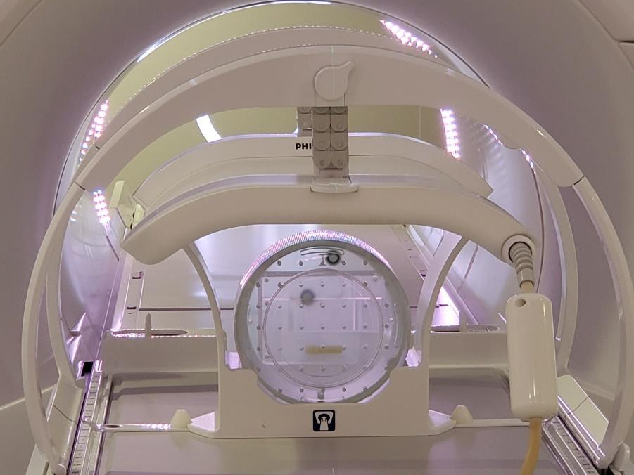

Figure 2: Setup of the Philips PIQT phantom.

After placing the phantom wait for 10 min before commencing the scan. This is needed to: 1) have the phantom fluid settle, and 2) reduce the effects of the preceding scan session on gradient temperature (please do not run this test directly after a gradient intensive scan session, e.g., DWI or bSSFP time-series). The ExamCard contains several time-series measurements to examine the effect of gradient heating and static images to test for ghosting. All scans are acquired with zero offset or a pre-defined offset for the ghosting scans.

1. SCOUT
2. t 2DFFE_dualecho_flyback (before)
3. SS bFFE 2.5min (cold)
4. SS T1FFE 2.5min (cold)
5. SS bFFE 2.5min (hot)
6. SS T1FFE 2.5min (hot)
7. t 2DFFE_dualecho_flyback (after)
8. EPI ghosting†
9. TSE ghosting†

†*the FOV is pre-defined such that the object is located in the bottom left quadrant (to visualize ghosts in two directions). No change in phantom position is required.*

The FBIRN analysis is performed on both the single-slice (SS) bFFE sequence, which is used for motion monitoring during treatment, and on the SS T1FFE sequence, which allows for the reconstruction of phase images, following [3]. Additionally the frequency drift over the dynamic time-series is analyzed by comparing the B0 maps calculated from the dual echo sequences prior to and directly after the time-series. The amount of ghosting is calculated on the last two imaging sequences (EPI ghosting and TSE ghosting) by taking the ratio of the average ghost intensity and the average signal intensity of the object following the procedure described by [4] and reported in %. Ghosts

# Radiation influence

ExamCard: **EXP_radiationeffect**

HW required: MRI scanner, Linac (RTD in service mode)

Phantom: Philips Head phantom (PIQT) + cradle

Receive coils: anterior + posterior

Required output: DICOM images

Place the head phantom in the PIQT cradle. See PIQT batch for instructions. The ExamCard contains a set of time-series measurements, which are run with and without radiation. **Note that the PIQT phantom should not be irradiated in this experiment.** The image stacks do not need to be adjusted (acquired with no offsets). Make sure to set up the treatment field with enough MU to irradiate for one minute. Start the scan immediately after beam on. After scan #2 the phantom is removed from the bore (moving the table in and out of the bore is fine). scans 3-5 are then performed without the phantom to provide noise-only scans (This somewhat cumbersome approach of removing the phantom was necessary, because noise-only (alpha=0) scans are not available without a research key).

1. SCOUT
2. ffe2d w phantom norad

<REMOVE PHANTOM FROM BORE>

1. ffe2d wo phantom norad

<prepare treatment field >

1. ffe2d wo phantom 10x10 (image while irradiating 10x10 field at G=0)

<prepare treatment field >

1. ffe2d wo phantom 56x22 (image while irradiating 56x22 field at G=0)

# Philips SPT: Periodic Image Quality Test (PIQT)

Batch files: **PIQT test via SPT**

Receive coils: anterior + posterior

Phantom: PIQT

output: PIQT report

These are the vendor provided QA measurements. Full instructions are provided when the batch is started and can be found in the instruction manual. At the end of each batch a report is generated, which can be stored offline for documentation. Please send in the report for inspection and also the log file from the PIQT days.

# Optional Tests

## ACR

ExamCard: **EXP_ACR**

Phantom: ACR phantom

Receive coils: anterior + posterior

Output: DICOM images

Place the phantom in the PIQT cradle or use a custom cradle (any other way that allows for reproducible setup in the isocenter is fine). Level the phantom using a non-ferromagnetic spirit level. Move the phantom to isocenter.

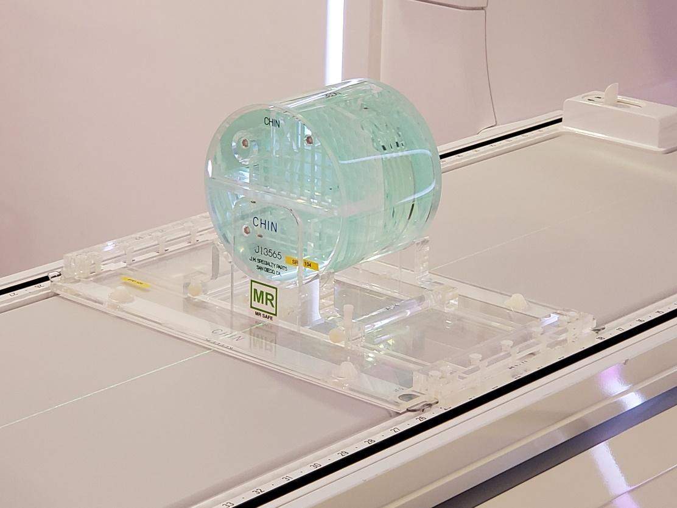

*Figure 3: setup of the ACR phantom: use an MR-compatible spirit level to level the phantom along all three axes if a dedicated cradle is not available.*

Plan the imaging FOV following the ACR instructions [5]. To assure accurate positioning in the isocenter the maximum offset of the imaging plane along feet-head is 5mm. If the required imaging offset is larger, the phantom needs to be realigned. Three sequences are ran: the T1 and T2 multi-slice sequences (designed for the ACR measurement). The analysis is performed as described in the ACR instructions [5]. Analysis is based on the code provided by the Open Source Automatic Quality Assurance (OSAQA) project (http://jidisun.wixsite.com/osaqa-project/download).

## Modus QUASARTM MRI3D phantom

ExamCard: **EXP_MRID3D_gfidelity**

Phantom: Modus QUASARTM MRI3D

Receive coils: body coil

Output: DICOM images

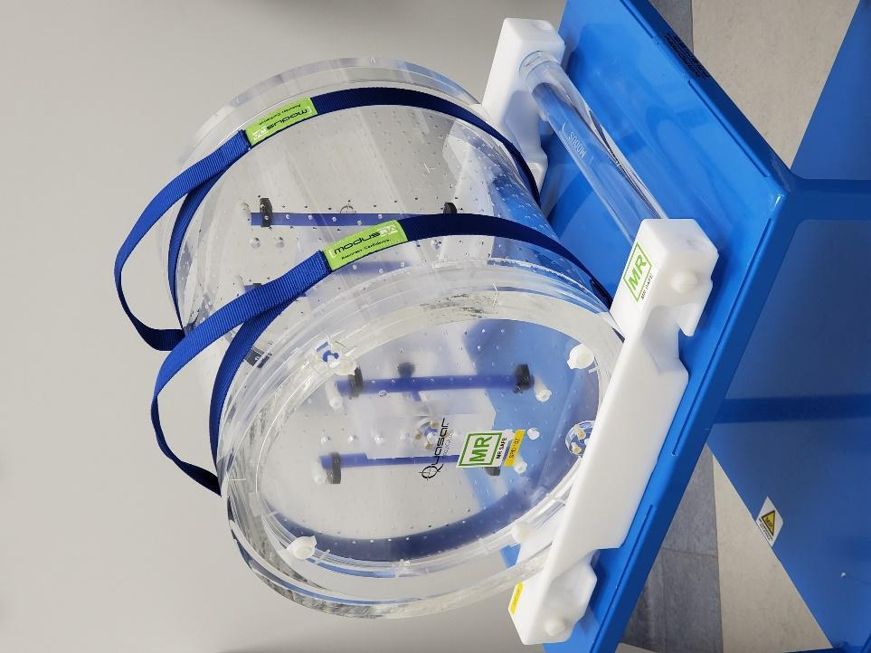

Figure 4. Modus MRI3D in a dedicated cradle. Similarly to the Philips body phantom setup, the posterior coil needs to be removed such that the central marker of the phantom (cross) can be positioned in the isocentre.

Follow the instructions provided by the phantom manufacturer in combination with the above mentioned exam card. Please enter the date of the scan in the placeholders within the exam card, as this makes processing in the commercial evaluation software more straight-forward.

# Recommended Tests

## RF interference

Batch file: C:\NMR\Gyroscan\testbatch\pbsviq_spurious_t15_180hz.acq

Phantom: 2 meter conducting wire

Receive coils: body coil

Output: DICOM images

The 2 m long wire acts as an antenna to increase the sensitivity of the measurement, place it on the couch through the bore. Run the specified batch program and follow the instructions on screen. Run the batch four times to test various potential sources of spurious noise during imaging.

1. LINAC OFF, to test the influence of in-room peripherals
2. Magnetron ON, but no radiation to test the influence of magnetron only
3. LINAC OFF, but moving MLCs to test the influence of MLC motors
4. LINAC ON (smallest field size) to test the influence in full operational mode

Note that the patient couch remains powered during imaging. Potential RF interference is tested under (1). The magnetron is turned on by confirming a field size setup (2), while the MLCs are best operated using the MLC Diagnostic Control tool (3). Finally, (4) is performed with the smallest field size to decouple radiation induced effects (which are tested under 5.5) from RF induced effects. Scans are automatically saved under patient name: spur T15 180Hz/px. Inspect the images for structured noise. The automatic window level scaling on the scanner host should be around 1200/700 (Window/Level). Deviations from this window/level setting indicate that spurious noise is present. Note down the window/level settings for each of the five images and store the DICOM images.

## Philips SPT: SNR and scaling tests

Batch files: **SNR and Scaling tests via SPT**

Receive coils: anterior + posterior

Phantom: PIQT

Output: SPT reports

These are the vendor provided QA measurements. Full instructions are provided when the batch is started and can be found in the instruction manual. At the end of each batch a report is generated, which can be stored offline for documentation. Daily SNR and scaling tests are recommended, as they can indicate e.g. faulty coil channels, which could reduce image contrast / visibility of lesions in a non-obvious way.

**References**

[1] Tijssen RHN, Philippens MEP, Paulson ES, Glitzner, M, Chugh, B, Wetscherek A, Dubec M, Wang J, van der Heide U. Radiother Oncol. 2019;132:114-120.

[2] Baldwin LN, Wachowicz K, Thomas SD, Rivest R, Fallone BG. Characterization, prediction, and correction of geometric distortion in 3 T MR images. Med Phys. 2007;34:388-99.

[3] Friedman L, Glover GH. Report on a multicenter fMRI quality assurance protocol. J Magn Reson Imaging. 2006;23:827-39.

[4] Simmons A, Moore E, Williams SC. Quality control for functional magnetic resonance imaging using automated data analysis and Shewhart charting. Magn Reson Med. 1999;41:1274-8.

[5] Radiology ACo. Large Phantom Guidance. 2018.