Supplementary material
Species | Mean Gibbs p |  |  | B2_{geo} | B2_{env} | Habitat range |  |  | Range overlap with current
 | Near-present | SSP 2-4.5 | SSP 5-8.5 |  |  | Current | SSP 2-4.5 | SSP 5-8.5 | SSP 2-4.5 | SSP 5-8.5
E. albensis | 0.0050±0.0005 | 0.0075±0.0008 | 0.0087±0.0009 | 0.6640 | 0.8032 | 2385 | 6939 | 10539 | 2379 | 2334
E. atrorubens | 0.1711±0.0135 | 0.1515±0.0108 | 0.1333±0.0098 | 0.8482 | 0.6887 | 317184 | 214085 | 143342 | 182088 | 104310
E. dunensis | 0.0172±0.0018 | 0.0179±0.0018 | 0.0231±0.0024 | 0.6092 | 0.1631 | 43026 | 45409 | 65680 | 42946 | 42440
E. fageticola | 0.0031±0.0004 | 0.0033±0.0004 | 0.0033±0.0004 | 0.3926 | 0.7497 | 2047 | 2498 | 3184 | 2035 | 1570
E. helleborine | 0.2880±0.0219 | 0.3525±0.0267 | 0.3671±0.0282 | 0.8524 | 0.7676 | 385645 | 462798 | 439304 | 310072 | 270798
E. kleinii | 0.0050±0.0007 | 0.0047±0.0006 | 0.0041±0.0005 | 0.6998 | 0.2792 | 5986 | 5701 | 3833 | 5251 | 3509
E. leptochila | 0.0145±0.0021 | 0.0107±0.0016 | 0.0085±0.0013 | 0.5831 | 0.6154 | 47869 | 32277 | 24684 | 29384 | 21445
E. lusitanica | 0.0026±0.0006 | 0.0090±0.0019 | 0.0128±0.0024 | 0.7095 | 0.9031 | 7440 | 51423 | 87987 | 7440 | 7440
E. microphylla | 0.0441±0.0058 | 0.0465±0.0060 | 0.0448±0.0056 | 0.8050 | 0.5386 | 113254 | 147815 | 142499 | 85288 | 60998
E. muelleri | 0.0554±0.0069 | 0.0540±0.0068 | 0.0489±0.0054 | 0.7267 | 0.6163 | 172179 | 164138 | 129545 | 120446 | 85446
E. palustris | 0.1978±0.0173 | 0.2171±0.0176 | 0.2114±0.0167 | 0.8535 | 0.6581 | 336987 | 320853 | 274912 | 248167 | 185529
E. phyllanthes | 0.0060±0.0009 | 0.0116±0.0016 | 0.0144±0.0020 | 0.8391 | 0.6320 | 9583 | 24185 | 31859 | 9583 | 9583
E. purpurata | 0.0319±0.0046 | 0.0206±0.0023 | 0.0138±0.0015 | 0.6662 | 0.5072 | 101232 | 32411 | 11477 | 16632 | 4504
E. tremolsii | 0.0113±0.0022 | 0.0158±0.0023 | 0.0178±0.0023 | 0.7190 | 0.3547 | 24465 | 41097 | 49072 | 21886 | 19846
Table S2 Mean Gibbs p with standard error for Epipactis species in near-present conditions and two future climate scenarios (SSP 2-4.5 & SSP 5-8.5) in 2061-2080, Levins’ B2 values in geographic and environmental space, area of suitable habitat (in 50km² units) above the Maximum Test Sensitivity and Specificity threshold, and overlap of current and future habitat areas.

Fig. S1 Latitudinal shifts in Epipactis habitat from current conditions to conditions predicted for 2061-2080 by two climate models, SSP 2-4.5 and SSP 5-8.5.
SSP 2-4.5 | SSP 5-8.5
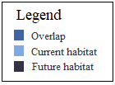  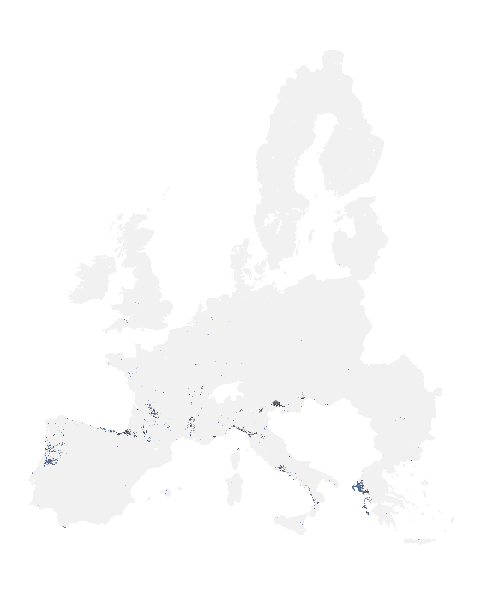 | 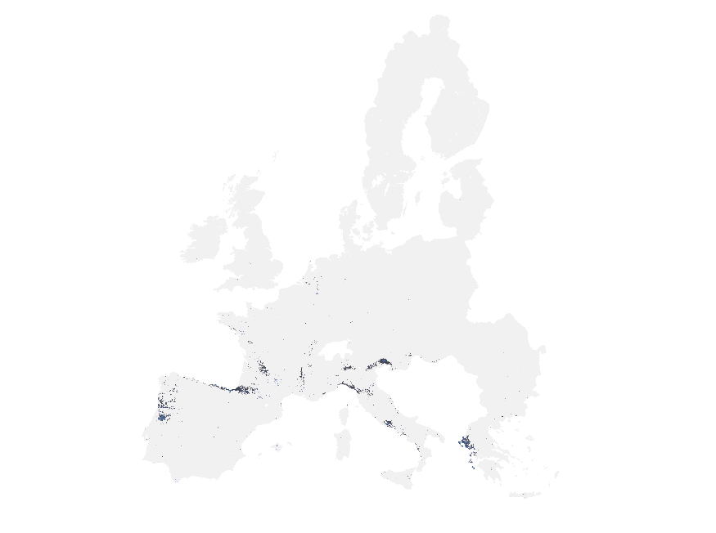
E. albensis

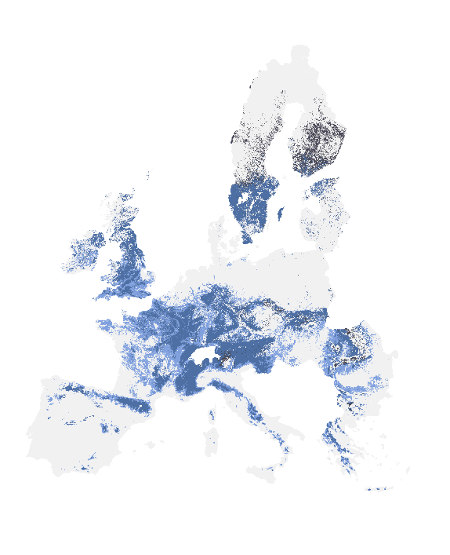  E. atrorubens | 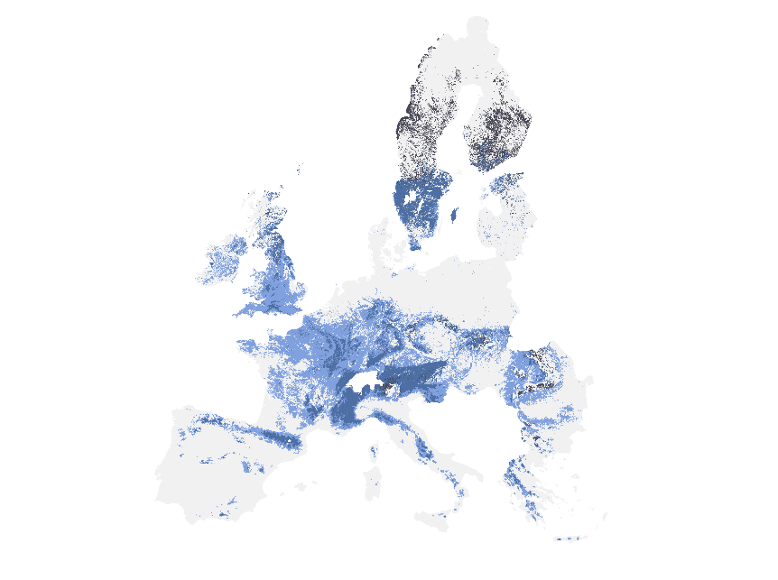
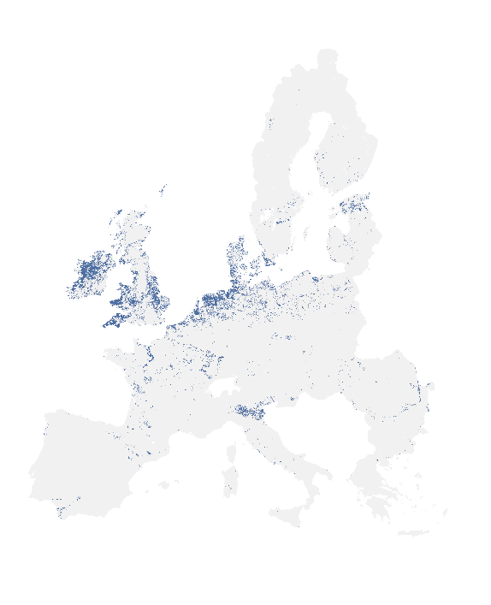  E. dunensis | 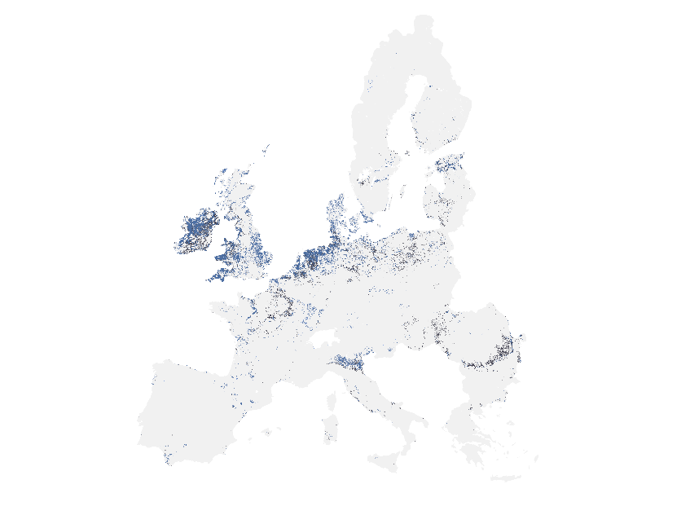
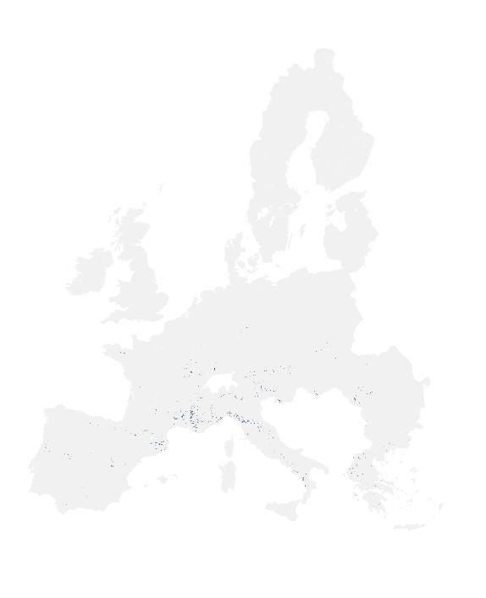  E. fageticola | 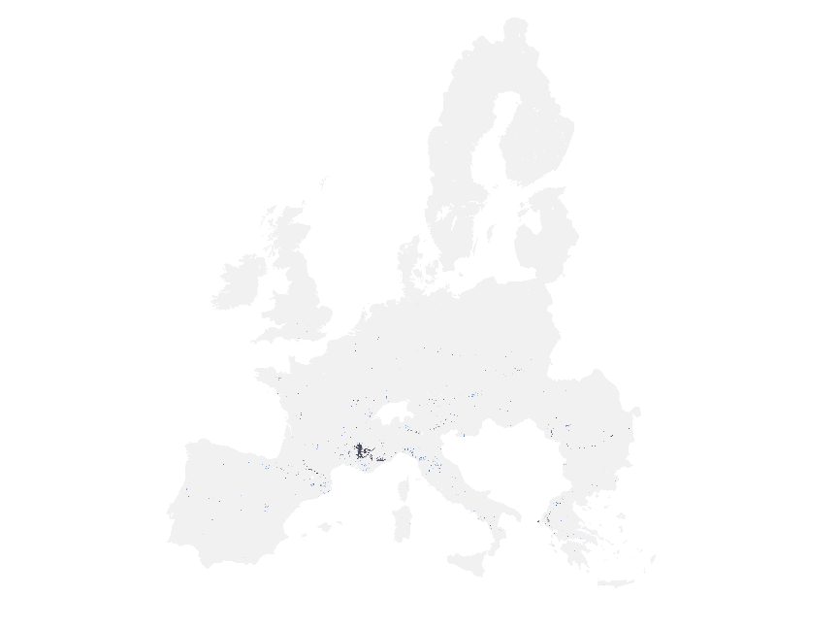
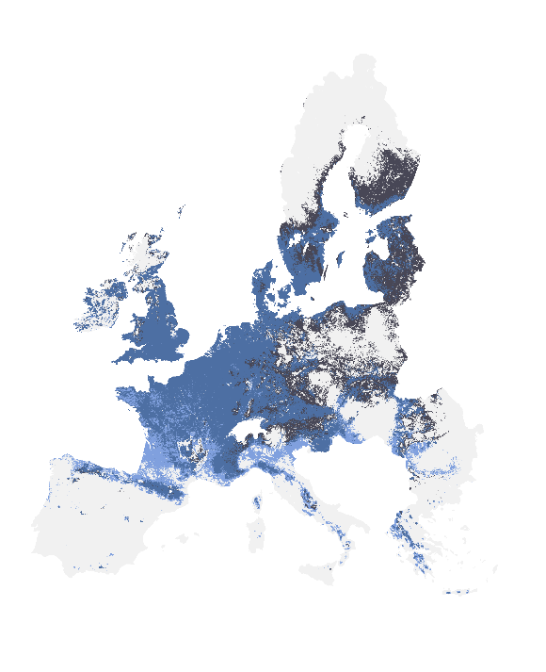  E. helleborine | 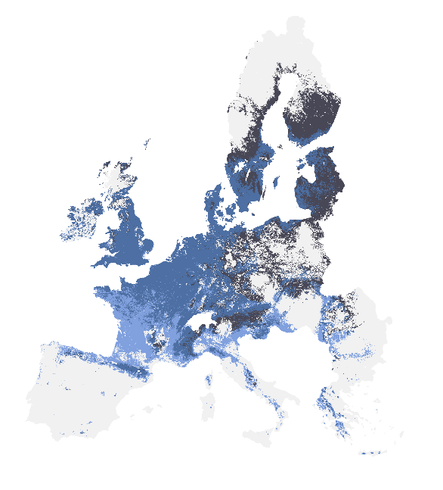
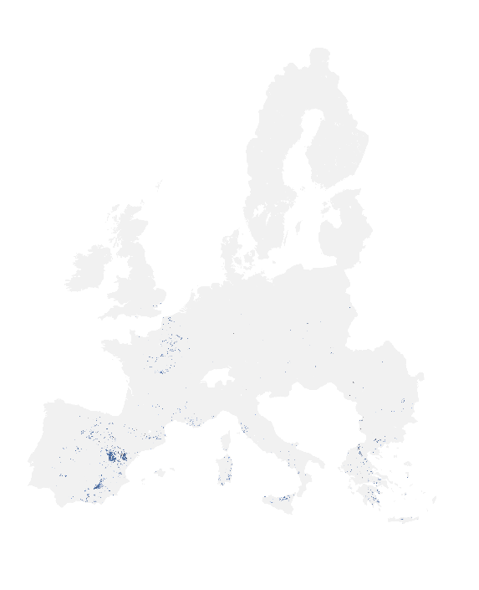  E. kleinii | 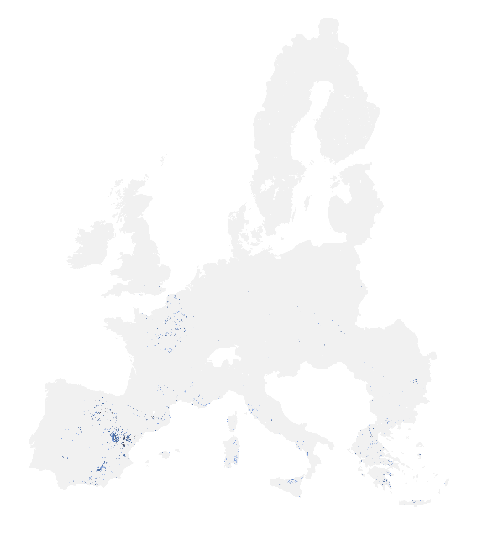
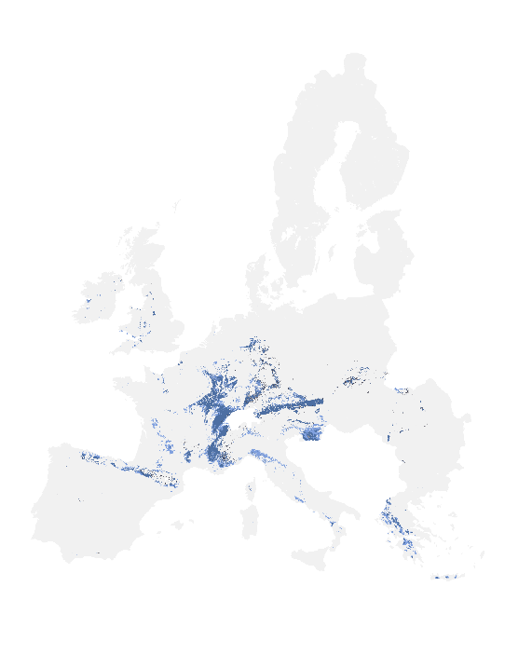  E. leptochila | 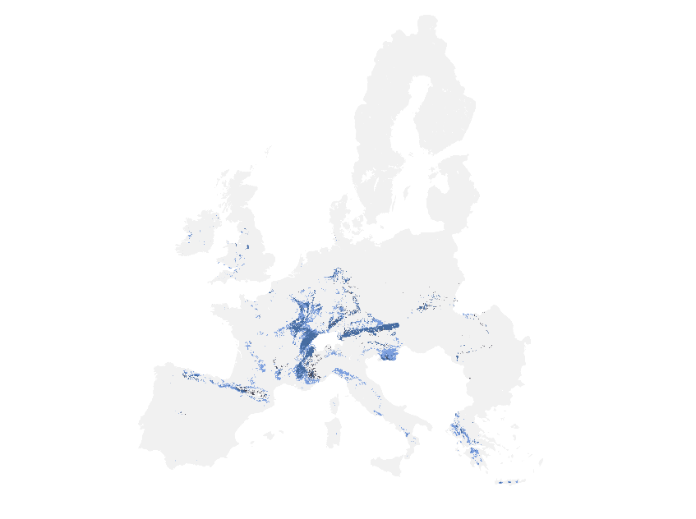
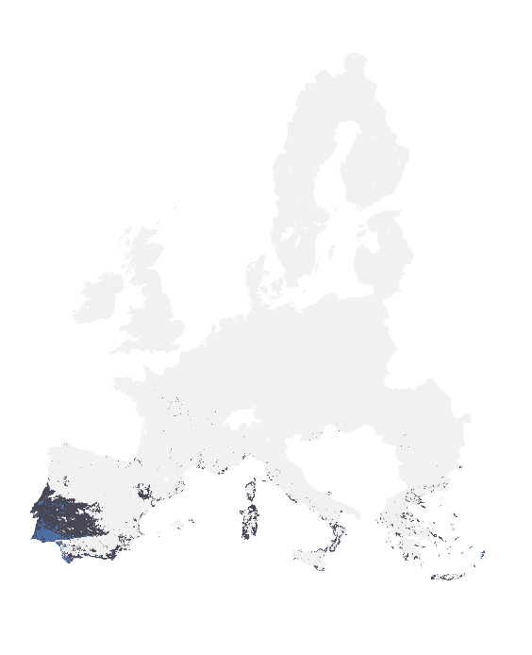  E. lusitanica | 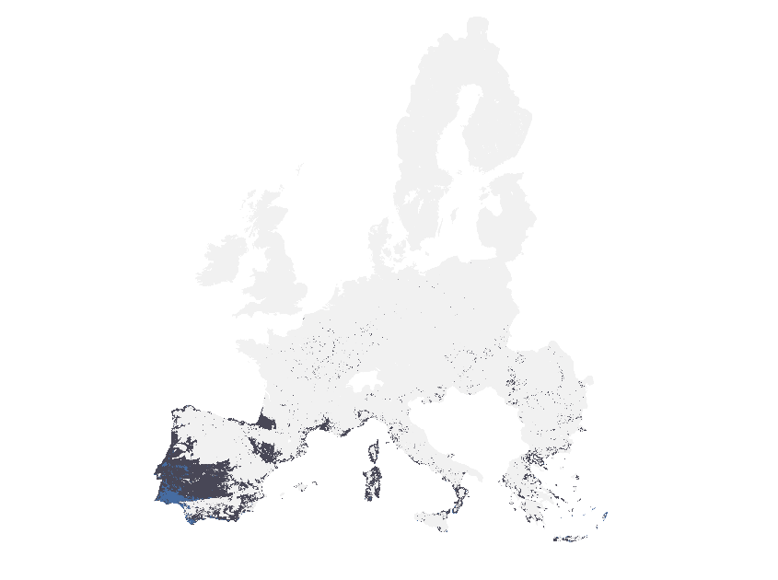
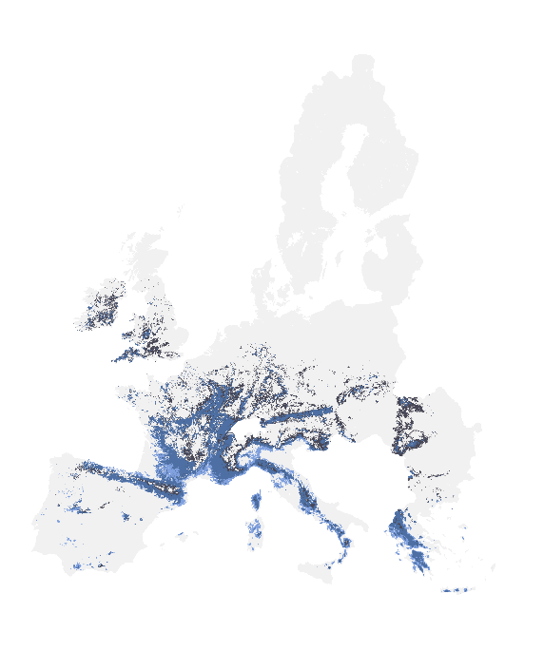  E. microphylla | 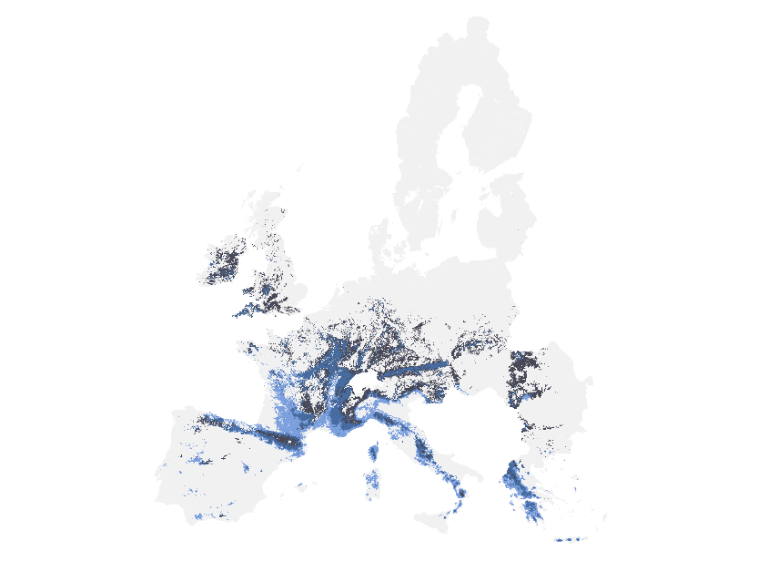
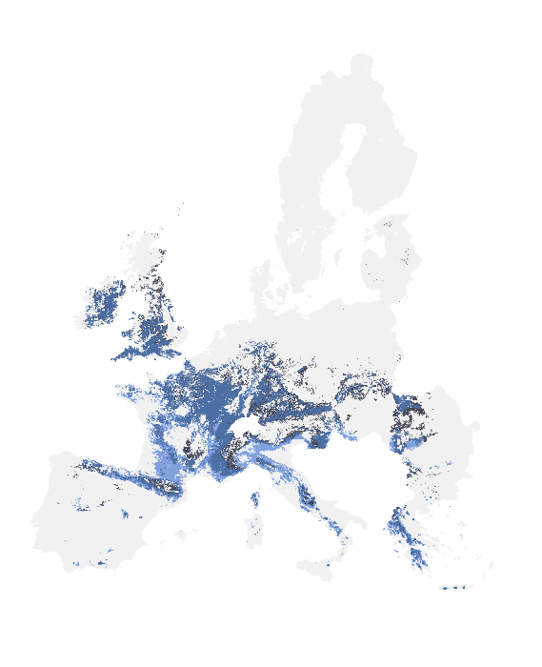  E. muelleri | 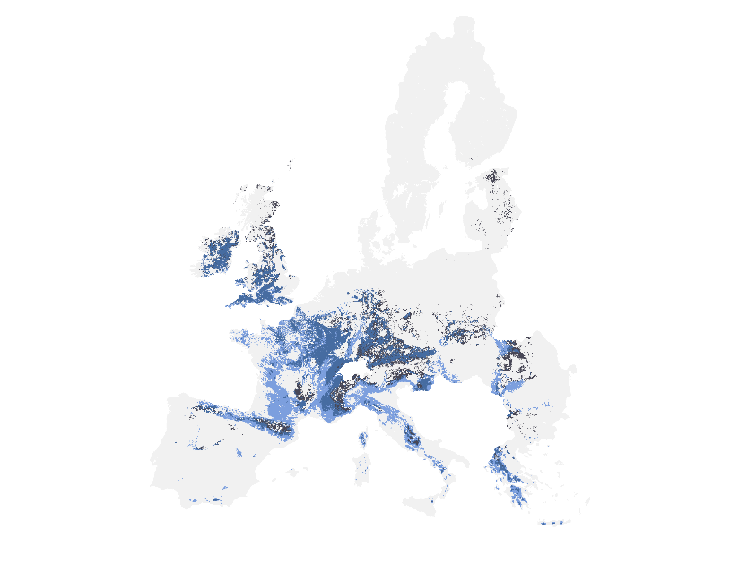
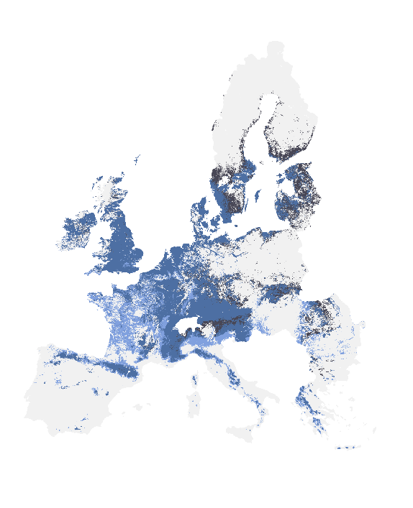  E. palustris | 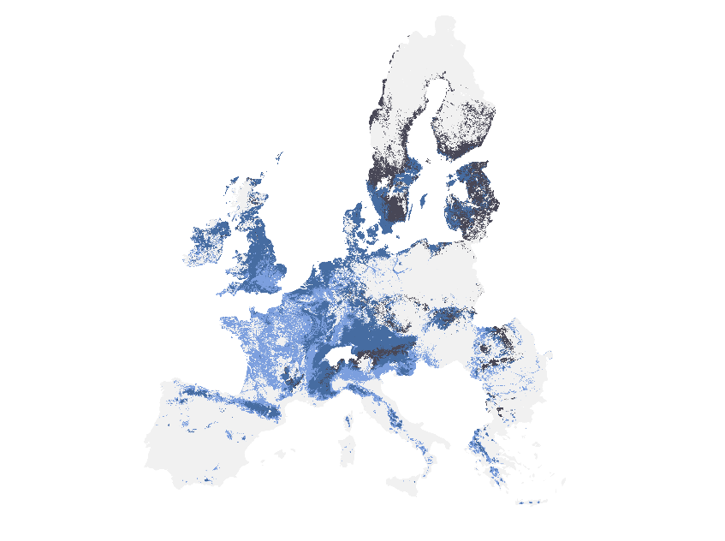
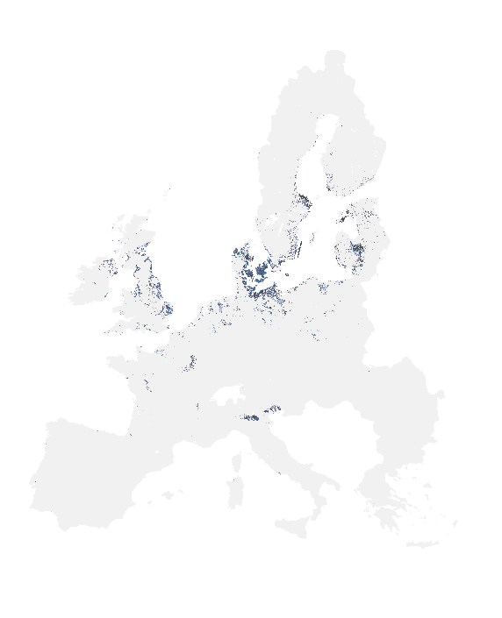  E. phyllanthes | 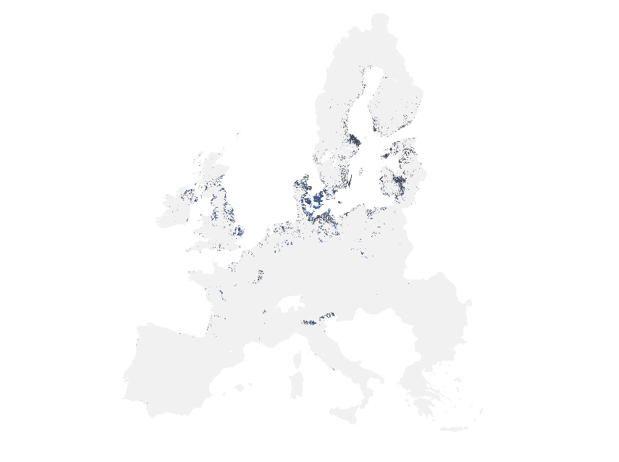
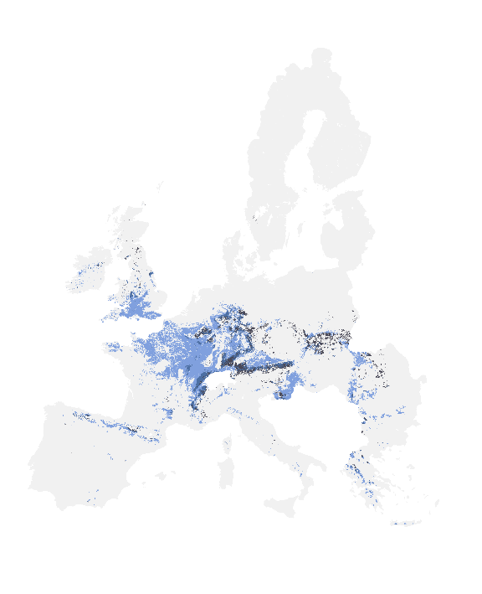  E. purpurata | 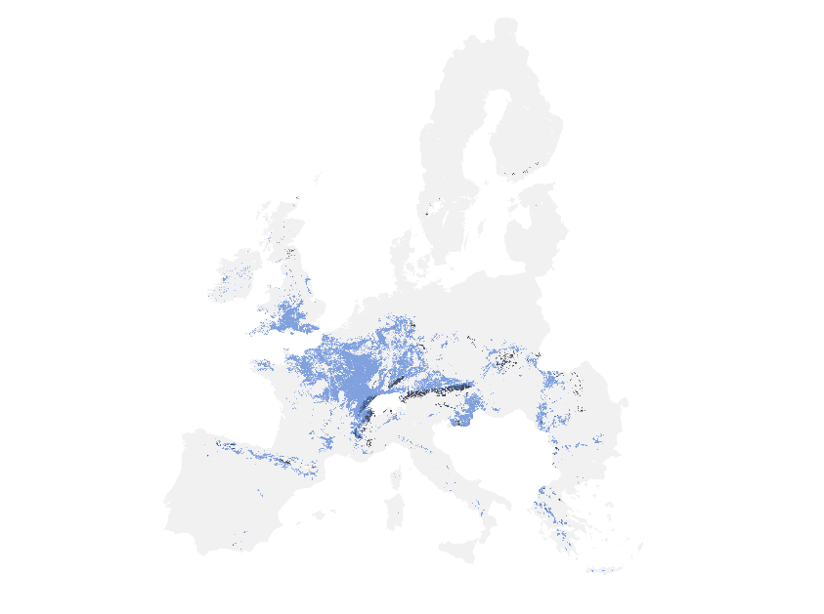
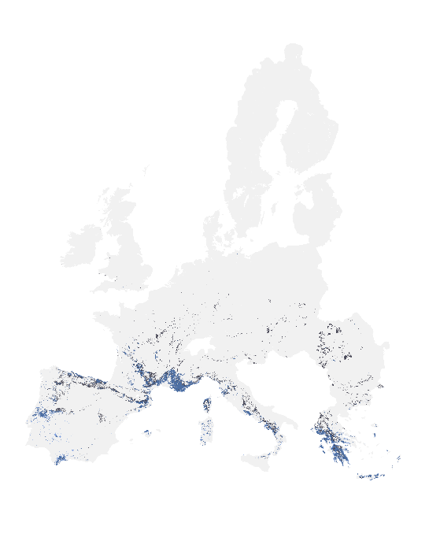  E. tremolsii | 