Supplementary Material A – Additional Figures

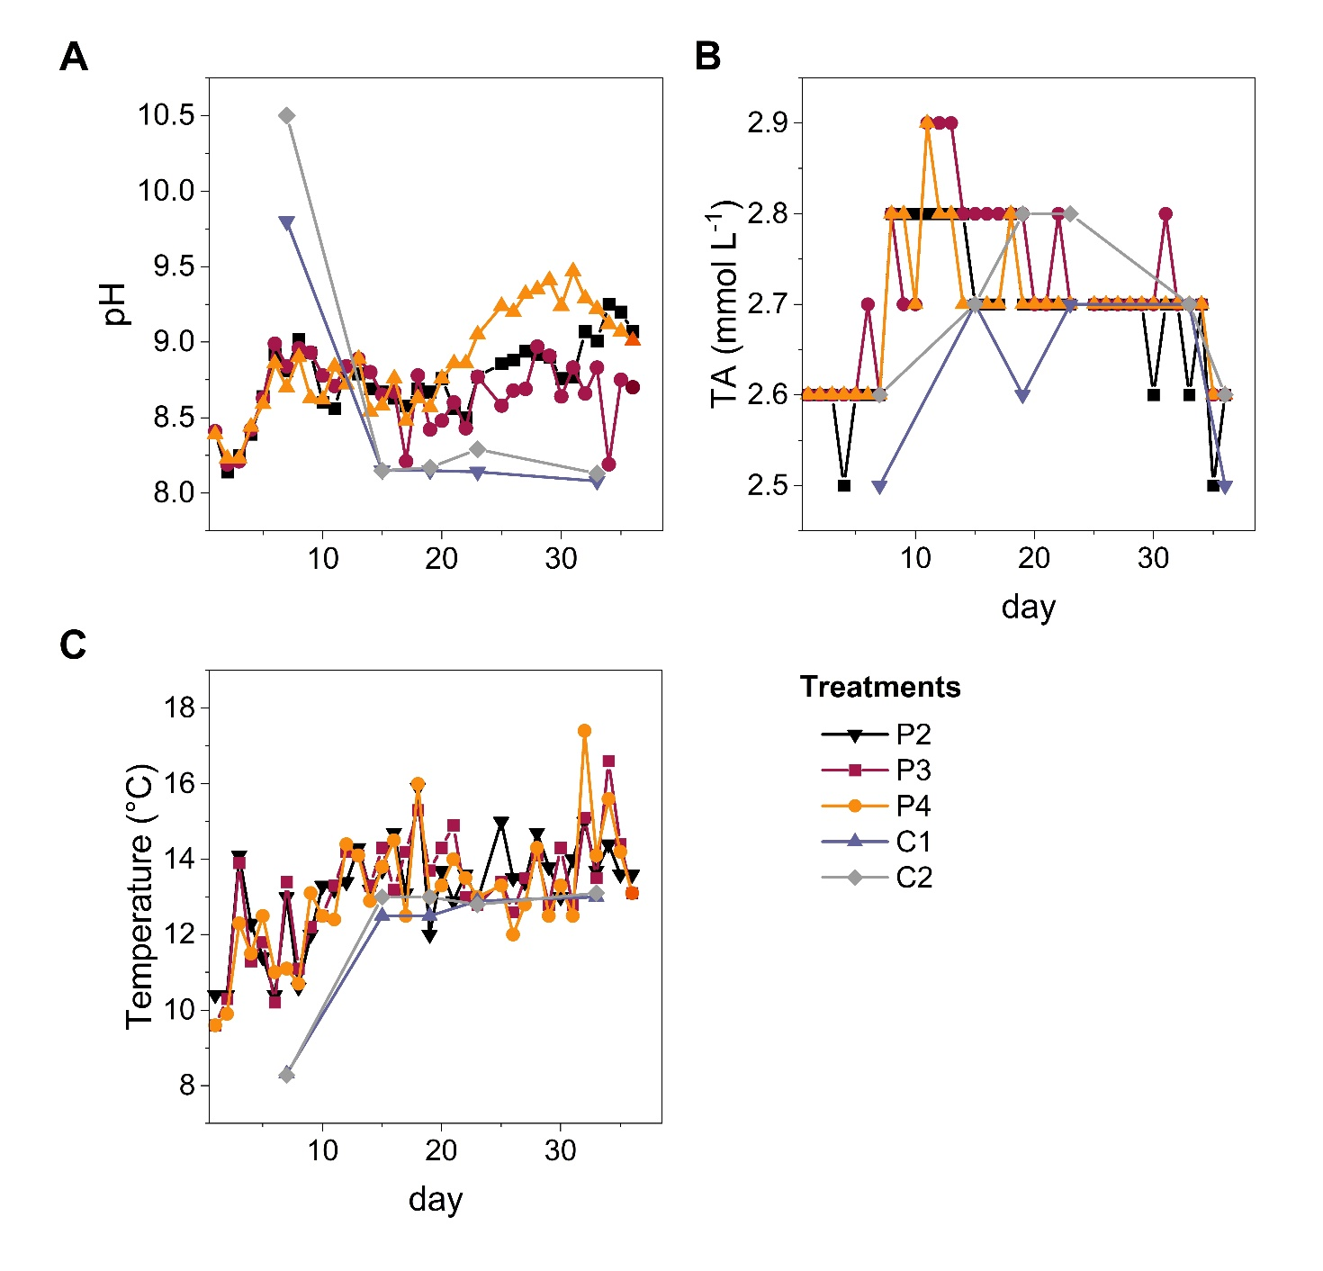

**Supplementary Figure 1:** ** **pH, **(B)** total alkalinity (TA) and **(C)** temperature over the incubation period of 38 days in the three biological replicates P2, P3, P4 represented by black squares/line, red circles/line and yellow triangles/line respectively, and the two biota-freecontrols C1 and C2, represented by violet triangles/line and grey rhombus/line, respectively.

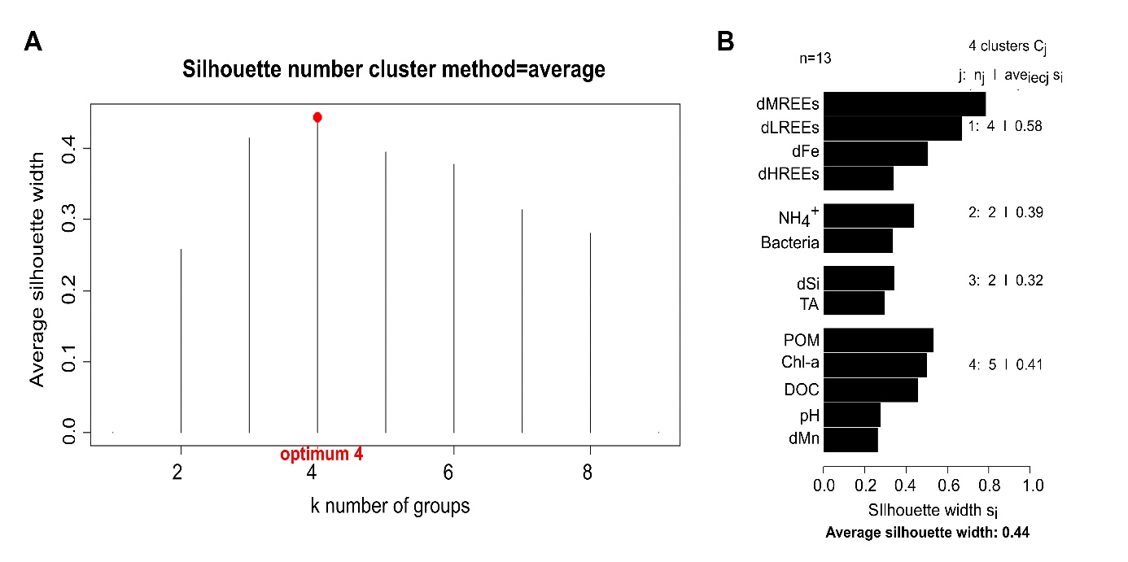**Supplementary Figure 2:** Qualitative statistical parameters concerning cluster analysis. (**A)** average silhouette width as function of number of cluster k. For the studied biogeochemical parameters, the optimal cluster number with maximum average silhouette width of 0.44 is k=4. (**B)** shows the individual silhouette width for each parameter and for each of the k=4 clusters. All parameters seem to fit their assigned cluster with silhouette widths being >0.2. The resulting dendrogram is shown in Supplementary Figure 3.

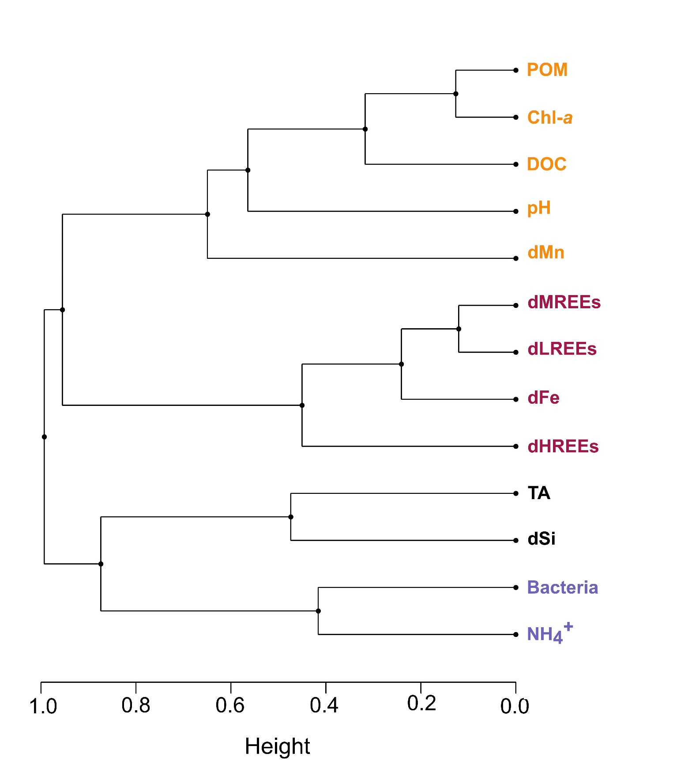

**Supplementary Figure 3:** Dendrogram of studied biogeochemical parameters for the optimal cluster number k=4 (Figure 2), based on a 1-|rho| distance matrix and the complete linkage algorithm. Individual clusters (k1-k4) are distinguished by the colours yellow, red, black and violet.

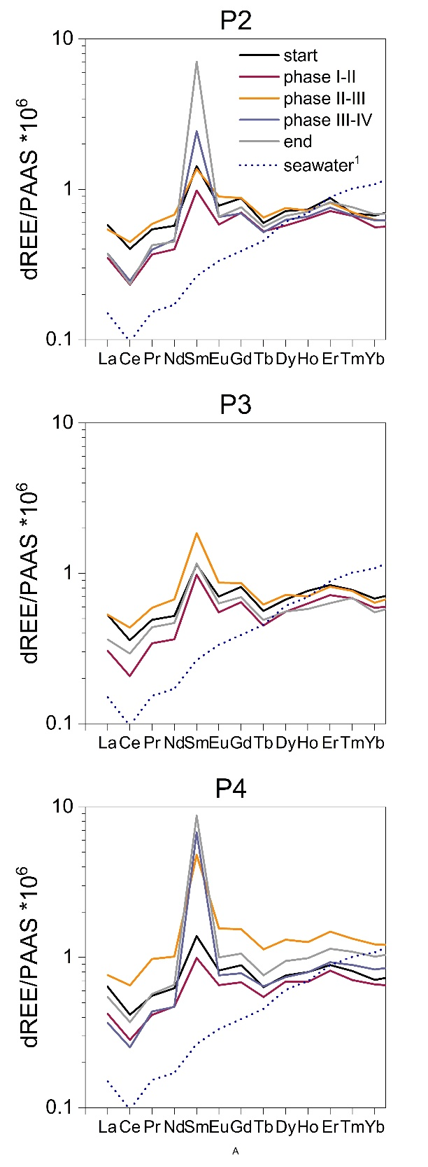

**Supplementary Figure 4:** Dissolved REE concentrations normalized to Post-Archaean Australian Shale (PAAS,(Rudnick and Gao, 2003) in the three biological replicates (P2-P4). Five different times are shown marking the start (black line) and end (grey line) point of the incubation, as well as the transition points between REE-characteristic phases distinguished by the red, yellow and violet lines, respectively. The dotted blue line represents shale-normalized dREE concentrations in coastal North Sea water during spring time as studied by Paffrath et al. (2020).

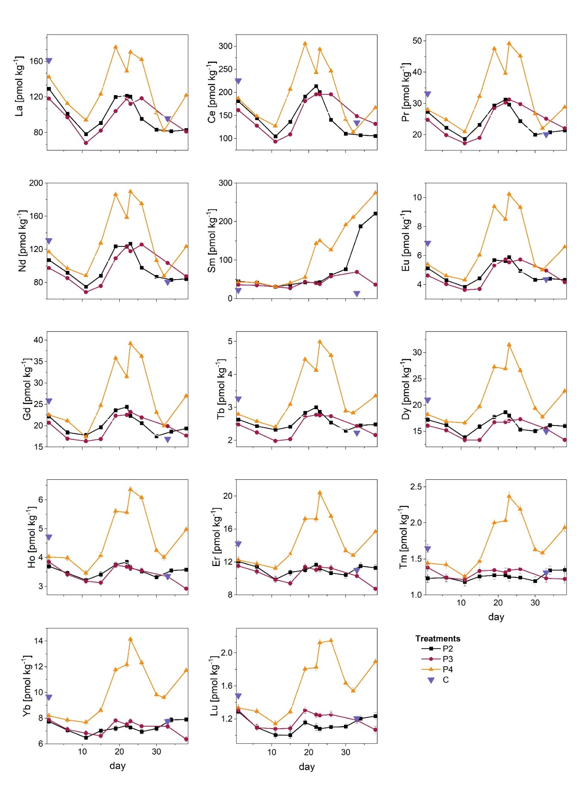

**Supplementary Figure 5:** Absolute concentrations for each individual dREE in pmol kg-1 over the incubation period of 38 days in three biological replicates P2-P4, and the mean of the two controls C1 and C2 denoted as C, distinguished by black squares/line, red circles/line, yellow triangles/line and violet triangles respectively. Error bars denote 1SD but are often smaller than the symbols.

# References

Paffrath, R., Pahnke, K., Behrens, M.K., Reckhardt, A., Ehlert, C., Schnetger, B., et al. (2020). Rare Earth Element Behavior in a Sandy Subterranean Estuary of the Southern North Sea. *Frontiers in Marine Science* 7(424). doi: 10.3389/fmars.2020.00424.

Rudnick, R.L., and Gao, S. (2003). "3.01 - Composition of the Continental Crust," in *Treatise on Geochemistry,* eds. H.D. Holland & K.K. Turekian. (Oxford: Pergamon), 1-64.