Supplementary Material B: PHREEQC model approach

The aim of the PHREEQC model is to investigate organic complexation of dissolved rare earth elements (dREEs) over the course of the incubation experiment in the three biological replicates P2-P4. We used an approach previously described by Christenson and Schijf (2011) and Schijf et al. (2015) that investigated the ability of desferrioxamine B (DFOB), a siderophore of bacterial origin with natural occurrence in marine waters, to complex REEs. A high potential of DFOB to form complexes with dREEs with high proportions of organic complexes to the dREE pool was shown. Since there is a possibility that other organic structures can have similar effects on dREEs, DFOB was set as the representative for strong organic ligands and used as such in our model approach.

# Database

Since no predefined database contained the needed information regarding stability constants of inorganic and organic complexes with dREEs, we constructed a new one. In the file ‘REE_Database.dat’ stability constants for most important seawater components and reactions with dREE are defined, following the concept of Schijf et al. (2015). Ion paring constants for the main seawater components were studied by Millero and Schreiber (1982). In Table 1 stability constants for REE complexes with the major seawater anions as inorganic ligands are defined for the ionic strength of 0.7 that corresponds to the ionic strength of the artificial seawater in the mescocosms. Stability constants for organic REE complexes are defined via previously published stability constants of DFOB, as the representative of a strong organic ligand (Christenson and Schijf, 2011) (Table 2).

Per default, the program calculates the thermodynamic constants before each run, based on the activity of the aqueous solution using the Debye-Hückel equation. To ensure application of the most accurate dataset for our approach, we defined all stability constants at the ionic strength of 0.7 and disabled the extrapolation. The first Debye-Hückel parameter was set to a high value of 106, while the second value was set to zero. Since the Debye-Hückel expression is mostly adequate at low ionic strength the disabling of this expression and working directly with the constants at the right ionic strength accounts for the most precise simulations.

Supplementary Table 1 Stability constants (I=0.7) for REE complexes with the major seawater anions. Hydrolysis constants from Klungness and Byrne (2000), stability constants for chlorides from Migdisov et al. (2009), for sulphate from Schijf and Byrne (2004) and for carbonate from Luo and Byrne (2004)

|  |  |  |  |  |  |  |  |
| --- | --- | --- | --- | --- | --- | --- | --- |
|  | $$\log{β_{1}^{*}}$$ | $$\log_{Cl}{β_{1}}$$ | $$\log_{Cl}{β_{2}}$$ | $$\log_{SO4}{β_{1}}$$ | $$\log_{CO3}{β_{1}}$$ | $$\log_{CO3}{β_{2}}$$ | $$\log_{HCO3}{β_{1}}$$ |
| La | -9.12 | -0.13 | -0.36 | 1.93 | 5.43 | 9.66 | 1.39 |
| Ce | -8.65 | -0.19 | -0.41 | 1.93 | 5.76 | 10.12 | 1.36 |
| Pr | -8.63 | -0.16 | -0.42 | 1.94 | 5.93 | 10.44 | 1.30 |
| Nd | -8.49 | -0.16 | -0.40 | 1.92 | 5.98 | 10.53 | 1.33 |
| Sm | -8.15 | -0.2 | -0.45 | 1.95 | 6.16 | 10.89 | 1.39 |
| Eu | -8.07 | -0.18 | -0.43 | 1.96 | 6.18 | 10.99 | 1.52 |
| Gd | -8.14 | -0.16 | -0.41 | 1.93 | 6.09 | 10.84 | 1.41 |
| Tb | -7.95 | -0.20 | -0.44 | 1.91 | 6.16 | 11.14 | 1.51 |
| Dy | -7.90 | -0.17 | -0.44 | 1.89 | 6.26 | 11.27 | 1.55 |
| Ho | -7.87 | -0.16 | -0.42 | 1.86 | 6.25 | 11.36 | 1.51 |
| Er | -7.83 | -0.17 | -0.41 | 1.83 | 6.31 | 11.48 | 1.54 |
| Tm | -7.70 | -0.16 | -0.41 | 1.80 | 6.38 | 11.63 | 1.57 |
| Yb | -7.55 | -0.18 | -0.43 | 1.78 | 6.51 | 11.66 | 1.58 |
| Lu | -7.58 | -0.20 | -0.44 | 1.76 | 6.45 | 11.73 | 1.54 |

Supplementary Table 2 Stability constants (I=0.7) for REE complexes with desferrioxamine B (DFOB), recalculated after Christenson and Schijf (2011)

|  |  |  |  |
| --- | --- | --- | --- |
|  | $$\log_{H3DFOB}{β_{1}}$$ | $$\log_{H2DFOB}{β_{1}}$$ | $$\log_{HDFOB}{β_{1}}$$ |
| La | 4.88 | -1.23 | -8.42 |
| Ce |  |  |  |
| Pr | 5.45 | 0.03 | -6.55 |
| Nd | 5.54 | 0.31 | -6.18 |
| Sm | 5.93 | 1.16 | -5.13 |
| Eu | 6.07 | 1.39 | -4.84 |
| Gd | 6.04 | 1.38 | -4.84 |
| Tb | 6.24 | 1.74 | -4.36 |
| Dy | 6.35 | 1.90 | -4.11 |
| Ho | 6.32 | 1.96 | -3.98 |
| Er | 6.38 | 2.06 | -3.85 |
| Tm | 6.44 | 2.20 | -3.61 |
| Yb | 6.53 | 2.34 | -3.34 |
| Lu | 6.48 | 2.32 | -3.32 |

# Model script

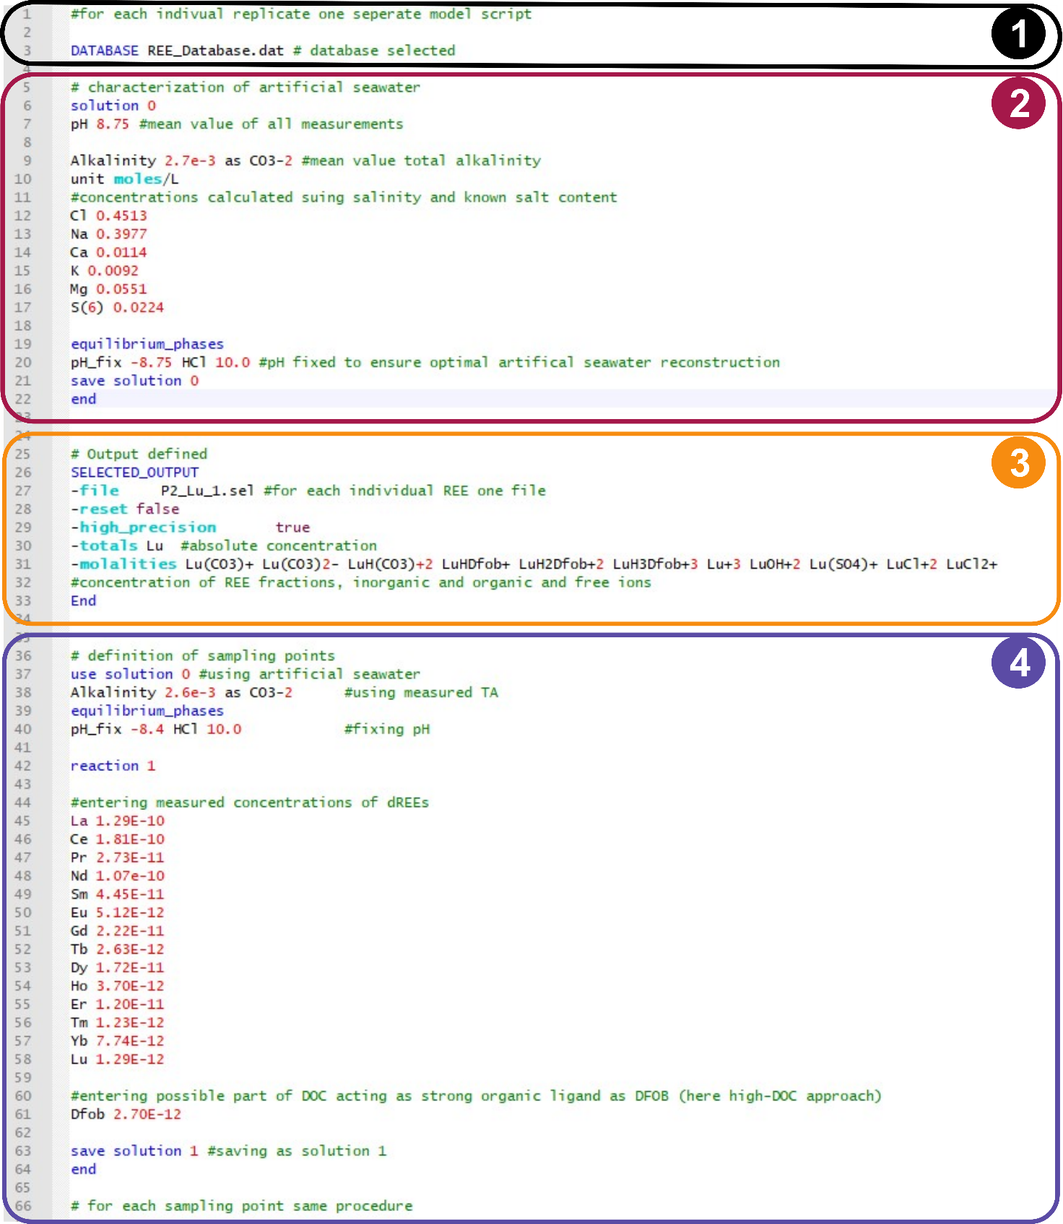

Supplementary Figure B 1: Example of one model script calculating complexes of lutetium (Lu) in the biological replicate P2. The simulation can be divided in four phases shown via coloured boxes.

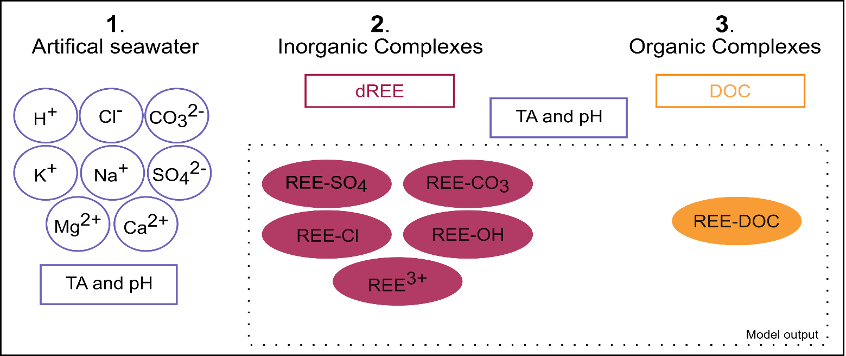

**Supplementary Figure B 2:** Conceptual illustration of the PHREEQC model approach to simulate organic complexation of dREEs. The simulation can be divided into three different steps. (1) Artificial seawater in the mescososms is defined by the concentrations of the main seawater ions (H+, Cl‑, CO3‑, K+, Na+, SO42‑, Mg2+ and Ca2+), as well as total alkalinity (TA) and pH. Violet shapes represent these characteristics of the artificial seawater. (2) Concentration of each individual dREE are entered for each data point via an individual reaction step. This enables calculation of free ions and inorganic complexes with components of the artificial seawater of each REE. The input and output for calculations of inorganic complexes is represented by red shapes. (3) After adding concentrations of DOC to the model, concentrations of organic REE-DOC complexes are calculated in addition to the inorganic complexes. The input and output for calculations of organic complexes is represented by yellow shapes. To ensure the most precise calculations, TA and pH are redefined for each reaction step. The final model output gives the total chemical speciation range of dREE with abundances of all inorganic and inorganic complexes, as well as free ions and the total concentration of each individual dREE.

Simulations of dREE complexes were carried out for each biological replicate P2-P4 in separate model scripts. Each script is divided in four main sections.

1. Thermodynamic data needed for simulation is entered via the database, here the newly constructed REE_Database **(**<https://doi.pangaea.de/10.1594/PANGAEA.942759>**).**
2. The artificial seawater in the mesocosms is defined as solution 0. Concentrations of major seawater cations and anions were calculated beforehand via salinity and salt composition of the used Tropical Reef Sea Salt listed by the manufacturer (Tropic Marin; Switzerland). Carbonate concentrations were acquired via the total alkalinity. Calculation of chemical speciation for this initial seawater solution were executed at a fixed pH of 8.4.
3. The selected output instruction tells the model which results to save in an output file. For each element individually, total dREE concentrations as well as concentrations of each individual fraction of dREE, inorganic and organic complexes as well as free ions, are saved in one file.
4. For each of the eleven sampling points in each replicate a new reaction was defined. For each reaction step, the defined artificial seawater was set to the studied mesocosm conditions by fixing the respective pH and entering the measured TA. Measured dREE concentrations were entered as well as parts of the DOC concentration, that equal DFOB in the ability to strongly complex dREEs. Since the specific fraction of the complex DOC pool that acts as a strong organic ligand for REEs (similar to DFOB) is not known, we used two different approaches assuming its concentration based on Schijf et al. (2015). For the ‘High-DOC’ approach, we assumed that 1*10-6 * c (DOC) (total measured DOC concentrations) acts as a strong organic ligand resulting in a maxima of 40% Lu-DFOB to total dLu. For the ‘Low-DOC’ approach we assumed a part of 2*10-7*c(DOC) that results in a maximum of 10% Lu-DFOB. The part of DOC acting as a strong organic ligand was set stable over the monitoring period, that is for each reaction step in the simulation.

# References

Christenson, E.A., and Schijf, J. (2011). Stability of YREE complexes with the trihydroxamate siderophore desferrioxamine B at seawater ionic strength. *Geochim. Cosmochim. Acta* 75(22)**,** 7047-7062. doi: 10.1016/j.gca.2011.09.022.

Klungness, G.D., and Byrne, R.H. (2000). Comparative hydrolysis behavior of the rare earths and yttrium: the influence of temperature and ionic strength. *Polyhedron* 19(1)**,** 99-107. doi: 10.1016/S0277-5387(99)00332-0.

Luo, Y.-R., and Byrne, R.H. (2004). Carbonate complexation of yttrium and the rare earth elements in natural waters. *Geochim. Cosmochim. Acta* 68(4)**,** 691-699. doi: 10.1016/S0016-7037(03)00495-2.

Migdisov, A.A., Williams-Jones, A.E., and Wagner, T. (2009). An experimental study of the solubility and speciation of the Rare Earth Elements (III) in fluoride- and chloride-bearing aqueous solutions at temperatures up to 300°C. *Geochim. Cosmochim. Acta* 73(23)**,** 7087-7109. doi: 10.1016/j.gca.2009.08.023.

Millero, F., and Schreiber, D. (1982). Use of the ion pairing model to estimate activity coefficients of the ionic components of natural waters. *American Journal of Science* 282**,** 1508-1540. doi: 10.2475/ajs.282.9.1508.

Schijf, J., and Byrne, R.H. (2004). Determination of SO4β1 for yttrium and the rare earth elements at I = 0.66 m and t = 25°C—implications for YREE solution speciation in sulfate-rich waters1 1Associate editor: D. J. Wesolowski. *Geochim. Cosmochim. Acta* 68(13)**,** 2825-2837. doi: 10.1016/j.gca.2003.12.003.

Schijf, J., Christenson, E.A., and Byrne, R.H. (2015). YREE scavenging in seawater: A new look at an old model. *Mar. Chem.* 177**,** 460-471. doi: 10.1016/j.marchem.2015.06.010.