Anemia Increases Oxygen Extraction Fraction in Deep Brain Structures but Not in the Cerebral Cortex
Supplemental data
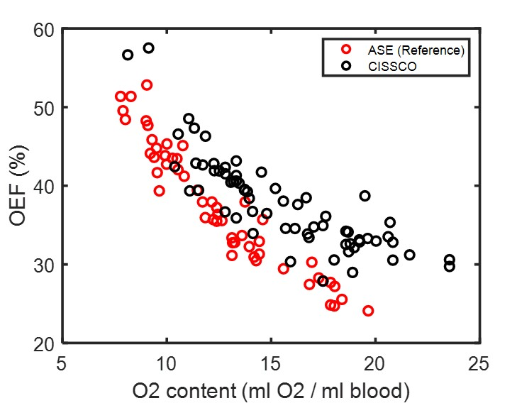
Figure S1. Relationship between OEF and O₂ content by CISSCO (OEF-CISSCO) and reference data (OEF-ASE) (Fields et al., 2018).

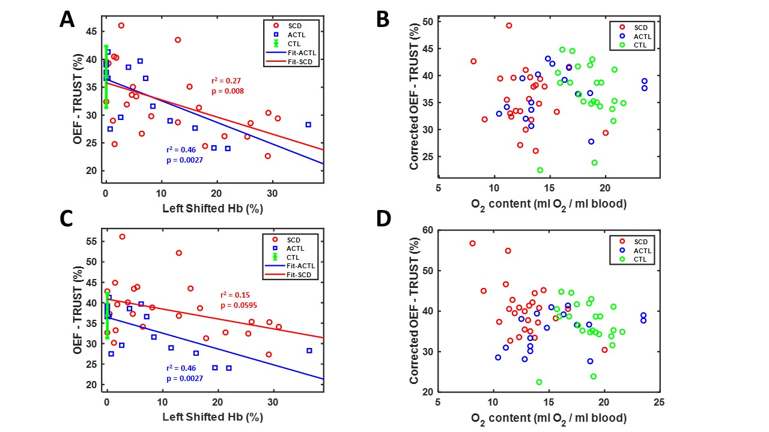
Figure S2. (A) Relationship between OEF-TRUST with left shifted hemoglobin using the mixture model. Linear correlations are shown in blue line (r² = 0.46, p = 0.0027) for ACTL and red line (r² = 0.27, p = 0.008) for SCD. The control group is shown as 36.8 ± 5.5 (mean ± std) in green. (B) Relationship between corrected OEF-TRUST with O₂ content using the mixture model. Figure S2. (C) Relationship between OEF-TRUST with left shifted hemoglobin using the HbA model. Linear correlations are shown in blue line (r² = 0.46, p = 0.0027) for ACTL and red line (r² = 0.15, p = 0.0595) for SCD. The control group is shown as 36.8 ± 5.5 (mean ± std) in green. (D) Relationship between corrected OEF-TRUST with O₂ content using the HbA model.

Reference:
Fields, M.E., Guilliams, K.P., Ragan, D.K., Binkley, M.M., Eldeniz, C., Chen, Y., Hulbert, M.L., McKinstry, R.C., Shimony, J.S., Vo, K.D., others, 2018. Regional oxygen extraction predicts border zone vulnerability to stroke in sickle cell disease. Neurology 90, e1134–e1142.

