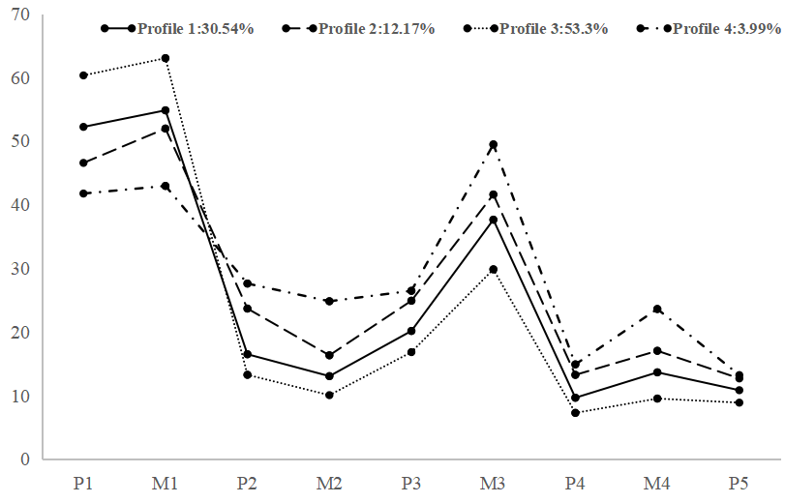
Supplementary Figure 1 Plot of 4 latent profiles of parenting styles
(Note: P1=paternal emotional warmth; M1=maternal emotional warmth; P2=paternal severe punishment; M2=maternal severe punishment; P3=paternal excessive interference; M3=maternal excessive interference; P4=paternal rejection and denial; M4=maternal rejection and denial; P5=paternal over protection.)

Supplementary Table 1 Average posterior probabilities associated with the three-profile model.
Latent Profile | 1 | 2 | 3
1 | 0.966 | 0.034 | 0.000
2 | 0.055 | 0.929 | 0.016
3 | 0.000 | 0.046 | 0.954
Note. Posterior probabilities are the probability that an individual belongs to the assigned profile and to no other profiles.

Supplementary Table 2 Number, % and OR of depression symptoms by level of parenting style and resilience in girls and boys.
Variable | Girls |  |  |  | Boys
Variable | n(%) | OR(95%CI) ^{b} | P |  | n(%) | OR(95%CI) ^{b} | P
Parenting style
Positive parenting | 92(19.5) | 0.36(0.26-0.51) | <0.001 |  | 102(13.5) | 0.28(0.21-0.37) | <0.001
Negative parenting | 31(64.6) | 2.71(1.42-5.16) | 0.002 |  | 67(47.2) | 1.60(1.09-2.35) | 0.017
Moderate parenting | 97(40.2) | 1.00 |  |  | 152(35.8) | 1.00
Resilience
Low | 209(36.5) | 9.95(5.25-18.86) | <0.001 |  | 295(30.2) | 5.54(3.60-8.51) | <0.001
High | 11(5.9) | 1.00 |  |  | 26(7.6) | 1.00
^{b} Adjusted for only child, registered residence, self-reported academic performance, parents’ education level.

Supplementary Table 3 Number, % and OR of anxiety symptoms by level of parenting style and resilience in girls and boys.
Variable | Girls |  |  |  | Boys
Variable | n(%) | OR(95%CI) ^{b} | P |  | n(%) | OR(95%CI) ^{b} | P
Parenting style
Positive parenting | 50(10.6) | 0.36(0.20-0.45) | <0.001 |  | 41(5.4) | 0.30(0.20-0.45) | <0.001
Negative parenting | 23(47.9) | 1.85(1.17-2.91) | 0.008 |  | 37(26.1) | 1.85(1.17-2.91) | 0.008
Moderate parenting | 60(24.9) | 1.00 |  |  | 68(16.0) | 1.00
Resilience
Low | 117(20.5) | 2.70(1.61-4.52) | <0.001 |  | 128(13.1) | 2.87(1.65-5.02) | <0.001
High | 16(8.5) | 1.00 |  |  | 18(5.3) | 1.00
^{b} Adjusted for only child, registered residence, self-reported academic performance, parents’ education level.

Supplementary Table 4 Association between different level of resilience defined as ≥P₆₇ and ≥P₉₀ with depression/anxiety symptoms in adolescents.
Variable | Depression symptoms |  |  | Anxiety symptoms
Variable | Crude OR (95% CI) | Adjusted OR (95% CI)ª |  | Crude OR (95% CI) | Adjusted OR (95% CI)ª
P₆₇
Low | 5.76(4.32-7.67)** | 6.12(4.57-8.20)** |  | 2.91(2.09-4.05)** | 3.03(2.16-4.24)**
High | 1.00 | 1.00 |  | 1.00 | 1.00
P₉₀
Low | 5.95(3.29-10.77)** | 5.96(3.28-10.82)** |  | 3.46(1.75-6.83)** | 3.33(1.67-6.62)**
High | 1.00 | 1.00 |  | 1.00 | 1.00
ª Adjusted for gender, only child, registered residence, self-reported academic performance, parents’ education level. **P ≤ 0.001.

Supplementary Table 5 The prevalence of parenting style by level of resilience, n(%)
Parenting style | Resilience |  |  | Adjusted OR(95%CI) ^{b} | P
Parenting style | Low | High | χ² | Adjusted OR(95%CI) ^{b} | P
Positive parenting | 834(68.1) | 390(31.9) | 64.178** | 2.24(1.76-2.84) | ＜0.001
Negative parenting | 163(85.8) | 27(14.2) | 64.178** | 0.81(0.51-1.28) | 0.361
Moderate parenting | 552(83.0) | 113(17.0) | 64.178** | 1.00
^{b} Adjusted for gender, only child, registered residence, self-reported academic performance, parents’ education level. **P < 0.001.

Table DS 6 Interaction effects between parenting style and resilience on depression and anxiety symptoms in adolescents.
Variable | Anxiety symptoms |  |  | Depressive symptoms
Variable | Crude OR (95% CI) | P |  | Crude OR (95% CI) | P
Parenting style
Positive parenting | 0.33(0.15-0.71) | 0.004 |  | 0.39(0.19-0.83) | 0.014
Negative parenting | 1.75(0.57-5.41) | 0.333 |  | 1.75(0.57-5.41) | 0.333
Moderate parenting | 1.00 |  |  | 1.00
Resilience
Low | 2.74(1.89-3.98) | ＜0.001 |  | 6.43(4.53-9.13) | ＜0.001
High | 1.00 |  |  | 1.00
Parenting style×Resilience
Positive parenting×Low | 1.14(0.50-2.61) | 0.754 |  | 0.90(0.42-1.96) | 0.796
Negative parenting×Low | 1.11(0.34-3.65) | 0.868 |  | 1.02(0.31-3.32) | 0.977

