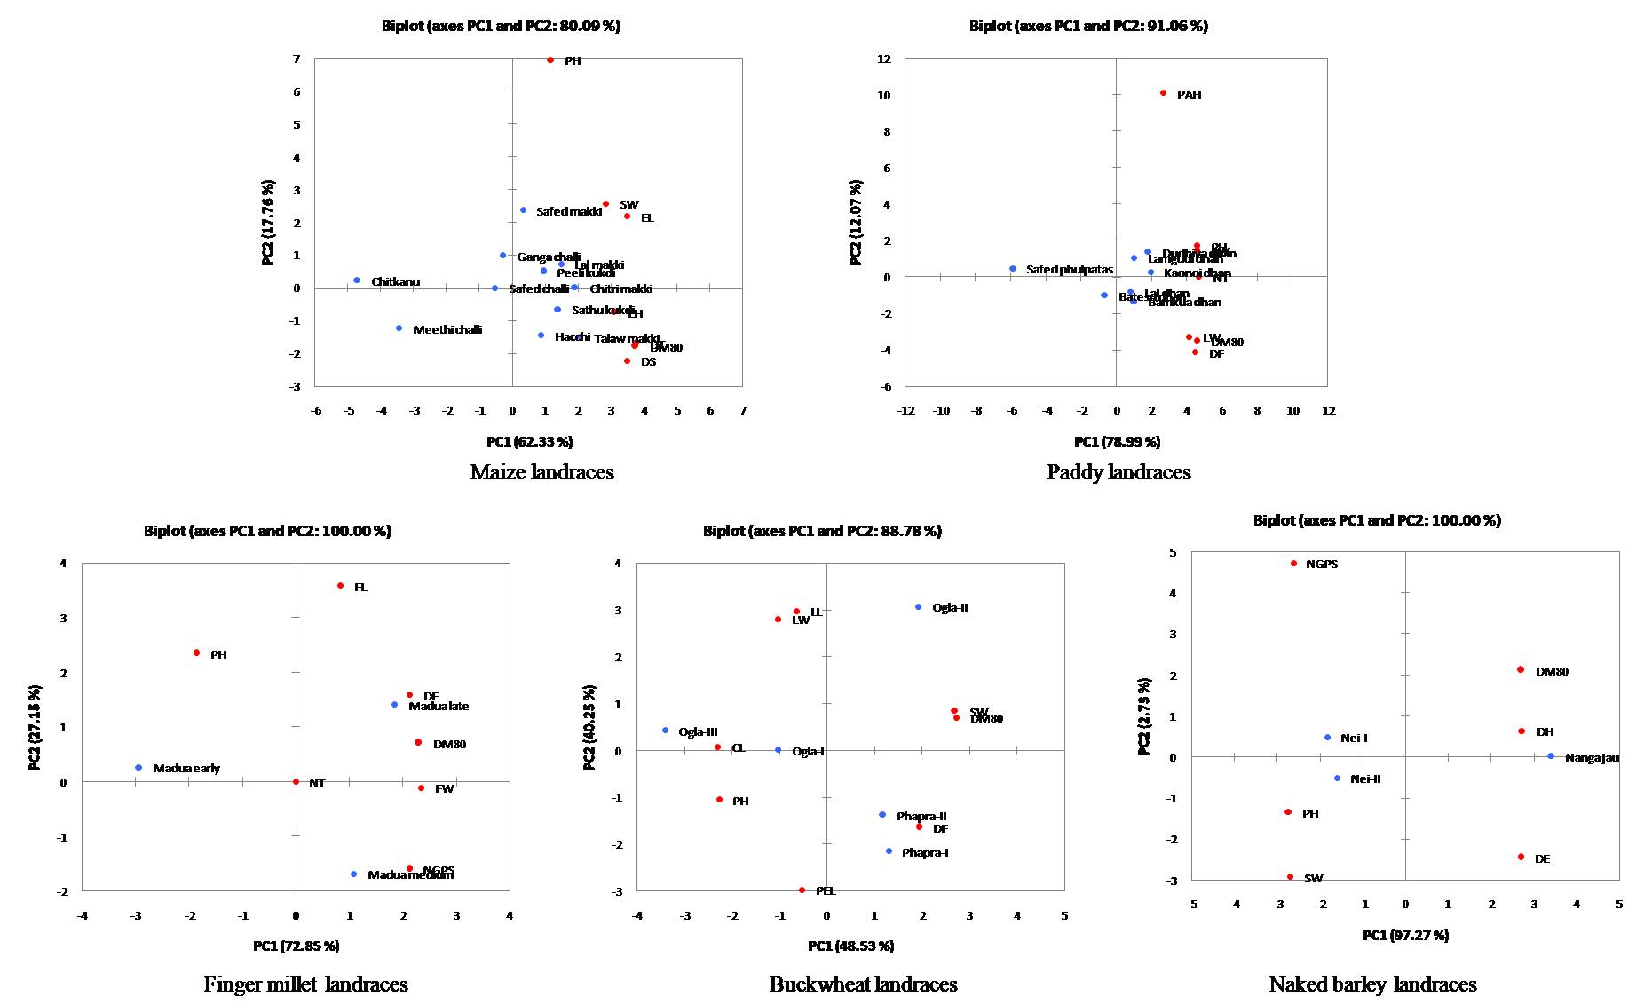

**SUPPLEMENTARY FIGURE S1** PCA analysis showing variability in agro-morphological traits among traditional crop landraces of northwest Indian Himalayas.

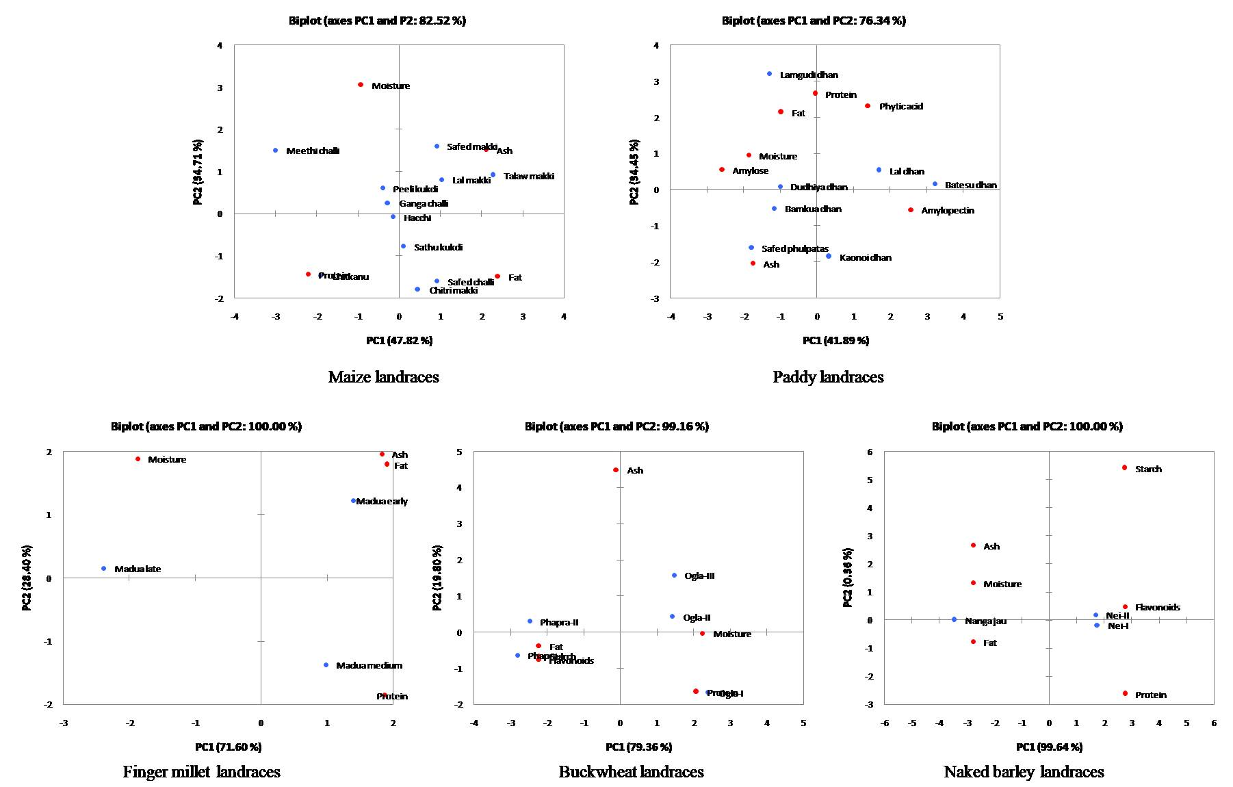

**SUPPLEMENTARY FIGURE S2** PCA analysis showing variability in nutritional traits among traditional crop landraces of northwest Indian Himalayas.