Fig. S1 *E. nutants* of each treatment after 24 hours of grasshoppers feeding.

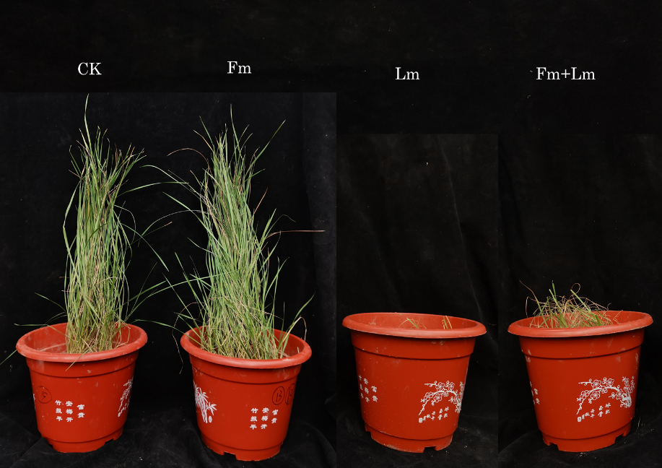

Table S1 Nutrient content of each plant under different treatments.

|  |  |  |  |
| --- | --- | --- | --- |
| Treatment | Total nitrogen  (g·plant-1) | Total phosphorus  (g·plant-1) | Total carbon  (g·plant-1) |
| CK | 0.00318±0.00022b | 0.00027±0.00002b | 0.08602±0.00630b |
| Fm | 0.00666±0.00042a | 0.00060±0.00004a | 0.16102±0.00928a |
| Lm | 0.00145±0.00004c | 0.00011±0.00001c | 0.04409±0.00074c |
| Fm+Lm | 0.00319±0.00031b | 0.00024±0.00002b | 0.08412±0.00767b |