Supplemental information
S-Figure 1. Design of Luna’s nanoSPRi-based assay for malaria antigen detection. This assay is run in the flow cell of an OpenPlex SPRi instrument from HORIBA Scientific. A malaria antigen is captured by the specific capture antibody array, detected by the biotinylated antibody, and amplified using a quantum dot nano enhancer. The concentration and real-time binding kinetics of antigen to its antibody are determined from changes in reflectivity.
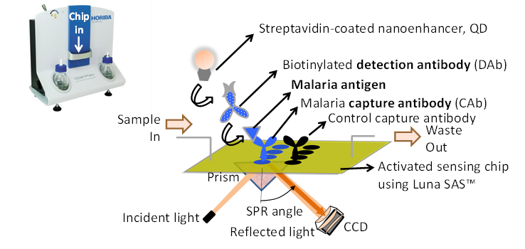

S-Figure 2. Average size of TMC-TPP single nanoparticle, self-assembly nanoparticle at different reaction time, and LbL NP-protein complex.
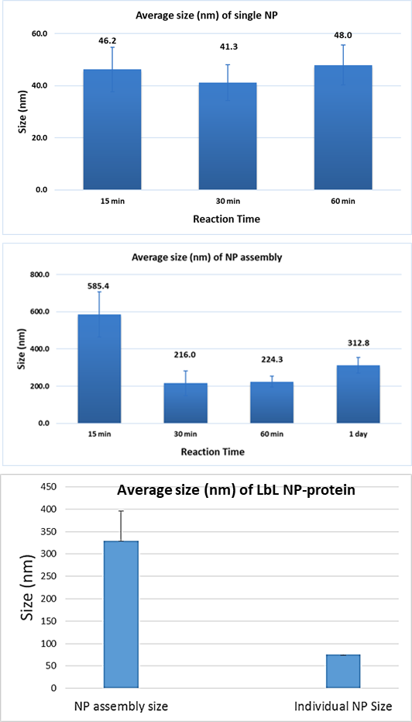

S-Table 1. Study schedule and dose ranges for IM administration of rat.
Group | Sex | n | Animal No. | TMC/TPP-NPs (mg/kg)
1 (control) | Male | 4 | 1001-1004 | 0 (vehicle)
2 (low) | Male | 4 | 2001-2004 | 5
3 (moderate) | Male | 4 | 3001-3004 | 10
4 (high) | Male | 4 | 4001-4004 | 25

S-Table 2. Parameters of NP (TMC-PSS) and related zeta-potential value of NPs

Ratio of TMC: PSS | Reaction time (min) | TMC (mg) | TPP (mg) | PSS (mg) | zeta-potential (mV)
1: 2 | 60 | 0.5 | 0 | 1 | -37
1: 1 | 60 | 1 | 0 | 1 | -27
1:0.91 | 60 | 1.1 | 0 | 1 | -23
1:0.83 | 60 | 1.2 | 0 | 1 | 23
1:0.77 | 60 | 1.3 | 0 | 1 | 19
1:0.71 | 60 | 1.4 | 0 | 1 | 25
1:0.67 | 60 | 1.5 | 0 | 1 | 30
1:0.5 | 60 | 2 | 0 | 1 | 35

S-Table 3. Parameters of NP (TMC-TPP-PSS) and related zeta-potential value of NPs
Ratio  (TMC: TPP: PSS) | Reaction time (min) | TMC  (mg) | TPP  (mg) | PSS  (mg) | zeta-potential  (mV)
1:0.2:0.1 | 60 | 1 | 0.2 | 0.1 | 5
1:0.2:0.25 | 60 | 1 | 0.2 | 0.25 | 4
1:0.2:0.5 | 60 | 1 | 0.2 | 0.5 | 4
1:0.2:0.75 | 60 | 1 | 0.2 | 0.75 | -23

