Table S1 Mobile phase and injection time.
Time(min) | Solvent A | Solvent B
Time(min) | (0.1% Formic acid water) | (Acetonitrile)
0~2 | 98% A | 2% B
2~3 | 98~65% A | 2~35% B
3~10 | 65%~30% A | 35~70% B
10~12 | 30~15% A | 70~85% B
12~16 | 15%~2% A | 85~98% B
16~18 | 2% A | 98% B
18~20 | 2%~98% A | 98~2% B
20~23 | 98%A | 2% B

Table S2 Targeted metabolites and internal standard reference substances.
No. | Compounds | Specifications | Molecular weight | CAS | Stock solution（mg/mL） | Mixed standard range（μg/mL）
1 | AMP | 1000 mg | 347.22 | 61-19-8 | 4.17 | 0.3125-80
2 | IMP | 5 mg | 348.21 | 131-99-7 | 1.00 | 0.3125-80
3 | GMP | 500 mg | 407.18 | 5550-12-9 | 7.00 | 0.46875-120
4 | Adenine | 500 mg | 135.13 | 73-24-5 | 4.30 | 0.3125-80
5 | Hypoxanthine | 10 mg | 136.11 | 68-94-0 | 1.00 | 0.78125-200
6 | Xanthine | 100 mg | 152.11 | 69-89-6 | 4 .00 | 0.3125-80
7 | Guanine | 500 mg | 151.13 | 73-40-5 | 2.16 | 0.3125-80
8 | Adenosine | 500 mg | 267.25 | 58-61-7 | 5.76 | 0.3125-80
9 | Inosine | 500 mg | 268.23 | 58-63-9 | 20.53 | 3.125-800
10 | Xanthosine | 5 mg | 284.23 | 146-80-5 | 2.24 | 0.3125-80
11 | Guanosine | 500 mg | 283.24 | 118-00-3 | 6.16 | 0.3125-80
12 | IS1 | 5 mg | 301.69 | 146-77-0 | 1.00 | 1.2
13 | IS2 | 5 mg | 287.35 | 357-70-0 | 1.00 | 0.15

Table S3 Preparation of quality control solution.
Compounds | QC1 | QC2 | QC3 | LLOQ
AMP, IMP, Adenine, Xanthine, Guanine, Adenosine, Xanthine, Guanosine | 40 μg/mL | 5 μg/mL | 0.625 μg/mL | 0.3125  μg/mL
GMP | 60 μg/mL | 7.5 μg/mL | 0.9375 μg/mL | 0.46875 μg/mL
Hypoxanthine | 100 μg/mL | 12.5 μg/mL | 1.5625 μg/mL | 0.78125 μg/mL
Inosine | 400 μg/mL | 50 μg/mL | 6.25 μg/mL | 3.125  μg/mL

Table S4 The RSD values of the relative peak areas of 20 random ions in the 6 QC samples.
NO. | m/z | TR  (min) | Relative  peak area | RSD  (%) | Ion mode
1 | 148.0419 | 1.017 | 0.0112 | 11.34 | +
2 | 132.1018 | 1.250 | 0.0080 | 11.41 | +
3 | 268.1035 | 1.252 | 0.0021 | 9.03 | +
4 | 269.0876 | 1.258 | 0.0056 | 4.14 | +
5 | 198.0371 | 1.310 | 0.0069 | 13.13 | +
6 | 132.1018 | 2.687 | 0.0024 | 9.64 | +
7 | 149.0596 | 4.595 | 0.0042 | 11.79 | +
8 | 205.097 | 4.907 | 0.0026 | 14.15 | +
9 | 275.2773 | 8.262 | 0.0023 | 5.92 | +
10 | 274.2736 | 8.263 | 0.0147 | 7.00 | +
11 | 362.3259 | 8.460 | 0.0013 | 5.90 | +
12 | 496.3213 | 11.722 | 0.0132 | 10.62 | +
13 | 523.3582 | 12.258 | 0.0012 | 5.60 | +
14 | 149.0232 | 13.095 | 0.0028 | 9.69 | +
15 | 524.3707 | 13.413 | 0.0025 | 8.25 | +
16 | 485.3156 | 14.207 | 0.0036 | 6.24 | +
17 | 352.3024 | 14.548 | 0.0035 | 8.00 | +
18 | 256.2631 | 14.814 | 0.0081 | 11.22 | +
19 | 291.2677 | 15.558 | 0.0010 | 6.12 | +
20 | 141.9832 | 20.587 | 0.0043 | 14.1 | +

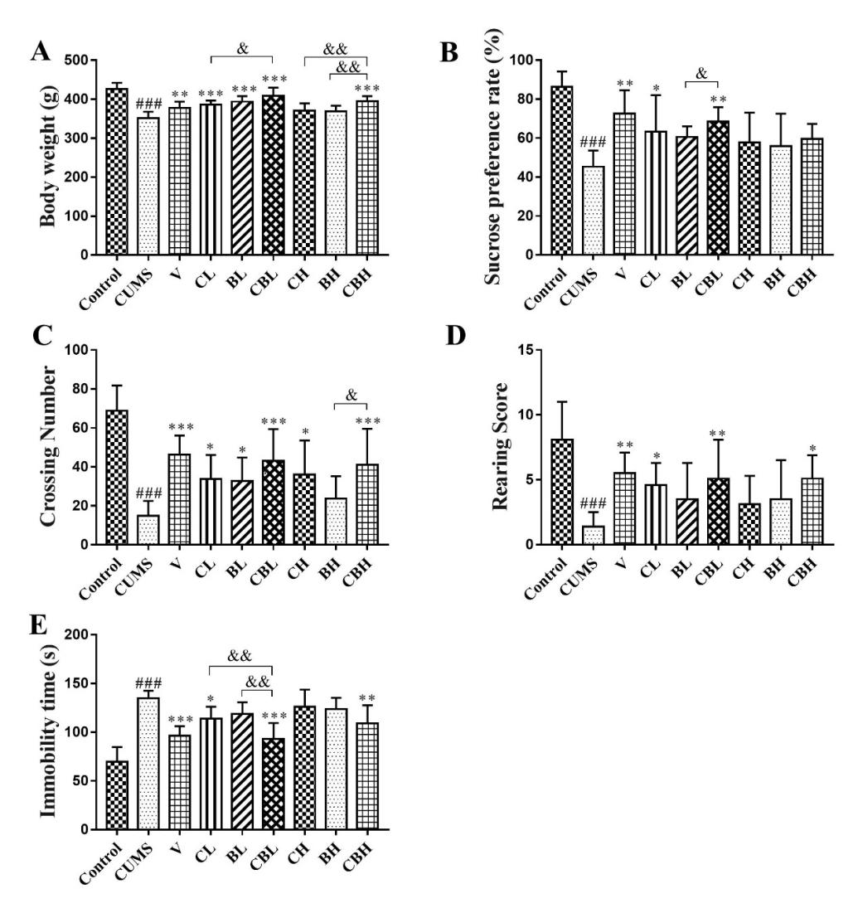
Figure S1 Comparison of antidepressant effect between Chaihu and Baishao before and after compatibility. (A) Body weight. (B) Sucrose preference. (C) The crossing number in OFT. (D) The rearing score in OFT. (E) Immobility time in FST. All data were expressed as mean ± SD, n = 9. Compared with control group: ###P<0.001; compared with CUMS group: *P<0.05 **P<0.01 ***P<0.001; compared with Chaihu-Baishao group: &P<0.05, &&P<0.01, &&&P<0.001.

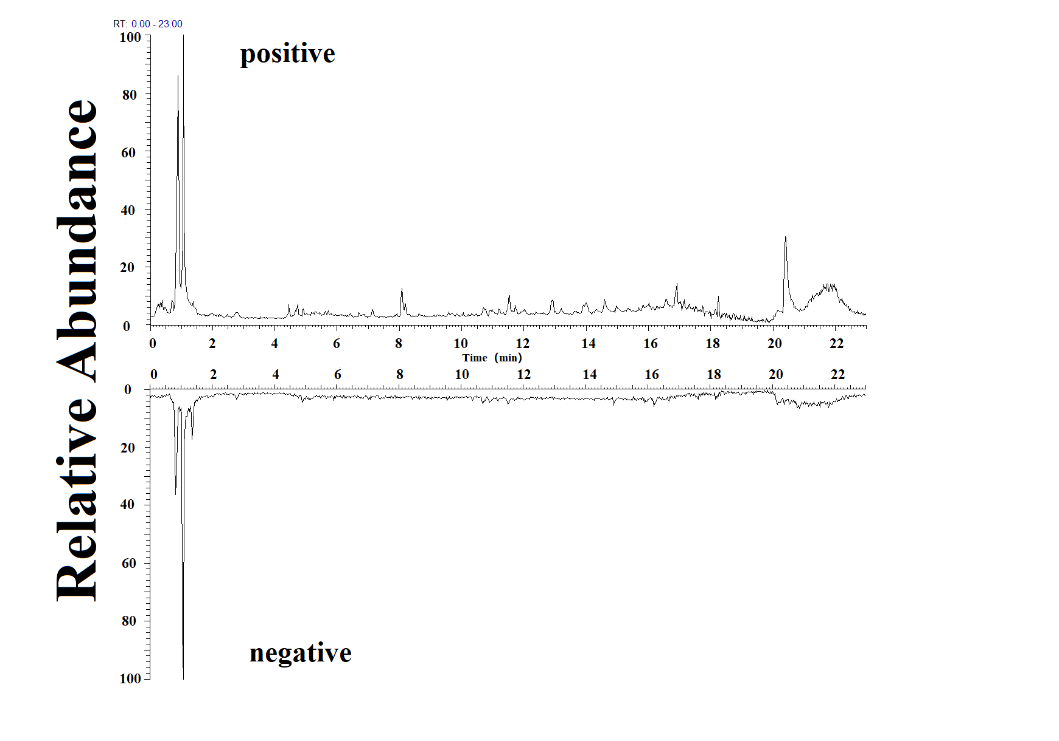
Figure S2 Typical LC-MS/MS spectrum of control rat cortex.

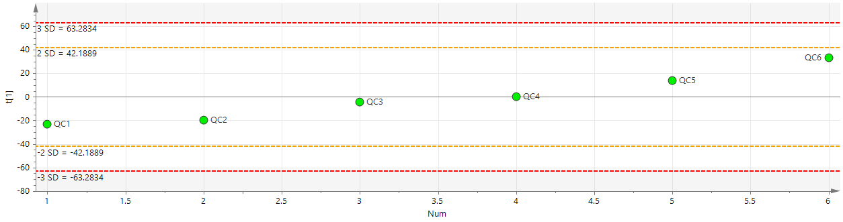
Figure S3 The deviation of QC samples.

Methodological validation of targeted quantitative analysis
1 Selectivity
The total ion chromatogram and MRM chromatogram of the blank solution, QC-2 and normal rat cerebral cortex sample were shown in Figure S4.
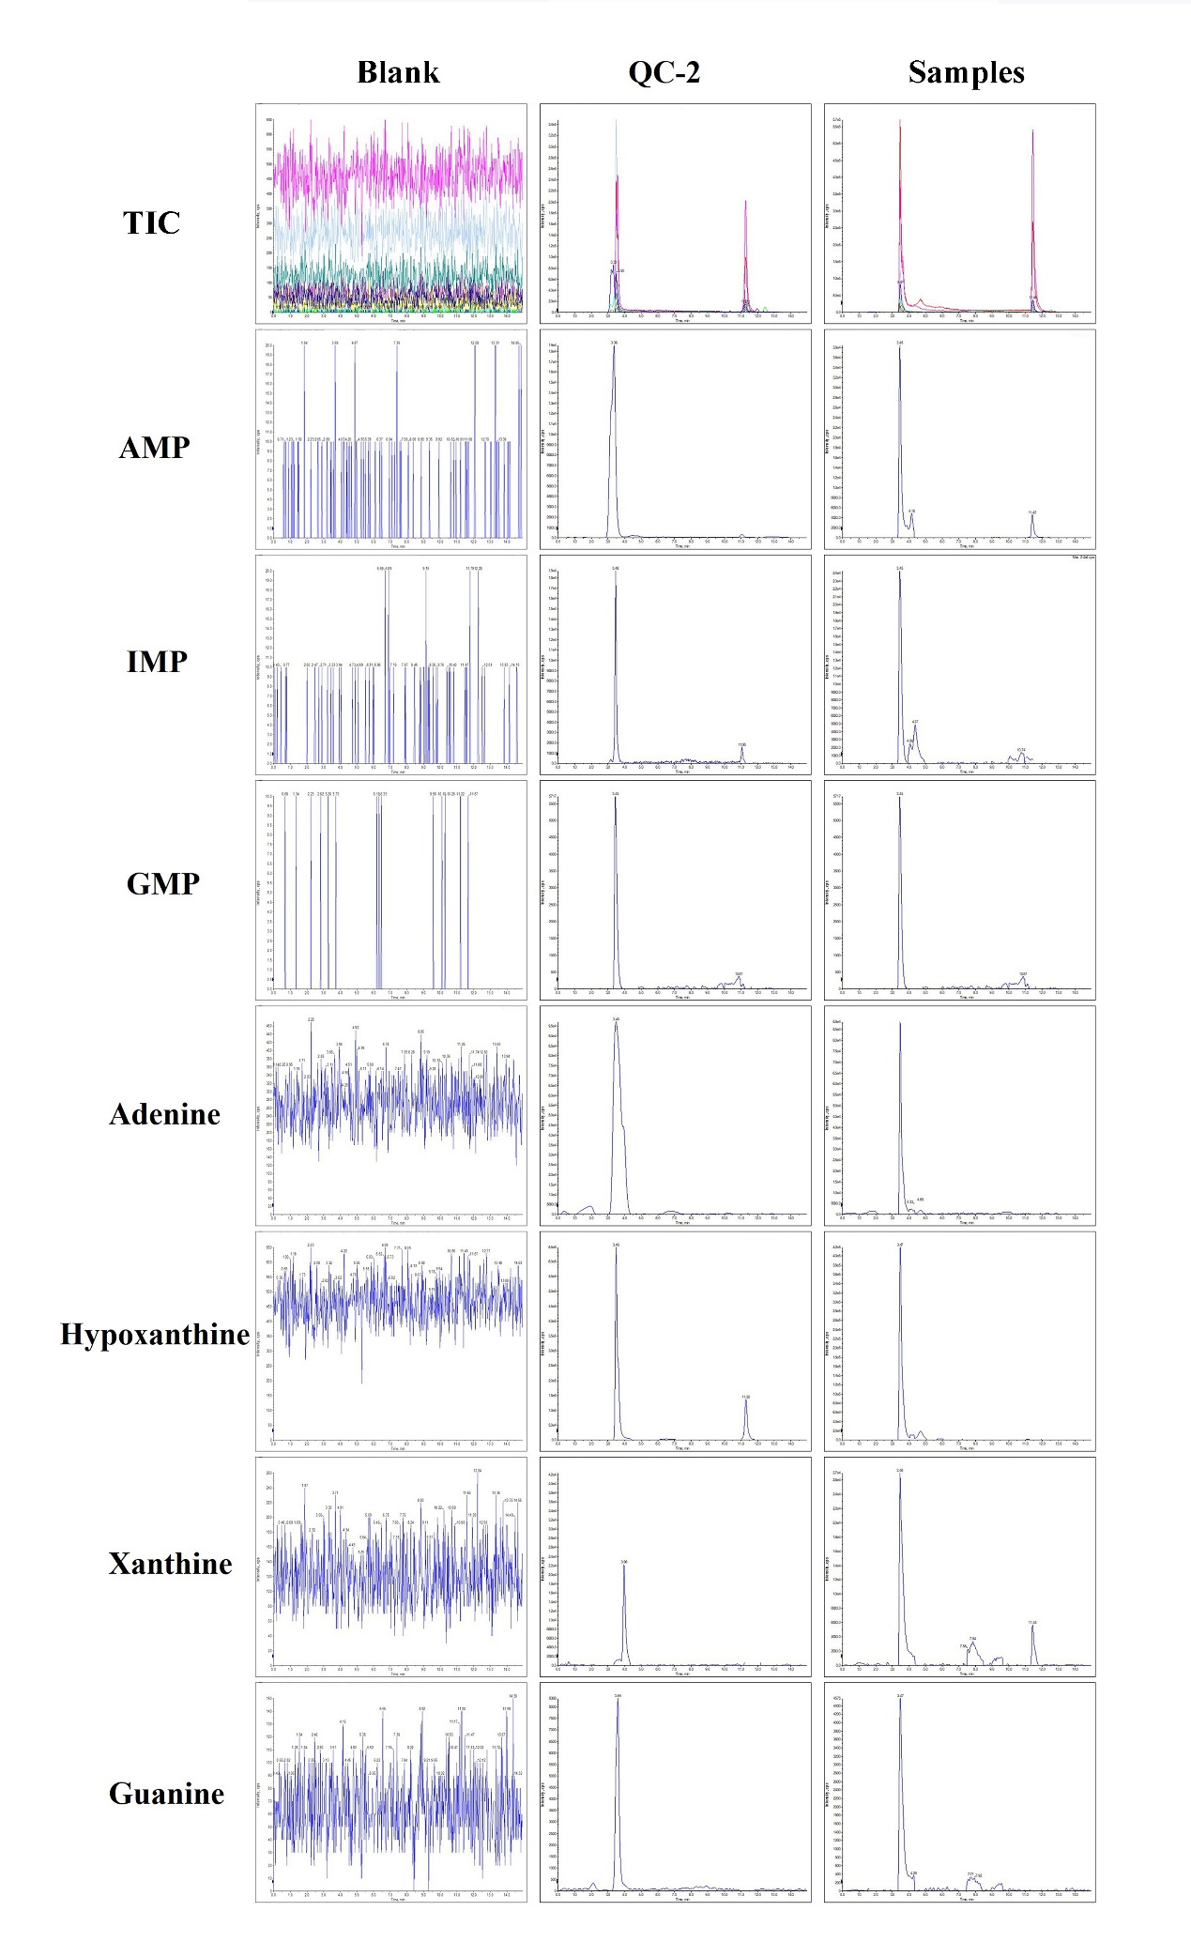
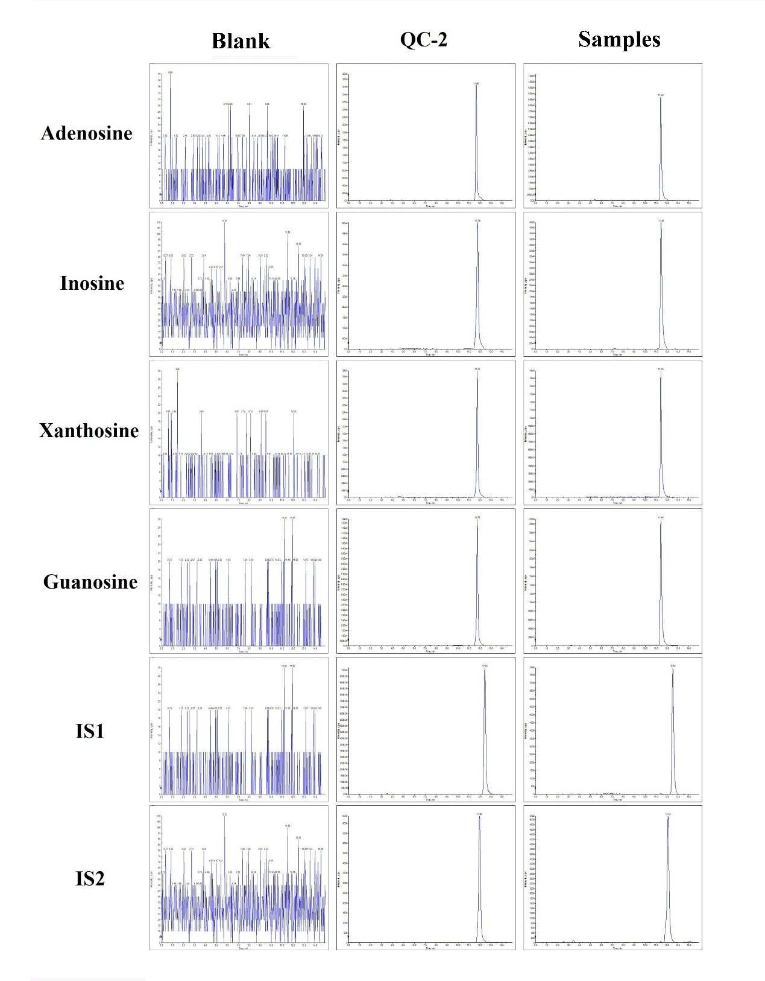
Figure S4 Selectivity.

2 Linearity and concentration range
The regression equation, correlation coefficient (R²), linear range and corresponding internal standard were shown in Table S5. As shown in Figure S5, 11 metabolites in purine metabolism have good linearity.
Table S5 Linearity relationship of 11 metabolites in purine metabolism.
Metabolites | TR  (min) | Regression equation (n = 9) | R² | Range  (μg/mL) | LLOQ | LOD | IS
Adenine | 3.34 | y=0.6257x+1.2885 | 0.9998 | 0.3125-80 | 0.3125 | 0.104167 | IS2
Hypoxanthine | 3.53 | y=0.306x+0.2602 | 0.9994 | 0.78125-200 | 0.78125 | 0.260417 | IS2
Xanthine | 3.43 | y=0.1477x+0.1554 | 0.9966 | 0.3125-80 | 0.3125 | 0.104167 | IS2
Guanine | 3.38 | y=0.0561x+0.08 | 1.0000 | 0.3125-80 | 0.3125 | 0.104167 | IS2
Adenosine | 11.18 | y=2.27x-0.1066 | 0.9997 | 0.3125-80 | 0.3125 | 0.104167 | IS1
Inosine | 11.28 | y=0.272x+3.4985 | 0.9978 | 3.125-800 | 3.125 | 1.041667 | IS1
Xanthosine | 11.26 | y=0.145x+0.0559 | 0.9996 | 0.3125-80 | 0.3125 | 0.104167 | IS1
Guanosine | 11.26 | y=0.3931x+0.045 | 0.9998 | 0.3125-80 | 0.3125 | 0.104167 | IS1
AMP | 3.32 | y=0.154x-0.094 | 0.9998 | 0.3125-80 | 0.3125 | 0.104167 | IS2
IMP | 3.43 | y=0.0393x+0.0167 | 0.9996 | 0.3125-80 | 0.3125 | 0.104167 | IS2
GMP | 3.41 | y=0.0291x+0.0456 | 0.9998 | 0.46875-120 | 0.46875 | 0.15625 | IS2

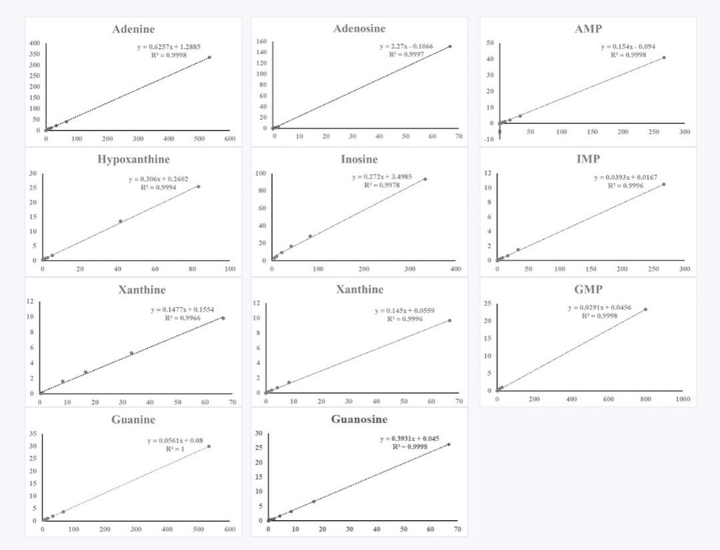
Figure S5 Standard curves of 11 metabolites in purine metabolism.

3 Precision
As shown in Table S6, the precision deviation met the requirement under the established method, indicating that the established method was suitable for the detection of samples.
Table S6 The RSD values of the intra-day and inter-day precision of 11 metabolites.
Metabolites | Theoretical concentration (μg/mL) | Intra-day (n = 6) |  | Inter-day (n = 6)
Metabolites | Theoretical concentration (μg/mL) | Measured (μg/mL) | RSD (%) | Measured  (μg/mL) | RSD (%)
Adenine | 40 | 37.41±1.687 | 4.45 | 38.91±3.008 | 4.49
Adenine | 5 | 4.931±0.047 | 1.96 | 4.888±0.110 | 2.24
Adenine | 0.625 | 0.5572±0.024 | 5.62 | 0.5654±0.031 | 5.55
Adenine | 0.3125 | 0.309±0.009 | 2.36 | 0.3132±0.009 | 2.99
Hypoxanthine | 100 | 88.94±3.951 | 4.69 | 89.6±3.984 | 4.45
Hypoxanthine | 12.5 | 12.3±0.491 | 3.12 | 12.09±0.507 | 4.20
Hypoxanthine | 1.5625 | 1.194±0.041 | 3.65 | 1.23±0.051 | 4.12
Hypoxanthine | 0.78125 | 0.7895±0.015 | 3.25 | 0.7845±0.025 | 3.23
Xanthine | 40 | 31.72±1.753 | 4.45 | 31.67±1.421 | 4.49
Xanthine | 5 | 4.482±0.103 | 3.58 | 4.464±0.172 | 3.84
Xanthine | 0.625 | 0.5872±0.015 | 3.78 | 0.606±0.026 | 4.33
Xanthine | 0.3125 | 0.2275±0.009 | 5.59 | 0.2171±0.025 | 11.43
Guanine | 40 | 38.53±2.453 | 6.05 | 39.23±2.326 | 5.93
Guanine | 5 | 4.695±0.308 | 5.19 | 4.752±0.341 | 7.18
Guanine | 0.625 | 0.6426±0.019 | 5.02 | 0.6411±0.032 | 4.98
Guanine | 0.3125 | 0.2958±0.011 | 4.18 | 0.2987±0.014 | 4.53
Adenosine | 40 | 39.07±1.531 | 4.59 | 38.84±1.731 | 4.46
Adenosine | 5 | 4.731±0.146 | 4.17 | 5.088±0.343 | 6.73
Adenosine | 0.625 | 0.5369±0.029 | 3.41 | 0.5336±0.020 | 3.83
Adenosine | 0.3125 | 0.3088±0.005 | 1.58 | 0.3071±0.005 | 1.65
Inosine | 400 | 412.1±17.130 | 4.91 | 406.2±20.210 | 4.98
Inosine | 50 | 43.23±2.862 | 5.68 | 44.17±2.677 | 6.06
Inosine | 6.25 | 5.497±0.359 | 5.72 | 5.523±0.307 | 5.55
Inosine | 3.125 | 3.349±0.249 | 8.94 | 3.482±0.339 | 9.72
Xanthosine | 40 | 39.6±1.618 | 4.80 | 39.31±1.858 | 4.73
Xanthosine | 5 | 5.22±0.364 | 5.25 | 5.465±0.359 | 6.57
Xanthosine | 0.625 | 0.4058±0.042 | 9.08 | 0.3778±0.042 | 11.22
Xanthosine | 0.3125 | 0.3418±0.015 | 11.22 | 0.3198±0.039 | 15.76
Guanosine | 40 | 38.46±1.555 | 4.30 | 38.01±1.574 | 4.14
Guanosine | 5 | 4.176±0.147 | 4.37 | 4.4±0.252 | 5.74
Guanosine | 0.625 | 0.6068±0.062 | 9.16 | 0.597±0.053 | 8.97
Guanosine | 0.3125 | 0.3192±0.017 | 4.83 | 0.3107±0.016 | 5.12
AMP | 40 | 34.75±1.582 | 4.79 | 34.72±1.675 | 4.82
AMP | 5 | 5.038±0.114 | 2.27 | 4.936±0.142 | 2.87
AMP | 0.625 | 0.5938±0.016 | 2.87 | 0.6021±0.017 | 2.89
AMP | 0.3125 | 0.3291±0.048 | 6.57 | 0.3234±0.036 | 11.26
IMP | 40 | 38.9±1.700 | 4.77 | 38.6±1.793 | 4.65
IMP | 5 | 5.144±0.332 | 4.18 | 5.034±0.236 | 4.68
IMP | 0.625 | 0.5939±0.014 | 3.26 | 0.6012±0.020 | 3.26
IMP | 0.3125 | 0.3133±0.012 | 5.03 | 0.3033±0.024 | 8.02
GMP | 60 | 58.43±2.995 | 4.59 | 58.11±3.203 | 5.51
GMP | 7.5 | 7.393±0.071 | 1.83 | 7.431±0.144 | 1.94
GMP | 0.9375 | 1.219±0.127 | 6.73 | 1.366±0.139 | 10.15
GMP | 0.46875 | 0.3708±0.017 | 7.60 | 0.3281±0.062 | 18.82

4 Stability
As shown in Table S7, the RSD values of two different treatments met the requirement, indicating that the established method was stable for the detection of the samples.
Table S7 Stability of 11 metabolites in purine metabolism.
Metabolites  (n = 3) | Theoretical concentration (μg/mL) | Repeated freeze-thaw 3 times at -20 °C |  | Placed in an autosampler at 4 °C for 24 hours
Metabolites  (n = 3) | Theoretical concentration (μg/mL) | Measured (μg/mL) | RSD  (%) | Measured (μg/mL) | RSD (%)
Adenine | 40 | 38.64±2.034 | 5.26 | 38.88±2.454 | 6.31
Adenine | 0.625 | 0.5489±0.020 | 3.58 | 0.5458±0.030 | 5.44
Hypoxanthine | 100 | 87.55±2.234 | 2.55 | 88.78±3.425 | 3.86
Hypoxanthine | 1.5625 | 1.213±0.031 | 2.52 | 1.215±0.035 | 2.92
Xanthine | 40 | 31.75±0.402 | 1.27 | 31.62±0.869 | 2.75
Xanthine | 0.625 | 0.5913±0.015 | 2.47 | 0.6002±0.029 | 4.73
Guanine | 40 | 38.66±1.579 | 4.08 | 39.03±2.337 | 5.99
Guanine | 0.625 | 0.6261±0.039 | 6.24 | 4.16±0.244 | 5.85
Adenosine | 40 | 39.08±1.210 | 3.10 | 40.1±1.012 | 2.52
Adenosine | 0.625 | 0.5204±0.016 | 3.12 | 0.5326±0.020 | 3.79
Inosine | 400 | 397.5±8.775 | 2.21 | 412.4±18.970 | 4.60
Inosine | 6.25 | 5.371±0.128 | 2.38 | 5.409±0.196 | 3.62
Xanthosine | 40 | 39.42±0.620 | 1.57 | 40.2±1.325 | 3.30
Xanthosine | 0.625 | 0.353±0.011 | 3.02 | 0.3546±0.012 | 3.27
Guanosine | 40 | 38.77±0.719 | 1.85 | 38.95±0.914 | 2.35
Guanosine | 0.625 | 0.5966±0.032 | 5.29 | 0.5959±0.031 | 5.19
AMP | 40 | 35.2±1.804 | 5.12 | 34.38±1.890 | 5.50
AMP | 0.625 | 0.5982±0.016 | 2.67 | 0.5978±0.021 | 3.54
IMP | 40 | 39.28±0.856 | 2.18 | 38.38±0.991 | 2.58
IMP | 0.625 | 0.618±0.005 | 0.88 | 0.6056±0.024 | 3.89
GMP | 60 | 59.66±1.386 | 2.32 | 57.93±3.193 | 5.51
GMP | 0.9375 | 1.435±0.012 | 0.84 | 1.415±0.037 | 2.64

5 Extraction recovery rate and matrix effect
As shown in Table S8, the RSD values of extraction recovery rate ranged from 0.69% to 3.66%, and the RSD range of matrix effect was from 1.29% to 4.77%, indicating that the established method was stable and reliable in extraction recovery rate and matrix effect.
Table S8 Extraction recovery rate and matrix effect of 11 metabolites in purine metabolism.
Metabolites | Theoretical concentration (μg/mL) | Extraction recovery rate  (n = 6) |  | Matrix effect  (n = 6)
Metabolites | Theoretical concentration (μg/mL) | Mean±SD (%) | RSD (%) | Mean±SD (%) | RSD (%)
Adenine | 40 | 94.98±3.063 | 3.23 | 103.6±4.937 | 4.77
Adenine | 0.625 | 97.69±1.447 | 1.48 | 100.9±1.305 | 1.29
Hypoxanthine | 100 | 97.75±1.985 | 2.03 | 102.4±3.629 | 3.54
Hypoxanthine | 1.5625 | 98.37±1.792 | 1.82 | 99.09±4.082 | 4.12
Xanthine | 40 | 97.09±2.248 | 2.32 | 102.6±2.480 | 2.42
Xanthine | 0.625 | 97.46±1.508 | 1.55 | 99.93±2.775 | 2.78
Guanine | 40 | 96.81±2.223 | 2.30 | 101.6±4.196 | 4.13
Guanine | 0.625 | 95.69±2.499 | 2.61 | 100.2±3.150 | 3.14
Adenosine | 40 | 97.13±3.028 | 3.12 | 98.76±2.697 | 2.74
Adenosine | 0.625 | 98.77±0.857 | 0.87 | 97.08±2.721 | 2.80
Inosine | 400 | 99.5±0.6883 | 0.69 | 99.72±1.978 | 1.98
Inosine | 6.25 | 96.28±3.014 | 3.13 | 98.09±2.059 | 2.10
Xanthosine | 40 | 95.26±2.614 | 2.74 | 98.79±3.421 | 3.46
Xanthosine | 0.625 | 96.5±2.071 | 2.15 | 98.1±2.578 | 2.63
Guanosine | 40 | 98.39±1.603 | 1.63 | 100±2.483 | 2.48
Guanosine | 0.625 | 94.22±1.729 | 1.84 | 97.31±2.637 | 2.71
AMP | 40 | 95.58±3.499 | 3.66 | 104±4.367 | 4.20
AMP | 0.625 | 97.74±1.826 | 1.86 | 100.2±2.569 | 2.56
IMP | 40 | 97.43±1.406 | 1.44 | 101.4±4.078 | 4.02
IMP | 0.625 | 97.75±1.413 | 1.45 | 100.9±1.428 | 1.42
GMP | 60 | 97.49±1.649 | 1.69 | 101.6±3.483 | 3.43
GMP | 0.9375 | 95.06±2.960 | 3.11 | 100.2±2.351 | 2.35
IS1 | 1.2 (QC1) | 96.95±1.998 | 2.06 | - | -
IS1 | 1.2 (QC3) | 97.66±1.835 | 1.88 | - | -
IS2 | 0.15 (QC1) | 96.99±1.938 | 2.00 | - | -
IS2 | 0.15 (QC3) | 97.63±1.943 | 1.99 | - | -

6 Dilution effect
As shown in Table S9, the RSD values ranged from 0.05% to 1.07%, indicating that the method was stable and reliable in terms of dilution effect.
Table S9 Dilution effect of 11 metabolites in purine metabolism.
Metabolites | 128 times dilution (n = 5)
Metabolites | Measured (μg/mL) | RSD (%)
Adenine | 0.6189±0.002 | 0.40
Hypoxanthine | 1.552±0.005 | 0.30
Xanthine | 0.6049±0.003 | 0.46
Guanine | 0.6147±0.004 | 0.58
Adenosine | 0.6084±0.004 | 0.73
Inosine | 6.212±0.024 | 0.39
Xanthosine | 0.607±0.005 | 0.76
Guanosine | 0.6156±0.007 | 1.07
AMP | 0.6028±0.001 | 0.20
IMP | 0.6171±0.001 | 0.05
GMP | 0.9047±0.002 | 0.18

