**Investigating potential links between fine-grained components in loess and westerly air-flow: evidence from East and Central Asia**

**Yue Li1,2, Yougui Song1,3*, Kathryn E. Fitzsimmons4,5, Aditi K. Dave4,5, Yuming Liu1, Xiulan Zong1, Huanyu Sun6, Huifang Liu1, Rustam Orozbaev7,8**

1State Key Laboratory of Loess and Quaternary Geology, Institute of Earth Environment, Chinese Academy of Sciences, Xi’an, 710061, China

2Key Laboratory of Desert and Desertification, Northwest Institute of Eco-Environment and Resources, Chinese Academy of Sciences, Lanzhou 730000, China

3CAS Center for Excellence in Quaternary Science and Global Change, Xi’an 710061, China

4Department of Geosciences, University of Tübingen, 72076 Tübingen, Germany

5Research Group for Terrestrial Palaeoclimates, Max Planck Institute for Chemistry, 55128 Mainz, Germany

6College of Resource Environment and Tourism, Capital Normal University, Beijing 100048, China

7Institute of Geology, National Academy of Sciences of Kyrgyz Republic, Bishkek, 720040, Kyrgyzstan

8Research Center for Ecology and Environment of Central Asia (Bishkek), Bishkek 720040, Kyrgyzstan

**Text S1. Luminescence dating**

**(a) Sample preparation and Instrumentation**

The samples for luminescence dating were processed under filtered red-light conditions at the Johannes Gutenberg University and Max Planck Institute for Chemistry, Mainz. The 7 selected samples were sieved to obtain grains of different size fractions. Of these, the 63 – 90 µm fraction was chosen for further analyses. This fraction was treated with 10% HCl and 10% H2O2 to remove carbonates and organics respectively. This was followed by density separation using lithium polytungstate (LST) to obtain quartz (between 2.65 – 2.68 g.cm-3) and K-feldspar (≤ 2.62 g.cm-3) respectively. Finally, pure quartz was obtained by etching the quartz fraction for 40 min in 40% hydrofluoric acid (HF). Of the seven samples, two samples (A0390 and A0417) did not yield enough quartz and hence, the K-Feldspar fraction was used for analysis (Buylaert et al., 2012).

All luminescence measurements were made using an automated Risø TL-DA-20 reader equipped with a 90Sr/90Y beta source (Thomsen et al., 2006). The sample was stimulated using IR LED (870 ± 30 nm, 300 mW/cm2) and blue LED (470±30 nm, 80 mW/cm2) and the emitted luminescence signal was detected by EMI 9235QA photomultiplier tube fitted with a 7.5 mm Hoya U-340 and a combination of Schott BG-39 and BG-3 filters to detect quartz and feldspar emissions respectively. In order to avoid stimulation cross-talk, aliquots were placed at alternate positions in the sample carousel. All luminescence measurements were conducted on aliquots consisting of a monolayer of 63 – 90 µm quartz or K-feldspar grains placed on stainless steel cups using silicone spray.

**(b) Luminescence measurements and age determination**

Initial Infrared (IR) stimulation tests showed minor feldspar contamination in the quartz samples. Due to lack of enough quartz material available for another HF treatment, the D-SAR (Double-Aliquot Regenerative; Banerjee et al., 2001) protocol was used for analyses of the quartz samples. The D-SAR is a modified version of the SAR (Single Aliquot Regenerative) (Murray and Wintle, 2000) protocol, where an IR stimulation step is included before each OSL (natural and regenerated) measurement to optically reduce the contamination by feldspar. Therefore, five samples (Table S1) were dated using the DSAR protocol on coarse-grained quartz. Prior to any luminescence measurements, the preheat and dose recovery tests were undertaken on a representative sample (A0393) from the site. 18 aliquots of the sample were bleached with blue LEDs and irradiated with a beta dose of c. 125 Gy. Following which, a simple SAR protocol was applied to all the aliquots but with different preheat temperatures (200, 220, 240, 260, 280 and 300°C) for every 3 aliquots. The preheat and dose-recovery tests on a representative sample suggests an acceptable preheat plateau between 200-260°C (Refer Fig S1), therefore a preheat of 200°C and 260°C and a cutheat of 160°C and 220°C respectively, were used for measurement of equivalent dose (De) from all the samples. The De was determined from 12-20 aliquots each using the DSAR protocol. Only those aliquots were analysed for De determination wherein the recycling ratio was found within 10% of unity and the recuperation ratio was <2% of the natural OSL signal. The De was calculated by integrating the initial 0.8 s after subtracting the last 8s from the background OSL signal from each aliquot. The Central Age model (Galbraith et al., 1999) was used to calculate the De for all the samples.

For two samples, A0390 and A0417, due to lack of quartz material available for analysis, elevated temperature post-infrared Infrared stimulated luminescence (pIR-IRSL) dating of coarse-grained K-Feldspar was undertaken. A pIR-IRSL protocol, following Thiel et al. (2011) and Buylaert et al. (2008), with a preheat of 320oC for 60s, a first IR stimulation at 50 oC for 200s and subsequent measurement of pIR-IRSL signal at 290 oC for 200s was employed for the two samples. A high temperature bleach at 325 oC for 100s was performed after each cycle. The De was evaluated for 12 aliquots each, by using the net signal from the first 3.2s of stimulation after subtraction of the background from the last 40 s. Studies based on application of elevated temperature pIRIR protocol on feldspar have shown low fading rates for the resulting IRSL signal (Buylaert et al., 2008; Thiel et al., 2011; Thomsen et al., 2008) and therefore we consider fading to be minimum for our samples. Nonetheless, since the K-feldspar ages presented in this paper have not been corrected for residual dose and fading, we consider these as maximum ages for our samples. Since the work in this study aims at evaluating the potential overlap between the two subsections at Fanshan for purposes of granulometry, therefore, further work on multi-method luminescence dating of different grain size fractions from this site is currently in preparation and will be presented elsewhere.

The absolute ages for the samples were determined by taking a ratio of the equivalent dose (De) to the environmental dose rate received by the sample during its burial. The environmental dose rates were calculated from the U, Th and K concentrations obtained from bulk sediment samples using high resolution gamma spectrometry performed at VKTA, Dresden. Radionuclide concentrations were converted to dry dose rates using conversion factors of Guérin et al. (2011). The cosmic ray component of the dose rates was determined from sample depths and uniform values for sediment density as well as using the site altitude and location (latitude and longitude), following Prescott and Hutton (1994). The measured water content of most samples from the study site varies from 5 - 15% and therefore, a water content of 10 ± 5% was assumed for all samples. An alpha efficiency value (a-value) of 0.15 ± 0.05 (Balescu and Lamothe, 1994) and an internal K concentration of 12.5 ± 0.5% (Huntley and Baril, 1997) was taken into account in the dose rate calculations for coarse-grained K-feldspar. All dose rate calculations were performed using DRAC v.1.2 (Durcan et al., 2015) and results are summarized in Table S1

**Text S2. Chronological Overlap of the study-sections at Fanshan: A consideration for granulometry**

Luminescence dating results show that Subsection A spans the past 60 ky, while Subsection B is dated between c. 25-140 ka. This suggests a chronological overlap between the two subsections. Therefore, to determine the overlap between the two subsections (A and B) at Fanshan simple age-depth modelling based on luminescence ages from the two subsections was undertaken using linear regression analysis (Fig. S2). Simple linear regression analysis conducted on the ages for Subsection B (Fig. S2), with a linear correlation coefficient (r) of 0.99, yields a linear regression equation, where Depth = 0.1 * age + 4.84 (Fig. S2). On the basis of this equation (by substituting an average age of 57.5 ky in the equation) we determined the overlap between the two subsections as shown in Fig. S2. Our results show that the top 3.6 m of Subsection B overlaps with subsection A which suggests that Subsection A (c. 7 m in depth) has higher sedimentation than subsection B (c. 8 m in depth). Therefore, owing to the high sedimentation of subsection A, we decided to forgo the analysis of the overlapping top c.3.6 m of subsection B for granulometry. Hence for this study, a composite subsection spanning the last interglacial consisting of c. 7 m of Subsection A and the bottom 3.6 m (from 10.6 to 14.5m, see Fig.S2) of subsection B was investigated for grain-size as well as CI analysis.

**Text S3. Genetic interpretations of coarse-grained EMs in the East and Central Asian loess**

In recent years, there have been many studies decomposing GSDs of East and Central Asian loess deposits into different subpopulations (Jia et al., 2018; Li et al., 2018; Prins et al., 2007; Prins et al., 2009; Qin et al., 2005; Sun et al., 2002; Sun et al., 2004; Vriend and Prins, 2005; Vriend et al., 2011), which were related to different dust sources, transport modes, and changes of paleoenvironmental conditions (Vandenberghe, 2013). Vandenberghe (2013) applied visual inspection of GSD curves and the EMMA in combination to characterize GSDs of primary loess deposits from central and eastern Asia and northwestern and central Europe, and reviewed their respective processes and conditions of transports and deposition. Using the sediment groups identified in Vandenberghe (2013), various studies (e.g., Nottebaum et al., 2015; Rasmussen et al., 2014; Yang et al., 2016) interpreted multiple sources and dynamic conditions for loess sediments. Therefore, these successful cases confirmed broad applicability of the sediment groups identified by Vandenberghe (2013) and their interpretations of aeolian process and transport conditions. In the following, we interpret the EMMA results of the East and Central Asian loess based on the sediment groups of Vandenberghe (2013), with the aim of reconstructing dominant eolian processes. Additionally, modern observations (e.g., Lin et al., 2016; Sun et al., 2003) were also used to strengthen our interpretations.

**(a) Central Asian loess**

The BSK and CMG sections are located in north piedmont of the Kyrgyz Tian Shan and southwest edge of the Asian high mountains, respectively (Fig. 1). The BSK and CMG loess lack fine-sand subpopulations (Fig. 4d, e) due to the higher altitudes (Li et al., 2018; Li et al., 2020; Lu et al., 2020; Pye, 1987), which can minimize the impact of local sources area on grain-size characterizations and to amplify signals of the westerlies in the loess records.

EM2 of the BSK loess has a modal size approximately corresponding to the “subgroup 1.b.3” of Vandenberghe (2013). Sun et al. (2004, 2008a) identified the coarse components with a mode size range of 25 – 40 µm and 16 – 32 µm in the central CLP. The mode size of the BSK EM2 falls into the range of the CLP loess. Sun et al. (2004) suggested that such subpopulation, as the main grain-size component in the central CLP (Vandenberghe, 2013), represented the sediments generated by discontinuous dust events. As measured from modern depositional events, this grain-size component originated from dust fallout (Muhs and Bettis, 2003; Pye, 1995) and from low-altitude suspension clouds (Sun, 2004). Therefore, EM2 in the BSK loess is interpreted to have been transported in low to near-surface suspension clouds during seasonal dust storms (Tsoar and Pye, 1987).

The GSD of EM2 identified from the CMG loess has a modal peak at 18.9 μm (Fig. 4e). This subpopulation belongs to “subgroup 1.c.1” (corresponding to fine silt) in Vandenberghe (2013). This subpopulation is also widespread in loess from the CLP, northeastern Tibet Plateau (NE-TP), and the west coast of South Korea (Park et al., 2014; Prins and Vriend, 2007; Prins et al., 2007), and the Danube Basin loess of Europe (Bokhorst et al., 2011; Varga, 2011). As described by Li et al. (2018), there is no consensus regarding the transport processes responsible for this grain size subpopulation. Grains of this size can be lifted by strong vertical air movement and subsequently incorporated into the high-altitude westerly air streams (Pye, 1995; Pye and Zhou, 1989). Thus, several studies suggested that the component may have been transported and deposited by westerly airstreams (Nottebaum et al., 2014; Prins et al., 2007; Vandenberghe, 2013; Vriend et al., 2011).

Conversely, Zhang et al. (1999) suggested its derivation from “non-dust storm processes” associated with surface winds. We argue for the latter for the following reasons. The present-day dust fall-out captured from suspension continuously over year at heights of tens meters shows very similar modal size to that of the CMG EM2 (Fig. 6; Sun et al., 2003). Lim and Matsumoto (2006) and Park et al. (2014) partitioned the grain sizes of the chemically isolated aeolian quartz grains deposited in a maar on Jeju (or Cheju) Island in Korea and the loess–paleosol sequence on the west coast of South Korea using Weibull function, respectively, and the results indicated that the coarse components with a modal size of ~20 μm were mainly transported by the winter monsoon in the lower atmosphere, rather than the high-altitude westerlies. Vriend (2007) suggested that the subpopulation was particularly common in interglacial paleosol, which was also illustrated by dramatical increase in the same subpopulation in paleosol unit of the NLK loess section in the Ili Basin, Central Asia (Li et al., 2018). While the regional-scale transport of Asian dust during interglacial stages was mainly attributed to non-dust storm processes and was dominated by northwesterly surface winds (Zhang et al., 1999). In addition, the westerly dust settled in Northern Pacific and ice cores from Greenland has a modal size of 1.94 μm and median diameters of about 1 – 2 μm (Ruth et al., 2003; Steffensen, 1997; Sun et al., 2004), which is much smaller than those of the CMG EM2. In conclusion, we infer the CMG EM2 to derive from low altitude, non-dust storm processes as background dust (Li et al., 2018). The parametric decompositions of modern aeolian dust at the southern margins of the Tarim Basin identified a fine component with modal size of ~18.9 µm, which occurred in floating dust days (Lin et al., 2016). Therefore, the CMG EM2 could settle down as floating dust during non-dust storm or after dust storms, when the wind velocity decreased and even stopped. In the CMG loess, the EM2 accounts for over 50%. Against this background, it is open to debate that grain size of the loess in southern Tajikistan reflected the oscillating strength of the westerlies (Vandenberghe et al., 2006).

In comparison to the BSK EM2, modal size of the CMG EM2 is significantly smaller (Fig. 4d, e). As described above, the EM2 of the CMG loess was derived from non-dust storm processes, while that of the BSK loess was related to high velocity wind conditions during dust storms. Therefore, we attributed the smaller modal size of the CMG EM2 to different aerodynamic environment. This is supported by observations of modern aeolian processes at the southern margins of the Tarim Basin, showing that fine component (˂ 20 µm) increased with the duration of floating dust after dust storms (Lin et al., 2016). Meanwhile, the smaller EM2 modal size may also be explained by relatively higher altitude of the CMG section (1549 m) than the BSK section (1432 m). This is supported by the fact that modern eolian dusts at altitudes varying by tens of meters have significantly different modal sizes (Fig. S4).

**(b) East Asian loess**

EM2 of the FS18 loess has a modal grain size of 42.3 μm (Fig. 4f). It approximately corresponds to the “subgroup 1.b.1” of Vandenberghe (2013). Such subpopulation is also identified in loess from the CLP, NE-TP, and the Ili Basin, eastern Central Asia (Li et al., 2018; Vriend et al., 2011). Sun et al. (2004) identified the coarse components with a mode size range of 25 – 40 µm in the central CLP and with a > 45 µm mode size on the northern margin of the CLP. Thus, the FS18 section is close to its source region based on the scenario of the CLP. The coarse-grained subpopulation (coarse silt fraction) is generally transported by surface winds in short duration suspension episodes (Pye, 1987; Tsoar and Pye, 1987), and subsequently deposited within several kilometers of the source areas (Vandenberghe, 2013; Vriend et al., 2011), not remaining in suspension for long enough to travel far distances. Sun et al. (2004) also suggested that the coarse component with a modal-size range of 20 – 50 µm represented the sediments generated by discontinuous dust events. Consequently, this component is probably deposited during cyclonal dust storm outbreaks in spring time (Vandenberghe, 2013). The interpretation of FS18 EM2 is supported by the GSD characteristics of dust deposited under a dusty weather in southern Tarim Basin (Lin et al., 2016) and in Harbin, China (Xie and Chi, 2016). However, the EM2 of FS18 loess indicated somewhat stronger wind dynamics than the EM2 of BSK loess. This may be attributed to the different distances of these two sections from the center of the SH. The SH predominates in the Kyrgyz Tian Shan and East Asia during cold phases, which leads to dust transport and increased loess accumulation (Hao et al., 2012; Li et al., 2018). Nevertheless, the FS18 section is relatively close to the SH pressure centre, and is not sheltered by high mountains. In addition. wind speed is suggested to have a positive correlation with dust storm frequency/intensity across northern and northwestern China (Chen et al., 2013; Grigholm et al., 2015; Kurosaki and Mikami, 2003; Liu et al., 2004; Xu et al., 2016; Zhou et al., 2006). Therefore, the FS18 EM2 can serve as a dicator of wind strength.

The grain size of EM3 in the FS18 loess falls into fine sand range, corresponding to“sediment type 1.a” in Vandenberghe (2013). Fine sand is a typical component of loess deposits near to or overlying river terraces, outcropping sandy substratum, or dry interfluves, or even pre-existing sand dunes (Enzel et al., 2010). For example, in loess deposits along the Huang Shui and Yellow Rivers, and Ili River in China (Li et al., 2019; Prins et al., 2009; Vandenberghe et al., 2006; Vriend and Prins, 2005), the Danube and Tisza rivers in Serbia (Bokhorst et al., 2011), and the Mississippi valley in the USA (Jacobs et al., 2011), sand fractions are common, and the GSDs typically present bimodal patterns. Since the EM3 was generally interpreted to originate from proximal sources via saltation, the grain size of the available source material, rather than wind energy, played a more important role in the presence and proportions of this grain size (Vandenberghe, 2013). The FS18 section is closer to the Yongding and Sanggan Rivers, than the Hunshandake desert (Xiong et al., 2001). Thus, occurrence of the EM3 in the FS18 loess was intimately associated with exposure of fluvial sediments in the river basins. In addition, the secondary peak (7.5 μm) of the EM3 may be characteristic of the existence of fine grans adhering to the surfaces of sand grains (Mctainsh et al., 1997; Pye, 1995). Notably, occurrence of the EM3 in the FS18 loess differs from the BSK and CMG loess, which could be attributed to lower elevation of the FS18 section. Sands are usually subjected to short-distance eolian transport, and may not have been transported and accumulated in high altitudes.

**Figure S1.** A combined preheat and dose recovery test from 63-90 µm quartz grains from a representative sample from the site of Fanshan. The grey line represents the laboratory beta dose given to the sample after bleaching with blue LEDs.

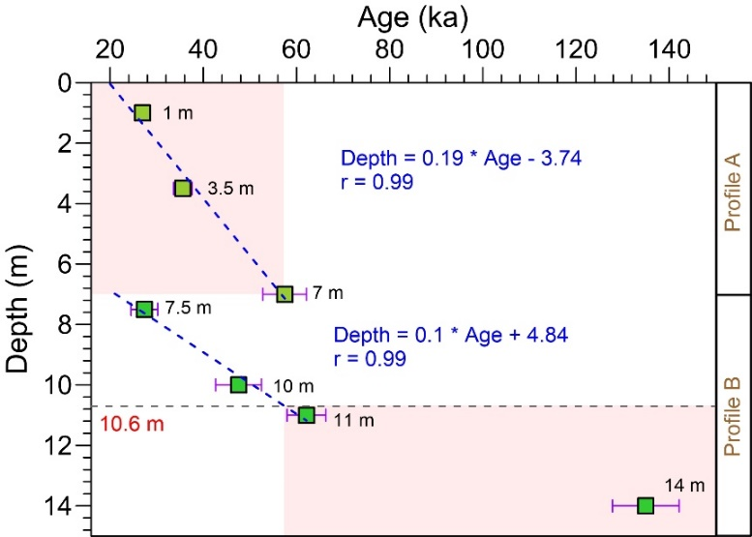

**Figure S2.** The age-depth model of the Fanshan section. The section consists of two vertical subsections [Subsection A (c. 7 m thick) and B (c. 8 m thick)]. Based on the modelling results, a composite of the two subsections (shown here in pink), that consist of 0-7 m (Subsection A) and the bottom c. 5.4 m of Subsection B (10.6 – 15 m) was investigated in this study.

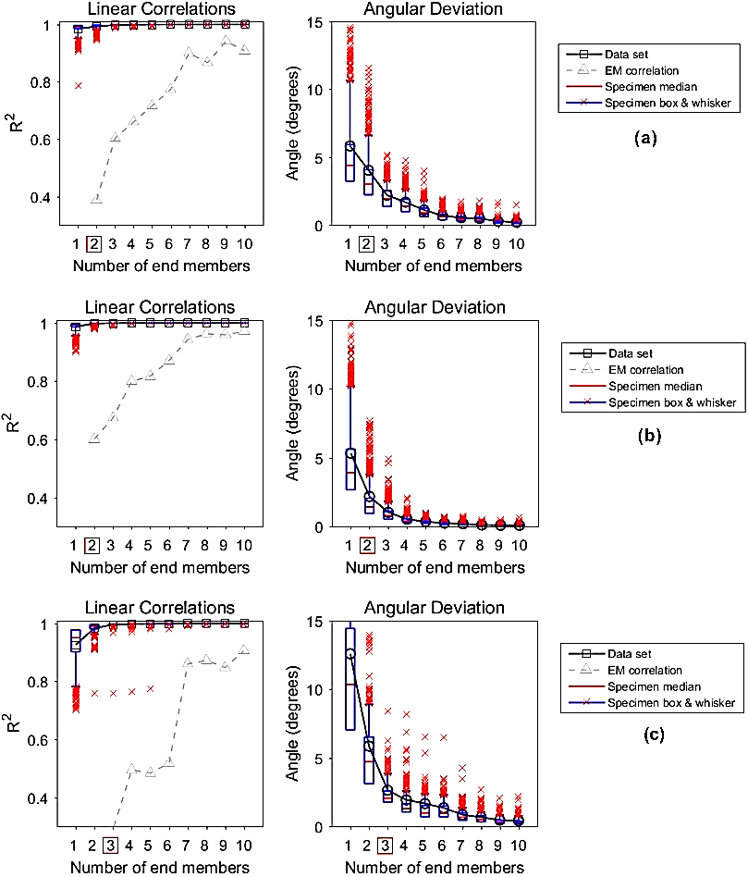

**Figure S3.** Coefficients of determination (R²) and mean angular deviation (θ) are used to determine the correct number of non-parametric end-member for the BSK (a), CMG (b) and FS18 (c) sections.

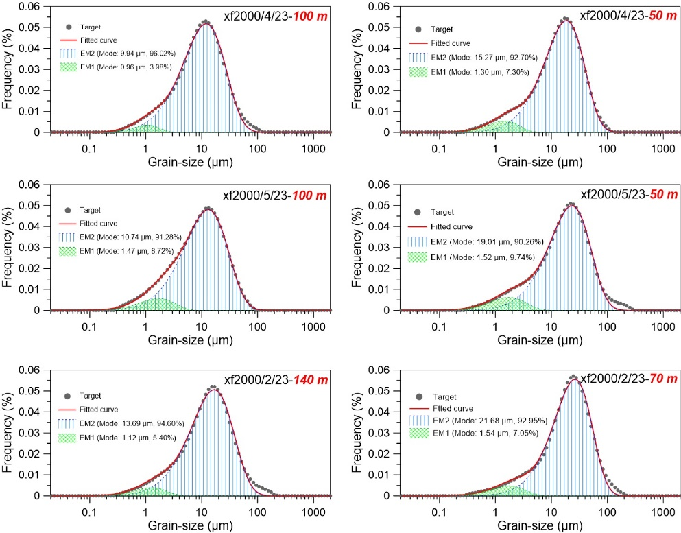

**Figure S4.** Parametric partitioning results of grain-size components of modern eolian dusts collected at different elevations on 23 Feb., 23 Apr., and 23 May. 2000 (Sun et al., 2003). Computed modal size and the percentages of coarse and fine components are given in the legends of the panels.



**Figure S5** Partitioning results of mean GSDs for the BSK, CMG and FS18 loess through parametric end-member modelling using Weibull function (Sun et al., 2002; Sun et al., 2004).

**References**

Balescu, S., Lamothe, M., 1994. Comparison of Tl and Irsl Age Estimates of Feldspar Coarse Grains from Waterlain Sediments. Quat. Sci. Rev. 13, 437-444.

Banerjee, D., Murray, A.S., Botter-Jensen, L., Lang, A., 2001. Equivalent dose estimation using a single aliquot of polymineral fine grains. Radiat Meas 33, 73-94.

Bokhorst, M.P., Vandenberghe, J., Sumegi, P., Lanczont, M., Gerasimenko, N.P., Matviishina, Z.N., Markovic, S.B., Frechen, M., 2011. Atmospheric circulation patterns in central and eastern Europe during the Weichselian Pleniglacial inferred from loess grain-size records. Quatern. Int. 234, 62-74.

Buylaert, J.-P., Murray, A., Vandenberghe, D., Vriend, M., De Corte, F., 2008. Optical dating of Chinese loess using sand-sized quartz: Establishing a time frame for Late Pleistocene climate changes in the western part of the Chinese Loess Plateau. Quat. Geochronol. 3, 99-113.

Buylaert, J.P., Jain, M., Murray, A.S., Thomsen, K.J., Thiel, C., Sohbati, R., 2012. A robust feldspar luminescence dating method for Middle and Late Pleistocene sediments. Boreas 41, 435-451.

Chen, F., Qiang, M., Zhou, A., Xiao, S., Chen, J., Sun, D., 2013. A 2000-year dust storm record from Lake Sugan in the dust source area of arid China. J. Geophys. Res. Atmos. 118, 2149-2160.

Durcan, J.A., King, G.E., Duller, G.A., 2015. DRAC: Dose Rate and Age Calculator for trapped charge dating. Quat. Geochronol. 28, 54-61.

Enzel, Y., Amit, R., Crouvi, O., Porat, N., 2010. Abrasion-derived sediments under intensified winds at the latest Pleistocene leading edge of the advancing Sinai-Negev erg. Quaternary Res. 74, 121-131.

Galbraith, R.F., Roberts, R.G., Laslett, G.M., Yoshida, H., Olley, J.M., 1999. Optical dating of single and multiple grains of quartz from Jinmium rock shelter, northern Australia: Part I, experimental design and statistical models. Archaeometry 41, 339-364.

Grigholm, B., Mayewski, P.A., Kang, S., Zhang, Y., Morgenstern, U., Schwikowski, M., Kaspari, S., Aizen, V., Aizen, E., Takeuchi, N., 2015. Twentieth century dust lows and the weakening of the westerly winds over the Tibetan Plateau. Geophys. Res. Lett. 42, 2434-2441.

Guérin, G., Mercier, N., Adamiec, G., 2011. Dose-rate conversion factors: update. Ancient. Tl 29, 5-8.

Hao, Q.Z., Wang, L., Oldfield, F., Peng, S.Z., Qin, L., Song, Y., Xu, B., Qiao, Y.S., Bloemendal, J., Guo, Z.T., 2012. Delayed build-up of Arctic ice sheets during 400,000-year minima in insolation variability. Nature 490, 393-396.

Huntley, D.J., Baril, M., 1997. The K content of the K-feldspars being measured in optical dating or in thermoluminescence dating. Ancient. Tl 15, 11-13.

Jacobs, P.M., Mason, J.A., Hanson, P.R., 2011. Mississippi Valley regional source of loess on the southern Green Bay Lobe land surface, Wisconsin. Quaternary Res. 75, 574-583.

Jia, J., Liu, H., Gao, F., Xia, D., 2018. Variations in the westerlies in Central Asia since 16ka recorded by a loess section from the Tien Shan Mountains. Palaeogeog. Palaeoclimatol. Palaeoecol., S0031018217309847.

Kurosaki, Y., Mikami, M., 2003. Recent frequent dust events and their relation to surface wind in east Asia. Geophys. Res. Lett. 30, 1736-1739.

Li, Y., Song, Y., Fitzsimmons, K.E., Chang, H., Orozbaev, R., Li, X., 2018. Eolian dust dispersal patterns since the last glacial period in eastern Central Asia: insights from a loess-paleosol sequence in the Ili Basin. Clim. Past. 14, 271-286.

Li, Y., Song, Y., Orozbaev, R., Dong, J., Zhou, J., 2020. Moisture evolution in Central Asia since 26 ka: Insights from a Kyrgyz loess section, Western Tian Shan. Quaternary Science Reviews 249, 106604.

Li, Y., Song, Y., Zong, X., Zhang, Z., Cheng, L., 2019. Dust accumulation processes of piedmont loess indicated by grain-size end members in northern Ili Basin (in Chinese). Acta Geog. Sin. 74, 162-177.

Lim, J., Matsumoto, E., 2006. Bimodal grain-size distribution of aeolian quartz in a maar of Cheju Island, Korea, during the last 6500 years: Its flux variation and controlling factor. Geophys. Res. Lett. 332, 183-203.

Lin, Y.C., Mu, G.J., Xu, L.S., Zhao, X., 2016. The origin of bimodal grain-size distribution for aeolian deposits. Aeolian Res. 20, 80-88.

Liu, X., Yin, J., Zhang, X., Yang, X., 2004. Analyses of the spring dust storm frequency of northern China in relation to antecedent and concurrent wind, precipitation, vegetation, and soil moisture conditions. J. Geophys. Res. Atmos. 109, doi:10.1029/2004JD004615.

Lu, H., Jia, J., Yin, Q.Z., Xia, D.S., Gao, F.Y., Liu, H., Fan, Y.J., Li, Z.J., Wang, X., Berger, A., Oimuhammadzoda, I., Gadoev, M., 2020. Atmospheric Dynamics Patterns in Southern Central Asia Since 800 ka Revealed by Loess-Paleosol Sequences in Tajikistan. Geophys. Res. Lett. 47.

Mctainsh, G.H., Nickling, W.G., Lynch, A.W., 1997. Dust deposition and particle size in Mali, West Africa. Catena 29, 307-322.

Muhs, D.R., Bettis, E., 2003. Quaternary loess-paleosol sequences as examples of climate-driven sedimentary extremes. Spec. Pap. Geol. Soc. Am., 53-74.

Murray, A.S., Wintle, A.G., 2000. Luminescence dating of quartz using an improved single-aliquot regenerative-dose protocol. Radiat Meas 32, 57-73.

Nottebaum, V., Lehmkuhl, F., Stauch, G., Hartmann, K., Wunnemann, B., Schimpf, S., Lu, H.Y., 2014. Regional grain size variations in aeolian sediments along the transition between Tibetan highlands and north-western Chinese deserts - the influence of geomorphological settings on aeolian transport pathways. Earth Surf Proc Land 39, 1960-1978.

Nottebaum, V., Stauch, G., Hartmann, K., Zhang, J., Lehmkuhl, F., 2015. Unmixed loess grain size populations along the northern Qilian Shan (China): Relationships between geomorphologic, sedimentologic and climatic controls. Quatern. Int. 372, 151-166.

Park, C.S., Hwang, S., Yoon, S.O., Choi, J., 2014. Grain size partitioning in loess-paleosol sequence on the west coast of South Korea using the Weibull function. Catena 121, 307-320.

Prescott, J.R., Hutton, J.T., 1994. Cosmic-Ray Contributions to Dose-Rates for Luminescence and Esr Dating - Large Depths and Long-Term Time Variations. Radiat Meas 23, 497-500.

Prins, M.A., Vriend, M., 2007. Glacial and interglacial eolian dust dispersal patterns across the Chinese Loess Plateau inferred from decomposed loess grain-size records. Geochem Geophy Geosy 8.

Prins, M.A., Vriend, M., Nugteren, G., Vandenberghe, J., Lu, H.Y., Zheng, H.B., Weltje, G.J., 2007. Late Quaternary aeolian dust input variability on the Chinese Loess Plateau: inferences from unmixing of loess grain-size records. Quat. Sci. Rev. 26, 230-242.

Prins, M.A., Zheng, H.B., Beets, K., Troelstra, S., Bacon, P., Kamerling, I., Wester, W., Konert, M., Huang, X.T., Ke, W., Vandenberghe, J., 2009. Dust supply from river floodplains: the case of the lower Huang He (Yellow River) recorded in a loess-palaeosol sequence from the Mangshan Plateau. J. Quat. Sci. 24, 75-84.

Pye, K., 1987. Aeolian dust and dust deposits. Academic Press, London.

Pye, K., 1995. The nature, origin and accumulation of loess. Quat. Sci. Rev. 14, 653-667.

Pye, K., Zhou, L.P., 1989. Late Pleistocene and Holocene Aeolian Dust Deposition in North China and the Northwest Pacific-Ocean. Palaeogeog. Palaeoclimatol. Palaeoecol. 73, 11-23.

Qin, X., Cai, B., Liu, T., 2005. Loess record of the aerodynamic environment in the east Asia monsoon area since 60,000 years before present. J. Geophys. Res. Solid Earth 110, -.

Rasmussen, S.O., Bigler, M., Blockley, S.P., Blunier, T., Buchardt, S.L., Clausen, H.B., Cvijanovic, I., Dahl-Jensen, D., Johnsen, S.J., Fischer, H., Gkinis, V., Guillevic, M., Hoek, W.Z., Lowe, J.J., Pedro, J.B., Popp, T., Seierstad, I.K., Steffensen, J.P., Svensson, A.M., Vallelonga, P., Vinther, B.M., Walker, M.J.C., Wheatley, J.J., Winstrup, M., 2014. A stratigraphic framework for abrupt climatic changes during the Last Glacial period based on three synchronized Greenland ice-core records: refining and extending the INTIMATE event stratigraphy. Quat. Sci. Rev. 106, 14-28.

Ruth, U., Wagenbach, D., Steffensen, J.P., Bigler, M., 2003. Continuous record of microparticle concentration and size distribution in the central Greenland NGRIP ice core during the last glacial period. J. Geophys. Res. Atmos. 108, doi: 10.1029/2002JD002376.

Steffensen, J.P., 1997. The size distribution of microparticles from selected segments of the GRIP ice core representing different climatic periods. J. Geophys. Res. Atmos. 102, 26755-26764.

Sun, D., Bloemendal, J., Rea, D.K., Vandenberghe, J., Jiang, F., An, Z., Su, R., 2002. Grain-size distribution function of polymodal sediments in hydraulic and aeolian environments, and numerical partitioning of the sedimentary components. Sediment. Geol. 152, 263-277.

Sun, D.H., 2004. Monsoon and westerly circulation changes recorded in the late Cenozoic aeolian sequences of Northern China. Global Planet. Change 41, 63-80.

Sun, D.H., Bloemendal, J., Rea, D.K., An, Z.S., Vandenberghe, J., Lu, H.Y., Su, R.X., Liu, T.S., 2004. Bimodal grain-size distribution of Chinese loess, and its palaeoclimatic implications. Catena 55, 325-340.

Sun, D.H., Chen, F.H., Bloemendal, J., Su, R.X., 2003. Seasonal variability of modern dust over the Loess Plateau of China. J Geophys Res-Atmos 108.

Sun, D.H., Su, R.X., Bloemendal, J., Lu, H.Y., 2008. Grain-size and accumulation rate records from Late Cenozoic aeolian sequences in northern China: Implications for variations in the East Asian winter monsoon and westerly atmospheric circulation. Palaeogeog. Palaeoclimatol. Palaeoecol. 264, 39-53.

Thiel, C., Buylaert, J.-P., Murray, A., Terhorst, B., Hofer, I., Tsukamoto, S., Frechen, M., 2011. Luminescence dating of the Stratzing loess profile (Austria)–Testing the potential of an elevated temperature post-IR IRSL protocol. Quatern. Int. 234, 23-31.

Thomsen, K.J., Botter-Jensen, L., Denby, P.M., Moska, P., Murray, A.S., 2006. Developments in luminescence measurement techniques. Radiat Meas 41, 768-773.

Thomsen, K.J., Murray, A.S., Jain, M., Bøtter-Jensen, L., 2008. Laboratory fading rates of various luminescence signals from feldspar-rich sediment extracts. Radiat Meas 43, 1474-1486.

Tsoar, H., Pye, K., 1987. Dust transport and the question of desert loess formation. Sedimentology 34, 139-153.

Vandenberghe, J., 2013. Grain size of fine-grained windblown sediment: A powerful proxy for process identification. Earth-Sci. Rev. 121, 18-30.

Vandenberghe, J., Renssen, H., van Huissteden, K., Nugteren, G., Konert, M., Lu, H.Y., Dodonov, A., Buylaert, J.P., 2006. Penetration of Atlantic westerly winds into Central and East Asia. Quat. Sci. Rev. 25, 2380-2389.

Varga, G., 2011. Similarities among the PlioePleistocene terrestrial aeolian dust deposits in the World and in Hungary. Quatern. Int. 234, 98-108.

Vriend, M., 2007. Lost in loess: Late Quaternary eolian dust dispersal patterns across Central China inferred from decomposed loess grain-size records, Amsterdam. VU University, The Netherlands, p. 53.

Vriend, M., Prins, M.A., 2005. Calibration of modelled mixing patterns in loess grain-size distributions: an example from the north-eastern margin of the Tibetan Plateau, China. Sedimentology 52, 1361-1374.

Vriend, M., Prins, M.A., Buylaert, J.P., Vandenberghe, J., Lu, H.Y., 2011. Contrasting dust supply patterns across the north-western Chinese Loess Plateau during the last glacial-interglacial cycle. Quatern. Int. 240, 167-180.

Xie, Y.Y., Chi, Y.P., 2016. Geochemical investigation of dry- and wet-deposited dust during the same dust-storm event in Harbin, China: Constraint on provenance and implications for formation of aeolian loess. J. Asian Earth Sci. 120, 43-61.

Xiong, S., Ding, Z., Liu, T., 2001. Climatic implications of loess deposits from the Beijing region. Journal of Quaternary ence 16, 575-582.

Xu, L., Mu, G., He, J., Yang, F., Ren, X., Wan, D., Lin, Y., 2016. Variability of dust mass concentrations and deposition rates under different weather conditions in Cele Oasis, southern Tarim Basin. Environmental Earth ences 75, 639.

Yang, F., Zhang, G.L., Yang, F., Yang, R.M., 2016. Pedogenetic interpretations of particle-size distribution curves for an alpine environment. Geoderma 282, 9-15.

Zhang, X.Y., Arimoto, R., An, Z.S., 1999. Glacial and interglacial patterns for Asian dust transport. Quat. Sci. Rev. 18, 811-819.

Zhou, Z.J., Zhang, G.C., Ai, W.X., Zhang, H.Z., Niu, R.Y., 2006. Time series of spring dust emission and its correlative climatic factors in northern China. J. Desert Res.