Supplementary Material

SUPPLEMENTARY TABLES

Supplementary Table 1. Summary of the Joint Commission Antimicrobial Stewardship Requirements (1).
Requirement | Rationale
Identify an individual responsible for developing, implementing, and monitoring activities to promote appropriate antibiotic prescribing | - Antimicrobial resistance is growing, improving use of antibiotics is a patient safety priority  - Identifying an individual increases likelihood of success  - Antimicrobial stewardship may be primary job or in addition to other duties
Organization sets ≥1 antibiotic stewardship goal each year | - Allows the organization to focus efforts  - Can review own prescribing data or consult national data to identify areas for focus  - Organization’s protocols and guidelines, education resources, and measurement activities should align with goal
Organization uses evidence-based practice guidelines related to antibiotic stewardship goal(s) | - Using protocols and guidelines will help ensure that antibiotics are given to only patients who need them
Organization provides all clinical staff with educational resources related to the goal, and strategies that promote appropriate antibiotic prescribing | - Clinical staff need education about the goal so that patients receive clear and consistent recommendations when antibiotics are not indicated  - Education can include recommended prescribing practices, and strategies to explain why some patients may not need an antibiotic
Organization collects, analyzes, and reports data on the goal to organizational leadership and prescribers | - Important to evaluate whether activities are successful, and share any progress with leadership  - Can involve electronic or manual data collection, analysis methods  - Sustained effort is often required to see change in culture of antibiotic prescribing

Supplementary Table 2. Safety-related factors that warrant careful consideration of antibiotic choice in outpatient treatment of pneumonia or skin infection (2).
Antibiotic | Risk factor
Fluoroquinolones | - QTc prolongation  - Tendinopathy/tendon rupture  - Neuropathy  - Risk for C. difficile infection (esp. age ≥65 years, recent antibiotic use)
Cephalosporins | - Risk for C. difficile infection (esp. age ≥65 years, recent antibiotic use)
Penicillins | - Hypersensitivity reaction
Clindamycin | - Risk for C. difficile infection (esp. age ≥65 years, recent antibiotic use)  - Hematologic or renal issues with prolonged therapy
Tetracyclines | - Developmental effects (avoid in children, pregnancy)  - Photosensitivity
Oxazolidinones | - Serotonin syndrome (esp. with prior or concomitant serotonergic agents)  - Myelosuppression, visual issues with prolonged therapy
Macrolides | - QTc prolongation
Aminoglycosides | - Nephrotoxicity  - Ototoxicity

Supplementary Table 3. Managing patient/parent expectations for antibiotic prescription.
When… | What to say…
Non-antibiotic treatments are indicated | “Drink extra fluids.”  “A humidifier or salt water nose spray can help congestion.”  “Popsicles or throat lozenges can help a sore throat.” [Lozenges for patients ≥4 years]  “Honey can help a cough.” [Honey for patients ≥1 year]  “Sleep with an extra pillow or towel to prop up your head, to relieve head pressure or coughing at night.”
Making plans for follow-up | “If you’re not feeling better in 3–4 days, call my office and we’ll see if we need to change the plan.”  “If your child is not better in 1 week or starts a fever, come back in.”
Antibiotics are not indicated | “Your sickness is caused by a virus, and antibiotics don’t work on viruses.”  “Antibiotics won’t help you feel better any sooner, and sometimes they can have side effects that we want to avoid if possible.”
Delayed prescribing | “Your child has an ear infection that should clear up on its own. In case it doesn’t, you can fill this antibiotic prescription in 2 days if your child is not feeling better or is getting worse.”
Adapted from Fleming-Dutra, et al (3).

SUPPLEMENTARY FIGURES
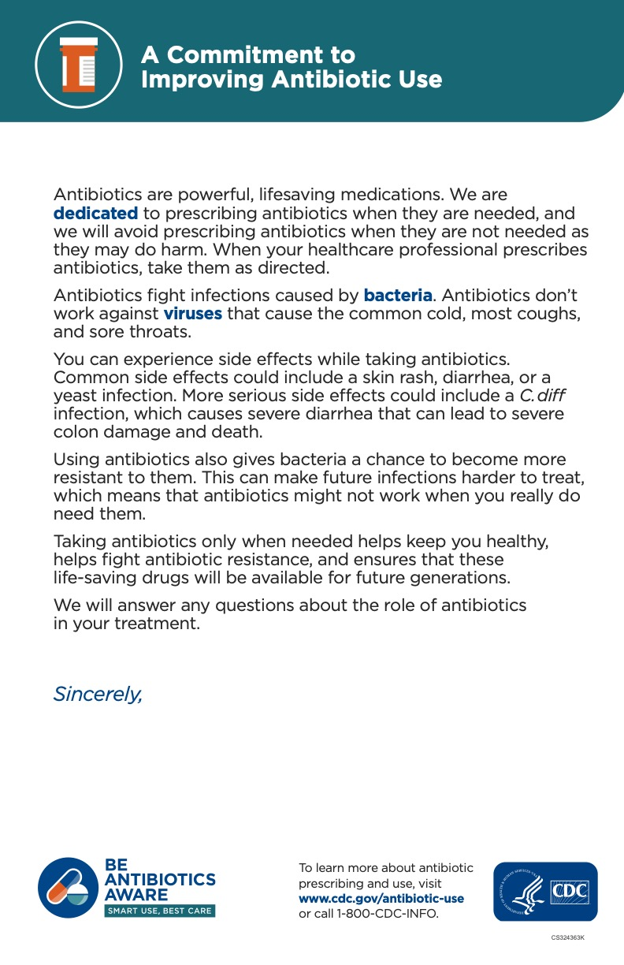
Supplementary Figure 1. Example of signed commitment letter to post in the clinic for appropriate antibiotic use. From the Centers for Disease Control and Prevention (4).

Viruses or Bacteria
What’s got you sick?
Illness | Usually Caused By… |  |  | Will Antibiotics Help?
 | Bacteria | Bacteria or Virus | Virus
Strep throat |  |  |  | Yes
Urinary tract infection |  |  |  | Yes
Whooping cough |  |  |  | Yes
Sinus infection |  |  |  | Usually not  Antibiotic need depends on symptoms, duration
Middle ear infection |  |  |  | Usually not  Most clear on their own  Swimmer’s ear can clear with ear drops
Chest cold/ bronchitis* |  |  |  | Usually not  Most clear on their own
Head cold/runny nose |  |  |  | No
Sore throat (not Strep) |  |  |  | No
Flu |  |  |  | No
Supplementary Figure 2. Printable poster for the clinic.
*In otherwise healthy children and adults.
Modified from the CDC’s Be Antibiotics Aware Campaign Materials to provide more specific, yet still concise, information for the patient (5).

REFERENCES
- The Joint Commission. R3 Report, Issue 23: Antimicrobial Stewardship in Ambulatory Health Care (2019). https://www.jointcommission.org/standards/r3-report/r3-report-issue-23-antimicrobial-stewardship-in-ambulatory-health-care/. [Accessed December 14, 2021]

- Lee GC, Burgess DS. “Antimicrobial regimen selection,”. In: DiPiro JT, Talbert RL, Yee GC, et al., editors. Pharmacotherapy: A Pathophysiologic Approach. New York, NY: McGraw Hill Education (2017). P. 1731-1742.

- Fleming-Dutra KE, Mangione-Smith R, Hicks LA. How to prescribe fewer unnecessary antibiotics: Talking points that work. Am Fam Physician. (2016) 94:200-2.

- Centers for Disease Control and Prevention. https://www.cdc.gov/antibiotic-use/pdfs/Commitment-Poster-english-11x17-P.pdf [Accessed December 14, 2021].

- Centers for Disease Control and Prevention Be Antibiotics Aware Campaign Materials. https://www.cdc.gov/antibiotic-use/materials-references/index.html [Accessed December 14, 2021].

