**Supplementary Content**

|  |  |  |
| --- | --- | --- |
| Session | acupoints | Location |
| 1, 4, 7 | EX-B2 | 0.5 *cun* lateral to the depression below the spinous process of the 4th cervical vertebra |
| LI 10 | on the dorsal-radial side of the forearm, 2 *cun* inferior the transverse crease of the elbow, on the line joining LI5 and LI11 |
| EX-UE | on the midpoint of the line between the top of anterior axillary folds and LI15 acupoint |
| GB 29 | at the lateral gluteal, the midpoint of the line between anterior superior iliac spine and the most convex point of the greater trochanter |
| GB 33 | on the lateral side of the knee, the depression above the external epicondyle of the femur |
| 2, 5, 8 | SJ14 | in the depression posteroinferior to the acromion when arm is abducted |
| LU5 | on the transverse cubital crease, the radial side of the tendon of the biceps brachii |
| SJ4 | in the dorsal of the transverse crease of the wrist, the depression of the ulnar border of the total extensor tendon |
| BL24 | 1.5 *cun* lateral to the depression below the spinous process of the 3th lumbar vertebra |
| BL40 | the midpoint of the transverse crease of the popliteal fossa |
| BL58 | on the lateral of the calf, 7 *cun* above the BL60 acupoint |
| 3, 6, 9 | LI14 | 7 *cun* above the transverse crease of the elbow, on the line joining LI11 and LI15 |
| PC3 | on the transverse cubital crease, the depression of the ulnar border of the tendon of biceps brachii |
| LI5 | at the dorsal transverse crease of the wrist, at the depression between the tendons of the short extensor and long extensor of the thumb when the thumb is upward |
| ST31 | In anterior of the thigh, flush with the transverse crease of the hips, on the line joining the anterior superior iliac spine and the lateral side on the bottom of the [patella](javascript:;) |
| LR8 | on the medial side of transverse crease of the knee, the posterior edge of the medial condyle of the femur when bending the knee |

Table 1: Location of acupoints chose in trial group

* Additional points could be chosen according to syndrome differentiation：

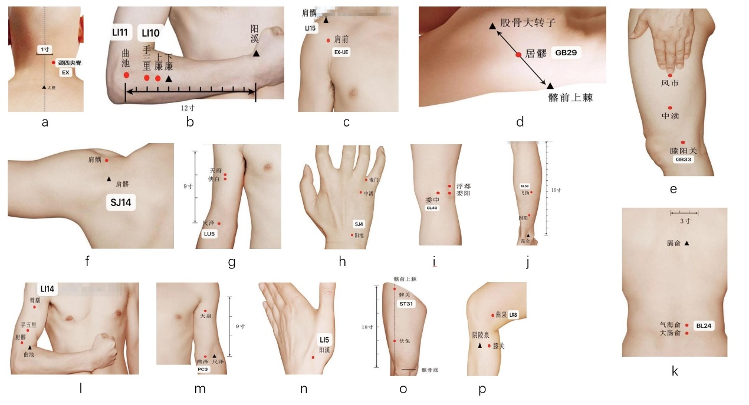（1）constipation：ST25；（2）insomnia: BL14