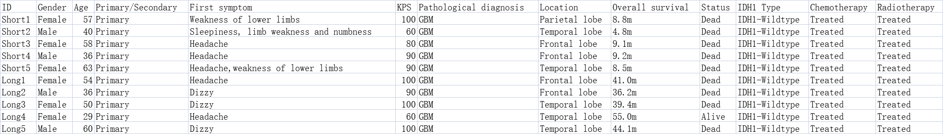
Supplementary Table 1:Clinical data of 10 patients by liquid chromatography-tandem mass spectrometry.

Supplementary Table 2:Clinical data of 4 patients in Western Blot.

