Linkage disequilibrium between the significant markers on chromosome 1A. The standardized disequilibrium coefficients (D’) are shown in the lower-left matrix and correlations between alleles at the two marker loci (r²) are shown in the upper-right matrix. 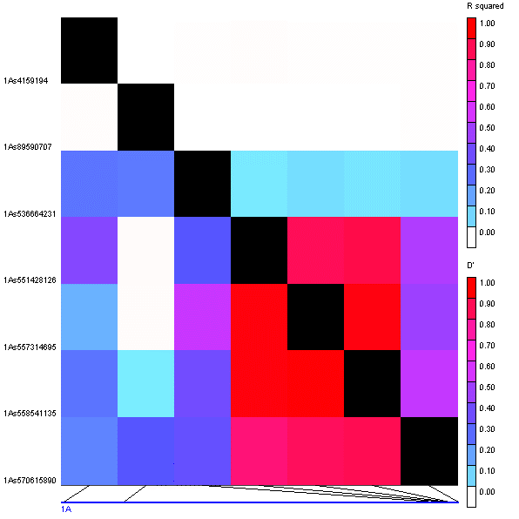

Linkage disequilibrium between the significant markers on chromosome 1B. The standardized disequilibrium coefficients (D’) are shown in the lower-left matrix and correlations between alleles at the two marker loci (r²) are shown in the upper-right matrix. 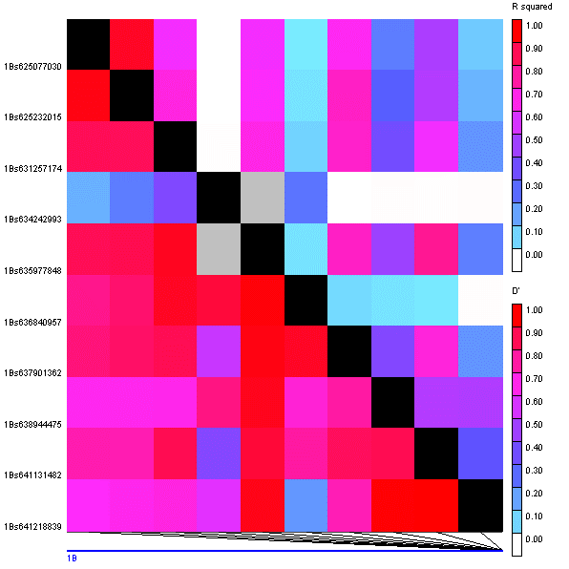

Linkage disequilibrium between the significant markers on chromosome 1D. The standardized disequilibrium coefficients (D’) are shown in the lower-left matrix and correlations between alleles at the two marker loci (r²) are shown in the upper-right matrix. 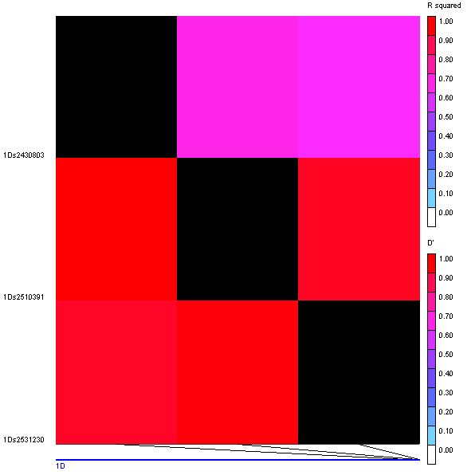

Linkage disequilibrium between the significant markers on chromosome 2A. The standardized disequilibrium coefficients (D’) are shown in the lower-left matrix and correlations between alleles at the two marker loci (r²) are shown in the upper-right matrix. 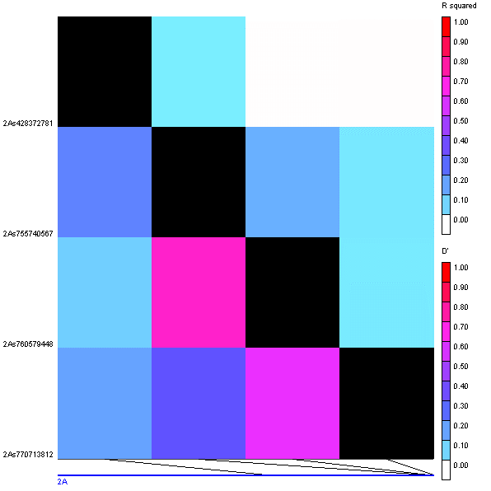

Linkage disequilibrium between the significant markers on chromosome 2B. The standardized disequilibrium coefficients (D’) are shown in the lower-left matrix and correlations between alleles at the two marker loci (r²) are shown in the upper-right matrix. 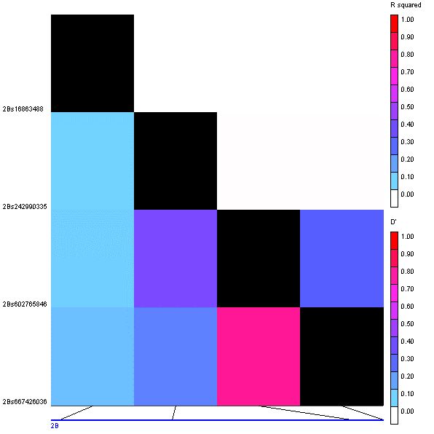

Linkage disequilibrium between the significant markers on chromosome 2D. The standardized disequilibrium coefficients (D’) are shown in the lower-left matrix and correlations between alleles at the two marker loci (r²) are shown in the upper-right matrix. 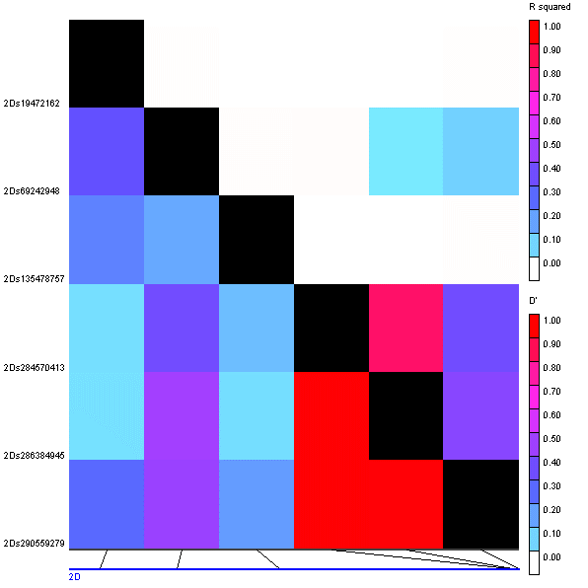

Linkage disequilibrium between the significant markers on chromosome 3B. The standardized disequilibrium coefficients (D’) are shown in the lower-left matrix and correlations between alleles at the two marker loci (r²) are shown in the upper-right matrix. 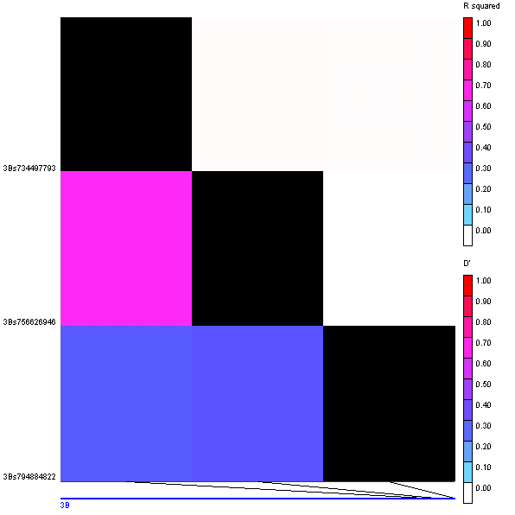

Linkage disequilibrium between the significant markers on chromosome 4A. The standardized disequilibrium coefficients (D’) are shown in the lower-left matrix and correlations between alleles at the two marker loci (r²) are shown in the upper-right matrix. 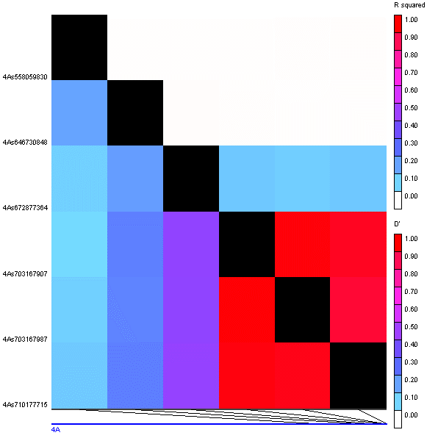

Linkage disequilibrium between the significant markers on chromosome 4B. The standardized disequilibrium coefficients (D’) are shown in the lower-left matrix and correlations between alleles at the two marker loci (r²) are shown in the upper-right matrix. 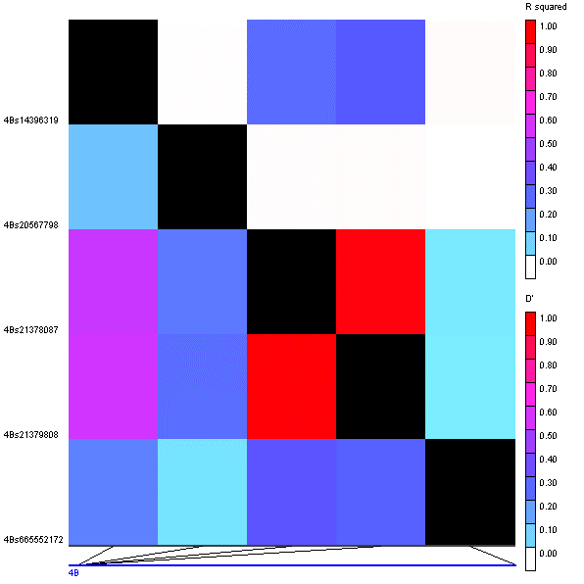

Linkage disequilibrium between the significant markers on chromosome 4D. The standardized disequilibrium coefficients (D’) are shown in the lower-left matrix and correlations between alleles at the two marker loci (r²) are shown in the upper-right matrix. 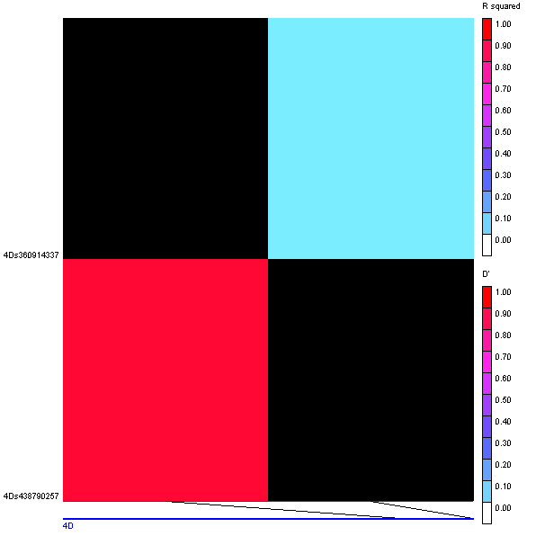

Linkage disequilibrium between the significant markers on chromosome 5A. The standardized disequilibrium coefficients (D’) are shown in the lower-left matrix and correlations between alleles at the two marker loci (r²) are shown in the upper-right matrix. 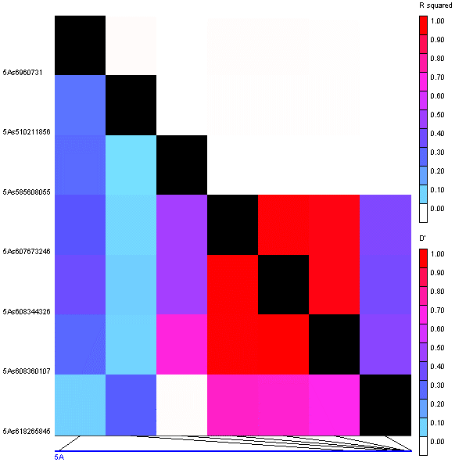

Linkage disequilibrium between the significant markers on chromosome 5B. The standardized disequilibrium coefficients (D’) are shown in the lower-left matrix and correlations between alleles at the two marker loci (r²) are shown in the upper-right matrix. 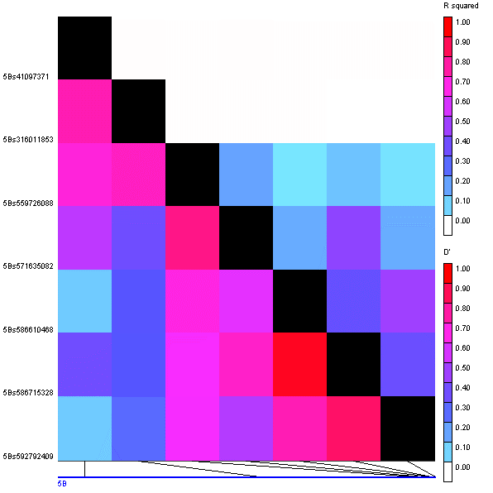

Linkage disequilibrium between the significant markers on chromosome 5D. The standardized disequilibrium coefficients (D’) are shown in the lower-left matrix and correlations between alleles at the two marker loci (r²) are shown in the upper-right matrix. 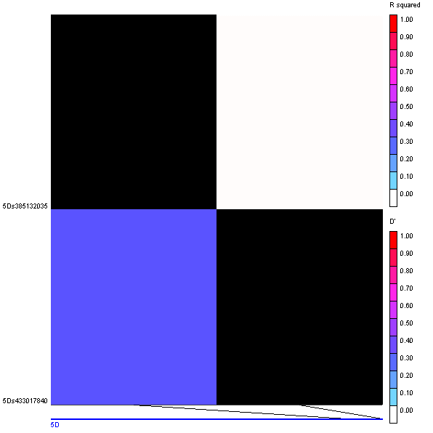

Linkage disequilibrium between the significant markers on chromosome 6B. The standardized disequilibrium coefficients (D’) are shown in the lower-left matrix and correlations between alleles at the two marker loci (r²) are shown in the upper-right matrix. 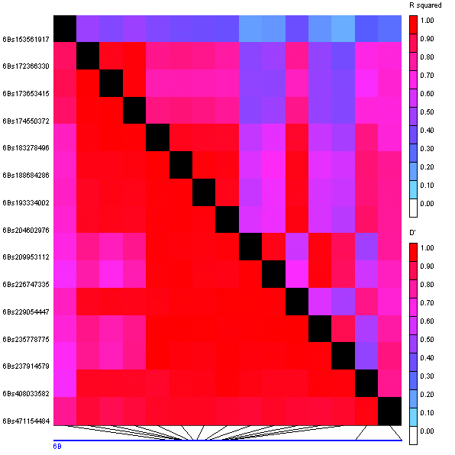

Linkage disequilibrium between the significant markers on chromosome 6D. The standardized disequilibrium coefficients (D’) are shown in the lower-left matrix and correlations between alleles at the two marker loci (r²) are shown in the upper-right matrix. 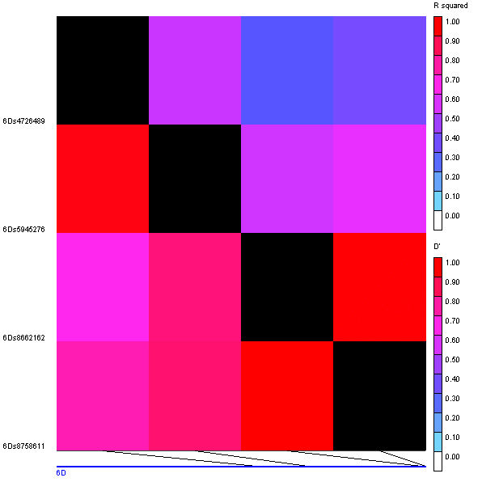

Linkage disequilibrium between the significant markers on chromosome 7A. The standardized disequilibrium coefficients (D’) are shown in the lower-left matrix and correlations between alleles at the two marker loci (r²) are shown in the upper-right matrix. 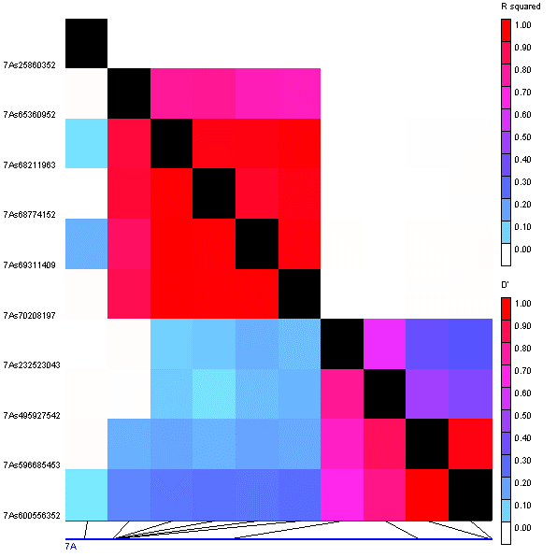

Linkage disequilibrium between the significant markers on chromosome 7B. The standardized disequilibrium coefficients (D’) are shown in the lower-left matrix and correlations between alleles at the two marker loci (r²) are shown in the upper-right matrix. 