Supplementary Material

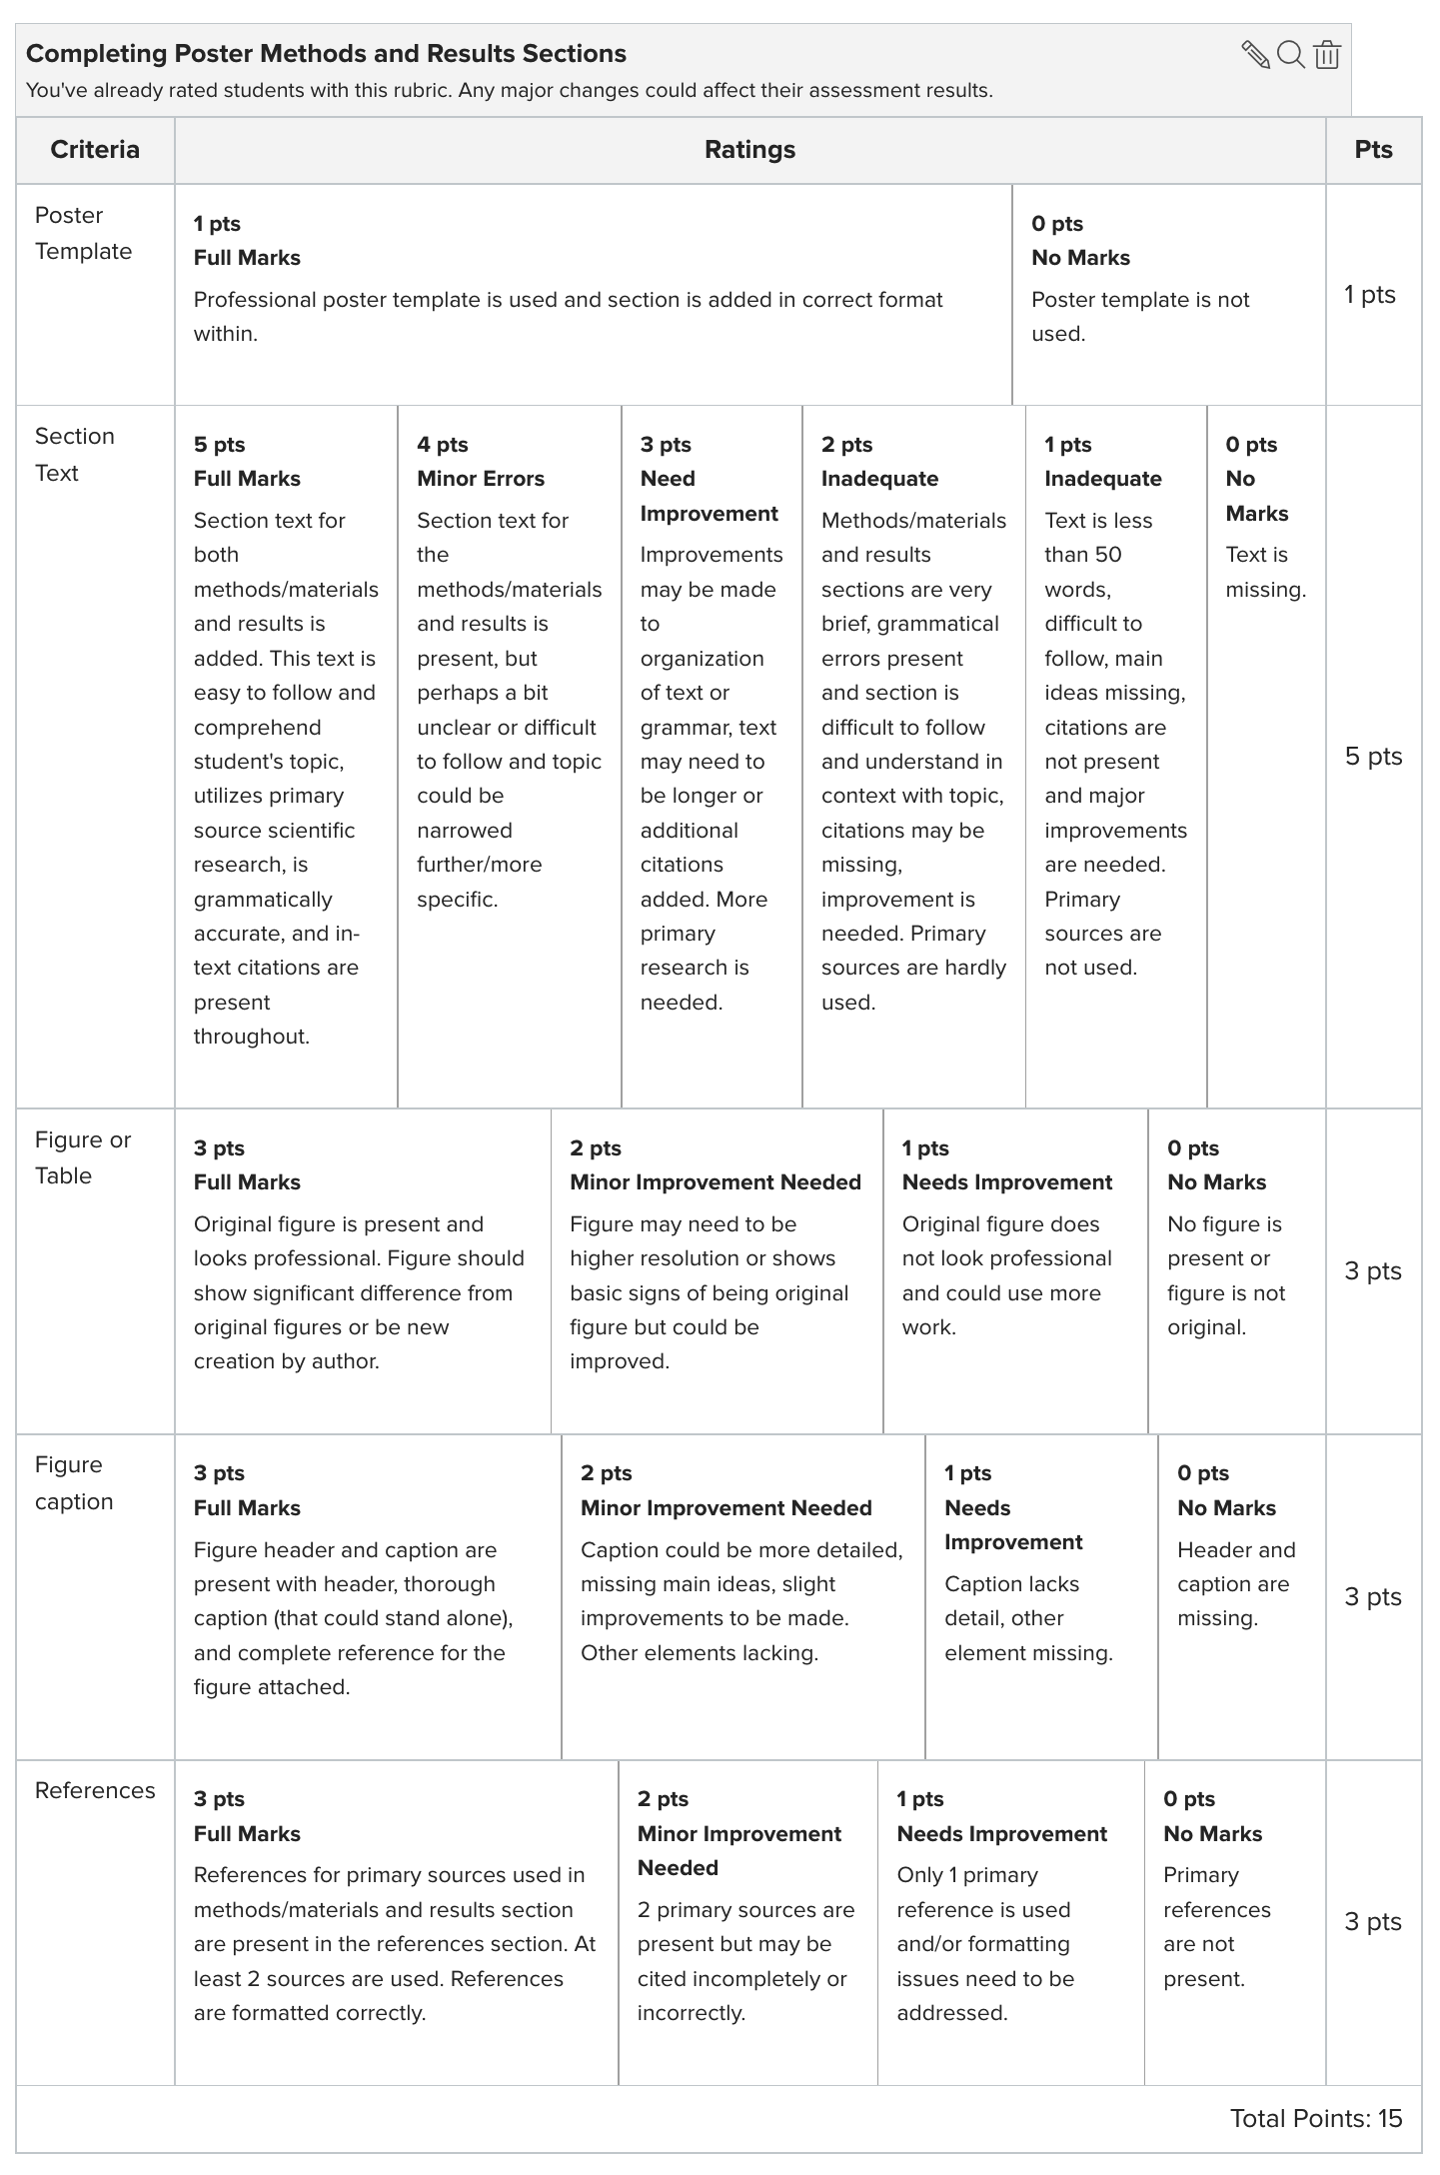

Supplementary Figure S1. Rubric used for Poster Assignment 3, Poster Materials, Methods, and Results Assignment.

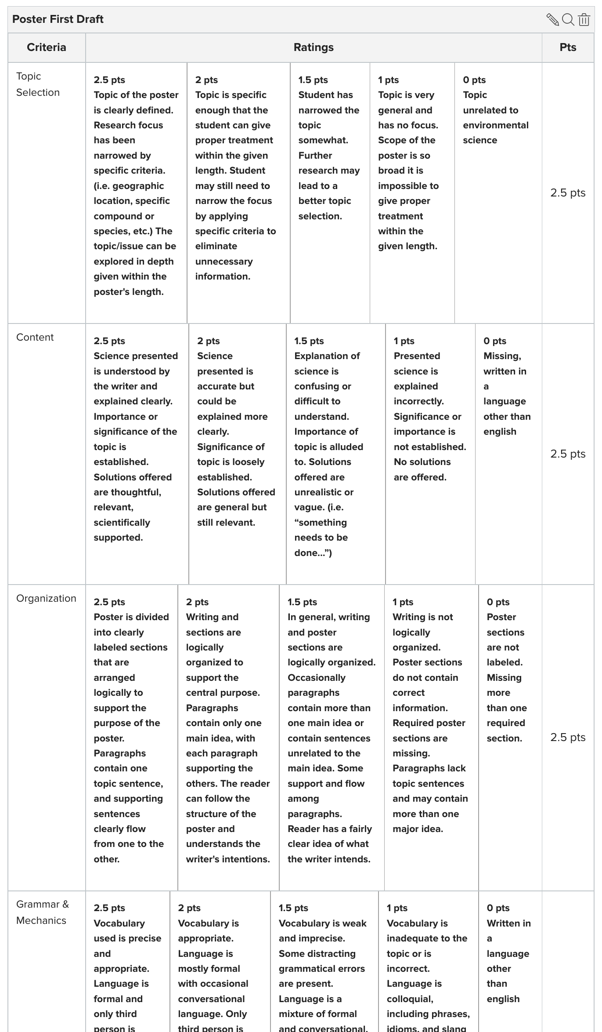
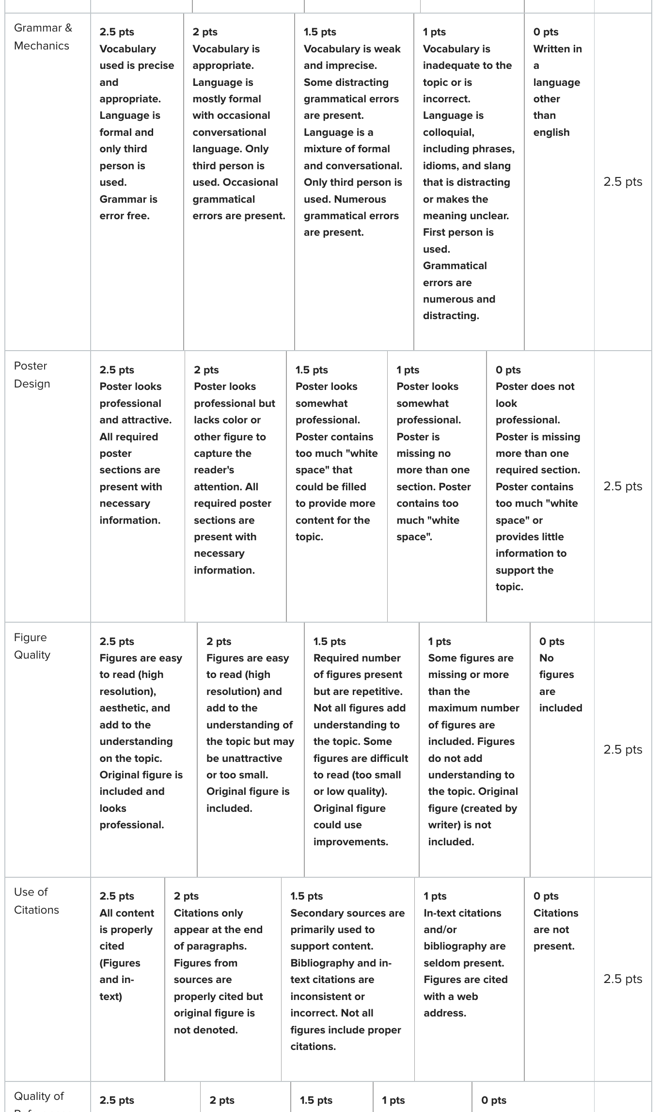
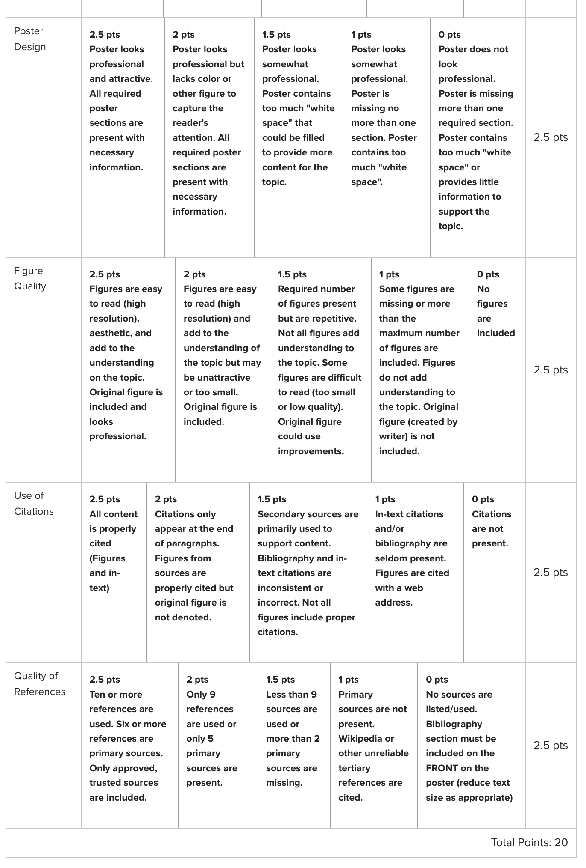
Supplementary Figure S2. Rubric used for Poster Assignment 4, Poster First Draft.

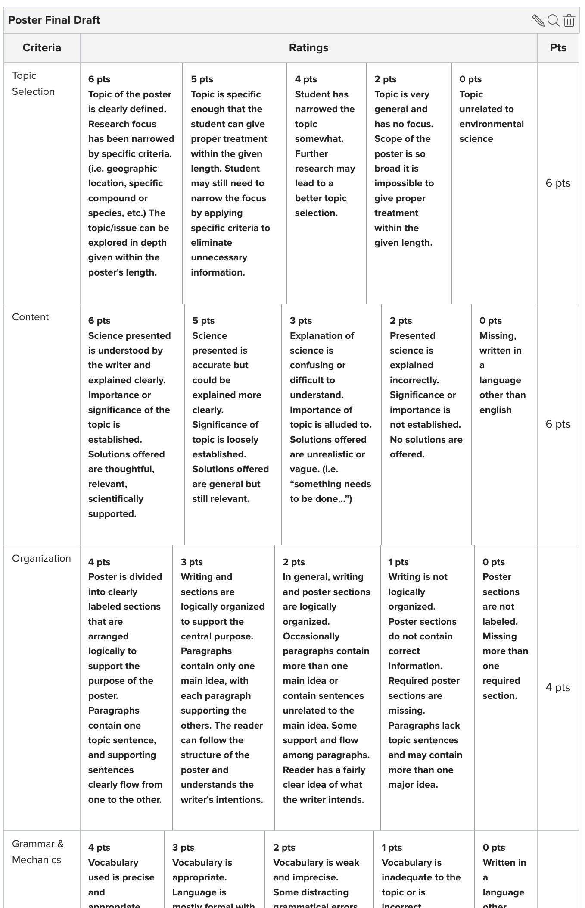
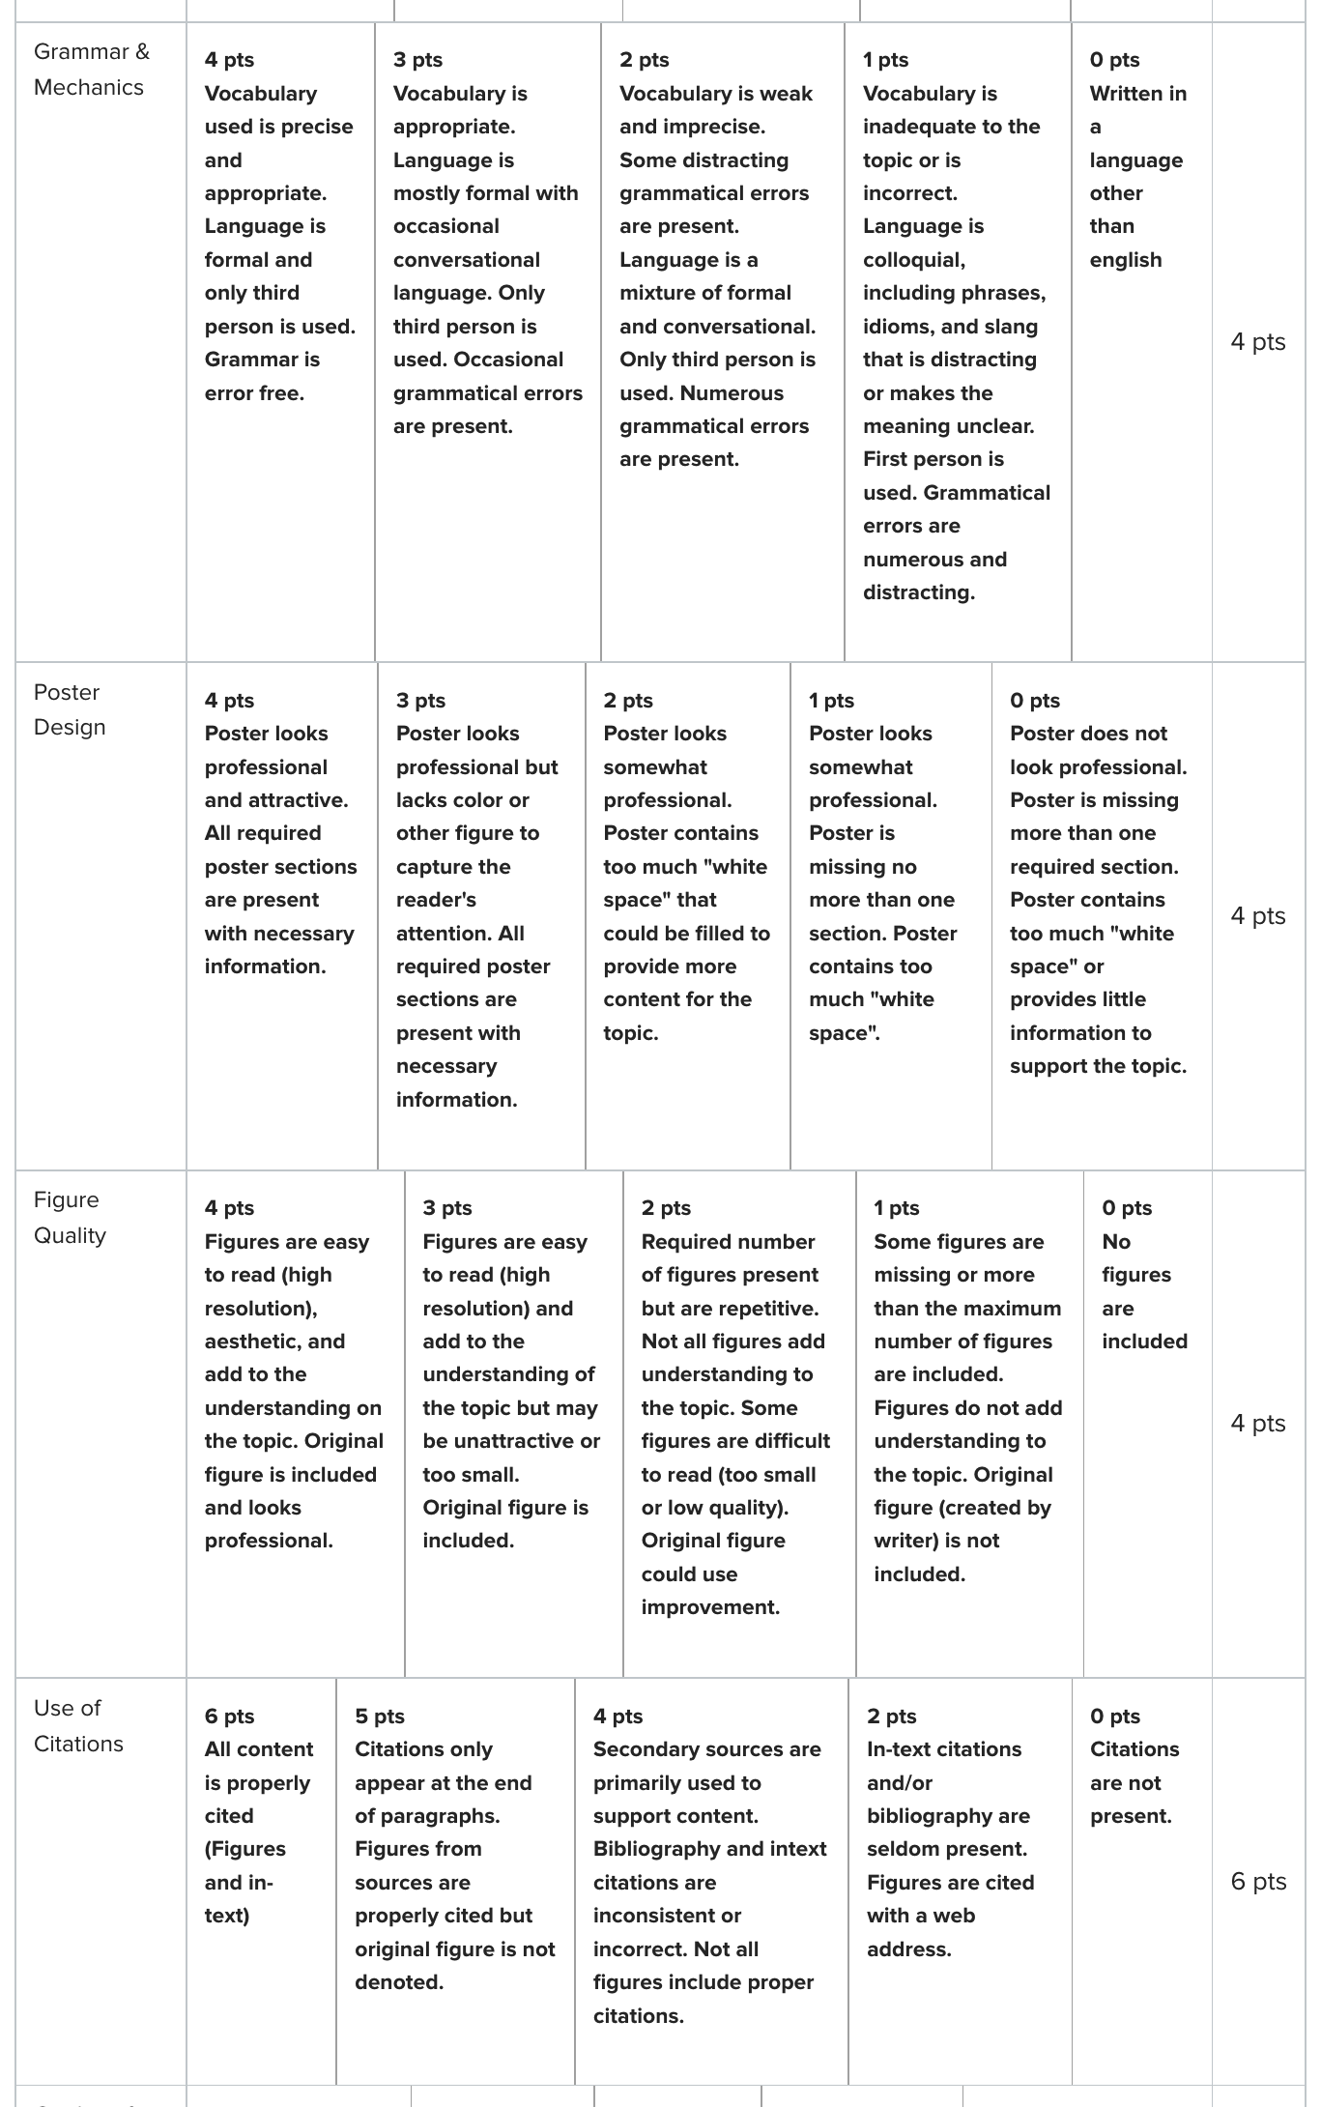
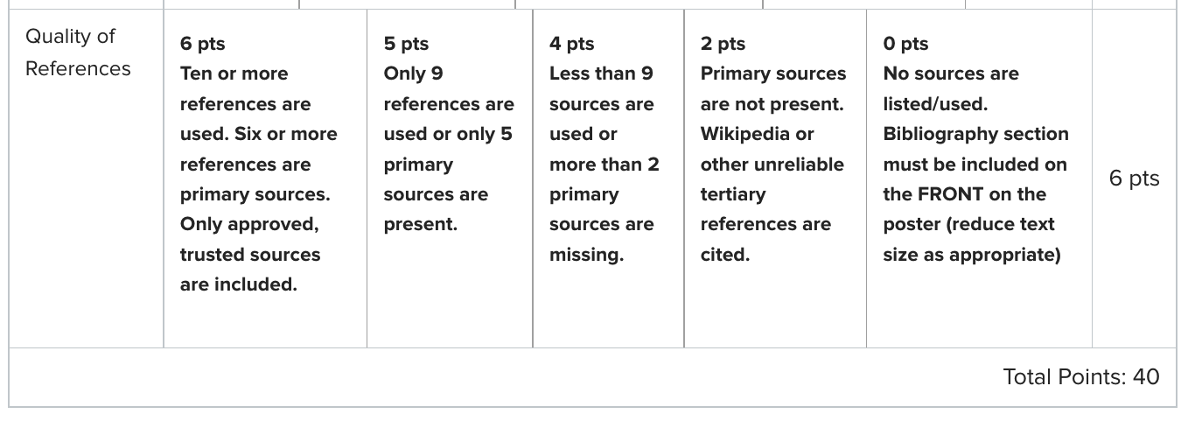Supplementary Figure S3. Rubric used for Poster Assignment 5, Poster Final Draft. 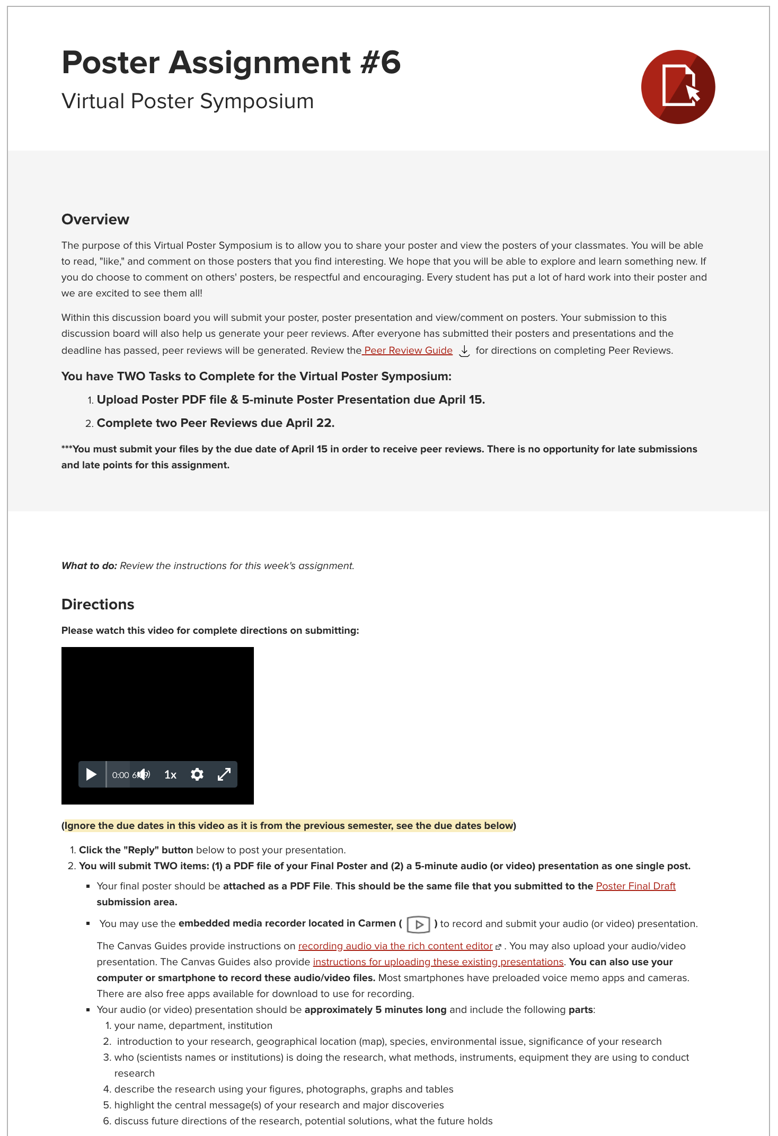

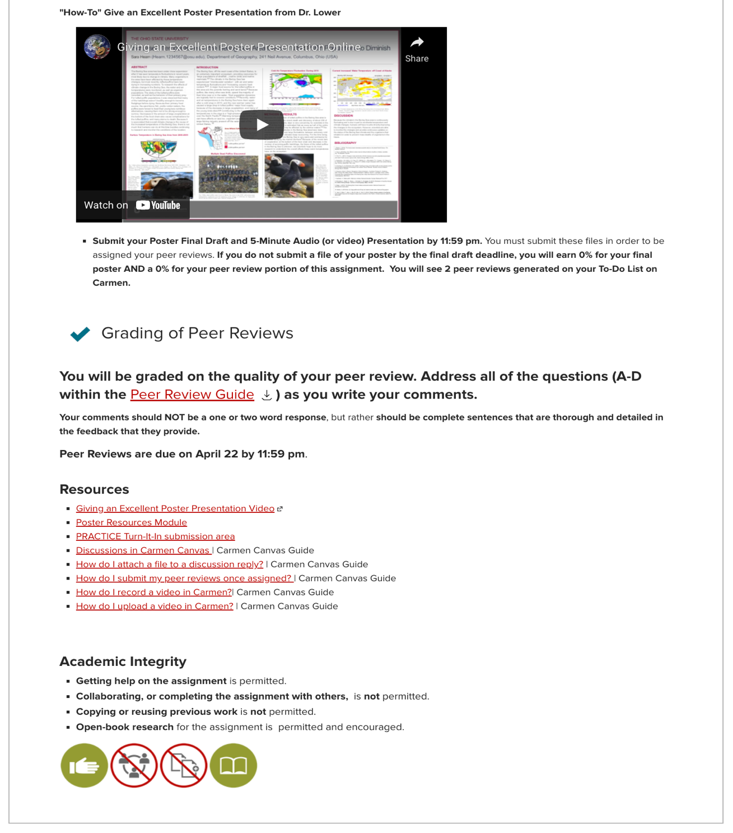
Supplementary Figure S4. Canvas instructions for the Virtual Poster Symposium (Poster Assignment 6 of 6). Instructions include a brief overview of the assignment, a YouTube video with step-by-step on how to submit a poster presentation to the discussion board, a YouTube video with directions on how to give a good poster presentation, and instructions for completing poster peer reviews. This Canvas view is from Week 13 of the Spring 2022 semester.

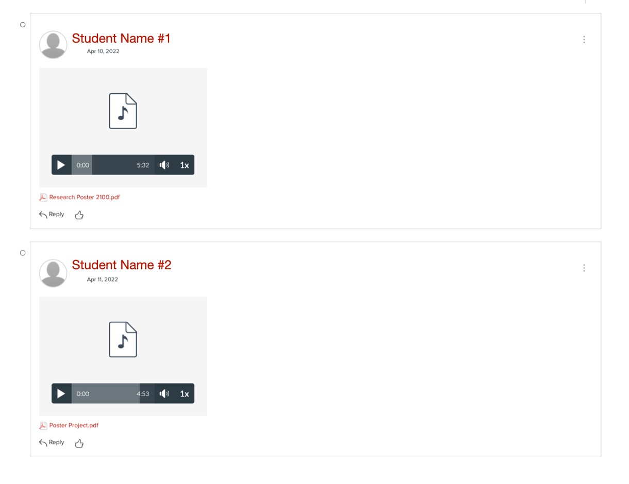
Supplementary Figure S5. Two poster presentations uploaded to the Virtual Poster Symposium by Student #1 and Student #2. Student #1 uploaded a 5 minute 32 second audio file (poster presentation) and a poster PDF file. Student #2 uploaded a 4 minute 53 second audio file (poster presentation) and a poster PDF file. The audio files here were recorded using the Canvas embedded media recorder. All students in the class have access to the Virtual Poster Symposium and can listen to audio presentations, review posters, and comment on their peers’ work. Students were permitted to upload a video file instead of an audio file, however, the instructor encouraged audio files since video files are so much larger (e.g., 2 MB for audio file versus 200 MB for video file).

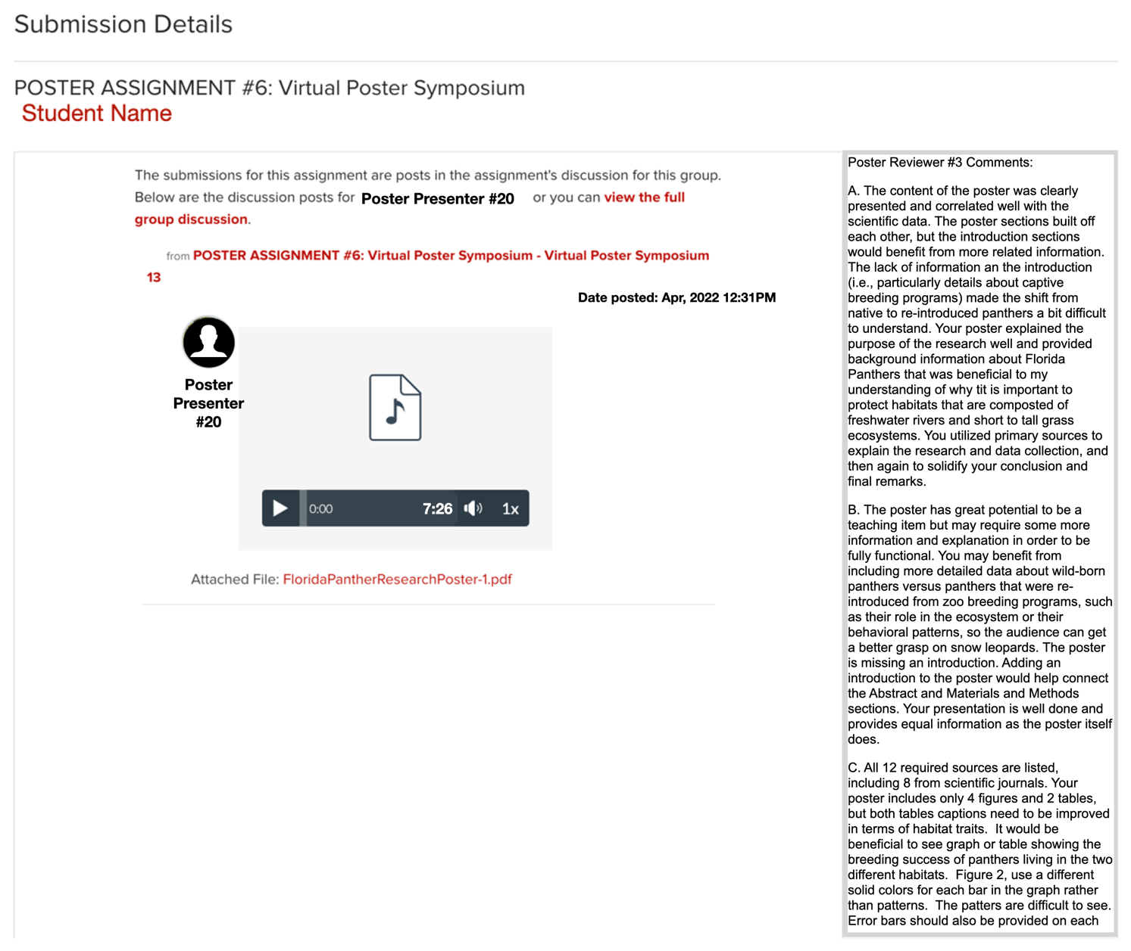
Supplementary Figure S6. Carmen view for a student who is completing a poster peer review. Here, Poster Reviewer #3 is completing a review of Poster Presentation #20. Before starting their reviews, reviewers are given instructions on how to conduct a thorough review and provide detailed and useful comments. Each reviewer types their review in the comment box (shown on the right-hand side) and saves it to the Virtual Poster Symposium so that the presenter can read their comments. Reviews are set up on Carmen to be single-blind reviews so that reviewers’ identities are kept hidden from the poster presenter.

Instructions for how to Conduct a Poster Peer Review
Students should answer ALL the questions in Parts A-D as you write your comments. Your comments should NOT be a one or two-word response, but rather should be complete sentences that are thorough and detailed in the feedback that they provide. You should describe BOTH what the author did well and what the author needs to improve upon their writing.
A. Intellectual Impact of the Poster
- Was the content presented clear and based on scientific data? Did each poster section build on one specific environmental science topic?
- Was the purpose of the research clearly addressed and background information to understand this issue easy to understand?
- Is primary literature used to outline the research on the issue and are the results of these studies used to discuss and draw conclusions about this environmental issue?
- Is it clear from the author’s presentation that the author understands and can intelligently communicate the topic to an audience?
B. Broader Impact of the Poster
- How well does the poster function as a piece of teaching (i.e., quality of pedagogy, clarity of explanations)? Does the poster tell an organized and detailed story that teaches you something new?
- Is the poster too general and/or does it lack details that would make the content more educational or easier to understand? What else could be added?
- Does the poster contain all the necessary components needed to describe the story (i.e., introduction, material & methods, results and discussion) or are things missing that could enhance the story and what element(s) is missing?
- Does the poster presentation contain all the necessary information? Does the author provide new insight to make the presentation interesting or are they simply reading straight from the poster?
C. Technical Details of the Poster
- Has the author included at least ten sources and at least 7 from scientific journals?
- Has the author included at least 5 high-quality figures or tables? Did the author provide a reference for each figure? Did the author provide a figure caption for every figure? Does the author include an original figure? Could the figures be improved, if so, how can they be improved?
- Has the author properly referenced their sources of data and information throughout their poster and if not where in the poster did they fail to do this?
- Was the poster overall visually appealing and well organized? Was each column filled out or was white space present? Did the graphics enhance the presentation? What could be improved so that you better understand the research that is being conducted?
- Did the author maintain a good pace and flow throughout their presentation? Were they clear, expressive and overall easy to understand? Did they spend adequate time on each section of the poster. Do you understand how the technique/method was done. Do you understand how the equipment/instrument was used to collect data? If not, what information was missing?
D. Summary of your Review
Based on your answers above, what is your final recommendation and why have you come to this conclusion?
- Recommendation #1: Publish the poster in its current state (the poster is excellent). It should be noted that this recommendation is very rarely given.
- Recommendation #2: Publish the poster with minor revisions noted in comments A-C.
- Recommendation #3: Publish the poster after major revisions are made to it. The poster is in good shape, but the author needs to complete a substantial amount of work before it is ready for publication. This work could include major changes required to fix figures and tables, or major changes required to fix large portions of the poster text.

What worked well (Dos) | What didn’t work (Don’ts)
Students should start working on their posters early in the semester. | Introducing students to the poster project midway through the semester results in confused students and overwhelmed TAs.
Provide students with frequent and focused feedback throughout the semester. | Students who received late feedback (e.g., more than 10 days after submitting a poster assignment) and students who didn’t read the feedback they received struggled on subsequent poster assignments.
Provide students with poster grading rubrics early in the semester and use the grading rubric to score poster assignments. | Lack of grading rubrics can result poor quality posters, presentations, figures.
Provide numerous high-quality examples for each poster assignment (e.g., using our poster guide book). | When poster examples or figure examples or presentation examples aren’t provided, students don’t understand what is expected of them.
Use free software to produce posters and utilize free resources from your academic library. Ensure that students have access to download and read journal articles for free. | Software (e.g., Microsoft PowerPoint) and journal articles that aren’t free places a significant financial burden on students and added stress.
Spend time early in the semester on information literacy and explaining primary, secondary and tertiary sources. Require students to use peer-reviewed journal articles in their posters but also allow them to use secondary sources to help them better understand the information. | If students don’t understand the importance of primary source journal articles, they will focus their posters mostly on information that they download directly from websites.
Permit students to upload poster presentation formats that are audio, video or transcripts. This flexibility is greatly appreciated by students. | Most students will upload audio files for their poster presentations. Video files are very large and students and the Canvas LMS can have a difficult time uploading video files. Some students receive accommodations that allow for their poster presentation to be a typed transcript.
Assign one TA to the same group of students throughout the semester. This allows the TA to build a more productive relationship with a group of students. | Allowing TAs to pick and choose which posters they grade throughout the semester is confusing for the students and inefficient in terms of feedback and grading.
Assign 1 TA to no more than 50 students. | Assigning more than 50 students to a single TA will overwhelm the TA and result in slow turnaround, poor quality feedback and inconsistent grading.
Explain academic misconduct early in the semester then give students a quiz focused on plagiarism. Allow students to take quiz as many times as they want, provide questions and answers to students. Use plagiarism detection service (e.g., Turnitin) to check all poster submissions throughout the entire semester. If plagiarism is detected early, contact student and talk to them, give them a 0% on the assignment, but permitted them to resubmit the assignment so they can receive feedback and continue with the subsequent poster assignment. | Plagiarism will occur if a plagiarism detection service like Turnitin isn’t used. Plagiarism will occur if the instructor doesn’t specifically talk about academic misconduct early in the semester.
Scaffold poster assignments in such a way that early poster assignments are worth less than assignments that are completed later in the semester. Students will end up producing higher quality poster presentations and earn higher grades. | Not scaffolding poster assignments results in students who are overwhelmed and confused. It will also result in lower quality poster presentations and poor grades. Having early poster assignments worth more points will result in lower grades and discouraged students.
Space poster assignments out throughout the semester such that there are 2-3 weeks between each assignment. This gives students plenty of time to complete their work and plenty of time for TAs to grade assignments and provide feedback before the next assignment is due. | Giving students 1-week or less to complete a poster assignment will be overwhelming to students and TAs and result in poor quality work.
Inform students of poster assignment due dates during the first week of the semester. However, if poster feedback and grading takes longer than expected, the instructor should be flexible and extend the following poster due date so that students have plenty of time to complete their work. | Being rigid with due dates will result in overwhelmed TAs, poor feedback, unhappy students and subpar poster presentations.
Offering incentives (e.g., bonus points) and providing examples of meaningful student-to-student interactions (e.g., email, Zoom, sharing files) encourages students to meet deadlines and interact with their peers on Canvas discussion boards, over Zoom, and by email. | Students can be unfamiliar and uncomfortable interacting with their peers when incentives aren’t provided or when they have to start a conversation from scratch.
Allow students to pick their own topic and then grouping posters by topic early in the semester can lead to more peer-to-peer interactions because students share common interests. | Assigning a specific poster topic to a student can discourage learning and peer-to-peer interactions.
Supplemental Table S1. Recommendations for poster assignments from our long-term study.

