Supplementary Material
 | Complex musical multi-feature paradigm
 | Musicians | Non-musicians
FI | 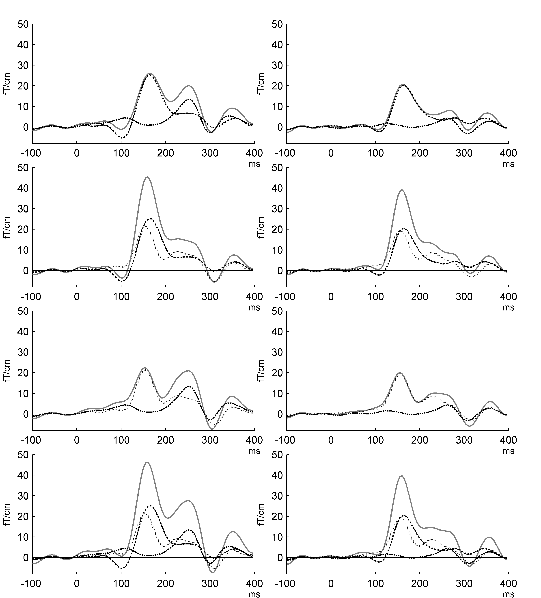
IL
LF
FIL
Supplementary Figure 1. Modelled MMNm responses in the complex musical multi-feature paradigm. Plots of the MMNm for individual single-feature deviants and the modelled MMNm response resulting from summation of these responses.

 | Simple control paradigm
 | Musicians | Non-musicians
FI | 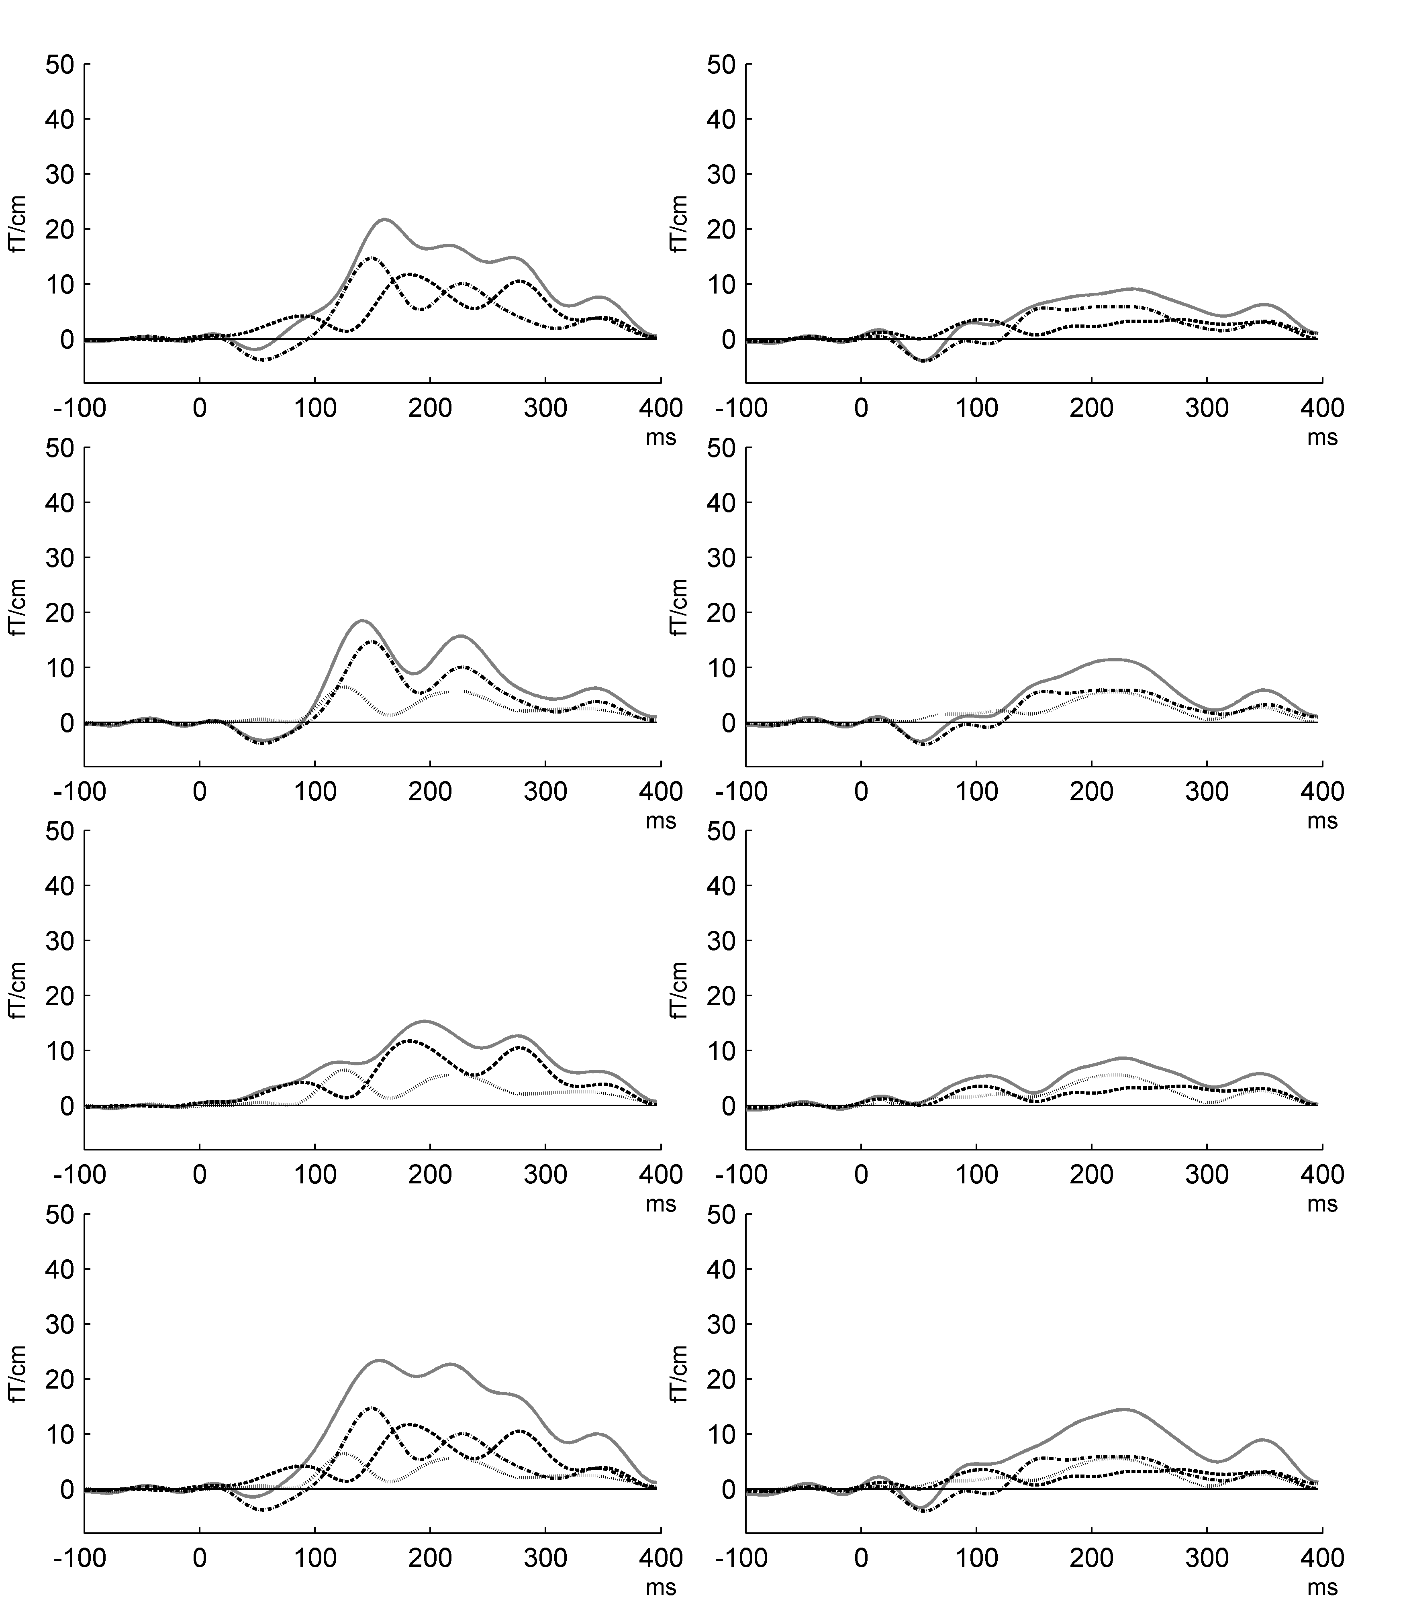
IL
LF
FIL
Supplementary Figure 2. Modelled MMNm responses in the simple control paradigm. Plots of the MMNm for individual single-feature deviants and the modelled MMNm response resulting from summation of these responses.

