Supplementary Material

# Supplementary Figures

**Supplementary Figure S1.** The mechanism for the surface functionalization of SBA-15

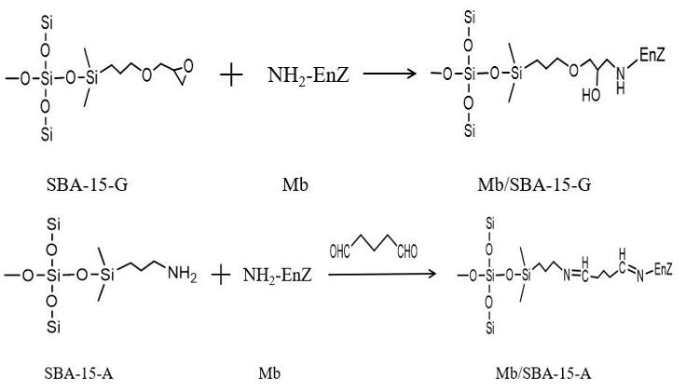

**Supplementary Figure S2.** The covalent immobilization of Mb on SBA-15-A and SBA-15-G

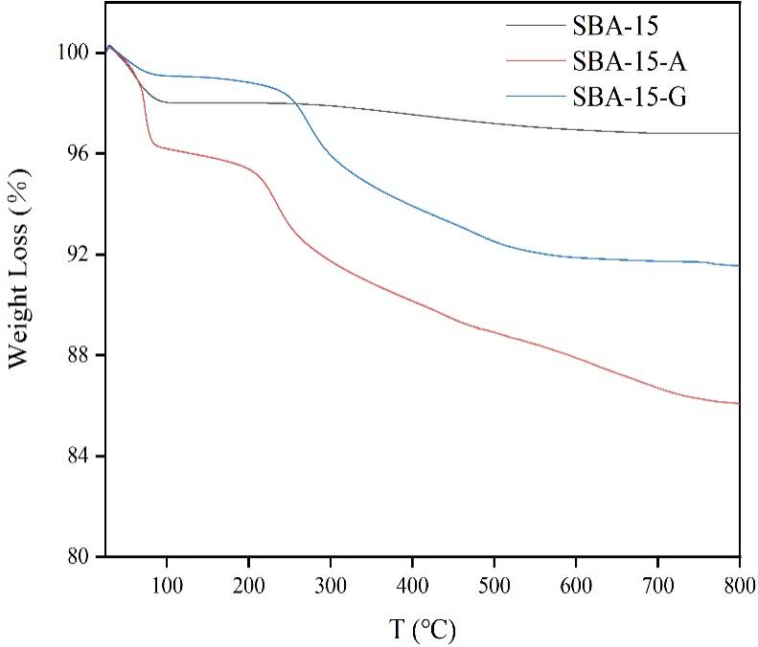

**Supplementary Figure S3.** The TG diagrams

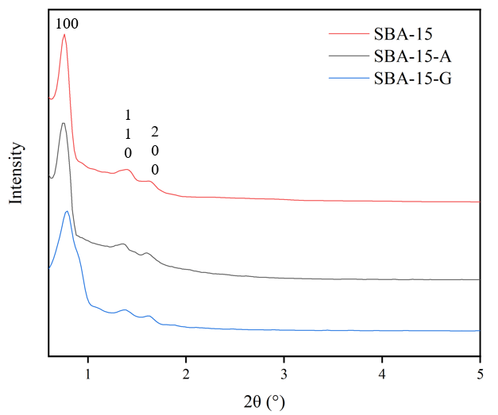

**Supplementary Figure S4.** Small-angle XRD patterns.

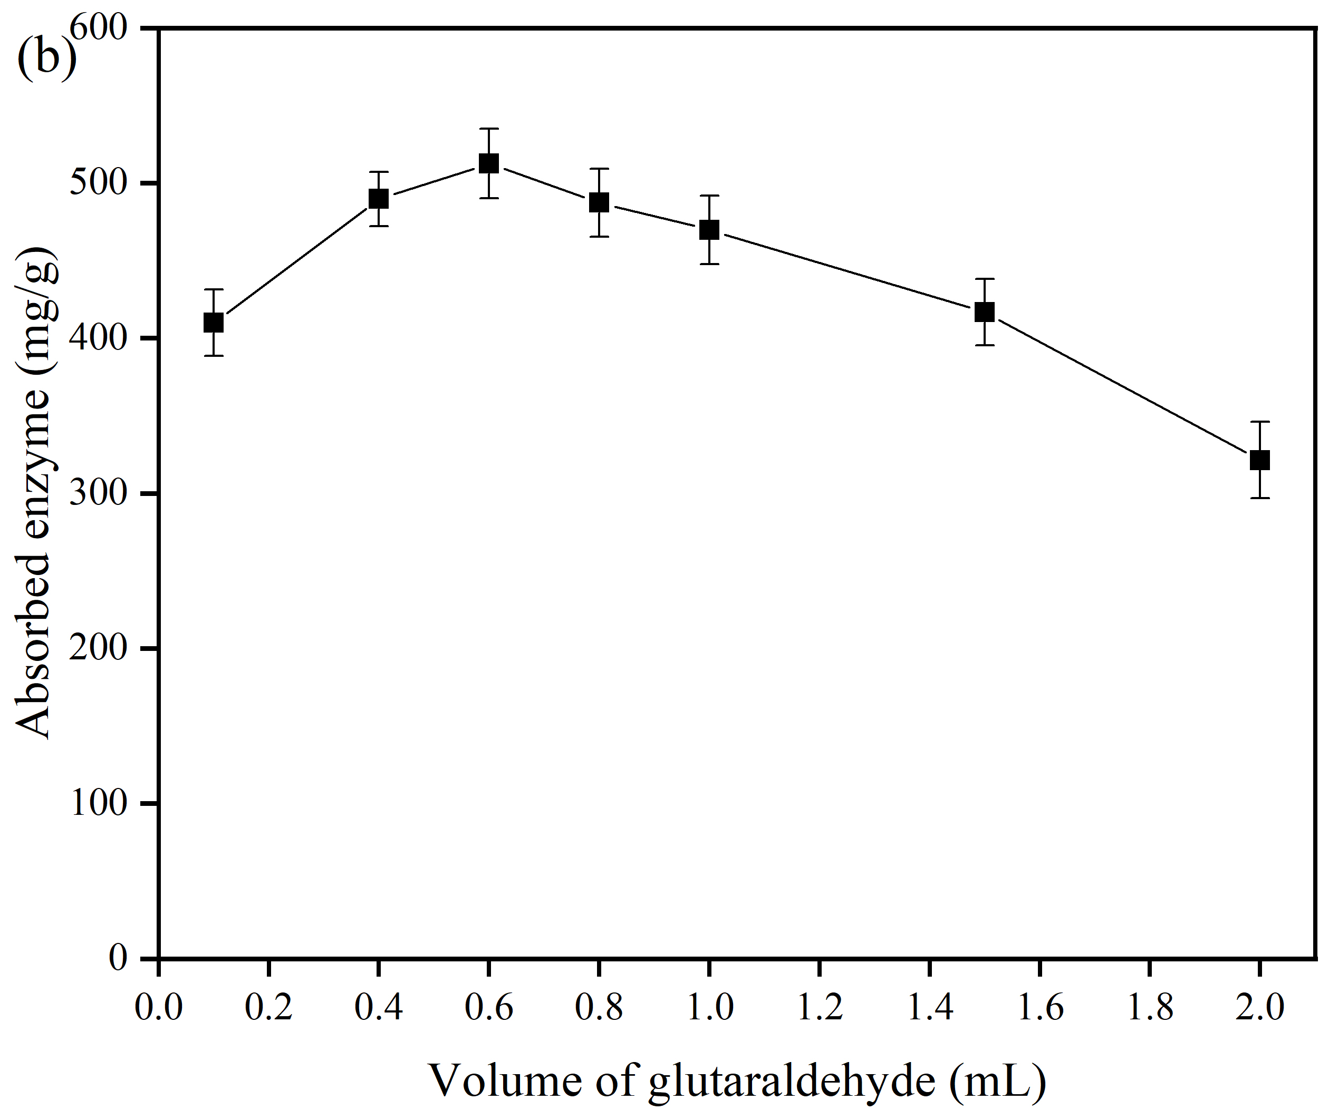

**Supplementary Figure S5.** The optimization of glutaraldehyde addition

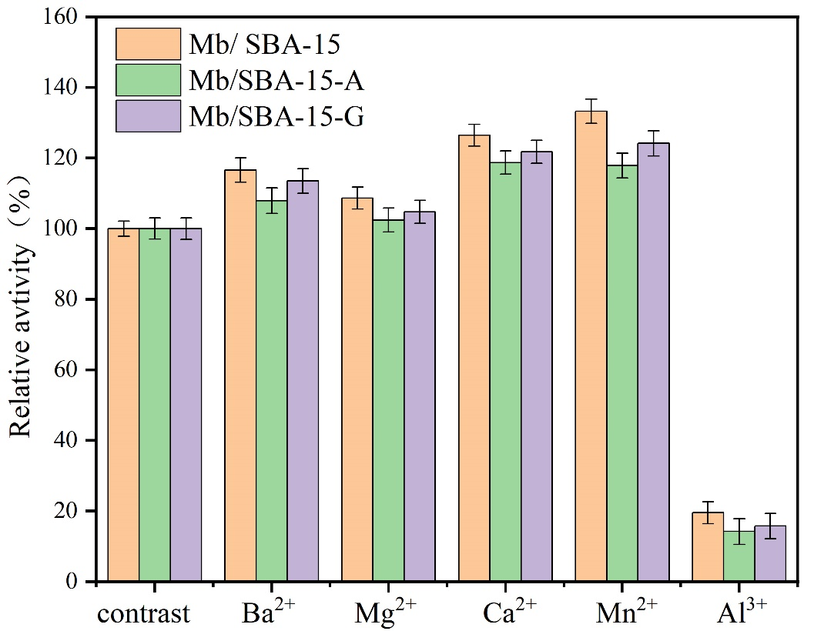

**Supplementary Figure S6 A.** The effects of metal ions.

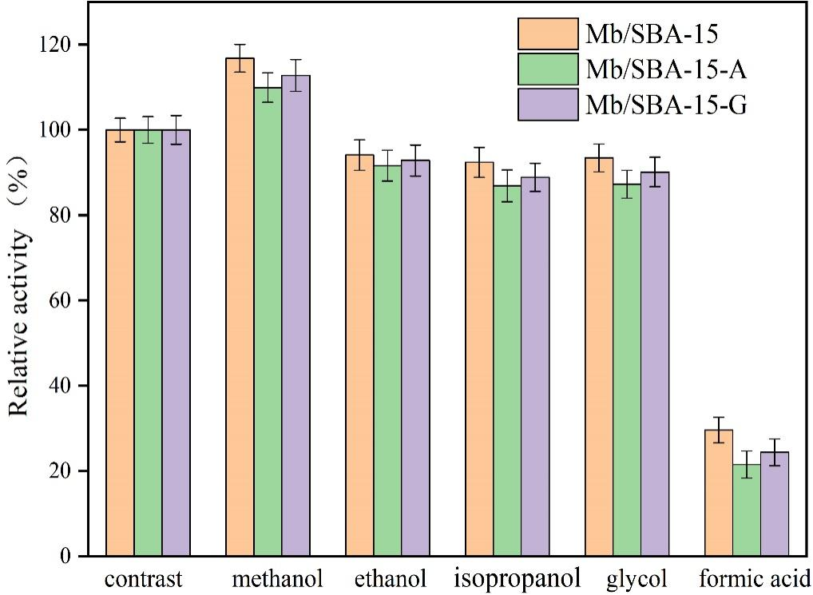

**Supplementary Figure S6 B.** The effects organic solvents.